Comparative study before and after the use of Episil® oral liquid in patients with hematological malignancies
Taeko Fukutani ^{1*}, Yukio Yoshioka ¹, Shinpei Imori ², Hirokazu Yanagihara ², Kensaku Sumi ¹, Yoshinari Myoken ³ ,Yoshinori Fujita ³, and Souichi Yanamoto ^{1,}
¹ Department of Oral Oncology, Graduate School of Biomedical and Health Sciences, Hiroshima University; fukutani@hiroshima-u.ac.jp, yyosioka@hiroshima-u.ac.jp, ksumi@horishima-u.ac.jp, syana@hiroshima-u.ac.jp; Phone number: +81 (0)82 257-5667; Address; 1-2-3 Kasumi, Minami Ward, Hiroshima, 734-8553, JAPAN
² Graduate School of Advanced Science and Engineering, Hiroshima University; imori@hiroshima-u.ac.jp, yanagi-hiro@hiroshima-u.ac.jp; Phone number: +81 (0)82 424-7357; Address; 1-9-6 Sendamachi, Naka-ku,Hiroshima, 730-8619, JAPAN
³ Department of Oral Surgery, Hiroshima Red Cross & Atomic-bomb Survivors Hospital; myoken@do5.enjoy.ne.jp, yssnhfujita＠energy.ocn.ne.jp; Phone number: +81 (0)82 241-3111; Address; 1-3-2 Kagamiyama, Higashi-Hiroshima City, Hiroshima, 739-8511, , JAPAN
* Correspondence: fukutani@hiroshima-u.ac.jp; Tel.: +81-(0)-82-257-5667

Supplementary Files

Table S1. List of cases in Study 1

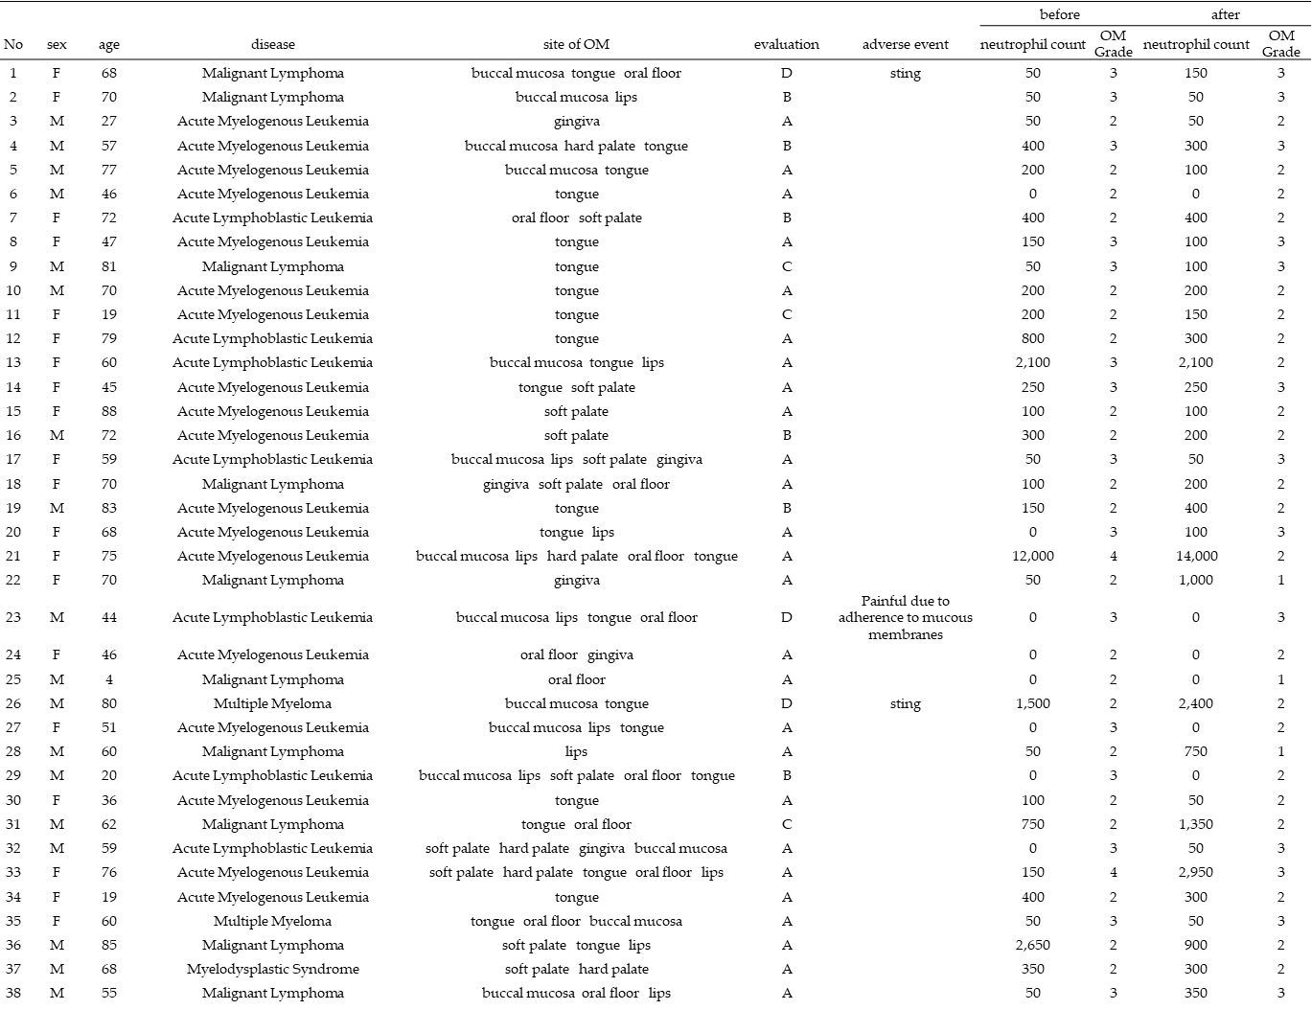

Table S2. List of cases in Study 2
