Multispecies-Coadsorption-Induced Rapid Preparation of Graphene Glass Fiber Fabric and Applications in Flexible Pressure Sensor Based on the Hierarchical Conductive Configuration

Kun Wang^{1,2,6}, Xiucai Sun^{1,2,6}, Shuting Cheng^{2,3,6}, Yi Cheng¹, Kewen Huang^{1,2}, Ruojuan Liu^{1,2}, Hao Yuan^{1,2}, Wenjuan Li^{1,2}, Fushun Liang^{1,2}, Yuyao Yang^{1,2}, Fan Yang^{1,2}, Kangyi Zheng^{2,4}, Zhiwei Liang^{2,5}, Ce Tu², Mengxiong Liu^{1,2}, Mingyang Ma^{1,2}, Yunsong Ge^{1,2}, Muqiang Jian^{1,2}, Wanjian Yin^{2,4}, Yue Qi²*, Zhongfan Liu^{1,2}*

- Centre for Nanochemistry, Beijing Science and Engineering Centre for Nanocarbons, Beijing National Laboratory for Molecular Sciences, College of Chemistry and Molecular Engineering, Peking University, Beijing 100871, China.
- Beijing Graphene Institute (BGI), Beijing 100095, China.
- State Key Laboratory of Heavy Oil Processing, College of Science, China University of Petroleum, Beijing 102249, China.
- College of Energy, Soochow Institute for Energy and Materials Innovations (SIEMIS), Jiangsu Provincial Key Laboratory for Advanced Carbon Materials and Wearable Energy Technologies, Soochow University, Suzhou 215006, China.
- Guangdong Provincial Key Laboratory of Quantum Engineering and Quantum Materials, School of Physics, South China Normal University, Guangzhou 510006, China
- These authors contributed equally: Kun Wang, Xiucai Sun, Shuting Cheng.

* Correspondence: zfliu@pku.edu.cn; qiyue@bgi-graphene.com

This PDF file includes:

Supplementary Methods
Supplementary Figs. 1 to 12
Supplementary Reference

Supplementary Methods

DFT computational details
The DFT calculations are performed using the Vienna Ab initio Simulation Package (VASP) software¹. The projector augmented wave (PAW) method was used to describe the interactions between the core and valence electrons. The Perdew-Burke-Ernzerhof (PBE) form involving the generalized gradient approximation (GGA) functional was used to describe the exchange correlation potential². The electron wave functions were expanded in a plane wave basis set with a kinetic energy cutoff of 450 eV, the Monkhorst-Pack scheme k-point grids were set to 2×2×1. A vacuum layer of 15 Å is added perpendicular to the sheet to avoid artificial interaction between periodic images. All the structures are relaxed until the residual forces on the atoms have declined to less than 0.05 eV Å⁻¹, and the convergence criterion for the total energy is set to 1 × 10⁻⁴ eV. For the calculation of the atomic dipole moments, with consideration of periodic boundary conditions, was accomplished by the application of the recently developed density-derived electrostatic and chemical (DDEC6) methods³. For transition state calculations, the climbing image nudged elastic band (CI-NEB) method was used to determine the energy barriers of various kinetic processes⁴. The transition states during each elementary reaction were verified by transition state imaginary frequency calculations.
The stability of hydrocarbon species adsorption geometry was evaluated by the adsorption energy (E_{ads}), which is defined as
$${\text{E}}_{\text{ads}}\text{ =}{\text{ E}}_{\text{tot}}-{\text{E}}_{\text{sub}}-{\text{ E}}_{{\text{CH}}_{\text{x}}} \text{(1)}$$
where E_{tot} and ${\text{E}}_{\text{sub}}$ are the total energies of the SiO₂(0001) substrate with and without adsorbed hydrocarbon species, ${\text{E}}_{{\text{CH}}_{\text{x}}}$ is the energy of a hydrocarbon molecule.
During the various elementary reaction calculations and transition state searching processes, the reaction barrier E_{a} is calculated as
$${\text{E}}_{\text{a}}\text{ =} {\text{E}}_{\text{TS}}-{\text{E}}_{\text{IS} } \text{(2)}$$
where E_{IS} and E_{TS} represent the energies of the initial state (IS) and transition state (TS), respectively.
Considering the weak absorption on insulating surfaces, the lifetime of a species on a surface can be estimated by
$$\text{τ}\text{ = }{\text{τ}}_{\text{0}}\text{exp(}{\text{E}}_{\text{b}}\text{/}{\text{k}}_{\text{B}}\text{T}\text{)} \text{(3)}$$
where ${\text{τ}}_{\text{0}}\text{ = }\text{h}\text{/}{\text{k}}_{\text{B}}\text{T}$ is the prefactor and h and k_{B} are the Plank and Boltzmann constants, respectively.

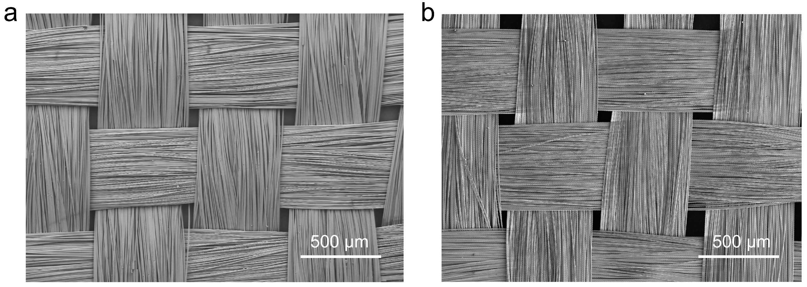
Supplementary Fig. 1 | SEM images of original GFF (a) and GGFF obtained after the high-temperature (~1100 °C) graphene CVD growing process (b). The structure of the fiber was well maintained after the high-temperature treatment.

Supplementary Fig. 2 | Current-voltage curves of GGFFs with growth time of (a) 15 s and (b) 30 s, showing open-circuit (corresponding to period I in Fig. 2) and connected-circuit (corresponding to period II in Fig. 2) characteristics, respectively.

Supplementary Fig. 3 | Growth rates of graphene grown with dichloromethane and methane at the different H₂/CH₂Cl₂ or H₂/CH₄ ratios. The growth rates of graphene on GFF in the dichloromethane CVD system kept at ~3 orders of magnitude higher that of methane.

Supplementary Fig. 4 | Comparison of Raman spectra for dichloromethane- and methane-grown graphene obtained with the same growth rate. In contrast to the characteristic Raman 2D band (~2,680 cm⁻¹) for dichloromethane-grown graphene, the Raman 2D band of methane-grown graphene is nearly negligible.

Supplementary Fig. 5 | DFT calculated bond lengths and overlap populations of (a) C−H in methane molecule and (b) C−H and C−Cl in dichloromethane molecule. The overlap population between two atoms provides a measure of the extent of electron density overlap between their respective atomic orbitals, indicating the strength of the bond between those atoms.

Supplementary Fig. 6 | Kinetic calculations of dichloromethane and methane pyrolysis. a, Energy barriers E_{a} (in eV) and possible routes for dichloromethane pyrolysis in gas phase.The black filled arrows indicate the main decomposition route. b, Energy barrier of CH₄ dehydrogenation processes in gas phase.

Supplementary Fig. 7 | Calculated partial pressure of the decomposition products of dichloromethane as a function of temperature. The reaction is assumed under a thermodynamic equilibrium, and P(CH₂Cl₂) = 2.5 × 10⁻⁴ bar, P(H₂) = 2.0 × 10⁻³ bar. The typical graphene growth temperature of ~1100 °C is marked with grey line.

Supplementary Fig. 8 | Calculation model of the GFF substrate. a, Schematic of the atomic configurations for SiO₂(0001) surfaces terminated with different elements. b, Stable configurations of O1-, O2-, and Si-terminated surface structures with or without H passivation. c, Comparisons of the surface energy corrosponding to the six configurations in (b), where Si-terminated SiO₂(0001) without H passivation (marked by the red box in (b)) is proved to be the most stable structure with the lowest surface energy.

Supplementary Fig. 9 | Stable configurations and adsorpstion energies (E_{ads}) of CH₂ adsorbed on SiO₂(0001) surface (a) without and (b) with Cl coadsorption. Without Cl coadsorption, the adsorption energy of CH₂ is ~−1.24 eV for Si site and ~1.40 eV for O site, revealing the nonactivity of O site for CH₂ adsorption. With Cl coadsorption on Si site, the adsorption energy of CH₂ decreases from ~−1.24 eV to ~−1.26 eV for Si site and from ~1.40 eV to ~−0.63 eV for adjacent non-bonding O site. The significant decrease of adsorpstion energies on O site indicates that CH₂ adsorption is greatly enhanced and the nonactive O site is thus activated.

Supplementary Fig. 10 | Energy profiles and the corresponding structure evolution during the dehydrogenation kinetics of thegrowing zigzag edges of graphene domain, where (H-)Gr represents that the frontier edge of graphene is terminated by H. The H atoms at graphene edges are removed by CH₂ species in the gas phase via CH₂ + H-Gr → CH₃ + Gr reaction. The high reaction energy barrier of ~2.06 eV severely limits the expansion of graphene edges.

Supplementary Fig. 11 | Schematic of the GGFF flexible pressure sensor, where GGFF is encapsulated by polypropylene films.

Supplementary Fig. 12 | ΔR/R₀ of GGFF pressure sensor at different finger bending angles, exhibiting a rapid relative resistance variations with the good repeatability and stability.

Supplementary References
1. Kresse, G. & Joubert, D. From ultrasoft pseudopotentials to the projector augmented-wave method. Phys. Rev. B 59, 1758–1775 (1999).
2. Perdew, J. P., Burke, K. & Ernzerhof, M. Generalized gradient approximation made simple. Phys. Rev. Lett. 77, 3865–3868 (1996).
3. Limas, N. & Manz, T. A. Introducing DDEC6 atomic population analysis: part 2. Computed results for a wide range of periodic and nonperiodic materials. RSC Adv. 6, 45727–45747 (2016).
4. Mills, G., Jonsson, H. & Schenter, G. K. Reversible work transition state theory: application to dissociative adsorption of hydrogen. Surf. Sci. 324, 305–337 (1995).

