Appendix Tables
Appendix Table 1: Categories of Expenditure Derived from the Consumer Expenditure Survey
 | Categories | Description
1 | Total Food Expenditure | Total expenditures on food (not including alcohol) purchased at grocery stores and convenience stores for home consumption. Food purchased at school (school meals) or employment; food at catered events; food during out of town trips; dining out at restaurants (including alcohol and tobacco purchases).
2 | Total Non-Food Expenditure | Total expenditures on all non-food items including Education, Entertainment, Housing, Utilities, Transportation, Healthcare, and other household consumption items (e.g., furnishing and appliances, clothing, other personal items).
3 | Education and Enrichment | Recreational lessons, tutoring, and other instruction. Babysitting, nursery school and daycare centers. School tuition. School-related books, supplies and equipment. Books and magazines (not related to school). Private school transportation. Admission fees for entertainment activities, (movie, theater, concert, sporting events); Sports-related items and general sports equipment; Personal electronic equipment. Membership fees for country clubs, health clubs, or other recreational organizations.
4 | Housing | Shelter expenditures in home city, including mortgage principle and interest for owned home and/or vacation home, rents, insurance, taxes, and maintenance.
5 | Utilities | Natural gas, electricity, telephone services, water and other public service, and fuel oil and other fuels.
6 | Transportation | Vehicle maintenance and repair, vehicle insurance, vehicle fee, public transportation, gasoline and other motor fuel.
7 | Healthcare | Health insurance, medical services (Physician, dental, eye-care etc.), and medical care (Lab tests, x-rays, hospital stay, etc.)
8 | Other | All other expenditures not included in categories 3-7 (Household operations, household furnishing and appliances, clothing, footwear, jewelry, personal care items, etc.)
Notes: Rows 3-8 are sub-items from the Total Non-food Expenditure category.

Appendix Table 2 First stage instrumental variable results by model and sample specification for households ≤ 185% of FPL
 | All households |  |  | HHs with children |  |  | HHs without children
IVs | Model 1 | Model 2 | Model 3 | Model 1 | Model 2 | Model 3 | Model 1 | Model 2 | Model 3
BBCE | 0.002 |  |  | 0.003 |  |  | 0.003
 | (0.002) |  |  | (0.004) |  |  | (0.002)
CAP | 0.024** | 0.026** |  | 0.008 | 0.010 |  | 0.020 | 0.021
 | (0.010) | (0.011) |  | (0.013) | (0.013) |  | (0.012) | (0.013)
BI | -0.039*** | -0.041*** | -0.046*** | -0.032** | -0.035*** | -0.038*** | -0.043*** | -0.046*** | -0.050***
 | (0.008) | (0.007) | (0.006) | (0.014) | (0.012) | (0.012) | (0.010) | (0.010) | (0.010)
Obs. | 71,476 | 71,476 | 71,476 | 27,992 | 27,992 | 27,992 | 43,484 | 43,484 | 43,484
R2 | 0.220 | 0.220 | 0.220 | 0.234 | 0.234 | 0.234 | 0.154 | 0.154 | 0.154
F-stat. | 16.45 | 25.39 | 50.72 | 3.70 | 4.76 | 10.66 | 8.51 | 12.24 | 23.13
Notes: Each column is a separate regression predicting SNAP participation. Each includes household and state-level controls as well as state, month and year dummies. Robust standard errors clustered at the state level are reported in parenthesis. Sampling weights are applied. *** p<0.001, ** p<0.01, * p<0.05

Appendix Table 3 The effects of SNAP on expenditure (logged) by household type and IV specification for households ≤ 185% of FPL
 | All households |  |  | HHs with children |  |  | HHs without children
DVs | Model 1 | Model 2 | Model 3 | Model 1 | Model 2 | Model 3 | Model 1 | Model 2 | Model 3
Food | 0.711 | 0.807 | 1.540*** | 0.535 | 1.371* | 0.878* | 1.227* | 1.247* | 1.980***
 | (0.496) | (0.501) | (0.339) | (0.666) | (0.747) | (0.520) | (0.633) | (0.655) | (0.362)
Non-food | 0.816* | 0.651* | 0.261 | 0.081 | 0.316 | 0.019 | 0.986** | 0.539 | 0.298
 | (0.409) | (0.358) | (0.305) | (0.478) | (0.474) | (0.338) | (0.427) | (0.346) | (0.376)
Ed.&enrich. | 1.415** | 1.340** | 0.926** | 0.894 | 1.222 | 0.796 | 1.644 | 1.373 | 0.885
 | (0.582) | (0.578) | (0.415) | (0.889) | (0.984) | (0.602) | (0.994) | (0.967) | (0.801)
Housing | 0.955 | 0.620 | 0.196 | 0.389 | -0.328 | -0.348 | 1.143* | 0.643 | 0.344
 | (0.713) | (0.629) | (0.297) | (0.981) | (1.171) | (1.243) | (0.618) | (0.475) | (0.468)
Util. | 0.976** | 0.894** | 0.701* | 0.119 | 0.333 | 0.439 | 1.309** | 1.047** | 0.819**
 | (0.383) | (0.357) | (0.369) | (0.663) | (0.769) | (0.650) | (0.538) | (0.496) | (0.306)
Transp. | -0.365 | -0.491 | -0.849** | -1.178 | -0.995 | -2.210** | 0.139 | -0.202 | -0.103
 | (0.436) | (0.467) | (0.305) | (1.076) | (1.524) | (1.079) | (0.487) | (0.508) | (0.397)
Health | -0.124 | -0.455 | -1.062 | -0.172 | -0.485 | -1.396 | 0.716 | -0.647 | -1.040
 | (0.860) | (0.840) | (1.046) | (1.123) | (1.179) | (1.403) | (1.264) | (1.316) | (0.988)
Other | 1.452** | 1.329* | 0.531 | 2.383*** | 1.875** | 1.015 | -0.722 | 0.056 | -0.136
 | (0.664) | (0.693) | (0.792) | (0.787) | (0.799) | (0.733) | (0.986) | (1.056) | (1.108)
Obs. | 71,476 | 71,476 | 71,476 | 27,992 | 27,992 | 27,992 | 43,484 | 43,484 | 43,484
F-stat. | 16.45 | 25.39 | 50.72 | 3.70 | 4.76 | 10.66 | 8.51 | 12.24 | 23.13
Notes: Model 1 applies BI, CAP and BBCE as IVs. Model 2 applies BI and CAP. Model 3 applies BI as IV. Each cell comes from a separate regression that includes the full set of household and state-level controls as well as state, month, and year indicators. Robust standard errors clustered at the state level in parentheses. Sampling weights are applied. *** p<0.001, ** p<0.01, * p<0.05

Appendix Table 4 Misclassification of SNAP participation for households ≤ 185% of FPL
SNAP misclassification | All households |  |  | HHs with children |  |  |  | HHs without children
SNAP misclassification | M 1 | M 2 | M3 |  | M 1 | M 2 | M3 |  | M 1 | M 2 | M3
Over-report α₀ | 0.004 | 0.006 | 0.005 |  | 0.021 | 0.020 | 0.020 |  | 0.021 | 0.021 | 0.021
 | (0.006) | (0.004) | (0.004) |  | (0.009) | (0.009) | (0.009) |  | (0.002) | (0.002) | (0.002)
Under-report α₁ | 0.107 | 0.106 | 0.106 |  | 0.068 | 0.068 | 0.066 |  | 0.248 | 0.258 | 0.258
 | (0.011) | (0.011) | (0.011) |  | (0.015) | (0.015) | (0.015) |  | (0.018) | (0.018) | (0.018)
Obs. | 71,476 | 71,476 | 71,476 |  | 27,992 | 27,992 | 27,992 |  | 43,484 | 43,484 | 43,484
Notes: Model 1 applies BI, CAP and BBCE as IVs. Model 2 applies BI and CAP. Model 3 applies BI as IV. Each cell comes from a separate regression that includes the full set of household and state-level controls as well as state, month, and year indicators. α₀ represents the probability of false positive; α₁ represents the probability of false negatives. Sampling weights are applied.

Appendix Table 5 The effects of SNAP on expenditure (logged) adjusted for misreporting by household type and IV specification for households ≤ 185% of FPL
 | All households |  |  | HHs with children |  |  | HHs without children
DVs | Model 1 | Model 2 | Model 3 | Model 1 | Model 2 | Model 3 | Model 1 | Model 2 | Model 3
Food | 0.464*** | 0.463*** | 0.441*** | 0.284*** | 0.283*** | 0.277*** | 0.057 | 0.056 | 0.067
 | (0.073) | (0.073) | (0.072) | (0.089) | (0.089) | (0.089) | (0.097) | (0.096) | (0.096)
Non-food | 0.230*** | 0.229*** | 0.225*** | -0.015 | -0.016 | -0.003 | -0.161** | -0.162** | -0.145**
 | (0.055) | (0.055) | (0.052) | (0.058) | (0.059) | (0.060) | (0.056) | (0.056) | (0.055)
Ed.&enrich. | 0.275** | 0.275** | 0.284** | 0.337** | 0.336** | 0.339** | 0.052 | 0.051 | 0.067
 | (0.115) | (0.115) | (0.115) | (0.143) | (0.143) | (0.141) | (0.103) | (0.103) | (0.098)
Housing | 0.393*** | 0.393*** | 0.391*** | 0.167 | 0.167 | 0.179 | 0.089 | 0.088 | 0.097
 | (0.119) | (0.119) | (0.124) | (0.122) | (0.121) | (0.121) | (0.090) | (0.089) | (0.097)
Util. | 0.764*** | 0.764*** | 0.723*** | 0.288** | 0.287** | 0.277** | 0.288*** | 0.286*** | 0.279***
 | (0.102) | (0.102) | (0.104) | (0.107) | (0.107) | (0.108) | (0.100) | (0.100) | (0.101)
Transp. | 0.228** | 0.227** | 0.241** | 0.003 | 0.003 | 0.034 | -0.436** | -0.436** | -0.385**
 | (0.105) | (0.105) | (0.103) | (0.108) | (0.108) | (0.106) | (0.187) | (0.187) | (0.189)
Health | -0.284* | -0.283* | -0.299* | -0.151 | -0.147 | -0.125 | -0.414** | -0.412** | -0.408**
 | (0.160) | (0.160) | (0.156) | (0.301) | (0.301) | (0.297) | (0.153) | (0.153) | (0.144)
Other | 0.337** | 0.336** | 0.340** | -0.467** | -0.467** | -0.442** | -0.301 | -0.301 | -0.263
 | (0.137) | (0.137) | (0.132) | (0.114) | (0.114) | (0.113) | (0.223) | (0.223) | (0.214)
Obs. | 71,476 | 71,476 | 71,476 | 27,992 | 27,992 | 27,992 | 43,484 | 43,484 | 43,484
Notes: Model 1 applies BI, CAP and BBCE as IVs. Model 2 applies BI and CAP. Model 3 applies BI as IV. Each cell comes from a separate regression that includes the full set of household and state-level controls as well as state, month, and year indicators. Robust standard errors clustered at the state level in parentheses. Sampling weights are applied. *** p<0.001, ** p<0.01, * p<0.05

Appendix Figures
Appendix Figure 1 Number of states that operate CAP, BBCE, and BI between 2000 and 2011 sampled in the CE Survey
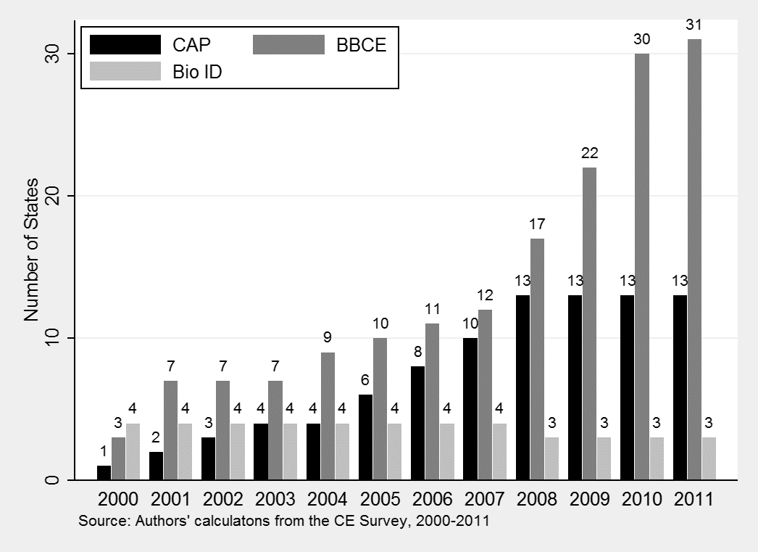
Notes: Eight states that are never represented in our CE sample include Arkansas, Iowa, Mississippi, Montana, New Mexico, North Dakota, South Dakota, and Wyoming. In addition, five states that are irregurarly presented in our CE sample includes Maine, Oklahoma, North Carolina, Vermont, and Rhode Island. Maine is observed only from 2005-2011, Oklahoma 2000-2006, North Carolina 2000-2005, Vermont 2000-2004, and Rhode Island is only observed in 2005. So, base count varies over time—the base count is 40 states for 2000-2004; 41 states for 2005; 39 states for 2006-2011.
Appendix Figure 2 Percentage of CE observations residing in states with CAP, BBCE, and BI between 2000 and 2011 sampled in the CE Survey
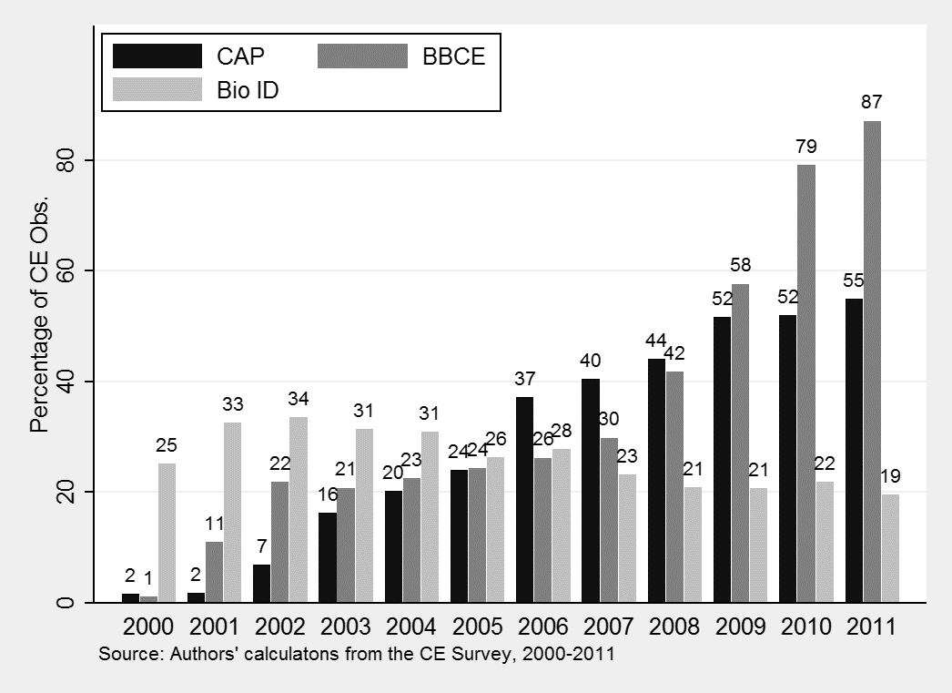
Notes: Same as above.

