Appendix A
1 – CDC Defined SVI measures²
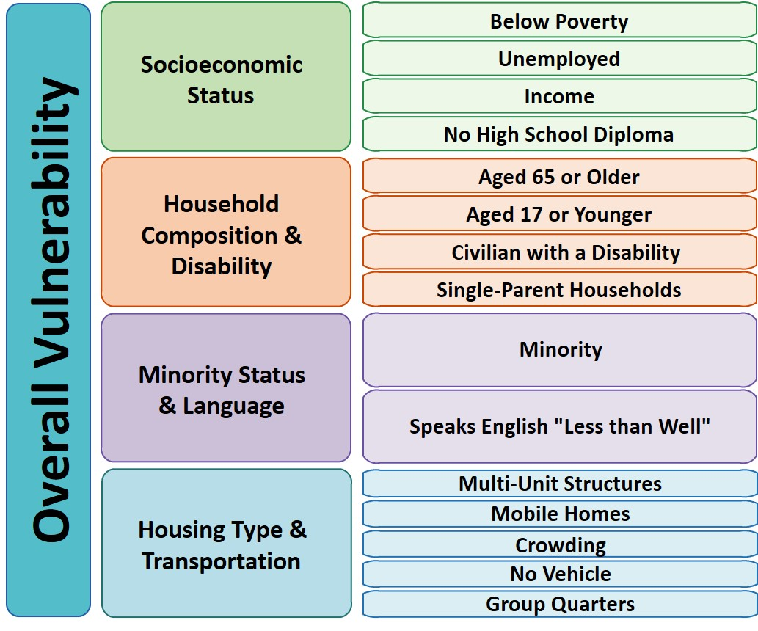
CDC © 2018

