Supporting Information

Multimodal imaging and photothermal/chemodynamic therapy of cervical cancer using GSH responsive nanoparticles

Runrun Shao¹, Xiaofang Qiao², Linlin Cao², Jianliang Man¹, Lingyun Guo¹,Lanlan Li¹,Wen Liu¹,Lihong Li¹,Bin Wang¹, Lixia Guo¹, Sufang Ma¹, Boye Zhang¹, Haojiang Wang¹, and Lili Yan¹*

¹College of Basic Medicine University, Shanxi Medical Univerity, Taiyuan, 030000, P. R. China.
²Henan Center For Drug Evaluation and Inspection, Henan, 450000, P. R. China.

A: Experimental Section
Chemicals.
Ethanol and ammonium hydroxide were purchased from DAMAO chemical reagent plants. Ammonium molybdate was provided by Sigma. Hydrazine hydrate, ethylene glycol, DA-HCl, KMnO_{4,} RhB, NaN₃, and MB were purchased from Shanghai Aladdin Biochemical Technology Co Ltd. MTT , Calcein-AM , PI and DCFH-DA were provided by Solarbio. No further purification was performed on any of the reagents.
Preparation of MoS₂@MnO₂-PEG
Preparation of MoS2 involved dispersing 27.5 mg of ammonium molybdate in 12.5 mL of ethylene glycol solution through ultrasonic treatment for 10 minutes. Next, 147 μL of hydrazine hydrate (80%) was added, and the solution was subjected to ultrasonic treatment for 40 minutes and transferred to a 25 mL reactor for 10 hours at 140°C. After the reaction, the material was cooled to room temperature, washed with acetone three times, centrifuged for 5 minutes at 8000 rpm, and the pellets were collected and dried in a vacuum oven at 80°C for 24 hours.
To prepare MoS2@MnO2, 10 mg of dried MoS2 was dispersed in 10 mL of Tris-HCl (10 mmol L−1) in water through ultrasonic treatment for 10min until the solution was clear. Then, 1 mL of 1 mg mL−1 of DA-HCl was added and stirred for 30 minutes. Subsequently, 2 mL of KMnO4 was added to the solution, and the reactants were stirred for 4 hours and centrifuged. The black powder obtained was washed with deionized water three times to obtain MoS2@MnO2.
For the preparation of MoS2@MnO2-PEG, 5 mg of MoS2@MnO2 samples were dispersed in 10 mL of deionized water, and 2 mL of mPEG-NH2 (10 mg mL−1) was added. The solution was stirred for 24 hours at room temperature, and black powder nanoparticles MoS2@MnO2 were obtained.
Characterization
The hydrodynamic diameter of the nanoparticle was determined by dynamic light scattering (DLS,MALVERN ZEN3700).The transmission electron microscope (TEM) analysis results were harvested to confirm the particle morphology, elemental varieties and relative contents. The surface composition, chemical states and valence band spectra were investigated by X-ray photoelectron spectroscopy (XPS). The ultraviolet-visible-near infrared (UV−vis−NIR) absorbance spectra were recorded by UH-5300 spectrophotometer (Hitachi, Japa).

Cell Culture
The HeLa cells were purchased from Cell Bank, Chinese Academy of Sciences (Shanghai) and cultured by Dulbecco’s modified eagle medium (DMEM) containing 10% fetal bovine serum and 1% penicillin/streptomycin.
Cell Uptake
HeLa cells were seeded into a cell culture dish at a density of 1×10⁵ and cultured
for 24 hours. To evaluate the potential of MoS2@MnO2-PEG nanoparticles for cell
fluorescence imaging, Rhodamine B complex (RhB) was loaded into the
nanoparticles.

Cytotoxicity In Vitro
To evaluate the cytotoxicity of MoS2@MnO2-PEG nanoparticles, MTT assay was
performed. Different conditions of MoS2@MnO2-PEG dispersed in DMEM were
incubated for 12 h and 24 h. MTT (0.5 mg mL −1) was added to each well and
incubated for 4 h,the medium was discarded, followed by the addition of 150 μL
DMSO. The absorbance at 490 nm was measured to determine cell viability.

Tumor model
Female Balb/c mice were selected as animal models to mimic HeLa cancer cells.
The mice were purchased from Beijing Vital River Laboratory Animal Technology
Co., Ltd. and approved by the Animal Ethics and Use Committee of Shanxi Medical
University (IACUC 2017-018). The study was conducted in compliance with ethical
guidelines and the mice were euthanized at the end of the treatment.

Supplementary Figures

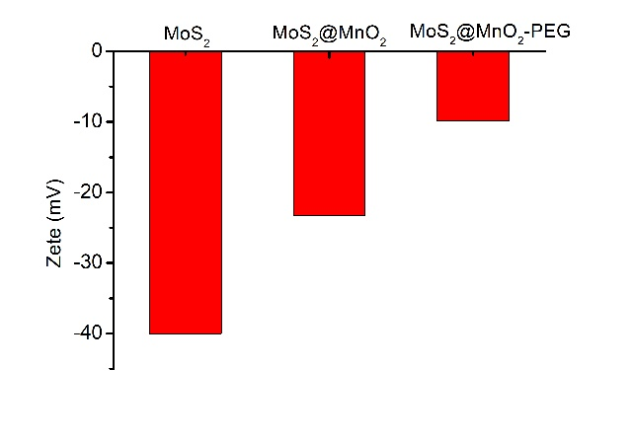
Figure S1.The potential of MoS₂, MoS₂@MnO₂, and MoS₂@MnO₂-PEG.

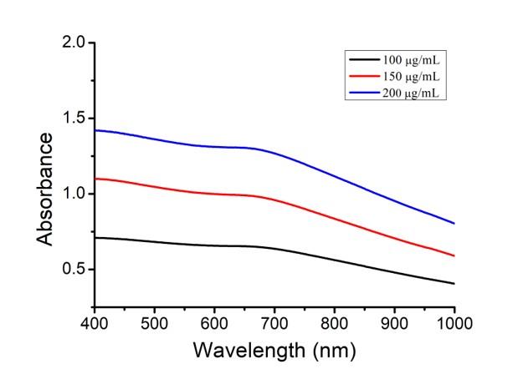
Figure S2.UV absorption MoS₂@MnO₂ at different concentrations
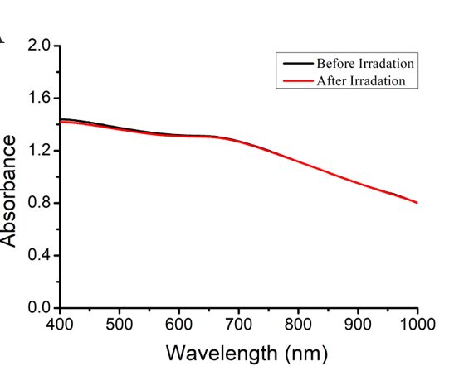
Figure S3.The photostability of MoS₂@MnO₂.

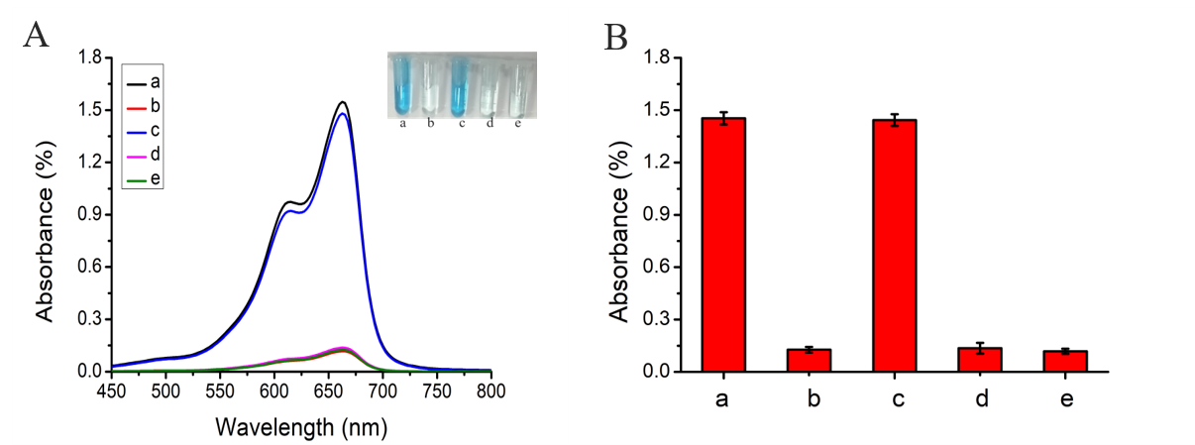
Figure S4. (A) Add different traps to detect the type of reactive oxygen species; (B) UV-Vis chart. where (a：MB；b：MB+MoS₂@MnO₂-PEG+H₂O₂+HCO₃⁻+1.0 mM GSH；c：MB+MoS₂@MnO₂-PEG+H₂O₂+HCO₃⁻+1.0 mM GSH+IPA；d：MB+MoS₂@MnO₂-PEG+H₂O₂+ HCO₃⁻+1.0 mM GSH+PBQ；e：MB+MoS₂@MnO₂-PEG+H₂O₂+HCO₃⁻+1.0 mM GSH+NaN₃））。

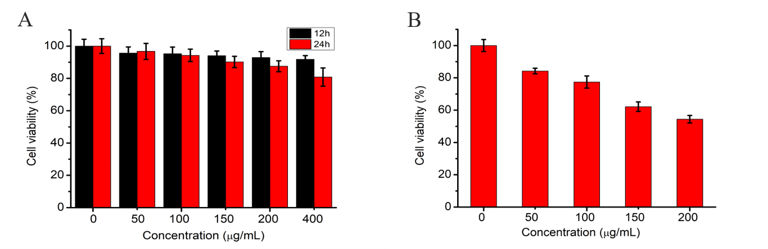
Figure S5.(A) Effects of different concentrations of MoS₂@MnO₂-PEG on HcerEpic cell viability;
- Effect of different concentrations of MoS₂@MnO₂-PEG on HeLa cell viability.

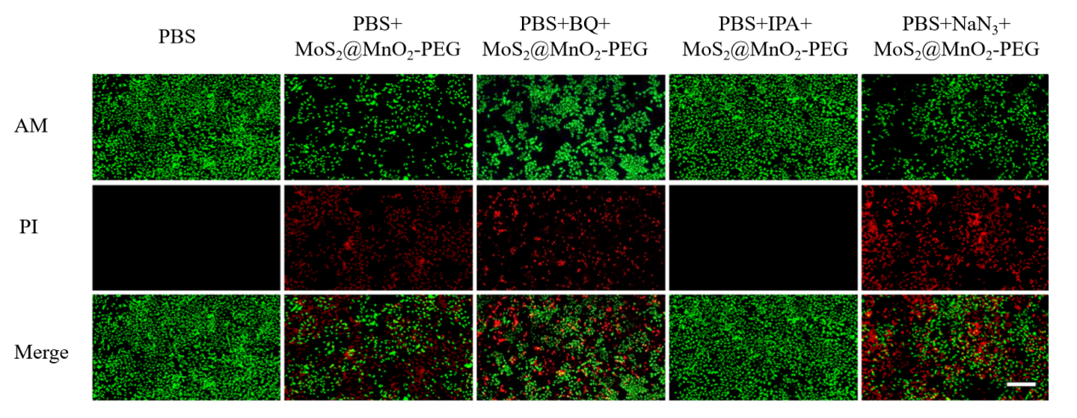
Figure S6.Calcein-AM/PI staining observation method to verify the type of reactive oxygen species that trigger apoptosis (scale bar : 100 μm)

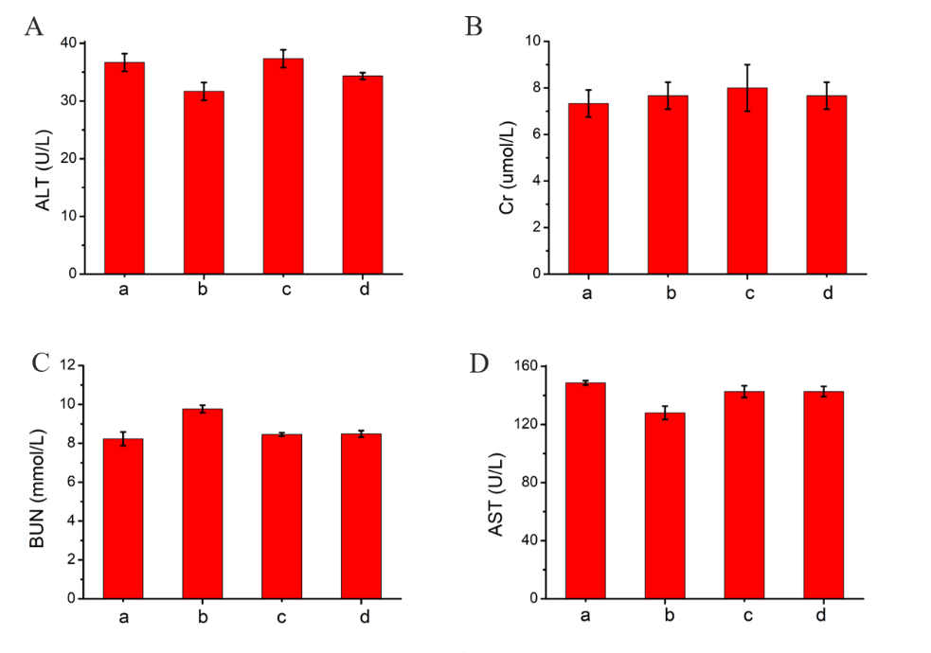
Figure S7.Statistical chart of serum biochemical indexes in nude mice. (A) alanine aminotransferase (ALT); (B) creatinine (Cr); (C) urea nitrogen (BUN); (D) Aspartate aminotransferase (AST). (a：PBS；b：PBS+Laser；c：MoS₂@MnO₂-PEG；d：MoS₂@MnO₂-PEG+Laser)。

