Appendix 2
The Beauty Premium: Physicians’ Appearance and Patients’ Selection and Evaluation Behavior in Online Health Communities
Appendix2: Common support and balance test
This section is about the testing of common support and balance assumptions that need to be met when using PSM for full sample and heterogeneity analysis. The common support assumption requires a large overlap between the propensity score distributions of the treatment and control groups. This can be checked by comparing the kernel density plots of the propensity scores before and after matching. If the matching results are satisfactory, the two curves after matching will be close together. The parallelism assumption states that, given P($x_{i}$), the treatment assignment is random, and there are no differences between the treatment and control groups prior to treatment, and that any effect of treatment is entirely due to the treatment.
Section 1: Full sample common support and balance test
As shown in Figure 1. Compared with before matching, the interactive part of the sample density function after matching is larger, and the two lines of the treatment group and control group after matching are closer, which can be considered to meet the common support hypothesis.
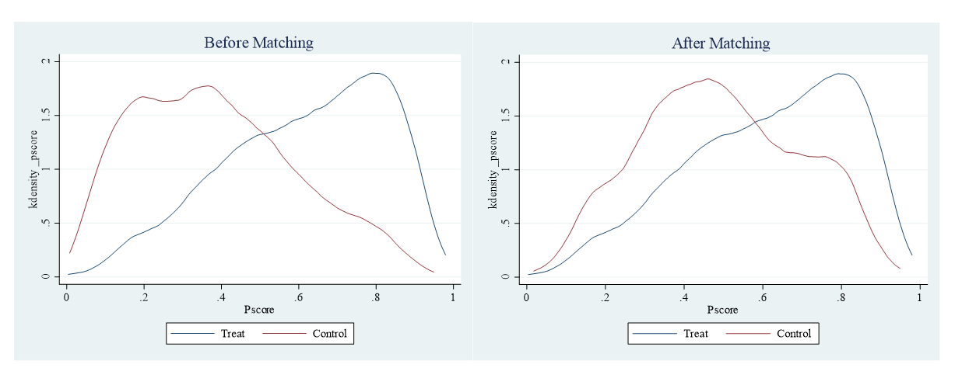
Fig 1 Tendency fractional density function of high and low appearance
As shown in Table 1, according to the test standard, if the absolute value of “standardized deviation” after matching is less than 20%, indicating that they meet the balance test.
Table 1 Balance test of all samples
Variables |  | Appearance
 | Match type | Bias (%) | Reduced Bias (%) | t Value | P
Gender | Unmatched | 34.2 |  | 18.74 | <.001
 | Match | -1.2 | 96.5 | -0.70 | .48
Age | Unmatched | -100.7 |  | -55.13 | <.001
 | Match | 0.3 | 99.7 | 0.15 | .88
Title | Unmatched | -34.9 |  | -19.12 | <.001
 | Match | -6.1 | 82.5 | -2.85 | .004
Disease | Unmatched | 27.6 |  | 15.14 | <.001
 | Match | 0.7 | 97.5 | 0.37 | .71
Hospital level | Unmatched | -4.6 |  | -2.05 | .012
 | Match | -3.2 | 29.5 | -1.74 | .08
Province | Unmatched | -1.1 |  | -0.61 | .54
 | Match | 3.9 | -245.0 | 2.12 | .03
Service duration | Unmatched | -35.6 |  | -19.50 | <.001
 | Match | -0.3 | 99.2 | -0.16 | .87
Section 2: Common support and balance test for heterogeneity analysis
As shown in Figure 2-5, compared to before matching, after matching, the two lines are closer and overlap more. The samples for heterogeneity analysis meet the common support hypothesis.
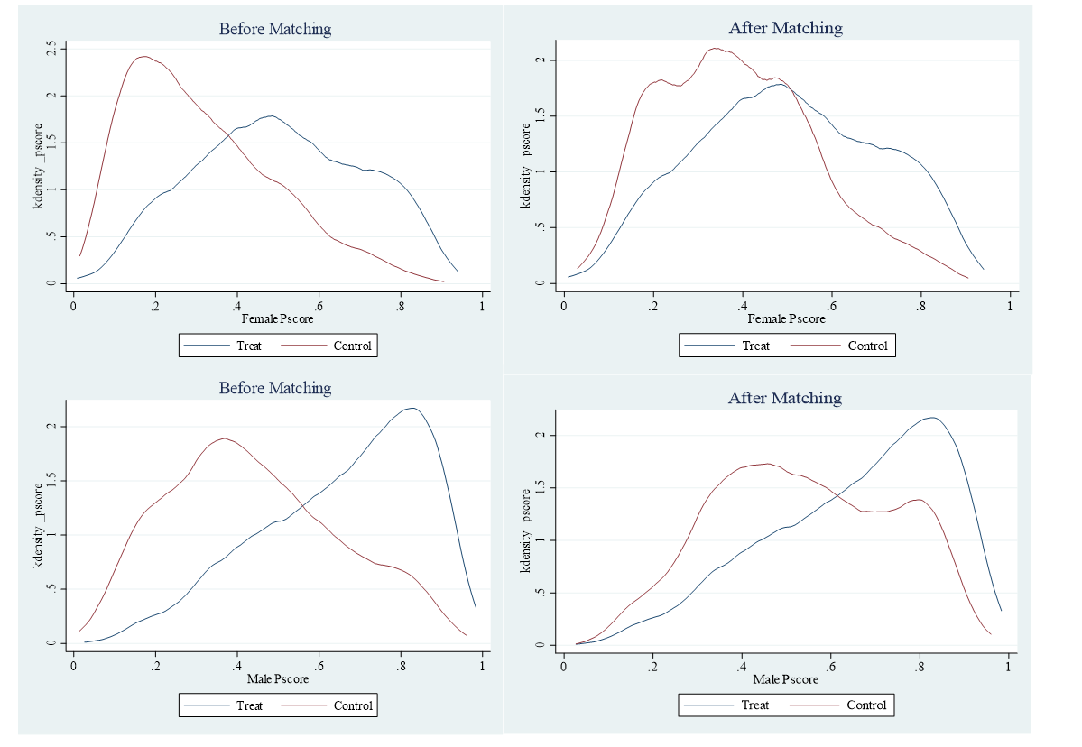
Fig 2 Tendency fractional density function of different gender
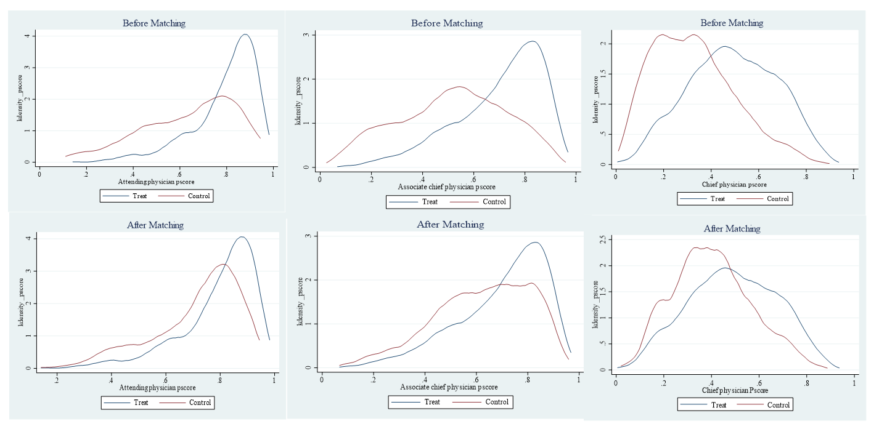
Fig 3 Tendency fractional density function of physician’s title
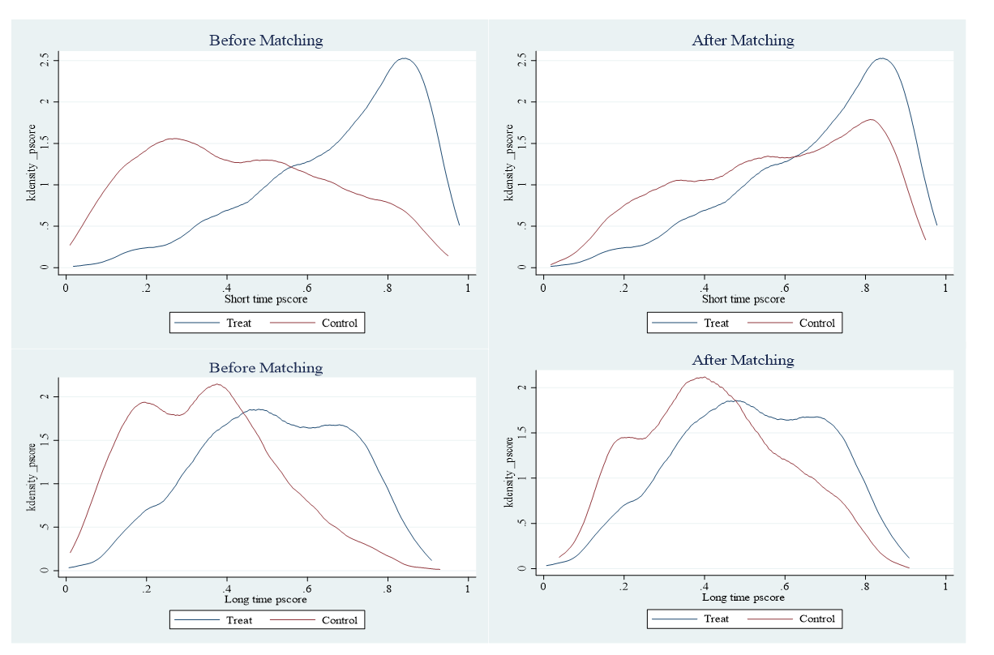
Fig 4 Tendency fractional density function of different service duration
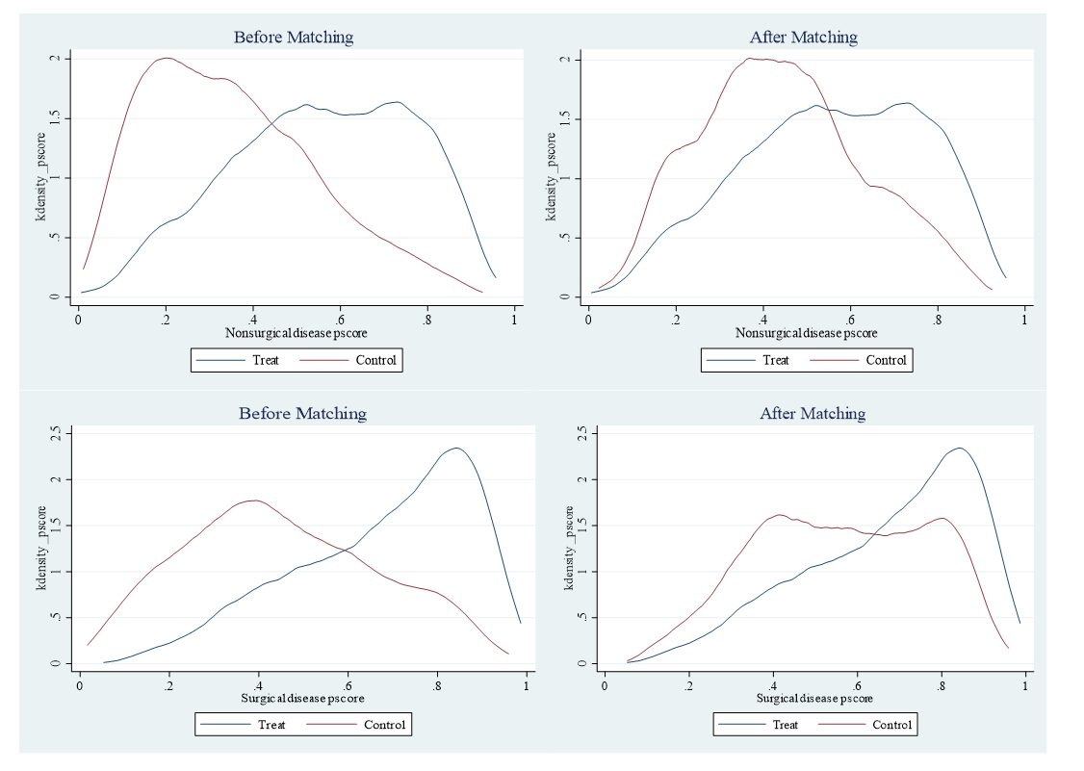
Fig 5 Tendency fractional density function of different disease
As shown in Table 2, the balance test of different gender shows that in the female physicians’ group, after matching, the absolute value of the standard error of variables after matching is less than 20%; in the male physicians’ group, after matching, the absolute value of the standard error of matching variables is less than 20%, and the balance test can be accepted. As shown in Table 3, the balance test of different physician’s title shows that the absolute value of the standard error of the three groups of samples after matching is less than 20%, and the balance test can be accepted. As shown in Table 4, it can be seen that in the group with shorter service duration, the deviations of matching variables such as gender, age, physician’s title have all decreased; in the group with longer service duration, the balance test can be accepted. As shown in Table 5, it can be seen that in nonsurgical disease and surgical disease groups, after matching, the absolute value of standard deviation of matching variables in both groups is less than 20%, and the balance test can be accepted.
Table2 Balance test of different gender
Variables |  | Female |  |  |  | Male
 | Match type | Bias  (%) | Reduced  Bias (%) | t Value | P | Bias (%) | Reduced Bias (%) | t Value | P
Age | Unmatched | -95.3 |  | -30.32 | <.001 | -101.0 |  | -44.20 | <.001
 | Match | 2.5 | 97.4 | 0.72 | .47 | 1.0 | 99.0 | 0.46 | .64
Title | Unmatched | -41.9 |  | -14.12 | <.001 | -34.0 |  | -14.39 | <.001
 | Match | -2.2 | 94.7 | -0.53 | .60 | -8.0 | 76.4 | -3.20 | .001
Disease | Unmatched | 3.7 |  | 14.92 | <.001 | 19.4 |  | 8.49 | <.001
 | Match | 4.3 | 99.0 | -0.15 | .88 | -0.5 | 97.6 | -0.22 | .83
Province | Unmatched | -1.1 |  | -0.35 | .24 | -1.0 |  | -0.44 | .66
 | Match | 11.5 | -932.4 | 3.34 | .73 | 9.0 | -792.9 | 4.21 | <.001
Hospital level | Unmatched | -7.7 |  | -2.48 | .001 | -2.2 |  | -0.94 | .35
 | Match | -13.1 | -71.5 | -3.96 | <.001 | -1.8 | 18.6 | -0.81 | .42
Service duration | Unmatched | -36.4 |  | -11.52 | <.001 | -46.0 |  | -20.09 | <.001
 | Match | -4.7 | 87.1 | -1.40 | .16 | -2.6 | 94.3 | -1.21 | .23
Table 3 Balance test of different physician’s title
Variables |  | Attending physician |  |  |  | Associate chief physician |  |  |  | Chief physician
 | Match type | Bias  (%) | Reduced  Bias (%) | t Value | P | Bias  (%) | Reduced  Bias (%) | t Value | P | Bias  (%) | Reduced  Bias (%) | t Value | P
Gender | Unmatched | 36.3 |  | 5.51 | <.001 | 51.0 |  | 15.02 | <.001 | 32.2 |  | 13.13 | <.001
 | Match | 5.9 | 83.8 | 1.23 | .22 | 0.9 | 98.2 | 0.34 | .74 | -1.8 | 94.5 | -0.71 | .48
Age | Unmatched | -83.8 |  | -13.43 | <.001 | -83.4 |  | -24.69 | <.001 | -84.5 |  | -34.77 | <.001
 | Match | 2.4 | 97.2 | 0.58 | .56 | 0.5 | 99.4 | 0.19 | .85 | 0.1 | 99.9 | 0.04 | .97
Disease | Unmatched | 27.5 |  | 4.06 | <.001 | 34.9 |  | 10.04 | <.001 | 24.6 |  | 10.22 | <.001
 | Match | -13.9 | 49.4 | -2.80 | .005 | -1.2 | 96.6 | -0.39 | .70 | -2.4 | 90.4 | -0.86 | .39
Province | Unmatched | 1.5 |  | 0.22 | .83 | -5.9 |  | -1.71 | .09 | -4.9 |  | -2.00 | .045
 | Match | 2.8 | -87.5 | 0.58 | .56 | 6.3 | -6.1 | 2.13 | .03 | 3.2 | 33.8 | 1.21 | .23
Hospital level | Unmatched | 0.4 |  | 0.07 | .95 | 1.1 |  | 0.32 | .75 | -1.5 |  | -0.64 | .52
 | Match | -1.8 | -293.6 | 0.36 | .72 | 0.4 | 60.2 | 0.15 | .88 | -9.6 | -526.7 | -3.90 | <.001
Service duration | Unmatched | -25.5 |  | -3.92 | <.001 | -17.6 |  | -5.16 | <.001 | -13.0 |  | -5.35 | <.001
 | Match | -10.1 | 60.5 | -2.20 | .03 | -0.2 | 98.7 | -0.08 | .94 | -3.6 | 72.2 | -1.36 | .17
Table 4 Balance test of different service duration
Variables |  | Shorter service duration |  |  |  | Longer service duration
 | Match type | Bias (%) | Reduced  Bias (%) | t Value | P | Bias (%) | Reduced  Bias (%) | t Value | P
Gender | Unmatched | 46.1 |  | 17.80 | <.001 | 33.5 |  | 12.56 | <.001
 | Match | -2.6 | 94.3 | -1.13 | .26 | 0.0 | 100.0 | 0.00 | .90
Age | Unmatched | -105.9 |  | -41.23 | <.001 | -84.8 |  | -32.25 | <.001
 | Match | -1.3 | 98.8 | -0.61 | .54 | -0.2 | 99.7 | -0.08 | .94
Title | Unmatched | -37.8 |  | -14.14 | <.001 | -13.4 |  | -5.30 | <.001
 | Match | 4.6 | 87.9 | 1.64 | .10 | 6.4 | 52.1 | 1.78 | .08
Disease | Unmatched | 40.4 |  | 15.37 | <.001 | 22.5 |  | 8.56 | <.001
 | Match | -1.3 | 96.8 | -0.51 | .61 | -4.2 | 81.5 | -1.45 | .15
Province | Unmatched | 3.1 |  | 1.18 | .24 | -0.2 |  | -0.07 | .94
 | Match | 0.1 | 98.0 | 0.03 | .98 | 6.3 | -3305.1 | 2.22 | .03
Hospital level | Unmatched | -4.4 |  | -1.67 | .10 | -3.9 |  | -1.51 | .13
 | Match | -4.7 | -8.1 | -1.96 | .050 | -7.1 | -81.1 | -2.58 | .010
Table 5 Balance test of different disease
Variables |  | Nonsurgical disease |  |  |  | Surgical disease
 | Match type | Bias (%) | Reduced  Bias (%) | t Value | P | Bias (%) | Reduced Bias (%) | t Value | P
Gender | Unmatched | 25.6 |  | 10.69 | <.001 | 25.2 |  | 8.95 | <.001
 | Match | 2.9 | 88.6 | 1.15 | .25 | -4.6 | 81.9 | -2.13 | .03
Age | Unmatched | -97.4 |  | -40.70 | <.001 | -101.0 |  | -35.18 | <.001
 | Match | 0.2 | 99.8 | 0.07 | .94 | 0.6 | 99.4 | 0.23 | .82
Title | Unmatched | -36.7 |  | -15.80 | <.001 | -33.8 |  | -11.25 | <.001
 | Match | 0.1 | 99.7 | 0.03 | .97 | -2.3 | 93.0 | -0.75 | .46
Province | Unmatched | -3.9 |  | -1.65 | .10 | 0.4 |  | 0.12 | .90
 | Match | 2.5 | 37.4 | 0.98 | .33 | 8.3 | -2264.8 | 3.16 | .002
Hospital level | Unmatched | -8.2 |  | -3.46 | .001 | -0.3 |  | -0.11 | .91
 | Match | 5.7 | 31.1 | 2.03 | .042 | -3.9 | -1144.3 | -1.51 | .13
Service duration | Unmatched | -30.9 |  | -12.89 | <.001 | -50.1 |  | -17.31 | <.001
 | Match | 3.0 | 90.3 | 1.21 | .23 | -5.2 | 89.6 | -1.97 | .049

