Appendix 1
The Beauty Premium: Physicians’ Appearance and Patients’ Selection and Evaluation Behavior in Online Health Communities
Appendix 1： Face++ recognition and analysis of photos
Face++ has the following requirements for uploaded images: image format: JPG(JPEG); image pixel size: minimum 48*48 pixels, maximum 4096*4096 pixels; image file size: 2MB; minimum face pixel size: the system can detect a square face frame, with a minimum side length of 150 pixels. Figure 1 shows the coordinates of 83 landmarks automatically detected by Face++’s face detection API. The Landmark object structure includes the face, eyes, eyebrows, lips and nose contour. The green dots are the key points of Landmark, so it can detect information such as appearance, gender, age, etc. in photos.
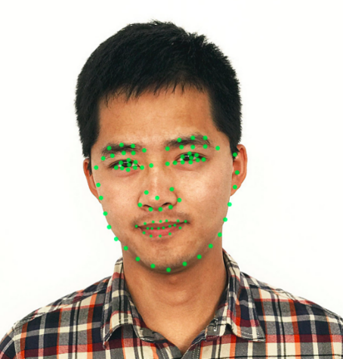
Fig 1. 83 key points of the face drawn according to the coordinate provided by Face++

