Supplementary material
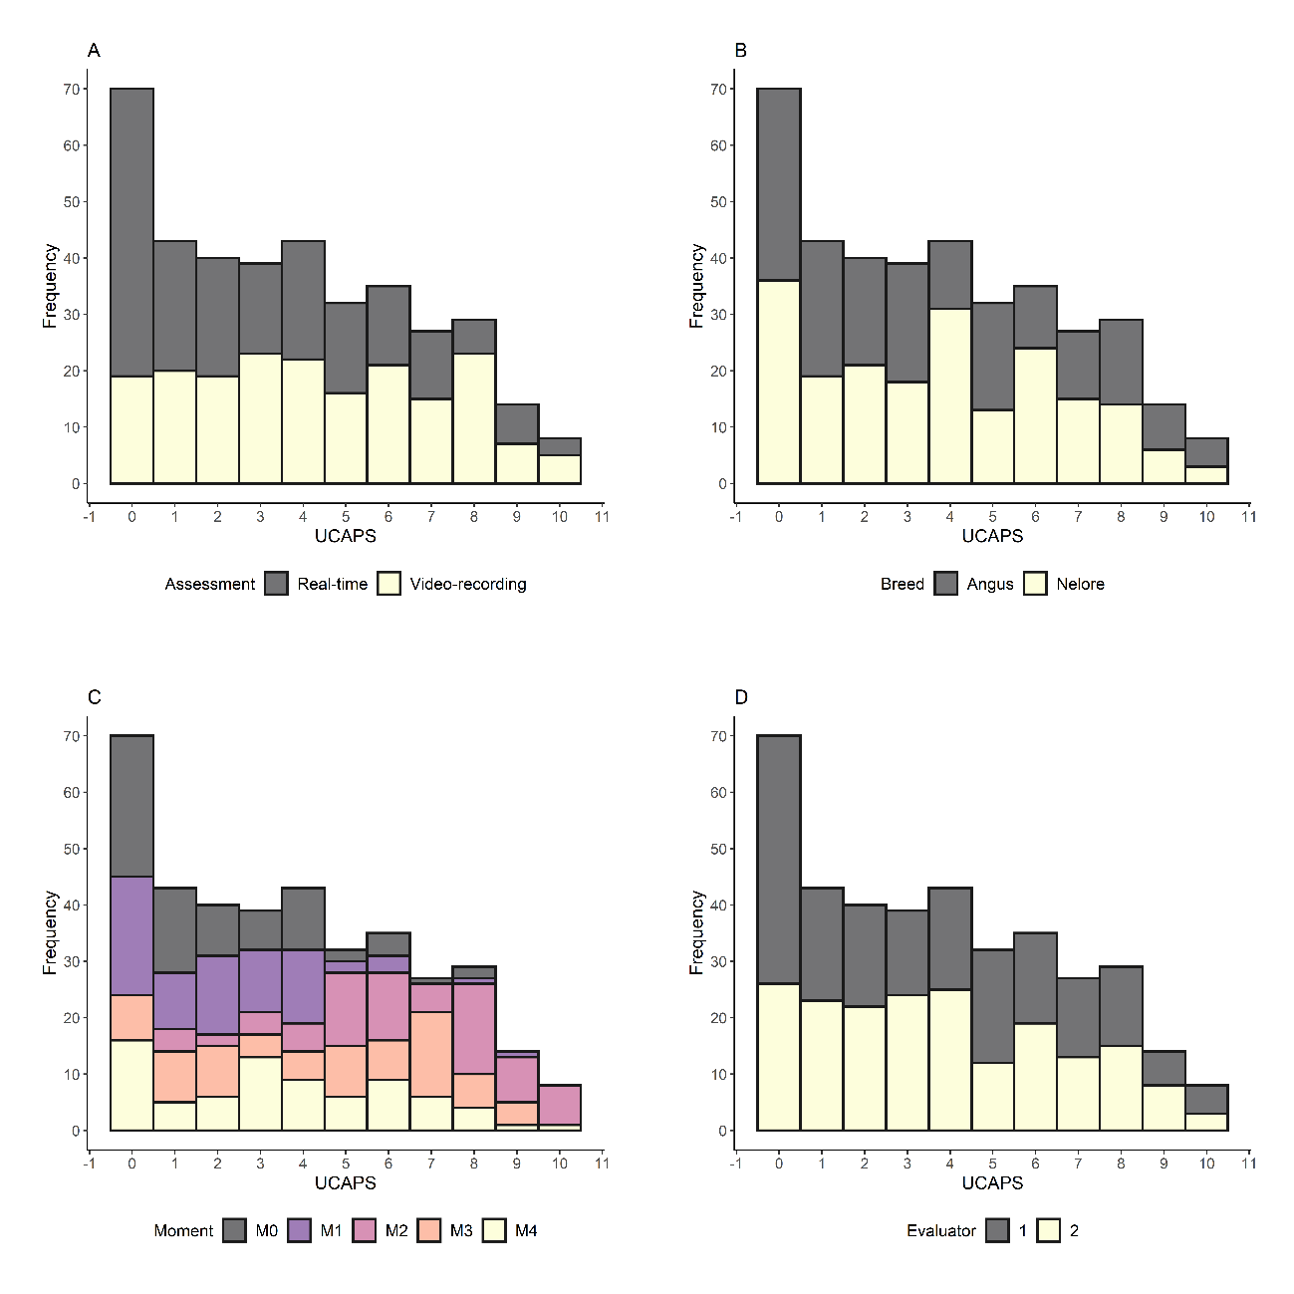
Figure S1. Histogram of Unesp-Botucatu cattle composite acute pain scale (UCAPS) overdispersion per assessment method (A), breed (B), moment (C), and evaluator (D).

Fixed effects | Estimate | SE | Z-value | P-value
Count component of the model
Linear coefficient (α) | 0.8197 | 0.1778 | 4.6111 | 4.01⁻⁰⁶
Slope coefficients (β)
AssessmentVideo-recorded | 0.1940 | 0.1954 | 0.9926 | 0.3209
MomentM1 | -0.1933 | 0.2107 | -0.9174 | 0.3589
MomentM2 | 1.0149 | 0.1694 | 5.9922 | 2.07⁻⁰⁹
MomentM3 | 0.5246 | 0.1810 | 2.8975 | 0.0038
MomentM4 | 0.4563 | 0.1906 | 2.3946 | 0.0166
BreedNelore | -0.0119 | 0.1074 | -0.1112 | 0.9114
Evaluator2 | 0.0155 | 0.0557 | 0.2789 | 0.7803
AssessmentVideo-recorded:MomentM1 | 0.3099 | 0.2599 | 1.1923 | 0.2331
AssessmentVideo-recorded:MomentM2 | -0.2106 | 0.2156 | -0.9766 | 0.3288
AssessmentVideo-recorded:MomentM3 | 0.1674 | 0.2264 | 0.7396 | 0.4595
AssessmentVideo-recorded:MomentM4 | 0.0842 | 0.2367 | 0.3558 | 0.7220
Logistic component of the model
Linear coefficient (α) | -1.3945 | 0.2301 | -6.0597 | 1.36⁻⁰⁹
Slope coefficients (β)
AssessmentVideo-recorded | -1.4269 | 0.4826 | -2.9566 | 0.0031
Random effects | Estimate | SD | Number
Cattle | 0.0394 | 0.1985 | 19
Table S1. Multilevel zero-inflated poisson model findings using Unesp-Botucatu pig composite acute pain scale (UPAPS) as response variable. SE, standard-error; SD, standard-deviation.

Fixed effects | Estimate | SE | Z-value | P-value
Linear coefficient (α) | -1.2512 | 0.3381 | -3.7010 | 0.0002
Slope coefficients (β)
Average between assessed methods | 0.0010 | 0.0754 | 0.0140 | 0.9888
Table S2. Simple linear model findings using the differences of Unesp-Botucatu cattle composite acute pain scale (UCAPS) total sum assessed in real-time and video-recorded as response variable. SE, standard-error.

