Supplementary material
Table S1: Number of farms by production system, number of CSA techniques used, and support from the KCSAP project
Production system | Number of CSA techniques used
Production system | 0 |  | 1-2 |  | 3-4 |  | 5 or more
 | S | U | S | U | S | U | S | U
Extensive | 22 | 0 | 64 | 53 | 62 | 29 | 40 | 27
Semi-intensive | 18 | 0 | 54 | 29 | 53 | 24 | 56 | 32
No-graze | 6 | 0 | 26 | 10 | 23 | 3 | 26 | 9
S = farms supported by the KCSAP project; U = farms not supported by the KCSAP project

Table S2: Multiple linear regression results assessing the effects of individual CSA practices on milk yields in extensive production systems
Analysis of Variance Table

Response: log(av_milk_yield)
Df Sum Sq Mean Sq F value Pr(>F)
county_of_survey 3 8.211 2.73687 10.4004 1.705e-06 ***
Improved_breeds 1 0.007 0.00651 0.0247 0.875184
Fertilizer 1 0.014 0.01365 0.0519 0.820000
Pasture 1 1.832 1.83222 6.9626 0.008812 **
By_products_feeding 1 0.232 0.23221 0.8824 0.348389
Residuals 267 70.261 0.26315
---
Signif. codes: 0 ‘***’ 0.001 ‘**’ 0.01 ‘*’ 0.05 ‘.’ 0.1 ‘ ’ 1

Coefficients:
Estimate Std. Error t value Pr(>|t|)
(Intercept) 0.892965 0.072209 12.366 < 2e-16 ***
county_of_surveyBomet 0.114200 0.093732 1.218 0.2242
county_of_surveyKericho 0.425410 0.085468 4.977 1.16e-06 ***
county_of_surveyLaikipia 0.469867 0.094570 4.968 1.21e-06 ***
Imp_breedsTRUE 0.007629 0.063289 0.121 0.9041
FertilizerTRUE 0.007924 0.079927 0.099 0.9211
PastureTRUE 0.161952 0.070999 2.281 0.0233 *
By_products_feedingTRUE 0.078726 0.083807 0.939 0.3484
---
Signif. codes: 0 ‘***’ 0.001 ‘**’ 0.01 ‘*’ 0.05 ‘.’ 0.1 ‘ ’ 1

Residual standard error: 0.513 on 267 degrees of freedom
Multiple R-squared: 0.1278, Adjusted R-squared: 0.1049
F-statistic: 5.589 on 7 and 267 DF, p-value: 5.016e-06

Table S3: Multiple linear regression results assessing the effects of individual CSA practices on GHG emission intensities in extensive production systems
Analysis of Variance Table

Response: log(total_CO2_milk_kg)
Df Sum Sq Mean Sq F value Pr(>F)
county_of_survey 3 5.237 1.74569 7.0841 0.0001345 ***
Improved_breeds 1 0.071 0.07081 0.2873 0.5923753
Fertilizer 1 0.002 0.00190 0.0077 0.9300763
Pasture 1 0.936 0.93627 3.7994 0.0523174 .
By_products_feeding 1 0.011 0.01131 0.0459 0.8304968
Residuals 267 65.795 0.24642
---
Signif. codes: 0 ‘***’ 0.001 ‘**’ 0.01 ‘*’ 0.05 ‘.’ 0.1 ‘ ’ 1

Coefficients:
Estimate Std. Error t value Pr(>|t|)
(Intercept) 1.08487 0.06988 15.526 < 2e-16 ***
county_of_surveyBomet -0.13570 0.09070 -1.496 0.1358
county_of_surveyKericho -0.37546 0.08271 -4.540 8.53e-06 ***
county_of_surveyLaikipia -0.29965 0.09151 -3.274 0.0012 **
Imp_breedsTRUE 0.02041 0.06124 0.333 0.7392
FertilizerTRUE 0.01985 0.07735 0.257 0.7977
PastureTRUE -0.13284 0.06871 -1.933 0.0542 .
By_products_feedingTRUE 0.01738 0.08110 0.214 0.8305
---
Signif. codes: 0 ‘***’ 0.001 ‘**’ 0.01 ‘*’ 0.05 ‘.’ 0.1 ‘ ’ 1

Residual standard error: 0.4964 on 267 degrees of freedom
Multiple R-squared: 0.08684, Adjusted R-squared: 0.0629
F-statistic: 3.628 on 7 and 267 DF, p-value: 0.0009373

Table S4: Multiple linear regression results assessing the effects of individual CSA practices on milk yields in semi-intensive production systems
Analysis of Variance Table

Response: log(av_milk_yield)
Df Sum Sq Mean Sq F value Pr(>F)
county_of_survey 3 2.843 0.94782 3.0714 0.02852 *
Improved_breeds 1 1.908 1.90840 6.1842 0.01358 *
Feed_processing 1 0.533 0.53280 1.7266 0.19012
Fodder_improvement 1 0.681 0.68066 2.2057 0.13883
Fertilizer 1 1.015 1.01469 3.2881 0.07105 .
Pasture 1 0.032 0.03200 0.1037 0.74774
By_products_feeding 1 0.007 0.00699 0.0227 0.88048
Stall_feeding_housing 1 0.214 0.21447 0.6950 0.40531
Residuals 237 73.136 0.30859
---
Signif. codes: 0 ‘***’ 0.001 ‘**’ 0.01 ‘*’ 0.05 ‘.’ 0.1 ‘ ’ 1

Coefficients:
Estimate Std. Error t value Pr(>|t|)
(Intercept) 1.097190 0.116661 9.405 <2e-16 ***
county_of_surveyBomet -0.030717 0.131113 -0.234 0.8150
county_of_surveyKericho 0.217276 0.109058 1.992 0.0475 *
county_of_surveyLaikipia 0.215278 0.116266 1.852 0.0653 .
Imp_breedsTRUE 0.194820 0.075931 2.566 0.0109 *
Feed_processingTRUE 0.145288 0.086480 1.680 0.0943 .
Fodder_improvementTRUE 0.141491 0.080081 1.767 0.0785 .
FertilizerTRUE -0.188526 0.104477 -1.804 0.0724 .
PastureTRUE 0.031138 0.077075 0.404 0.6866
By_products_feedingTRUE 0.001662 0.104551 0.016 0.9873
Stall_feeding_housingTRUE -0.072378 0.086820 -0.834 0.4053
---
Signif. codes: 0 ‘***’ 0.001 ‘**’ 0.01 ‘*’ 0.05 ‘.’ 0.1 ‘ ’ 1

Residual standard error: 0.5555 on 237 degrees of freedom
Multiple R-squared: 0.09, Adjusted R-squared: 0.05161
F-statistic: 2.344 on 10 and 237 DF, p-value: 0.01181

Table S5: Multiple linear regression results assessing the effects of individual CSA practices on GHG emission intensities in semi-intensive production systems
Analysis of Variance Table

Response: log(total_CO2_milk_kg)
Df Sum Sq Mean Sq F value Pr(>F)
county_of_survey 3 4.355 1.45180 5.8599 0.0007088 ***
Improved_breeds 1 0.119 0.11901 0.4803 0.4889451
Feed_processing 1 0.330 0.33015 1.3326 0.2495106
Fodder_improvement 1 0.765 0.76550 3.0898 0.0800767 .
Fertilizer 1 0.139 0.13918 0.5618 0.4542892
Pasture 1 0.003 0.00303 0.0122 0.9119810
By_products_feeding 1 0.283 0.28328 1.1434 0.2860254
Stall_feeding_housing 1 0.583 0.58323 2.3541 0.1262901
Residuals 237 58.717 0.24775
---
Signif. codes: 0 ‘***’ 0.001 ‘**’ 0.01 ‘*’ 0.05 ‘.’ 0.1 ‘ ’ 1

Coefficients:
Estimate Std. Error t value Pr(>|t|)
(Intercept) 0.88916 0.10453 8.506 2.05e-15 ***
county_of_surveyBomet 0.19729 0.11748 1.679 0.09439 .
county_of_surveyKericho -0.26335 0.09772 -2.695 0.00754 **
county_of_surveyLaikipia -0.18467 0.10418 -1.773 0.07757 .
Imp_breedsTRUE -0.06678 0.06804 -0.982 0.32730
Feed_processingTRUE -0.11895 0.07749 -1.535 0.12609
Fodder_improvementTRUE -0.10663 0.07175 -1.486 0.13861
FertilizerTRUE 0.04574 0.09361 0.489 0.62557
PastureTRUE 0.01049 0.06906 0.152 0.87942
By_products_feedingTRUE -0.12641 0.09368 -1.349 0.17849
Stall_feeding_housingTRUE 0.11936 0.07779 1.534 0.12629
---
Signif. codes: 0 ‘***’ 0.001 ‘**’ 0.01 ‘*’ 0.05 ‘.’ 0.1 ‘ ’ 1

Residual standard error: 0.4977 on 237 degrees of freedom
Multiple R-squared: 0.1008, Adjusted R-squared: 0.06281
F-statistic: 2.655 on 10 and 237 DF, p-value: 0.004336

Table S6: Multiple linear regression results assessing the effects of individual CSA practices on milk yields in no-graze production systems
Analysis of Variance Table

Response: log(av_milk_yield)
Df Sum Sq Mean Sq F value Pr(>F)
county_of_survey 3 0.7156 0.2385 0.8300 0.4808210
Improved_breeds 1 4.5556 4.5556 15.8513 0.0001396 ***
Feed_processing 1 0.0028 0.0028 0.0098 0.9212777
Fodder_improvement 1 1.0360 1.0360 3.6048 0.0608527 .
Fertilizer 1 0.3489 0.3489 1.2141 0.2734991
Stall_feeding_housing 1 0.0269 0.0269 0.0937 0.7602453
Residuals 89 25.5785 0.2874
---
Signif. codes: 0 ‘***’ 0.001 ‘**’ 0.01 ‘*’ 0.05 ‘.’ 0.1 ‘ ’ 1

Coefficients:
Estimate Std. Error t value Pr(>|t|)
(Intercept) 1.4961131 0.1424640 10.502 < 2e-16 ***
county_of_surveyBomet -0.1684269 0.2050993 -0.821 0.413729
county_of_surveyKericho 0.0007596 0.1989695 0.004 0.996962
county_of_surveyLaikipia 0.0345311 0.1476739 0.234 0.815651
Imp_breedsTRUE 0.4467886 0.1259713 3.547 0.000625 ***
Feed_processingTRUE 0.1115178 0.1485302 0.751 0.454748
Fodder_improvementTRUE -0.1943031 0.1249178 -1.555 0.123389
FertilizerTRUE -0.2031415 0.1863217 -1.090 0.278536
Stall_feeding_housingTRUE 0.0395449 0.1291905 0.306 0.760245
---
Signif. codes: 0 ‘***’ 0.001 ‘**’ 0.01 ‘*’ 0.05 ‘.’ 0.1 ‘ ’ 1

Residual standard error: 0.5361 on 89 degrees of freedom
Multiple R-squared: 0.2072, Adjusted R-squared: 0.136
F-statistic: 2.908 on 8 and 89 DF, p-value: 0.006288

Table S7: Multiple linear regression results assessing the effects of individual CSA practices on GHG emission intensities in no-graze production systems
Analysis of Variance Table

Response: log(total_CO2_milk_kg)
Df Sum Sq Mean Sq F value Pr(>F)
county_of_survey 3 1.4714 0.49047 2.3278 0.079941 .
Improved_breeds 1 2.2026 2.20256 10.4535 0.001718 **
Feed_processing 1 0.2952 0.29518 1.4010 0.239714
Fodder_improvement 1 0.5196 0.51964 2.4663 0.119862
Fertilizer 1 0.0553 0.05533 0.2626 0.609603
Stall_feeding_housing 1 0.0761 0.07611 0.3612 0.549367
Residuals 89 18.7523 0.21070
---
Signif. codes: 0 ‘***’ 0.001 ‘**’ 0.01 ‘*’ 0.05 ‘.’ 0.1 ‘ ’ 1

Coefficients:
Estimate Std. Error t value Pr(>|t|)
(Intercept) 0.58272 0.12198 4.777 6.96e-06 ***
county_of_surveyBomet 0.14653 0.17561 0.834 0.40630
county_of_surveyKericho -0.25931 0.17036 -1.522 0.13153
county_of_surveyLaikipia -0.08304 0.12644 -0.657 0.51303
Imp_breedsTRUE -0.35619 0.10786 -3.302 0.00138 **
Feed_processingTRUE 0.08416 0.12718 0.662 0.50983
Fodder_improvementTRUE 0.14642 0.10696 1.369 0.17446
FertilizerTRUE 0.08511 0.15953 0.533 0.59503
Stall_feeding_housingTRUE 0.06648 0.11062 0.601 0.54937
---
Signif. codes: 0 ‘***’ 0.001 ‘**’ 0.01 ‘*’ 0.05 ‘.’ 0.1 ‘ ’ 1

Residual standard error: 0.459 on 89 degrees of freedom
Multiple R-squared: 0.1977, Adjusted R-squared: 0.1256
F-statistic: 2.741 on 8 and 89 DF, p-value: 0.00945

Table S8: Costs, inputs, activities, amortisation and annualization, and assumptions used to estimate CSA practice costs
CSA practice | Activity or input | Quantity | Price (KES) | Quantity used | Amortisation/  annualisation | Assumptions
Feed supplement | Concentrates | 70 kg bag | 2400 | Amount used for one cow per year | None | 0.5kg concentrate per 100kg of liveweight per day, liveweight of local dairy cow = 400 kg
Stall infrastructure | Materials and labour | 1 | 75000 | 1 | 15 years | Infrastructure will last 15 years
Water harvesting | Tank and installation | 1 | 50000 | farm | 15 years | Infrastructure will last 15 years; average farm has around 1 lactating cow
Feed processing | Chaff cutter | 1 | 40000 | 1 | 15 years | Infrastructure will last 15 years and will be used around four times a year
Feed processing | Pulveriser | 1 | 30000 | 1 | 15 years
Feed processing | Machine operation - fuel | 30 minutes | 30 | 4 | None
By products (extensive) | Stover | - | 0 | - | None | Cows consume around 3% of body weight of low quality feed DM per day; local dairy cows weigh around 400 kg; Maize land cultivated 1.58 acres; maize residue 1521 kg/farm; shadow value of maize residues 5.94 KES; 30% feed is from residues
By products  (semi-intensive) | Stover | - | 1 | - | None | Cows consume around 3% of body weight of low quality feed DM per day; local dairy cows weigh around 400 kg; Maize land cultivated 1.58 acres; maize residue 1521 kg/farm; shadow value of maize residues 5.94 KES; 11% feed is from residues
By products  (no-graze) | Stover | - | 1 | - | None | Cows consume around 3% of body weight of low quality feed DM per day; local dairy cows weigh around 400 kg; Maize land cultivated 1.58 acres; maize residue 1521 kg/farm; shadow value of maize residues 5.94 KES; 6% feed is from residues
Marketing | Coop registration and shares | 1 | 1500 | 1 | 15 years | Cost regarded as a one off registration fee for cooperative membership
Improved cattle breeds (no-graze) | Adult animal | 1 | 60000 | 1 | 4.3 lactations | Market cost of an dairy cow; no change in calving intervals
Improved cattle breeds (semi-intensified) | Adult animal | 1 | 60000 | 1 | 3.7 lactations | Market cost of an dairy cow; no change in calving intervals
Improved cattle breeds (extensive) | Adult animal | 1 | 60000 | 1 | 3.2 lactations | Market cost of an dairy cow; no change in calving intervals
Fertilisers use | DAP | 50kg per bag | 3500 (1 bag) | 2 bags per ha | None | 100kg of DAP per ha; fertilisers are applied to 0.65 acres
Pasture  (extensive) | Seed | 1 acre / 4-5 kgs | 5000 | 1 acre | 10 years | Kikuyu DM annual yield = around 15 Mg DM ha-1 year-1; Cows consume around 3% of body weight of low quality feed DM per day; local dairy cows weigh around 400 kg, feed basket = 70% grazing
Pasture  (extensive) | Ploughing | 2 | 14000 | 1 acre | 10 years
Pasture  (extensive) | Planting | 1 | 2000 | 1 acre | 10 years
Pasture  (extensive) | Management | 1 | 10000 | 1 acre | None
Pasture  (semi-intensive) | Seed | 1 acre / 4-5 kgs | 5000 | 1 acre | 10 years | Kikuyu DM annual yield = around 15 Mg DM ha-1 year-1; Cows consume around 3% of body weight of low quality feed DM per day; local dairy cows weigh around 400 kg, feed basket = 50% grazing
Pasture  (semi-intensive) | Ploughing | 2 | 14000 | 1 acre | 10 years
Pasture  (semi-intensive) | Planting | 1 | 2000 | 1 acre | 10 years
Pasture  (semi-intensive) | Management | 1 | 10000 | 1 acre | None
Pasture  (no-graze) | Seed | 1 acre / 4-5 kgs | 5000 | 1 acre | 10 years | Kikuyu DM annual yield = around 15 Mg DM ha-1 year-1; Cows consume around 3% of body weight of low quality feed DM per day; local dairy cows weigh around 400 kg, feed basket = 30% grazing
Pasture  (no-graze) | Ploughing | 2 | 14000 | 1 acre | 10 years
Pasture  (no-graze) | Planting | 1 | 2000 | 1 acre | 10 years
Pasture  (no-graze) | Management | 1 | 10000 | 1 acre | None
Fodder improvement  (no-graze) | Seed | 5 kg | 20000 | 1 acre | 10 years | Napier grass DM annual yield = around 17 Mg DM ha-1 year-1; Cows consume around 3% of body weight of higher quality feed DM per day; local dairy cows weigh around 400 kg, feed basket = 50% cut forage
Fodder improvement  (no-graze) | Planting | 1 | 30000 | 1 acre | 10 years
Fodder improvement  (no-graze) | Weeding | 1 | 25000 | 1 acre | None
Fodder improvement  (no-graze) | Manure | 1 | 1500 | 1 acre | None
Fodder improvement  (no-graze) | Harvesting | 6 people 2 days | 1800 | 1 acre | None
Fodder improvement  (no-graze) | Transport | 1 | 4000 | 1 acre | None
Fodder improvement (semi-intensive) | Seed | 5 kg | 20000 | 1 acre | 10 years | Napier grass DM annual yield = around 17 Mg DM ha-1 year-1; Cows consume around 3% of body weight of higher quality feed DM per day; local dairy cows weigh around 400 kg, feed basket = 20% cut forage
Fodder improvement (semi-intensive) | Planting | 1 | 30000 | 1 acre | 10 years
Fodder improvement (semi-intensive) | Weeding | 1 | 25000 | 1 acre | None
Fodder improvement (semi-intensive) | Manure | 1 | 1500 | 1 acre | None
Fodder improvement (semi-intensive) | Harvesting | 6 people 2 days | 1800 | 1 acre | None
Fodder improvement (semi-intensive) | Transport | 1 | 4000 | 1 acre | None
Fodder improvement (extensive) | Seed | 5 kg | 20000 | 1 acre | 10 years | Napier grass DM annual yield = around 17 Mg DM ha-1 year-1; Cows consume around 3% of body weight of higher quality feed DM per day; local dairy cows weigh around 400 kg, feed basket = 12% cut forage
Fodder improvement (extensive) | Planting | 1 | 30000 | 1 acre | 10 years
Fodder improvement (extensive) | Weeding | 1 | 25000 | 1 acre | None
Fodder improvement (extensive) | Manure | 1 | 1500 | 1 acre | None
Fodder improvement (extensive) | Harvesting | 6 people 2 days | 1800 | 1 acre | None
Fodder improvement (extensive) | Transport | 1 | 4000 | 1 acre | None
Feed preservation  (no-graze) | Plastic silage bag | 15 bags | 15000 | 1 acre | None | Napier grass DM annual yield = around 17 Mg DM ha-1 year-1; Cows consume around 3% of body weight of higher quality feed DM per day; local dairy cows weigh around 400 kg, feed basket = 30% silage
Feed preservation  (no-graze) | Fuel |  | 180 | 1 acre | None
Feed preservation  (no-graze) | Labour | 5 people 2 days |  | 1 acre | None
Feed preservation (semi-intensive) | Plastic silage bag | 15 bags | 15000 | 1 acre |  | Napier grass DM annual yield = around 17 Mg DM ha-1 year-1; Cows consume around 3% of body weight of higher quality feed DM per day; local dairy cows weigh around 400 kg, feed basket = 15% silage
Feed preservation (semi-intensive) | Fuel |  | 180 | 1 acre
Feed preservation (semi-intensive) | Labour | 5 people 2 days |  | 1 acre
Feed preservation (extensive) | Plastic silage bag | 15 bags | 15000 | 1 acre | None | Napier grass DM annual yield = around 17 Mg DM ha-1 year-1; Cows consume around 3% of body weight of higher quality feed DM per day; local dairy cows weigh around 400 kg, feed basket = 15% silage
Feed preservation (extensive) | Fuel |  | 180 | 1 acre | None
Feed preservation (extensive) | Labour | 5 people 2 days |  | 1 acre | None

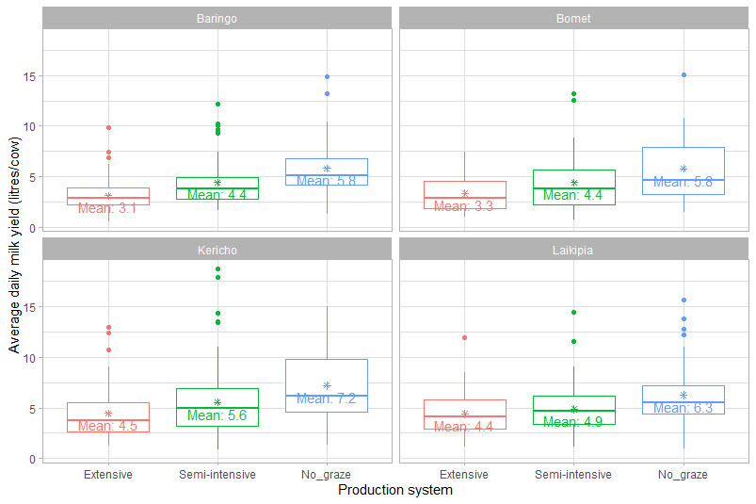
Figure S1: Boxplots displaying milk yields by production system and county

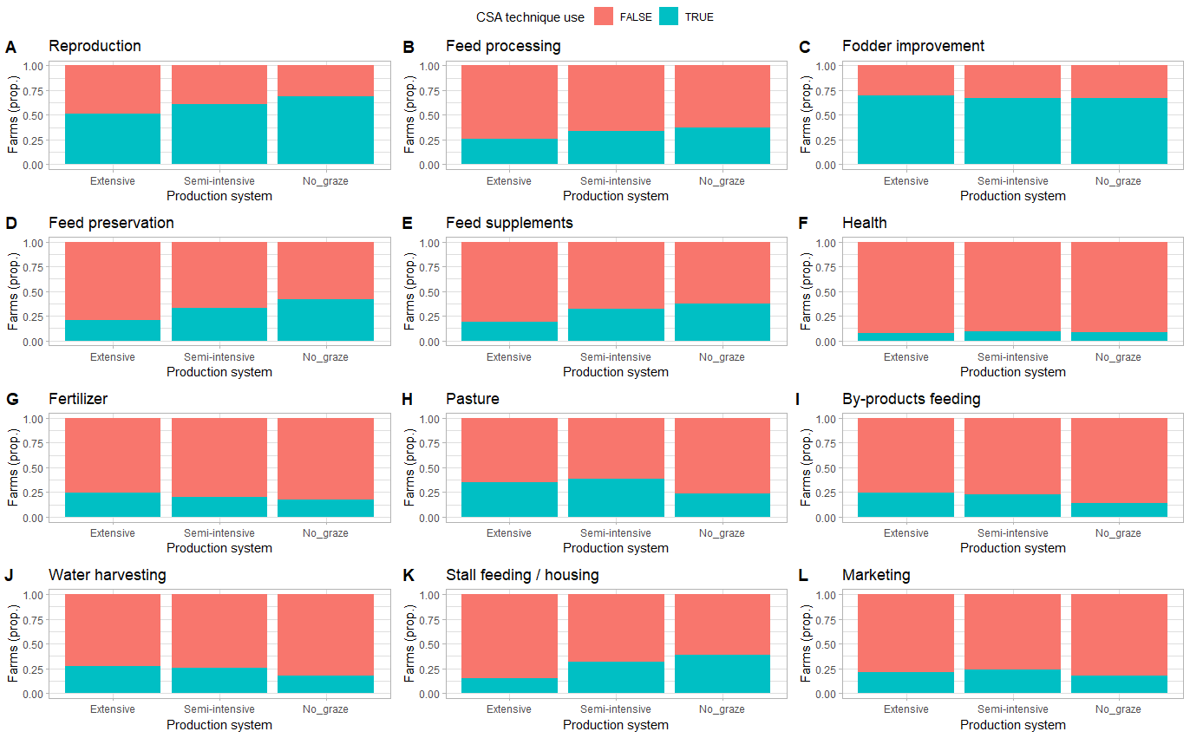
Figure S2: Plots presenting the proportion of all farms by production system that use the different CSA practices promoted by KCSAP
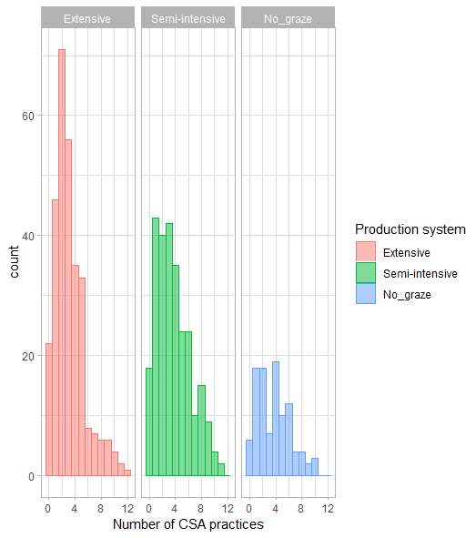
Figure S3: Histogram presenting the total number of farms using different numbers of CSA practices by production system
Figure S4: Boxplots presenting daily milk yield by number of CSA practices used and production system across all counties (plots A = Extensive production system; B = Semi-intensive production system; C = No-graze production system); and average GHG emission intensities by number of CSA practices used and production system across all counties (plots D = Extensive production system; E = Semi-intensive production system; F = No-graze production system). Numbers at the top of each plot indicate means (also indicated as white square within boxplot), while n = the number of samples, and the letters indicate results of the post-hoc least significant difference test, with different letters indicating differences at the 5% level of probability.

