Nature-inspired biomolecular corona-based on poly(caffeic acid) as a low potential and time-stable glucose biosensor

Maria Kuznowicz, Artur Jędrzak*, Teofil Jesionowski*
¹Institute of Chemical Technology and Engineering, Faculty of Chemical Technology, Poznan University of Technology, Berdychowo 4, PL-60965 Poznan, Poland;
*Corresponding authors: artur.jedrzak@put.poznan.pl and teofil.jesionowski@put.poznan.pl

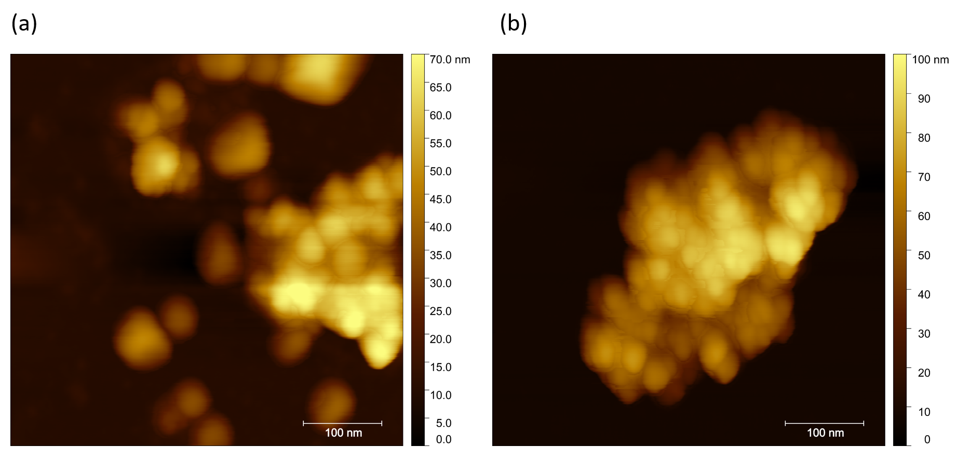
Fig. S1. AFM 2D images of Fe₃O₄@PCA nanomaterial before (a); and after GOx immobilization (b)

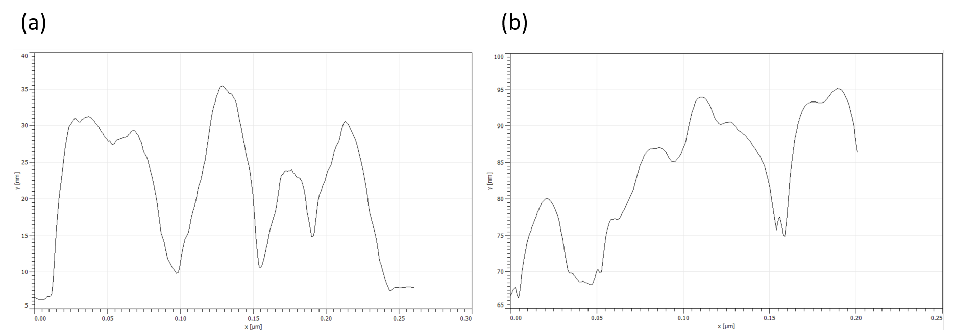
Fig. S2. Height profile plots for Fe₃O₄@PCA (a); and Fe₃O₄@PCA-GOx (b).
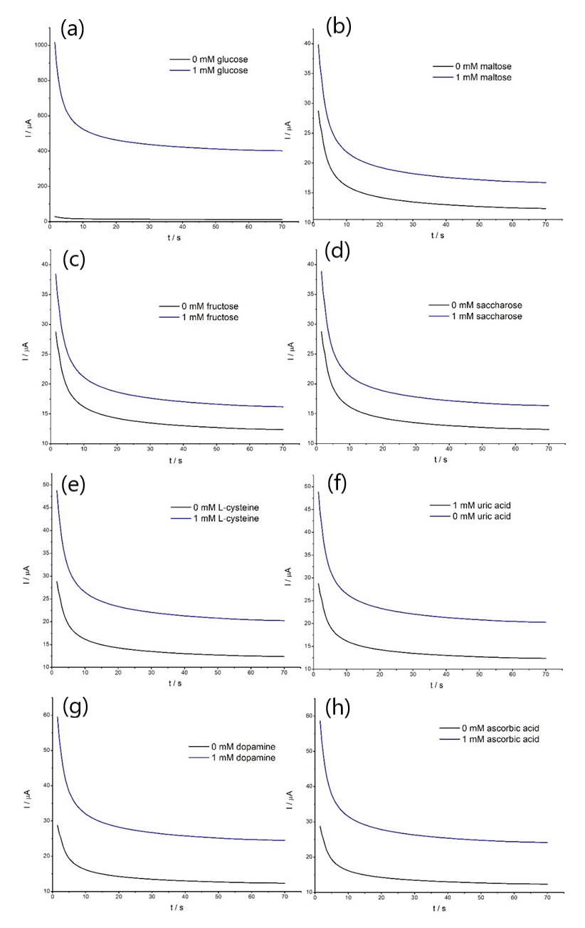
Fig. S3. Amperometric response of the GC/Fe₃O₄@PCA-GOx electrode with the addition of 1 mM glucose (a) and subsequent additions of 1 M maltose (b), 1 mM fructose (c), 1 mM saccharose (d), 1 mM L-cysteine (e), 1 mM uric acid (f), 0.1 mM dopamine (g), and 1 mM ascorbic acid (h) at +0.1 V.
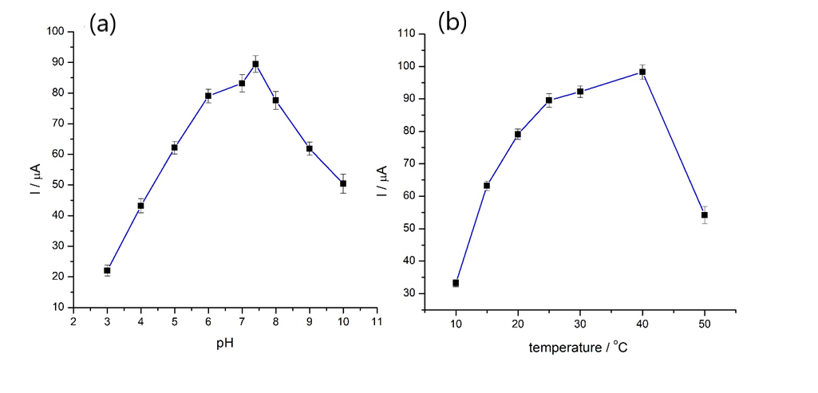
Fig. S4. The effect of pH (a); temperature (b) on the response of the SPE/Fe₃O₄@PCA-GOx biosensor (1 mM of glucose, at +0.1 V), (n=3)

