Critical Care Outreach Service at King’s College Hospital

The CCOS in the hospital gets involved in patient care either by direct referral from the ward teams or by responding to an increased National Early Warning Score (NEWS; see below in Supplement). For scores > 4 the ward medical team is asked to review the patient, whereas if the score is > 6, the CCOS is alerted and a prompt review of the patient is carried out. Involvement of the team occurs either with a telephone call from the ward clinicians or with an electronic alert on the portable devices they are carrying (Ascom MycoTM Smartphone, Sweden). Depending on the initial assessment, the patient’s co-morbidities and the clinical trajectory, the team either gives advice to the ward staff or intervenes and gets directly involved in patient care. The latter consists of a range of actions, including advice on fluid and electrolyte management; diagnostic procedures; initiation of non-invasive respiratory support via application of HFNCO or continuous positive airway pressure (CPAP) or transfer to ICU. HFNCO is delivered by the Fisher & Paykel Optiflow system, using the MR850 respiratory humidifier with MR290 chamber; RT241 heated delivery tubing, and RT033 or RT044 small or wide bore nasal cannulae (Fisher & Paykel Healthcare, Auckland, New Zealand). When the intervention is indicated, the initial standard settings are oxygen flow 60 L/min and adequate FiO2 to achieve SpO2 > 94%. In both situations, hourly monitoring and regular medical and nursing reviews are instituted until symptom resolution or decision to escalate treatment and ICU transfer.

National Early Warning Score

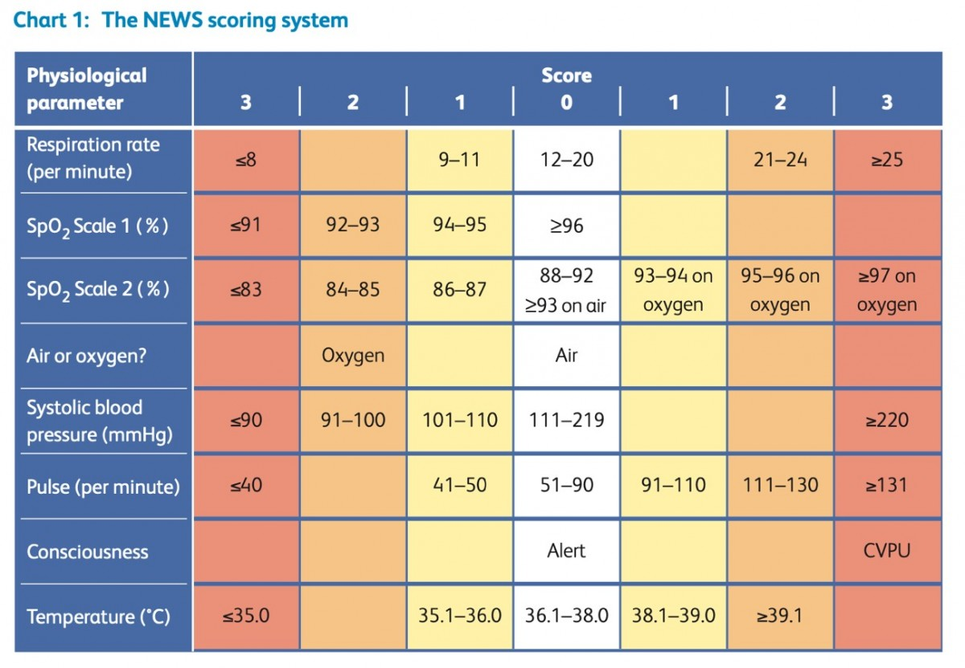

Supplementary table 1: Outcomes according to the days spent on the ward
Parameters | Days spent on HFNCO on ward
 | <1 | 1-3 | >3 | p-value
Intubated prior to arriving on ICU
No | 34 (43.0) | 31 (39.2) | 14 (17.7) | 0.710
Yes | 2 (40.0) | 3 (60.0) | 0 (0.0) | 0.710
Survived to ITU discharge
No | 12 (31.6) | 17 (44.7) | 9 (23.7) | 0.760
Yes | 28 (36.8) | 34 (44.7) | 14 (18.4) | 0.760

Supplementary Table 2: Analysis of factors associated with ICU mortality.
 | Univariate Analysis |  |  | Multivariable Analysis
Variables | OR | 95% CI | p-value | OR | 95% CI | p-value
Age in years
>60/≤60 | 1.35 | 0.60,3.04 | 0.469
HSCT
Yes/No | 0.19 | 0.08,0.44 | <0.001 | 0.30 | 0.07,1.36 | 0.120
Type of HSCT
Autologous | 11.25 | 1.31,96.39 | 0.027 | NE | NE | NE
NA | 6.53 | 2.59,16.45 | <0.001 | 1.50 | 0.31,7.35 | 0.618
Allogeneic | 1 | 1 | 1 | 1 | 1 | 1
HCT-CI
1-2 | 0.32 | 0.07,1.60 | 0.166 | 0.51 | 0.08,3.23 | 0.470
≥3 | 0.39 | 0.08,1.91 | 0.247 | 0.93 | 0.14,5.96 | 0.937
0 | 1 | 1 | 1 | 1 | 1 | 1
Parameters at HFNCO initiation: SpO₂
90-94% | 1.78 | 0.38,8.23 | 0.462
>94% | 2.00 | 0.49,8.22 | 0.336
<90% (ref) | 1 | 1 | 1
Parameters at HFNCO initiation: RR
<25/min/≥ 25 | 1.91 | 0.80,4.56 | 0.146 | 3.46 | 0.84,14.22 | 0.085
Parameters at HFNCO initiation: HR
<100min⁻¹/≥100min⁻¹ | 1.85 | 0.79,4.34 | 0.159 | 2.02 | 0.52,7.83 | 0.308
Intubation and IMV
Yes/No | 0.09 | 0.03,0.26 | <0.001 | 0.03 | 0.002,0.31 | 0.004
HSCT: haematopoietic stem cell transplant; HCT-CI: Hematopoietic cell transplantation - specific comorbidity index; HR: heart rate; RR: respiratory rate; HFNCO: high flow nasal cannula oxygen; IMV: invasive mandatory ventilation

Supplementary Table 3: Analysis of factors associated with in-hospital mortality
 | Univariate Analysis |  |  | Multivariable Analysis
Variables | OR | 95% CI | p-value | OR | 95% CI | p-value
Age in years
>60/≤60 | 1.23 | 0.60,2.53 | 0.580
HSCT
Yes/No | 0.35 | 0.16,0.77 | 0.009 | 0.51 | 0.10,2.53 | 0.411
Type of HSCT
Autologous | 19.8 | 2.30,170.71 | 0.007 | NE | NE | NE
NA | 3.08 | 1.39,6.84 | 0.006 | 1.70 | 0.28,10.23 | 0.563
Allogeneic | 1 | 1 | 1 | 1 | 1 | 1
HCT-CI
1-2 | 0.25 | 0.05,1.21 | 0.085 | 0.20 | 0.03,1.52 | 0.121
≥3 | 0.26 | 0.05,1.21 | 0.085 | 0.26 | 0.03,2.09 | 0.204
0 | 1 | 1 | 1
Aetiology of deterioration
Pulmonary oedema | 1.63 | 0.45,5.98 | 0.459 | NE | NE | NE
GvHD lung | 1.87 | 0.16,21.35 | 0.616 | - | - | -
Other | 0.39 | 0.13,1.20 | 0.100 | 0.20 | 0.02,1.94 | 0.167
Sepsis | 1 | 1 | 1 | 1 | 1 | 1
fiO2
<40%/≥40% | 0.55 | 0.24,1.29 | 0.168 | 2.72 | 0.51,14.42 | 0.241
Parameters at HFNCO initiation: spO₂
90-94% | 1.13 | 0.25,5.12 | 0.871
>94% | 0.70 | 0.18,2.82 | 0.618
<90% | 1 | 1 | 1
Parameters at HFNCO initiation: RR
<25/min/≥ 25 | 0.97 | 0.46,2.04 | 0.937
Parameters at HFNCO initiation: HR
<100 min⁻¹/≥100 min⁻¹ | 1.84 | 0.87,3.87 | 0.110 | 2.43 | 0.59,10.10 | 0.222
Intubated
Yes/No | 0.26 | 0.10,0.64 | 0.003 | 0.27 | 0.10,0.70 | 0.007
HSCT: haematopoietic stem cell transplant; HCT-CI: Hematopoietic cell transplantation - specific comorbidity index; HR: heart rate; RR: respiratory rate; HFNCO: high flow nasal cannula oxygen; IMV: invasive mandatory ventilation

