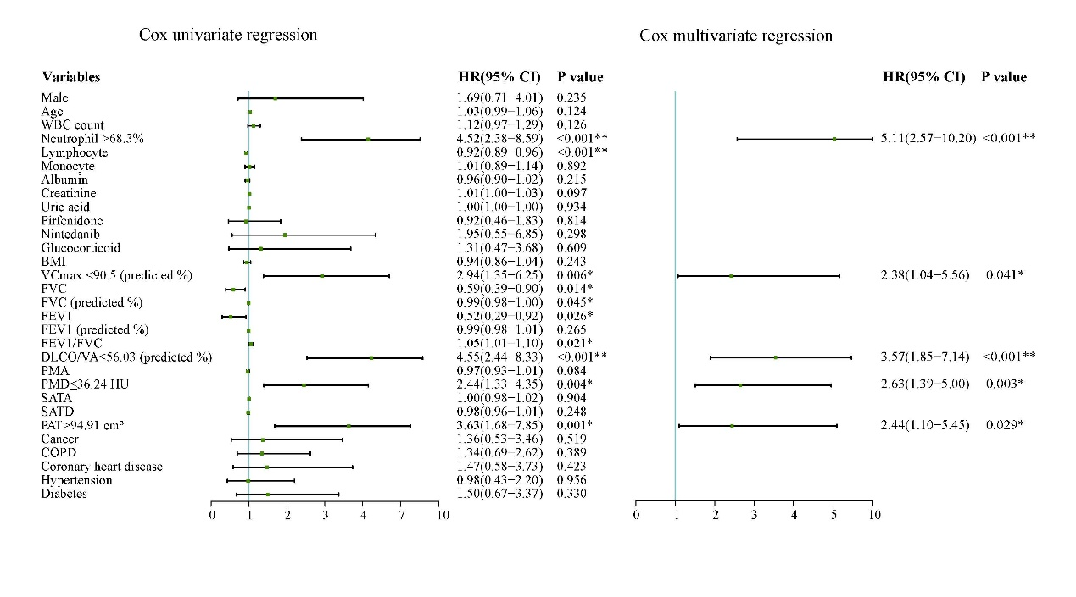 Supplementary Fig. 1 The forest plot of the Cox univariate and multivariate analyses for TFS in IPF patients. “*” indicates p<0.05, and “**” indicates p<0.001. HR represents Hazard Ratio, and 95% CI represents the 95% confidence interval.

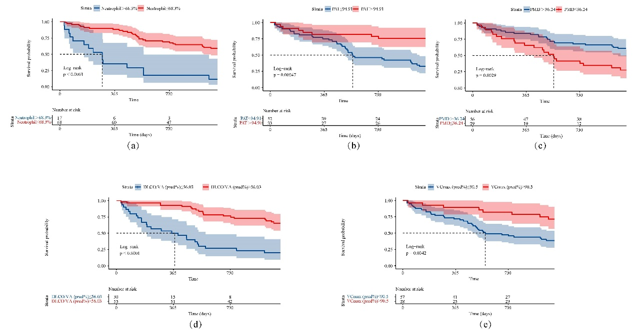
Supplementary Fig. 2 The Kaplan-Meier survival curves for statistically significant variables in COX multivariate analyze. (a) The survival difference based on the high or low proportion of neutrophils, (b) based on PAT (Pericardial adipose tissue), (c) based on PMD (pectoralis muscle radiodensity), (d) based on DLCO/VA (diffusing capacity of the lungs for carbon monoxide/alveolar ventilation), and (e) based on VCmax pred% (percentage of predicted vital capacity).

