Supplementary Materials

Experimental and theoretical revealing of piezo-photocatalyst Bi₂O₂CO₃ for ciprofloxacin degradation in water
Xiaofeng Sun¹, Guorong Liu², Ruishan Li², Liexiao Li², Jianfeng Dai², Hua Yang^{1,2}*
¹State Key Laboratory of Advanced Processing and Recycling of Non-ferrous Metals, Lanzhou University of Technology, Lanzhou 730050, China
²School of Science, Lanzhou University of Technology, Lanzhou 730050, China

Characterization of Bi₂O₂CO₃
Scanning electron microscopy (SEM) observation was performed on a JSM-6701F field-emission scanning electron microscope (JEOL Ltd.). Transmission electron microscopy (TEM) analysis was performed on JEM-1200EX field-emission transmission electron microscope (JEOL Ltd.). X-ray powder diffraction (XRD) analysis was carried out on a Bruker D8 Advance X-ray powder diffractometer with Cu Kα radiation (λ = 0.15406 nm). Fourier transform infrared (FTIR) spectroscopy analysis was carried out on a Spectrum Two FTIR spectrophotometer (PerkinElmer) in the range of 500–4000 cm⁻¹ using KBr powder. Ultraviolet-visible diffuse reflectance spectroscopy (UV-vis DRS) measurement was done on a TU-1901 double beam spectrophotometer (Beijing Purkinje General Instrument Co. Ltd.). X-ray photoelectron spectroscopy (XPS) investigation was performed a PHI-5702 multi-functional X-ray photoelectron spectrometer (Physical Electronics) with Mg Kα radiation (hv = 1253.6eV and power = 250 W). Electron paramagnetic resonance (EPR) signals were monitored on a Bruker microESR spectrometer. Liquid chromatography‒mass spectrometry (LC‒MS) analysis was performed on a thermos TSQ Quantum Ultra mass spectrometer and Agilent 1100 liquid chromatograph.
DFT calculation
Vienna Ab-initio Simulation Package (VASP) software was used to calculate the band structure and density of states of Bi₂O₂CO₃ based on the density functional theory (DFT) [1,2]. The interaction between electrons and ions was described by the projection augmented plane wave (PAW) method and Perdew–Burke–Ernzerhof (PBE) exchange correlation functional within a generalized gradient approximation (GGA). A truncation energy of the valence electron plane was set as 400 eV and the first Brillouin zone was sampled using a 6 × 1 × 6 Monkhorst-Pack k-points mesh. In our calculations, the lattice parameters of Bi₂O₂CO₃ are a = 5.55541 Å, b = 28.02602 Å, c = 5.53552 Å and α = β = γ = 90.0000º. In addition, the convergence for energy was chosen as 10⁻⁵ eV and the structural optimization was obtained until the Hellmann–Feynman forces acting on each atom was less than 0.03 eV/Å.
For calculating the elasticity matrix (c_{E}), relative permittivity matrix (ε_{r}), piezoelectric coupling matrix (e_{ES}) and volume density (ρ) of Bi₂O₂CO₃, the POSCAR, POTCAR and KPOINTS files are consistent with those in the state density calculation, but the INCAR files are different. In the process of calculating c_{E}, IBRION = 6, NFREE = 2, ISIF = 3 and ENCUT = 650 eV. In the process of calculating e_{ES} and ε_{r}, LEPSILON = T, LPEAD = T, KSPACING = 0.2, LREAL = Auto, ISIF=3, SIGMA = 0.1 and ENCUT = 400 [3].
Additionally, the q(N−1) (the molecule lost an electron), q(N) (the neutral molecule), q(N+1) (the molecule getting an electron), the Laplacian bond order (LBO), the lowest unoccupied molecular orbital (LUMO) and highest occupied molecular orbital (HOMO) of CIP were calculated by the Multiwfn software [4,5]. The condensed Fukui index including the nucleophilic (f ⁺), electrophilic (f ⁻), radical attack (f ⁰) and condensed dual descriptors (CDD) were calculated and applied to evaluate the reactive sites on the CIP molecule.
FEM simulation
The finite-element method (FEM) simulation involved a dynamic 3D analysis of a piezoelectric device using COMSOL Multiphysics software. The parameters c_{E}, ε_{r} and e_{ES} used for the simulation of piezoelectric potential distributions in the Bi₂O₂CO₃ nanoplates are presented in the body text. The volume density of Bi₂O₂CO₃ is ρ = 6860 kg/m³. The center of the Bi₂O₂CO₃ crystals was fixed and grounded. The polarization was aligned along the global co-ordinate z-axis.
Reference:
[1] G. Kresse, J. Furthmüller, Efficiency of ab-initio total energy calculations for metals and semiconductors using a plane-wave basis set, Comp. Mater. Sci. 6 (1996) 15‒50.
[2] G. Kresse, J. Furthmüller, Efficient iterative schemes for ab initio total-energy calculations using a plane-wave basis set, Phys. Rev. B 54 (1996) 11169.
[3] Y.L. Page, P. Saxe, Symmetry-general least-squares extraction of elastic data for strained materials from ab initio calculations of stress, Phys. Rev. B 65 (2002) 104104.
[4] T. Lu, F. Chen, Multiwfn: A multifunctional wavefunction analyzer, J. Comput. Chem. 33 (2012) 580–592.
[5] T. Lu, F. Chen, Bond order analysis based on the Laplacian of electron density in fuzzy overlap space, J. Phys. Chem. A 117 (2013) 3100–3108.

Table S1. Fathead minnow LC₅₀, daphnia magna LC₅₀, development toxicity and mutagenicity of CIP and its degradation intermediates analyzed by Toxicity Estimation Software Tool (TEST, version 5.1.1).
Compounds | Fathead minnow LC₅₀ (96 h) (mg/L) | Daphnia magna LC₅₀ (48 h) (mg/L) | Development toxicity | Mutagenicity
CIP | 0.19 | 2.84 | 1.09 | 0.62
P1 | 0.31 | 58.06 | 1.22 | 0.58
P2 | 0.14 | 6.59 | 1.01 | 0.39
P3 | 0.13 | 16.08 | 1.02 | 0.47
P4 | 0.20 | 10.36 | 0.90 | 0.29
P5 | 0.45 | 1.21 | 0.69 | 0.36
P6 | 3208.38 | 85.13 | 0.59 | 0.71
P7 | 36.59 | 39.05 | 0.34 | 0.08
P8 | 31128.35 | 23217.87 | 0.50 | 0.012
P9 | 14.80 | 18.77 | 0.36 | 0.00
P10 | 18.68 | 12.11 | 0.43 | 0.00
P11 | 7.56 | 5.37 | 0.46 | 0.00
P12 | 232.00 | 241.22 | 0.71 | -0.02
P13 | 227.57 | 28.90 | 0.66 | -0.05
P14 | 13493.12 | 9614.39 | 0.49 | 0.23
P15 | 762.37 | 1035.97 | 0.71 | -0.06
P16 | 0.23 | 18.80 | 1.02 | 0.58
P17 | 0.38 | 28.36 | 0.92 | 0.37
P18 | 0.21 | 9.73 | 0.96 | 0.34
P19 | 0.41 | 2.52 | 0.89 | 0.57
P20 | 9.95 | 273.32 | 0.74 | 0.13
P21 | 117.12 | 966.21 | 0.69 | 0.03
P22 | 52.64 | 567.54 | 0.87 | 0.14
P23 | 152.30 | 76.33 | 0.64 | 0.06
P24 | 946.72 | 437.38 | 0.37 | 0.07
P25 | 1401.32 | 677.53 | 0.51 | 0.28
P26 | 0.27 | 51.24 | 1.13 | 0.63
P27 | 0.44 | 315.87 | 0.99 | 0.48
P28 | 2.78 | 97.53 | 0.53 | 0.05
P29 | 7.24 | 41.84 | 0.73 | 0.21
P30 | 7.10 | 45.03 | 0.77 | 0.48
P31 | 23.07 | 1146.50 | 0.72 | 0.21
P32 | 57.70 | 1629.24 | 0.65 | 0.28
P33 | 4355.71 | 1283.45 | 0.43 | 0.29
P34 | 404.63 | 549.65 | 0.72 | 0.08

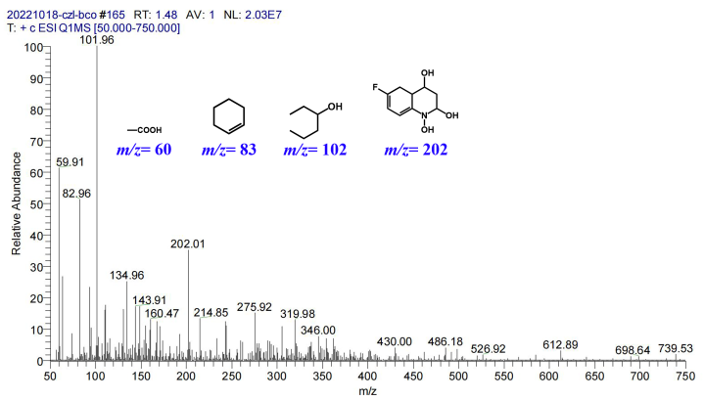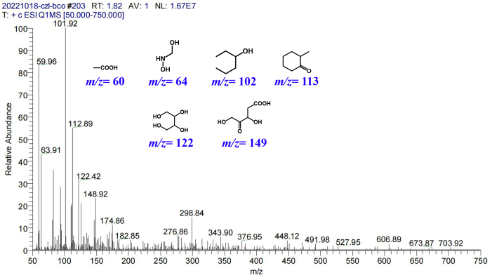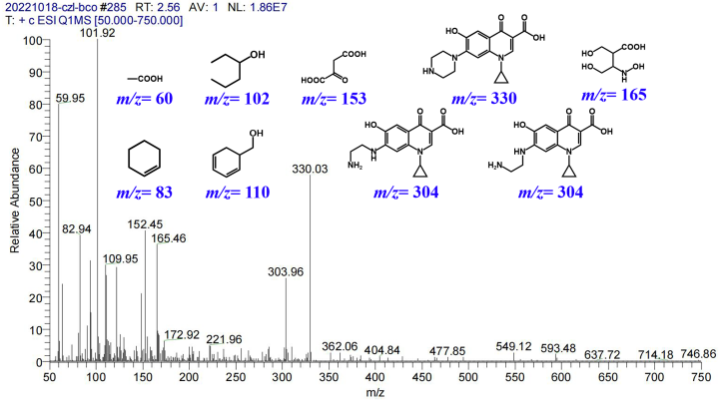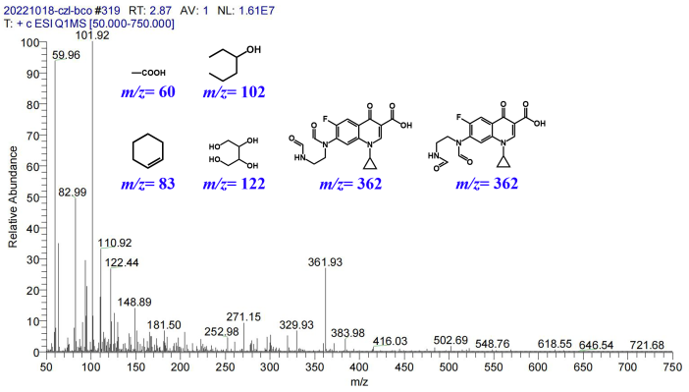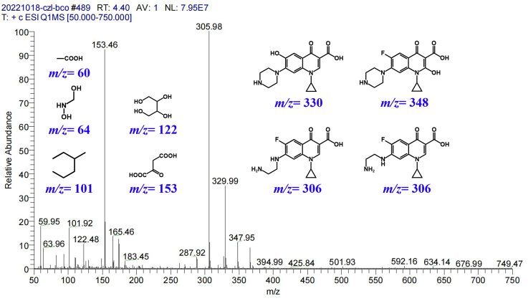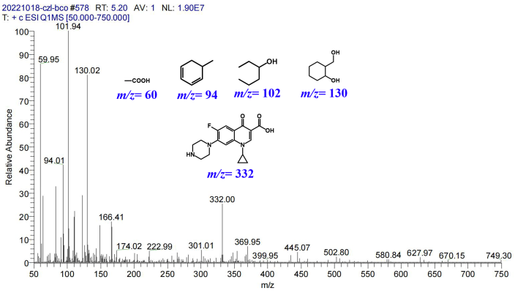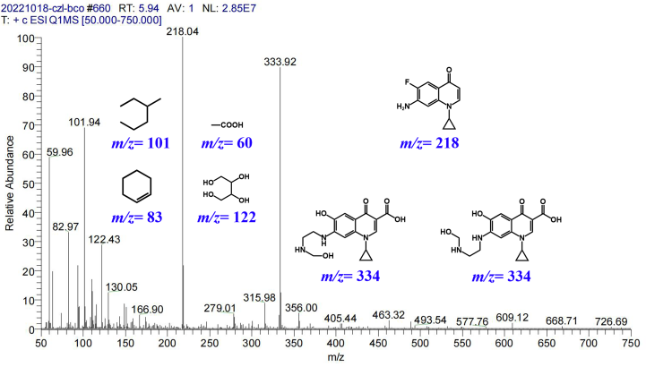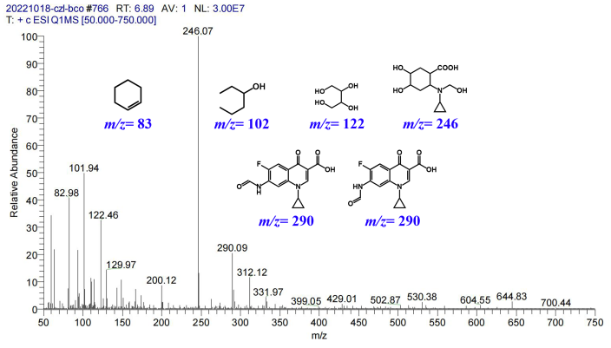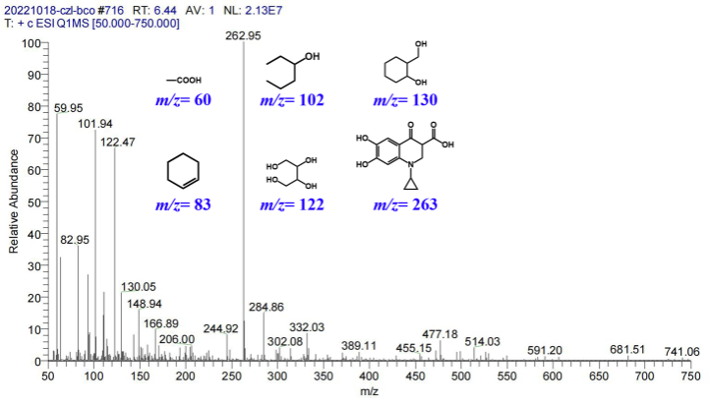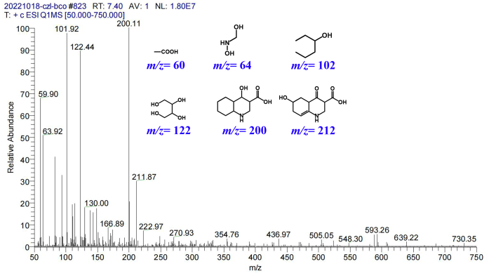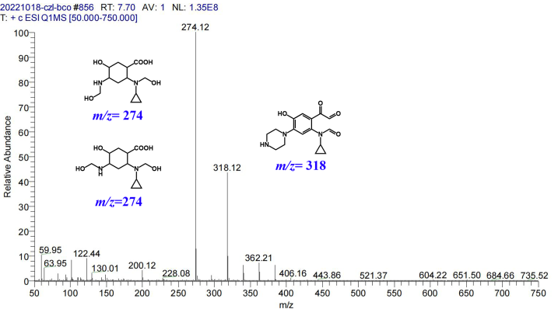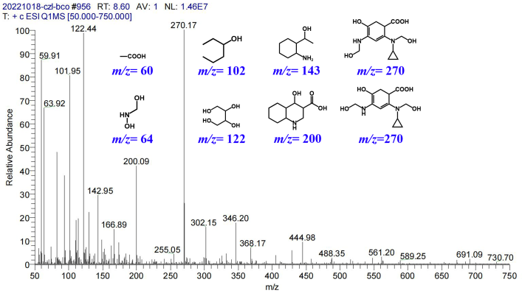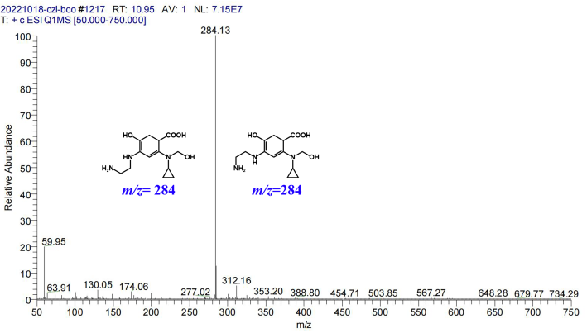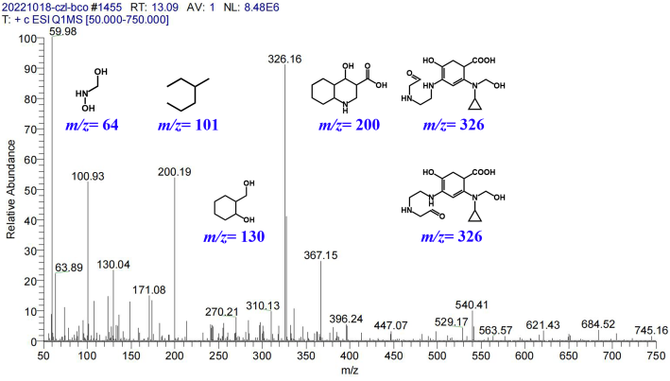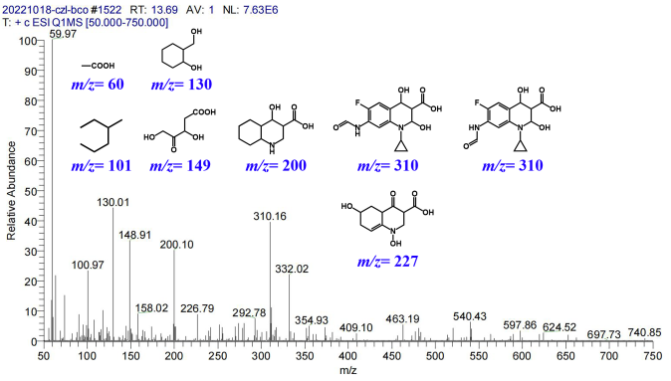
Fig. S1. Mass spectral database for piezo-photocatalytic decomposition products of CIP over Bi₂O₂CO₃ nanoplates.

