Supplementary
Supplementary figure legends
SF 1,
A, Homo sapiens ST8SIA6-AS1 gene expression in 54 tissues from Genotype-Tissue Expression (GTEx) RNA-seq of 17382 samples. B, siRNAs knock down the expression of ST8SIA6-AS1 in MHCC-97H and HCCLM3.
SF 2,
A, Representative flow cytometry plots showing the apoptosis in MHCC-97H with ST8SIA6-AS1 knockdown. B, Histograms showing statistical comparisons of the apoptosis percentage of MHCC-97H between control group and ST8SIA6-AS1 knockdown group.
SF 3
A, SiRNA was used to knock down MYC and FOXA1 in MHCC-97H and HCCLM3, respectively. The expression level of MYC and FOXA1 was detected by qPCR. B, Co-expression analysis between ST8SIA6-AS1 and MYC in liver tumors and GETx liver tissues (data from GEPIA).
Supplementary Table 1
Seven transcripts of ST8SIA6-AS1 were annotated in the LNCipedia database (https://lncipedia.org/).

Supplementary figures
SF 1
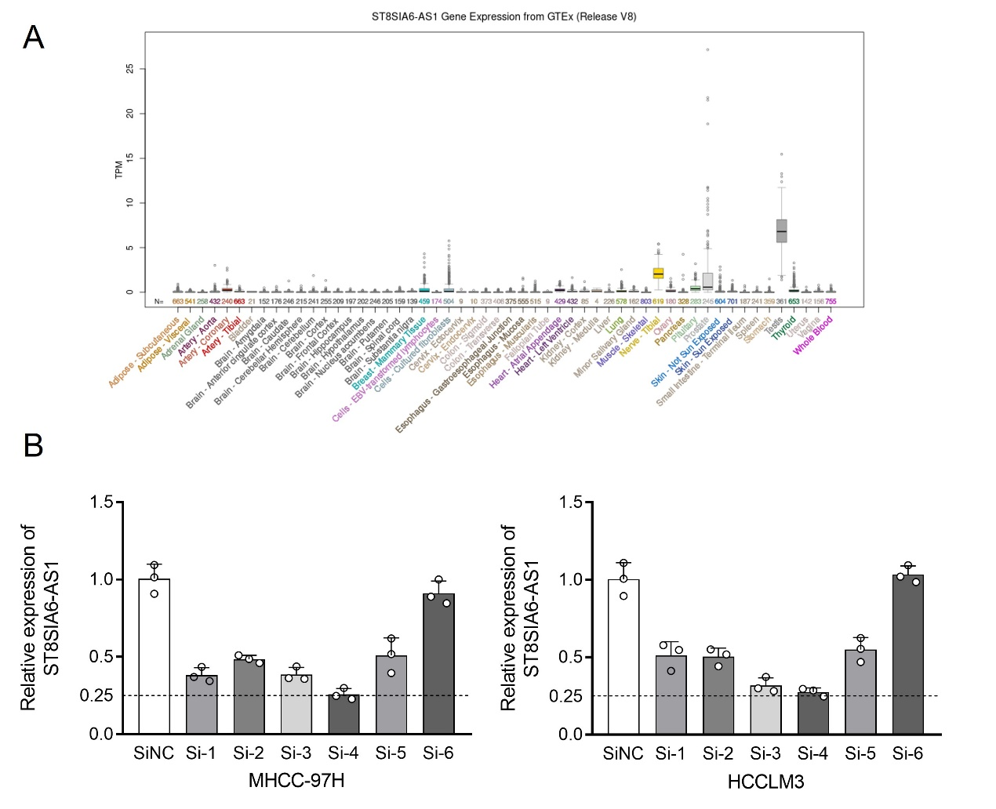

SF 2
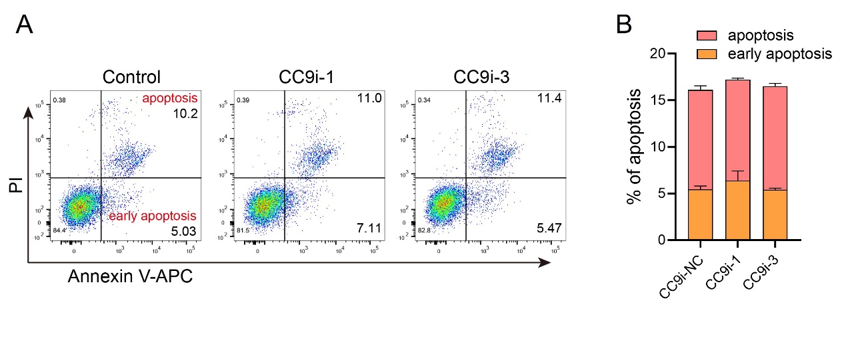

SF 3
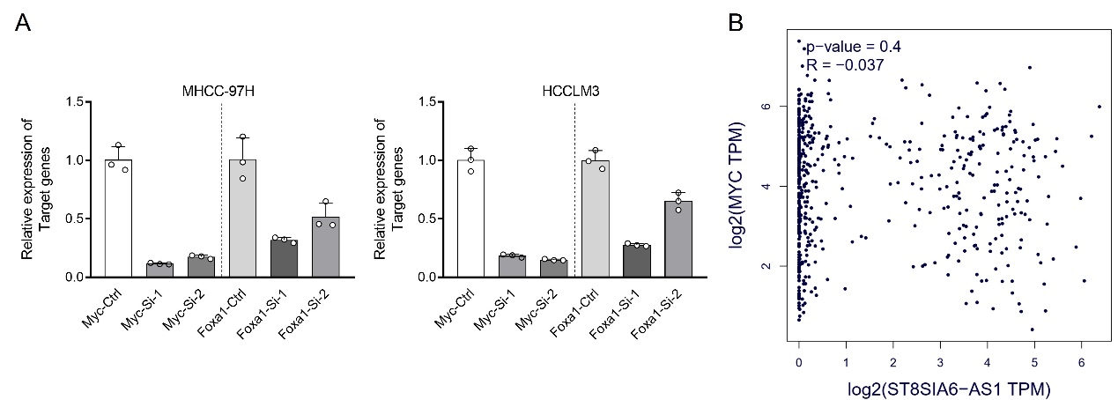

Supplementary Table 1
Primer sequences
ST8-AS1-qPCR-1F | CCATCCATCATGGCCAAAGC
ST8-AS1-qPCR-1R | CAGGGTTTCTTCGGTCGTCA
ST8-AS1-qPCR-2F | CATGCTCCTCCTTGCTCCAA
ST8-AS1-qPCR-2R | TGGCACAGATATCAGGTGAAGG
GAPDH-qPCR-F | ACAACTTTGGTATCGTGGAAGG
GAPDH-qPCR-R | GCCATCACGCCACAGTTTC
OE-hFOXA1-F | ATGTTAGGAACTGTGAAGATGGAAGG
OE-hFOXA1-R | CTAGGAAGTGTTTAGGACGGGTCT
OE-hMYC-F | CTGGATTTTTTTCGGGTAGTGG
OE-hMYC-F | TTACGCACAAGAGTTCCGTAGC
ST8-AS1-sgRNA1-S | CACCGCGTAAGCCGCCTTGCGCCTT
ST8-AS1-sgRNA1-A | AAACAAGGCGCAAGGCGGCTTACGC
ST8-AS1-sgRNA2-S | CACCGCCCAGGGAGGCTGACGTACG
ST8-AS1-sgRNA2-A | AAACCGTACGTCAGCCTCCCTGGGC
ST8-AS1-sgRNA3-S | CACCGAGGAGCTCGATCACAAGGTC
ST8-AS1-sgRNA3-A | AAACGACCTTGTGATCGAGCTCCTC
gDNA-ST8-AS1--260-F | CAGGCAGTTTTAATGAATGC
gDNA-ST8-AS1-+1489-R | TTGATCTGGGGATAAAGAAAC
CHIP-qPCR-BS1-F | TCTTTTTCATGCTCCTCCTTGC
CHIP-qPCR-BS1-R | ACTCACCAATAGGTTCTGGGC
CHIP-qPCR-BS2-F | CTGACTGGGCTCAGGCATGC
CHIP-qPCR-BS2-R | CCTTGATGTCCCAAGCCTG
CHIP-qPCR-FOXA1-F | TGGATGTGTCTCTTCCTCT
CHIP-qPCR-FOXA1-R | GTAGGTAAACCGGTTTAAC

Supplementary Table 2
Seven transcripts of ST8SIA6-AS1 were annotated in the LNCipedia database (https://lncipedia.org/).
Transcript ID | Gene ID | Location (hg38) | strand | transcript size
ST8SIA6-AS1:1 | ST8SIA6-AS1 | chr10:17386924-17408274 | + | 462
ST8SIA6-AS1:2 | ST8SIA6-AS1 | chr10:17386936-17408286 | + | 557
ST8SIA6-AS1:3 | ST8SIA6-AS1 | chr10:17386936-17410631 | + | 1826
ST8SIA6-AS1:4 | ST8SIA6-AS1 | chr10:17386951-17410631 | + | 1811
ST8SIA6-AS1:5 | ST8SIA6-AS1 | chr10:17386994-17408286 | + | 404
ST8SIA6-AS1:6 | ST8SIA6-AS1 | chr10:17399102-17410631 | + | 1689
ST8SIA6-AS1:7 | ST8SIA6-AS1 | chr10:17408027-17413503 | + | 372

