Supplementary information
Amount of motion encoding - To optimally set the strength of the motion-sensitizing gradients, five CSF-STREAM sub-scans were acquired in three subjects: one sub-scan without motion-sensitizing gradients, and four sub-scans with different motion-sensitizing gradient strengths (2, 3.5, 5 and 7 mm/s). All other imaging parameters were the same as in the original CSF-STREAM sequence. Images were reconstructed using BART’s pics command using a wavelet transform in the spatial dimensions with a regularization factor of 0.0015 and input coil sensitivities estimated from the k-space center using BART’s ecalib command.
The signal attenuation due to motion encoding was calculated as the relative difference between a sub-scan with motion-sensitizing gradients and the sub-scan without motion-sensitizing gradients. The resulting attenuation was evaluated in two regions of interest: in the SAS around the MCA as well as in PVS of the basal ganglia.
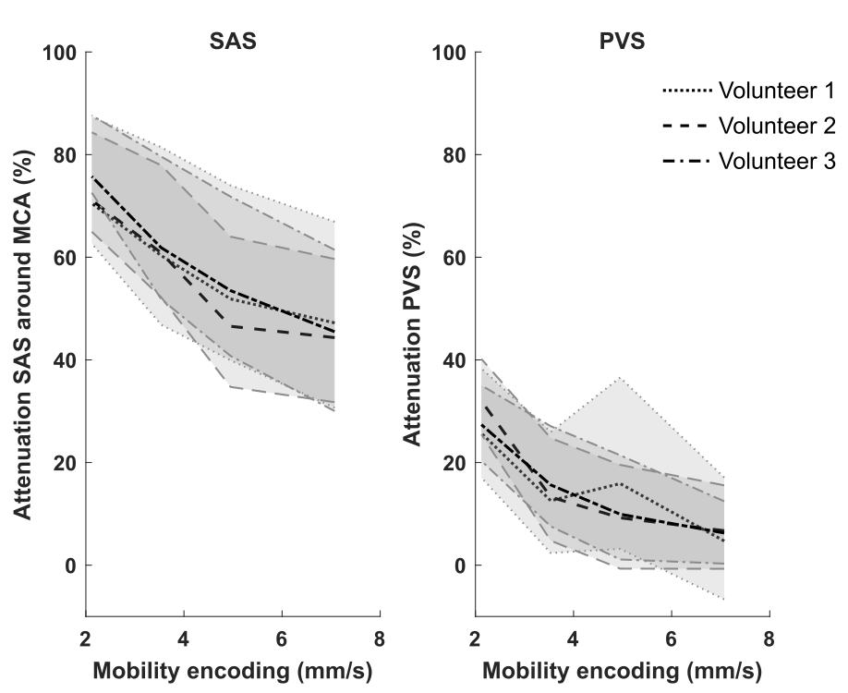
A motion-sensitizing gradient strength of 3.5mm/s was found optimal, as it attenuates CSF in both SAS and PVS, but does not reach too high (>80%) attenuations, which would make the calculation of CSF-mobility not accurate in these regions.

Supplementary figure 1: Choice of the motion-sensitizing gradient strength. Each black line represents the attenuation in one volunteer across motion-sensitizing gradient strengths. The shaded area displays the 30th and 70th percentiles over voxels in the region of interest.
Supplementary video 1: High-resolution, whole brain CSF-signal. Whole brain CSF-signal measured using the non-motion-sensitized reference scan, shown in one individual.
Supplementary video 2: Animation of CSF-mobility change across driving forces in the subarachnoid space around the circle of Willis. CSF-mobility change from the mean value over phases (in %) across the cardiac (left), respiration (middle) and random (right) cycles in one representative individual (same data as in Fig. 3, but as a gif). Please note that a a linear interpolation was applied between the phases to visually smoothen the video.
Supplementary video 3: Animation of CSF-mobility change across driving forces in PVS around penetrating arteries. CSF-mobility change from the mean value over phases (in %) across the cardiac (left), respiration (middle) and random (right) cycles in one representative individual (same data as in Fig. 4, but as a gif). Please note that a a linear interpolation was applied between the phases to visually smoothen the video.

