Extended data figures
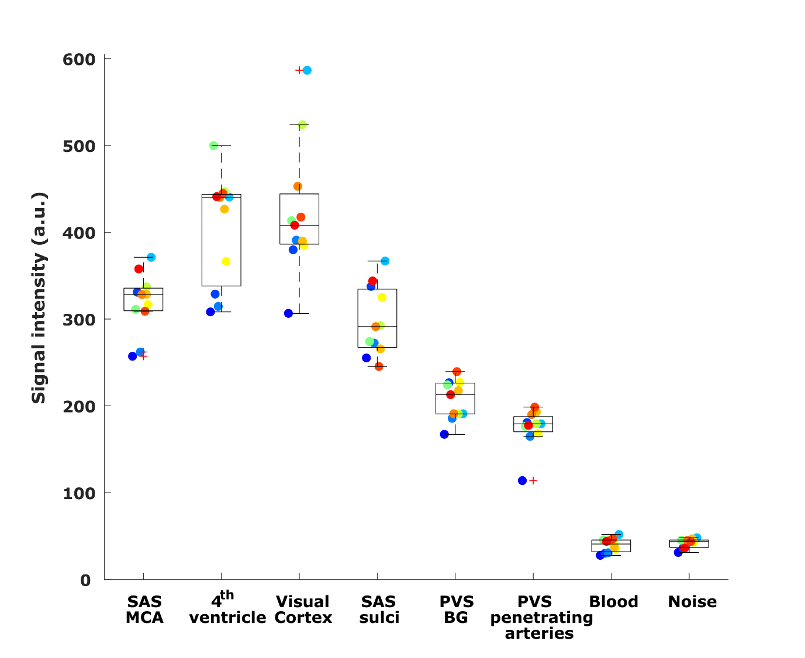
Extended data Fig. 1: Mean signal intensity in different regions of interest. Average signal intensity (in a.u.) measured on the non-motion-sensitized reference scan in eight regions of interest of eleven individuals. Each point represents the average value over voxels in each ROI per individual (one color per individual).
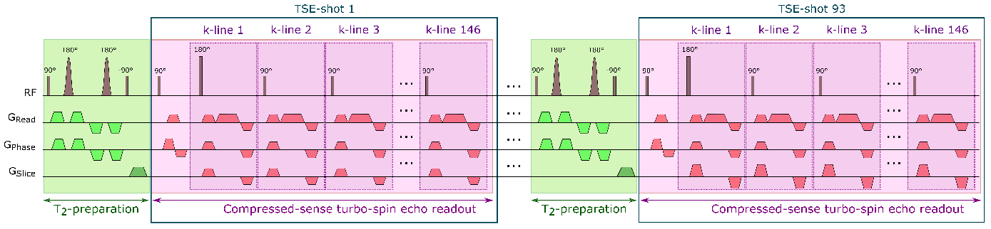
Extended data Fig. 2: Sequence diagram of one CSF-STREAM sub-scan. Example of the first and last turbo-spin-echo (TSE)-shots. The whole sub-scan consisted of 93 TSE-shots containing each 146 k-lines. Each TSE-shot was preceded by a T₂-preparation in which motion-sensitizing gradients could be added to encode CSF-mobility. In total, a CSF-STREAM scan consists of seven sub-scans: one without motion-sensitizing gradients and six with gradients applied in different, orthogonal directions. In this figure, motion-sensitizing gradients were applied in the read and phase directions.
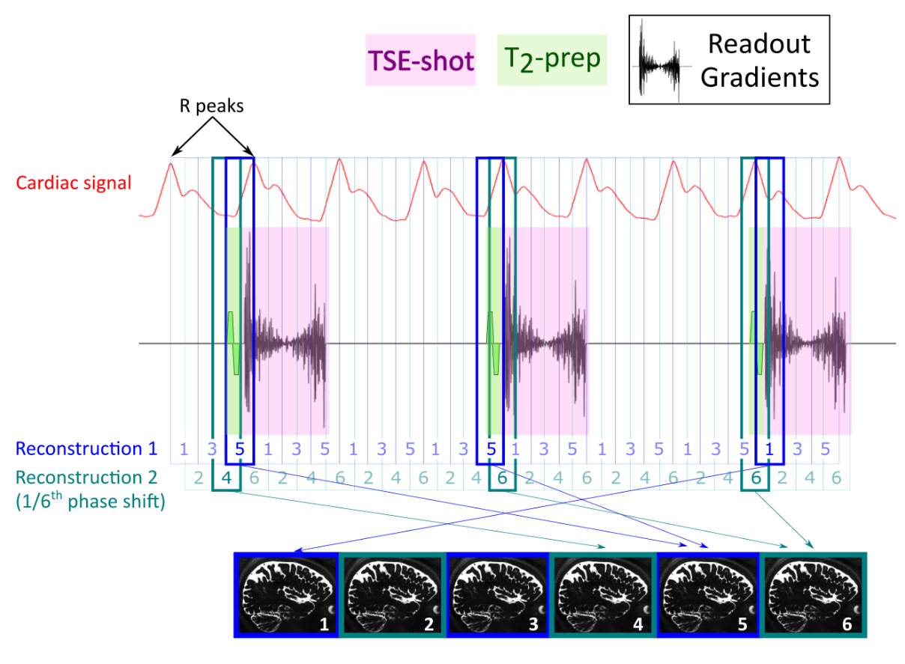Extended data Fig. 3: Retrospective binning. Schematic representation of the binning in cardiac phases with reference to the T₂-preparation preceding each TSE-shot. This scheme only represents 3 out of the 93 shots. The retrospective binning in 6 phases is performed in two steps: k-space is binned twice in 3 phases, with a 1/6th phase shift between the two steps. The T₂-preparation preceding each TSE-shot is taken as reference and the signal in the subsequent TSE-shot is considered to be dependent on this specific cardiac phase.

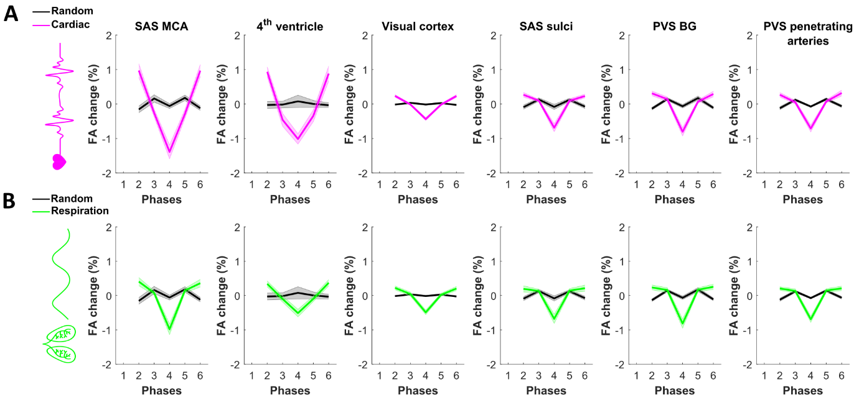
Extended data Fig. 4: Regional comparison of fractional anisotropy change across driving forces. FA change from the mean value over phases (in %) across (A) the cardiac cycle (pink), (B) respiratory cycle (green) and (A&B) random phases (grey) in six regions of interest in eleven individuals. Each line represents the mean over individuals and the shaded error areas represent confidence intervals of SD×1.96/√n (n=11).
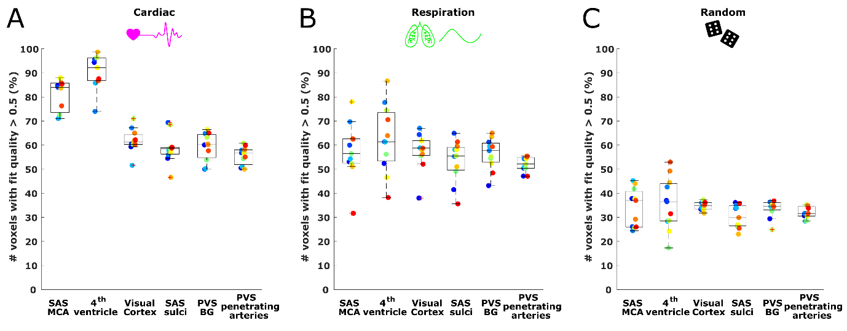
Extended data Fig. 5: Percentage of voxels showing coherent CSF-mobility changes across phases (i.e. R² > 0.5 when fitting a sinusoidal model) relative to the total amount of voxels in the ROI. Values are shown for (A) cardiac, (B) respiration and (C) random binning in six ROIs. Every colored point corresponds to the values in one subject.

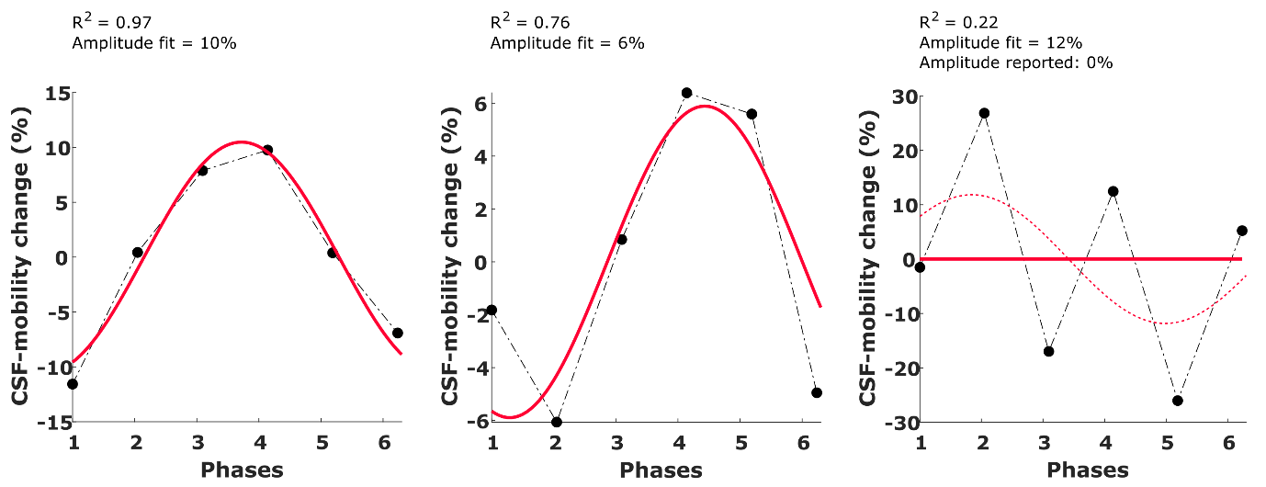
Extended data Fig. 6: Example of the voxel-wise sinusoidal fit (in red) applied to the signal across phases (black line with dots) in three different voxels. The associated fit quality and amplitude are shown above each graph. In the most right panel, the reported amplitude would have be 12%, even though the fit quality to the sinusoid is very low (R²=0.22, the corresponding fit is the red dashed line) and does not represent well the CSF-mobility change over phases. In that case, an amplitude of 0 is reported instead, as shown by the flat red line to better represent the absence of coupling.
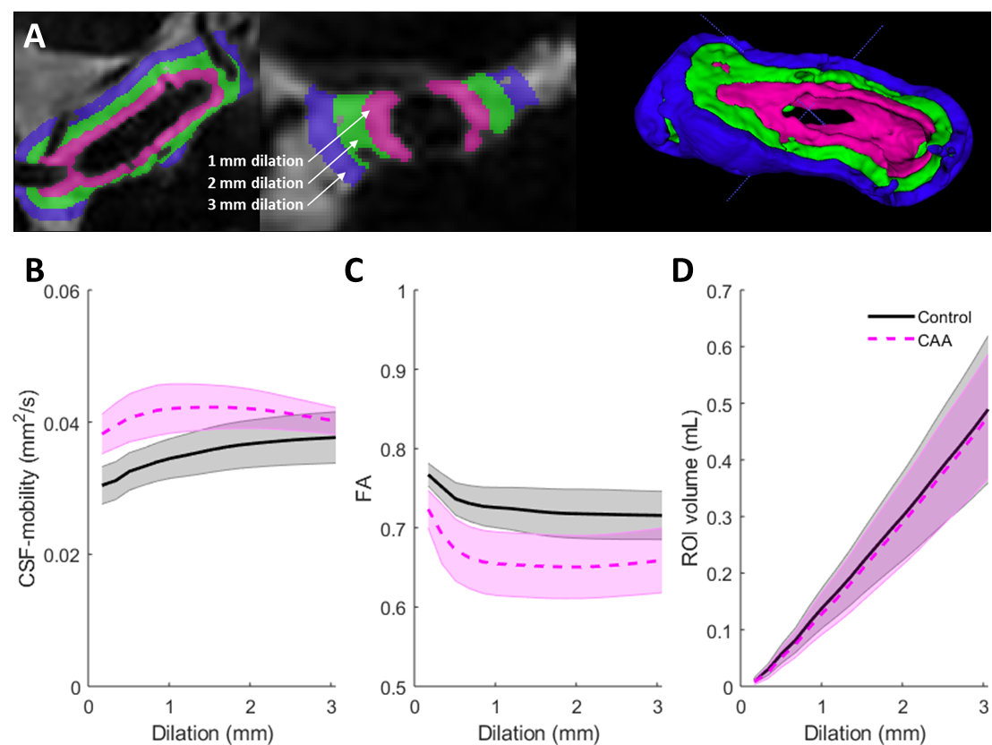
Extended data Fig. 7: CSF-mobility, FA and ROI volume as a function of the distance to the middle cerebral artery (MCA). (A) Example of dilations around the middle cerebral artery of 1 mm (magenta), 2 mm (green) and 3 mm (blue) containing CSF. (B) CSF-mobility, (C) FA and (D) ROI volume across dilation width in CAA patients (pink, dashed line) and healthy controls (black, full line). Each line represents the mean over individuals and the shaded error areas represent confidence intervals of SD×1.96/√n (n=8 per group).

Parameter | CAA patients (n=8) | Control subjects (n=8) | p
Age [years, mean ± SD] | 71.9 ± 6.6 | 72.9 ± 6.6 | 0.67
Female [n (%)] | 1 (12.5 %) | 2 (25.0 %) | 0.59
Cortical cerebral microbleed count [mean ± SD] | 31.1 ± 26.8 | 0.5 ± 1.0 | 0.001
Cortical superficial siderosis  [n (%)] | 7 (87.5 %) | 0 (0.0 %) | 0.001
Arterial hypertension [n (%)] | 5 (62.5 %) | 4 (50.0 %) | 0.67
Type II diabetes mellitus [n (%)] | 3 (37.5 %) | 1 (12.5) | 0.30
MOCA-Score [0-30, mean ± SD] | 26.6 ± 2.5 | 28.6 ± 1.3 | 0.12
Alcohol misuse [n (%)] | 1 (14.3 %, total n=7 for this parameter) | 3 (37.5 %) | 0.37
Extended data Fig. 8: Participant characteristics of the CAA sub-study. Numbers indicate mean absolute values and standard deviations. CAA, cerebral amyloid angiopathy; For arterial hypertension diagnosis, participants were asked whether as a known hypertension diagnosis was present and the clinician checked if a medication-based hypertension therapy was performed; MOCA, Montreal cognitive assessment test (0-30 points, >25 points: no impairment, 18-25 points: at least mild cognitive impairment, 10-17 points: moderate cognitive impairment <10 points: severe cognitive impairment); alcohol misuse was defined as alcohol consumption of ≥16 drinks/week over a time period of at least one year. Groups were compared using Mann-Whitney U-tests.
Supplementary video 1: High-resolution, whole-brain CSF-signal. Whole-brain CSF-signal measured using the non-motion-sensitized reference scan, shown in one individual.
Supplementary video 2: Animation of CSF-mobility change across driving forces in the subarachnoid space around the circle of Willis. CSF-mobility change from the mean value over phases (in %) across the cardiac (left), respiration (middle) and random (right) cycles in one representative individual (same data as in Fig. 3, but as a gif). Please note that a a linear interpolation was applied between the phases to visually smoothen the video.
Supplementary video 3: Animation of CSF-mobility change across driving forces in PVS around penetrating arteries. CSF-mobility change from the mean value over phases (in %) across the cardiac (left), respiration (middle) and random (right) cycles in one representative individual (same data as in Fig. 4, but as a gif). Please note that a a linear interpolation was applied between the phases to visually smoothen the video.

