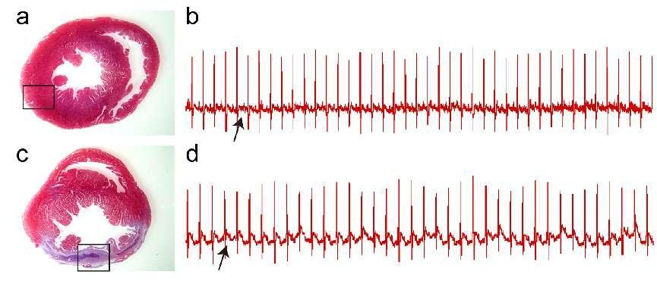
Supplementary Fig.1
The success of MI model
- b. Representative image of hearts stained with Masson’s Trichrome and electrocardiogram image in the sham groups.
c-d. Representative image of hearts stained with Masson’s Trichrome and electrocardiogram image in the MI groups.
MI: Myocardial infarction.
Supplementary Fig.2
- Flow cytometry image of M0 macrophages.
- Flow cytometry image of M1 macrophages.
- The percentage of M0 macrophages that had been converted into M1 macrophages.
Data are presented as the mean ± SD. *P<0.05 vs. con. SD：standard deviation.

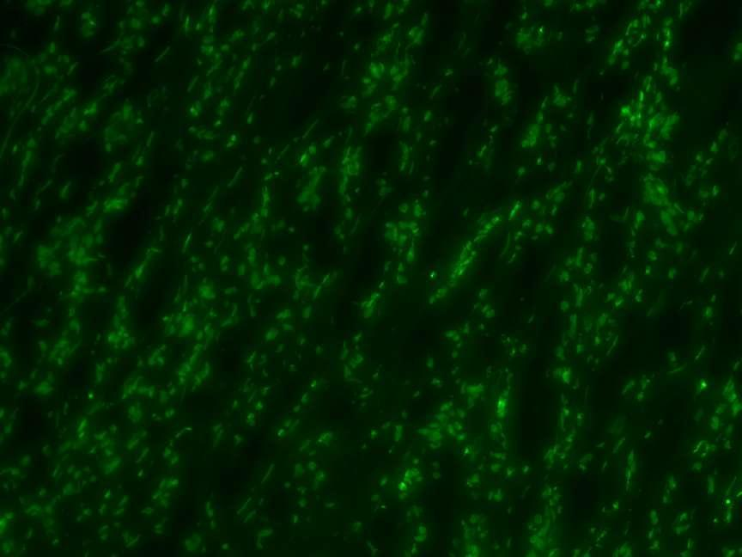
Supplementary Fig.3
Fluorescent microscopic image showing GFP expression, indicating that the lentivirus could be efficiently delivered in vivo via heart injection after 1 week.

