Supplementary Information

A facile and on-demand optimizing strategy for polyurethane elastomers via programmable hydrogen bonding
Zichen Bai¹, Xiaodong Li¹, Tianhao Wu¹, Hao Jiang¹, Xudong Zhang², Lichen Zhang¹, Yi Yang1, Shuang Liu¹, Lisha Lei¹, Ningning Song¹, Zhengdi Wang¹, Xing Su¹* and Meishuai Zou¹*
1 School of Materials Science and Engineering, Beijing Institute of Technology, No. 5 South Zhongguancun Street, Haidian District, Beijing, 100081, China
2 Shandong AOZO New Materials Co., Ltd., Tengzhou, 277524, China
* Corresponding authors: Xing Su and Meishuai Zou
Corresponding authors’ e-mail: sx1020@126.com (X. Su),
zoums@bit.edu.cn (M. Zou).

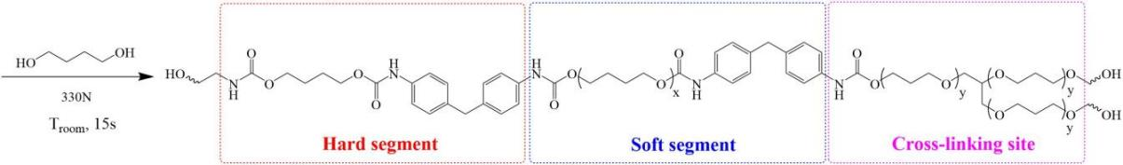
Figure S1 The synthesis and microstructure of the polyurethane matrix (PUE)

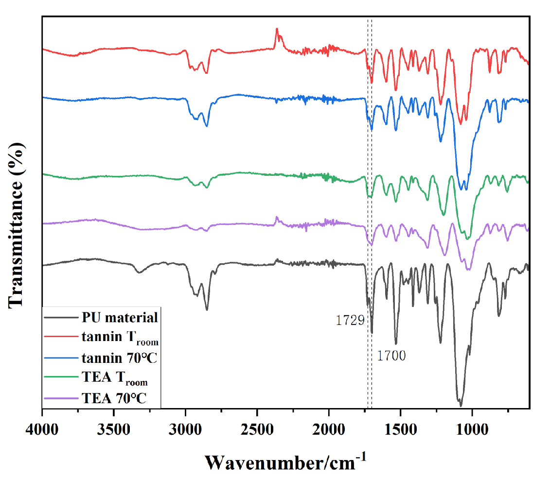
Figure S2 FTIR spectra of PUE, TA/PUE, 70-48-TA/PUE, EG/PUE, 70-48-EG/PUE samples at the wavelength between 4000 to 600 cm⁻¹.

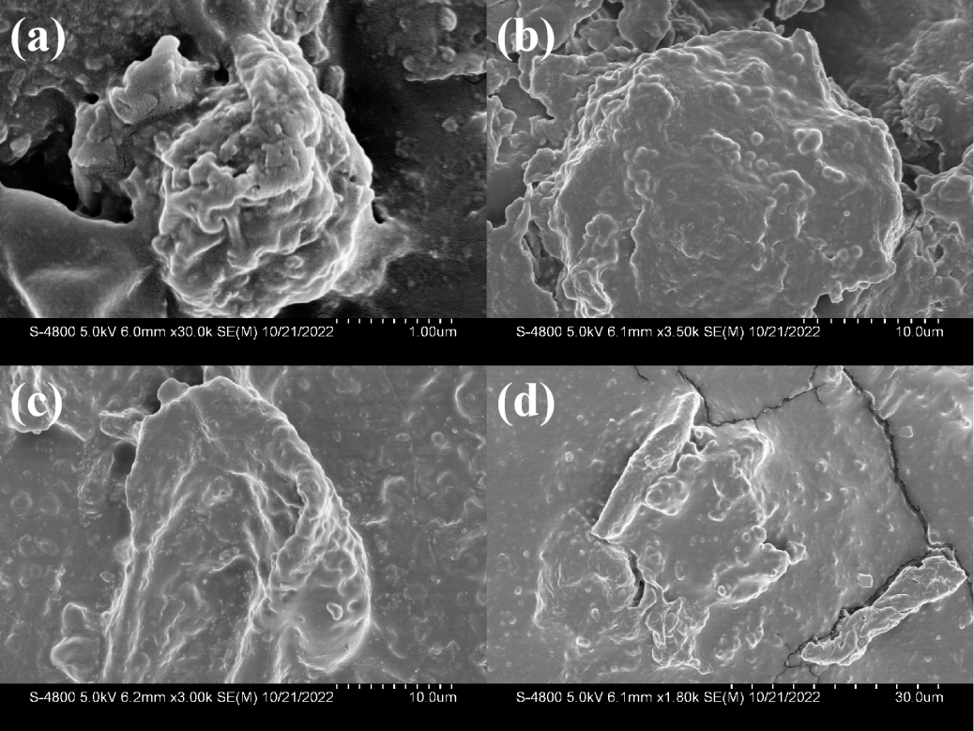
Figure S3 The SEM images of the cross-sectional area for (a) EG/PUE, (b) 70-48-EG/PUE, (c) TA/PUE, (d) 70-48-TA/PUE.

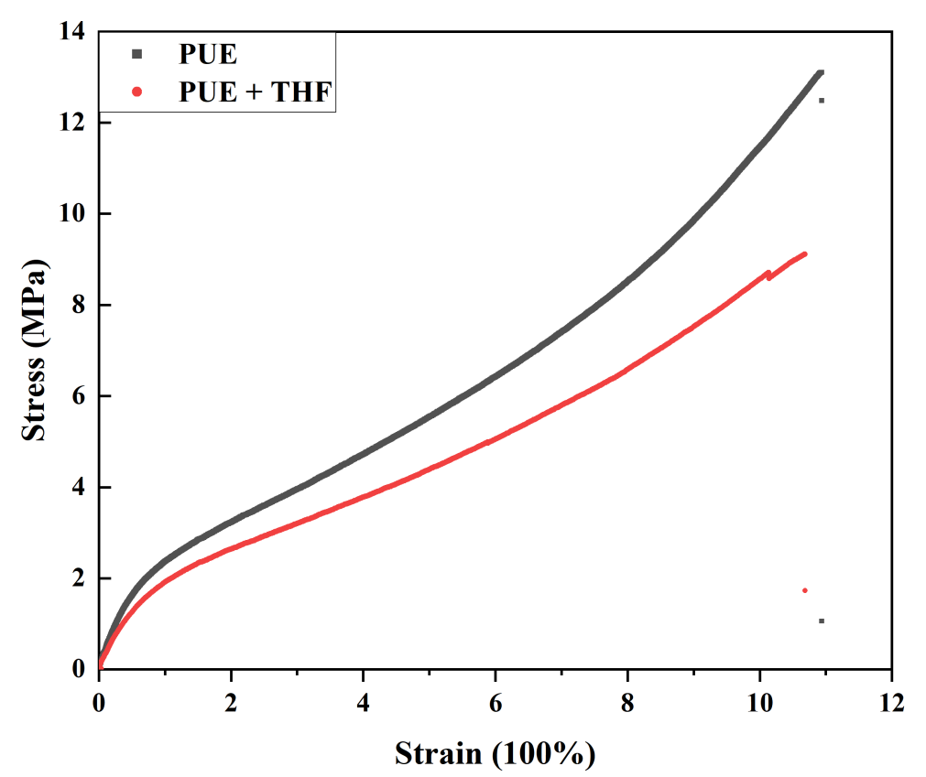
Figure S4 The representative stress-strain curves for PUE and PUE soaked in THF solution for 12 h.

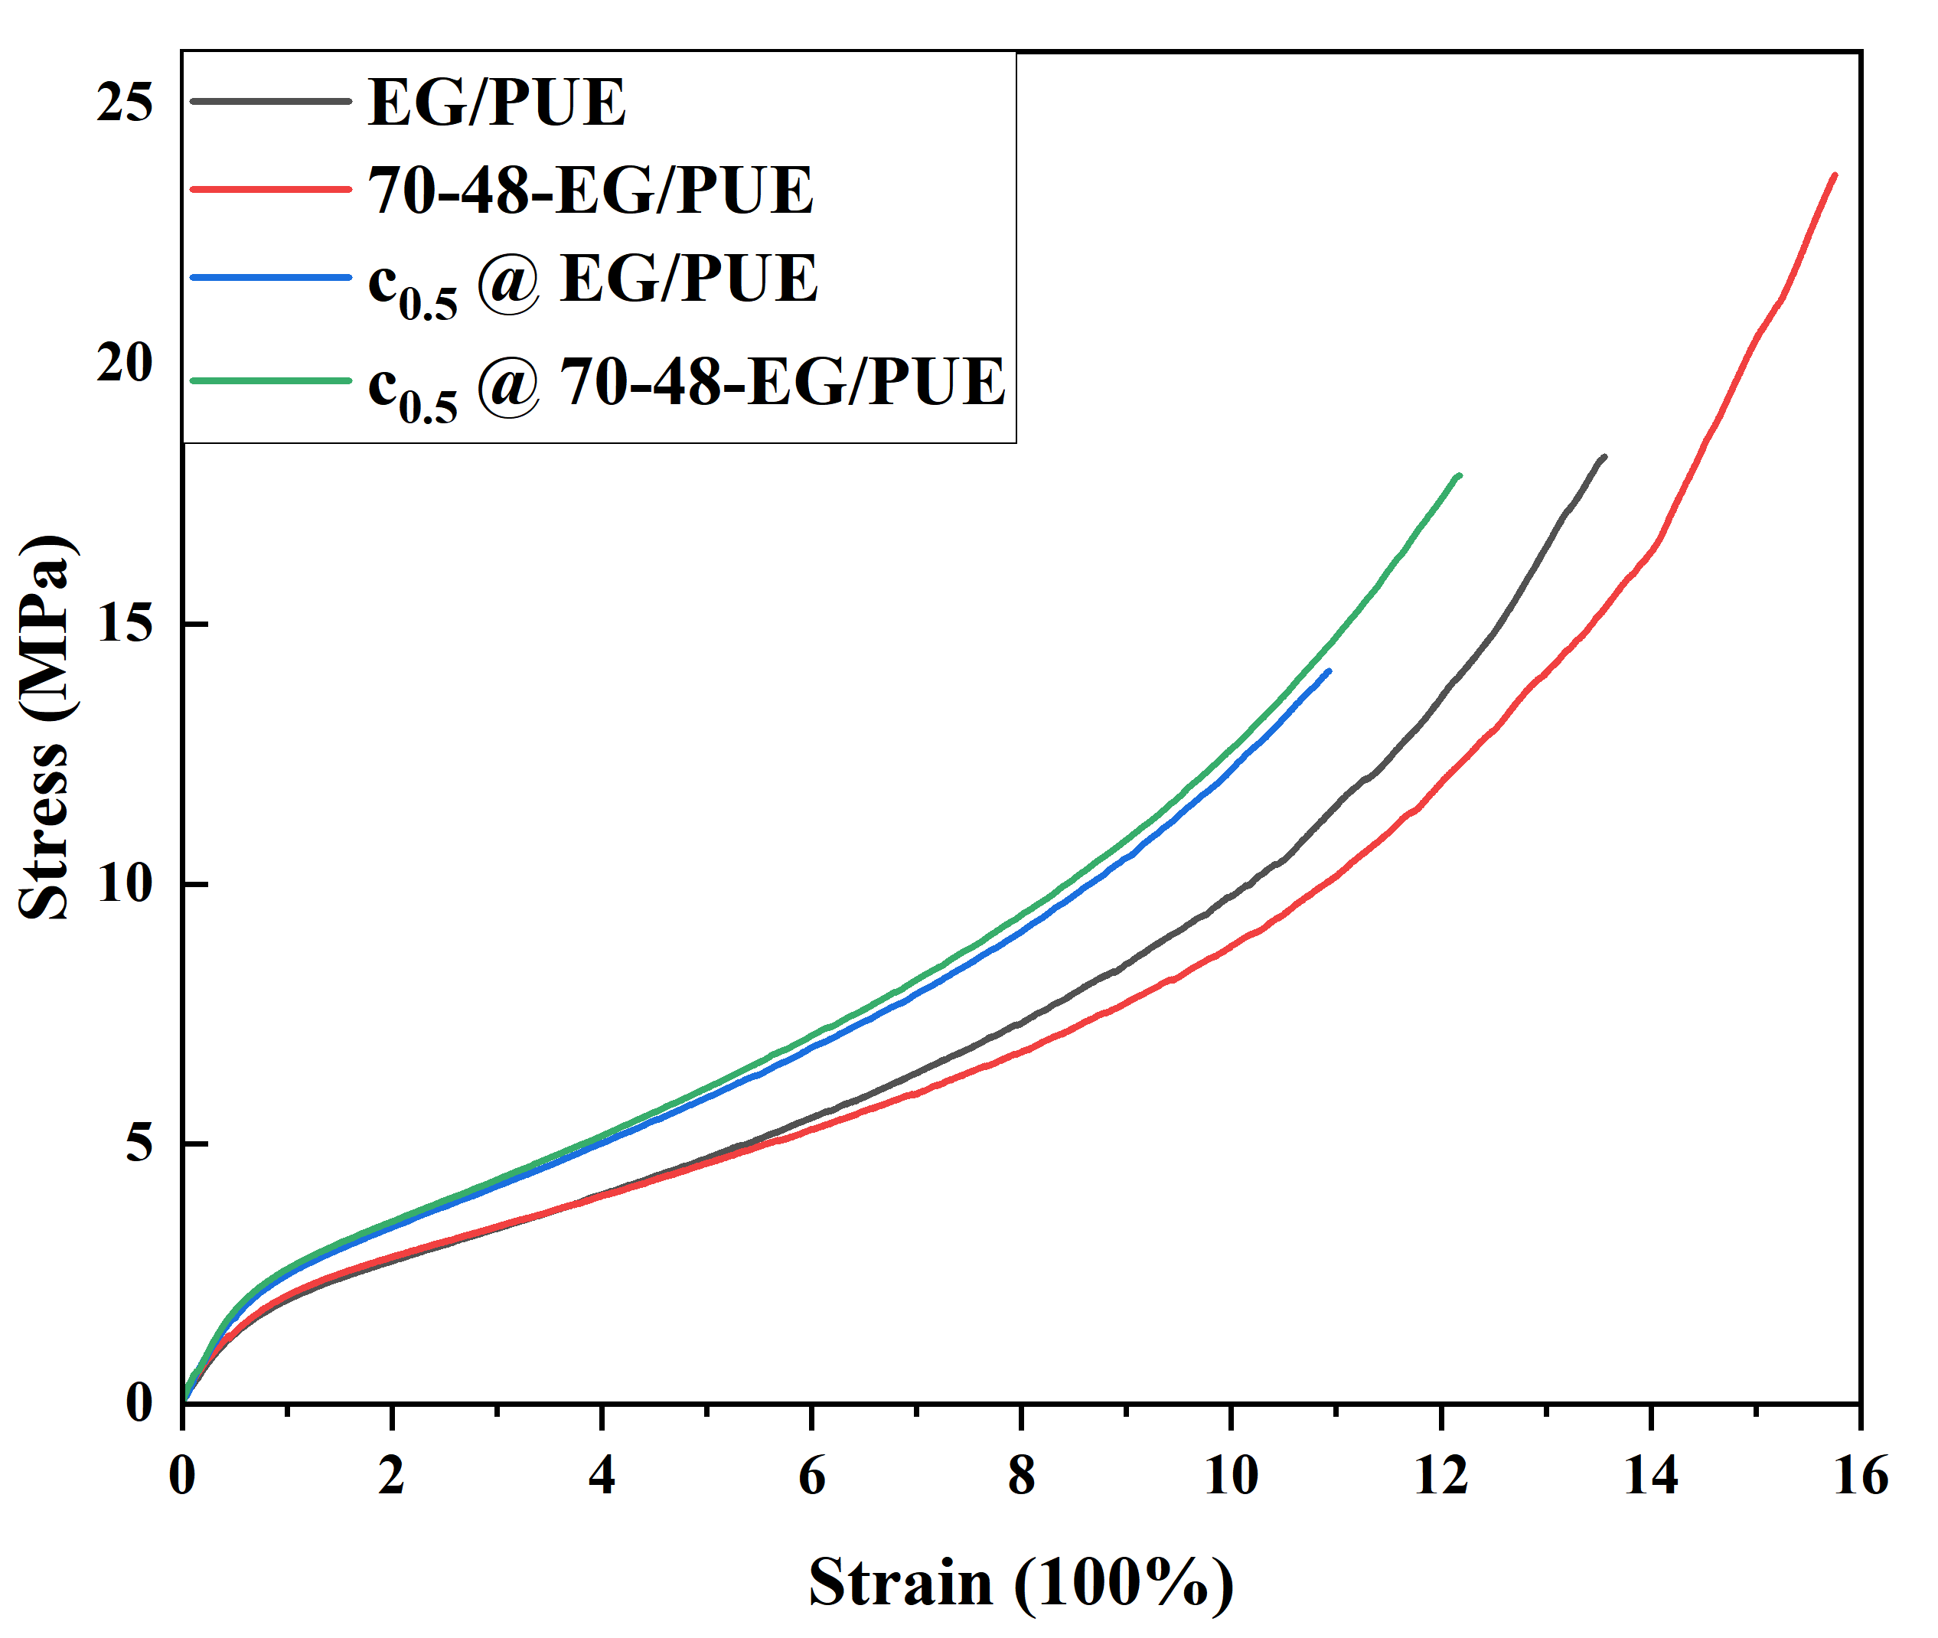
Figure S5 The representative stress-strain curves of EG/PUE , 70-48-EG/PUE, the half concentration of polyphenol solution treated EG/PUE and the half concentration of polyphenol solution treated 70-48-EG/PUE.

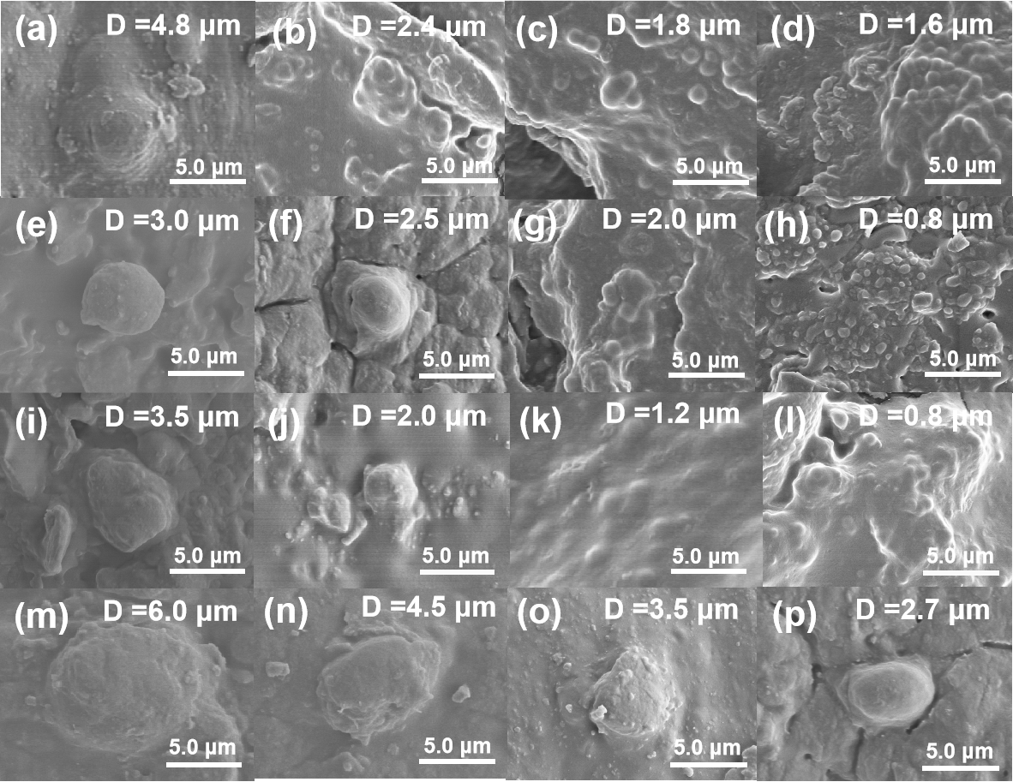
Figure S6 The SEM images of (a) 40-48-TA/PUE, (b) 50-48-TA/PUE, (c) 60-48-TA/PUE, (d) 70-48-TA/PUE, (e) 40-48-EG/PUE, (f) 50-48-EG/PUE, (g) 60-48-EG/PUE, (h) 70-48-EG/PUE, (i) EG/PUE, (j) 70-1-EG/PUE, (k) 70-9-EG/PUE, (l) 70-18-EG/PUE, (m) TA/PUE, (n) 70-1-TA/PUE, (o) 70-9-TA/PUE, (p) 70-18-TA/PUE

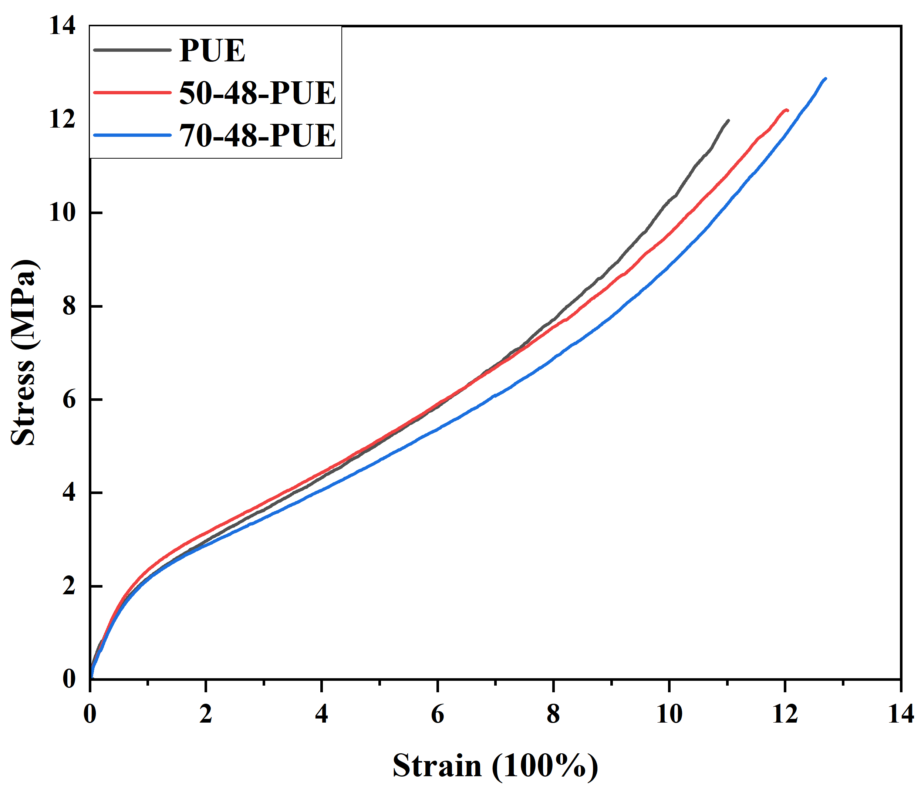
Figure S7 The representative stress-strain curves of PUE samples treated under different temperature(25, 50, 70 ℃) for a period of 48 h

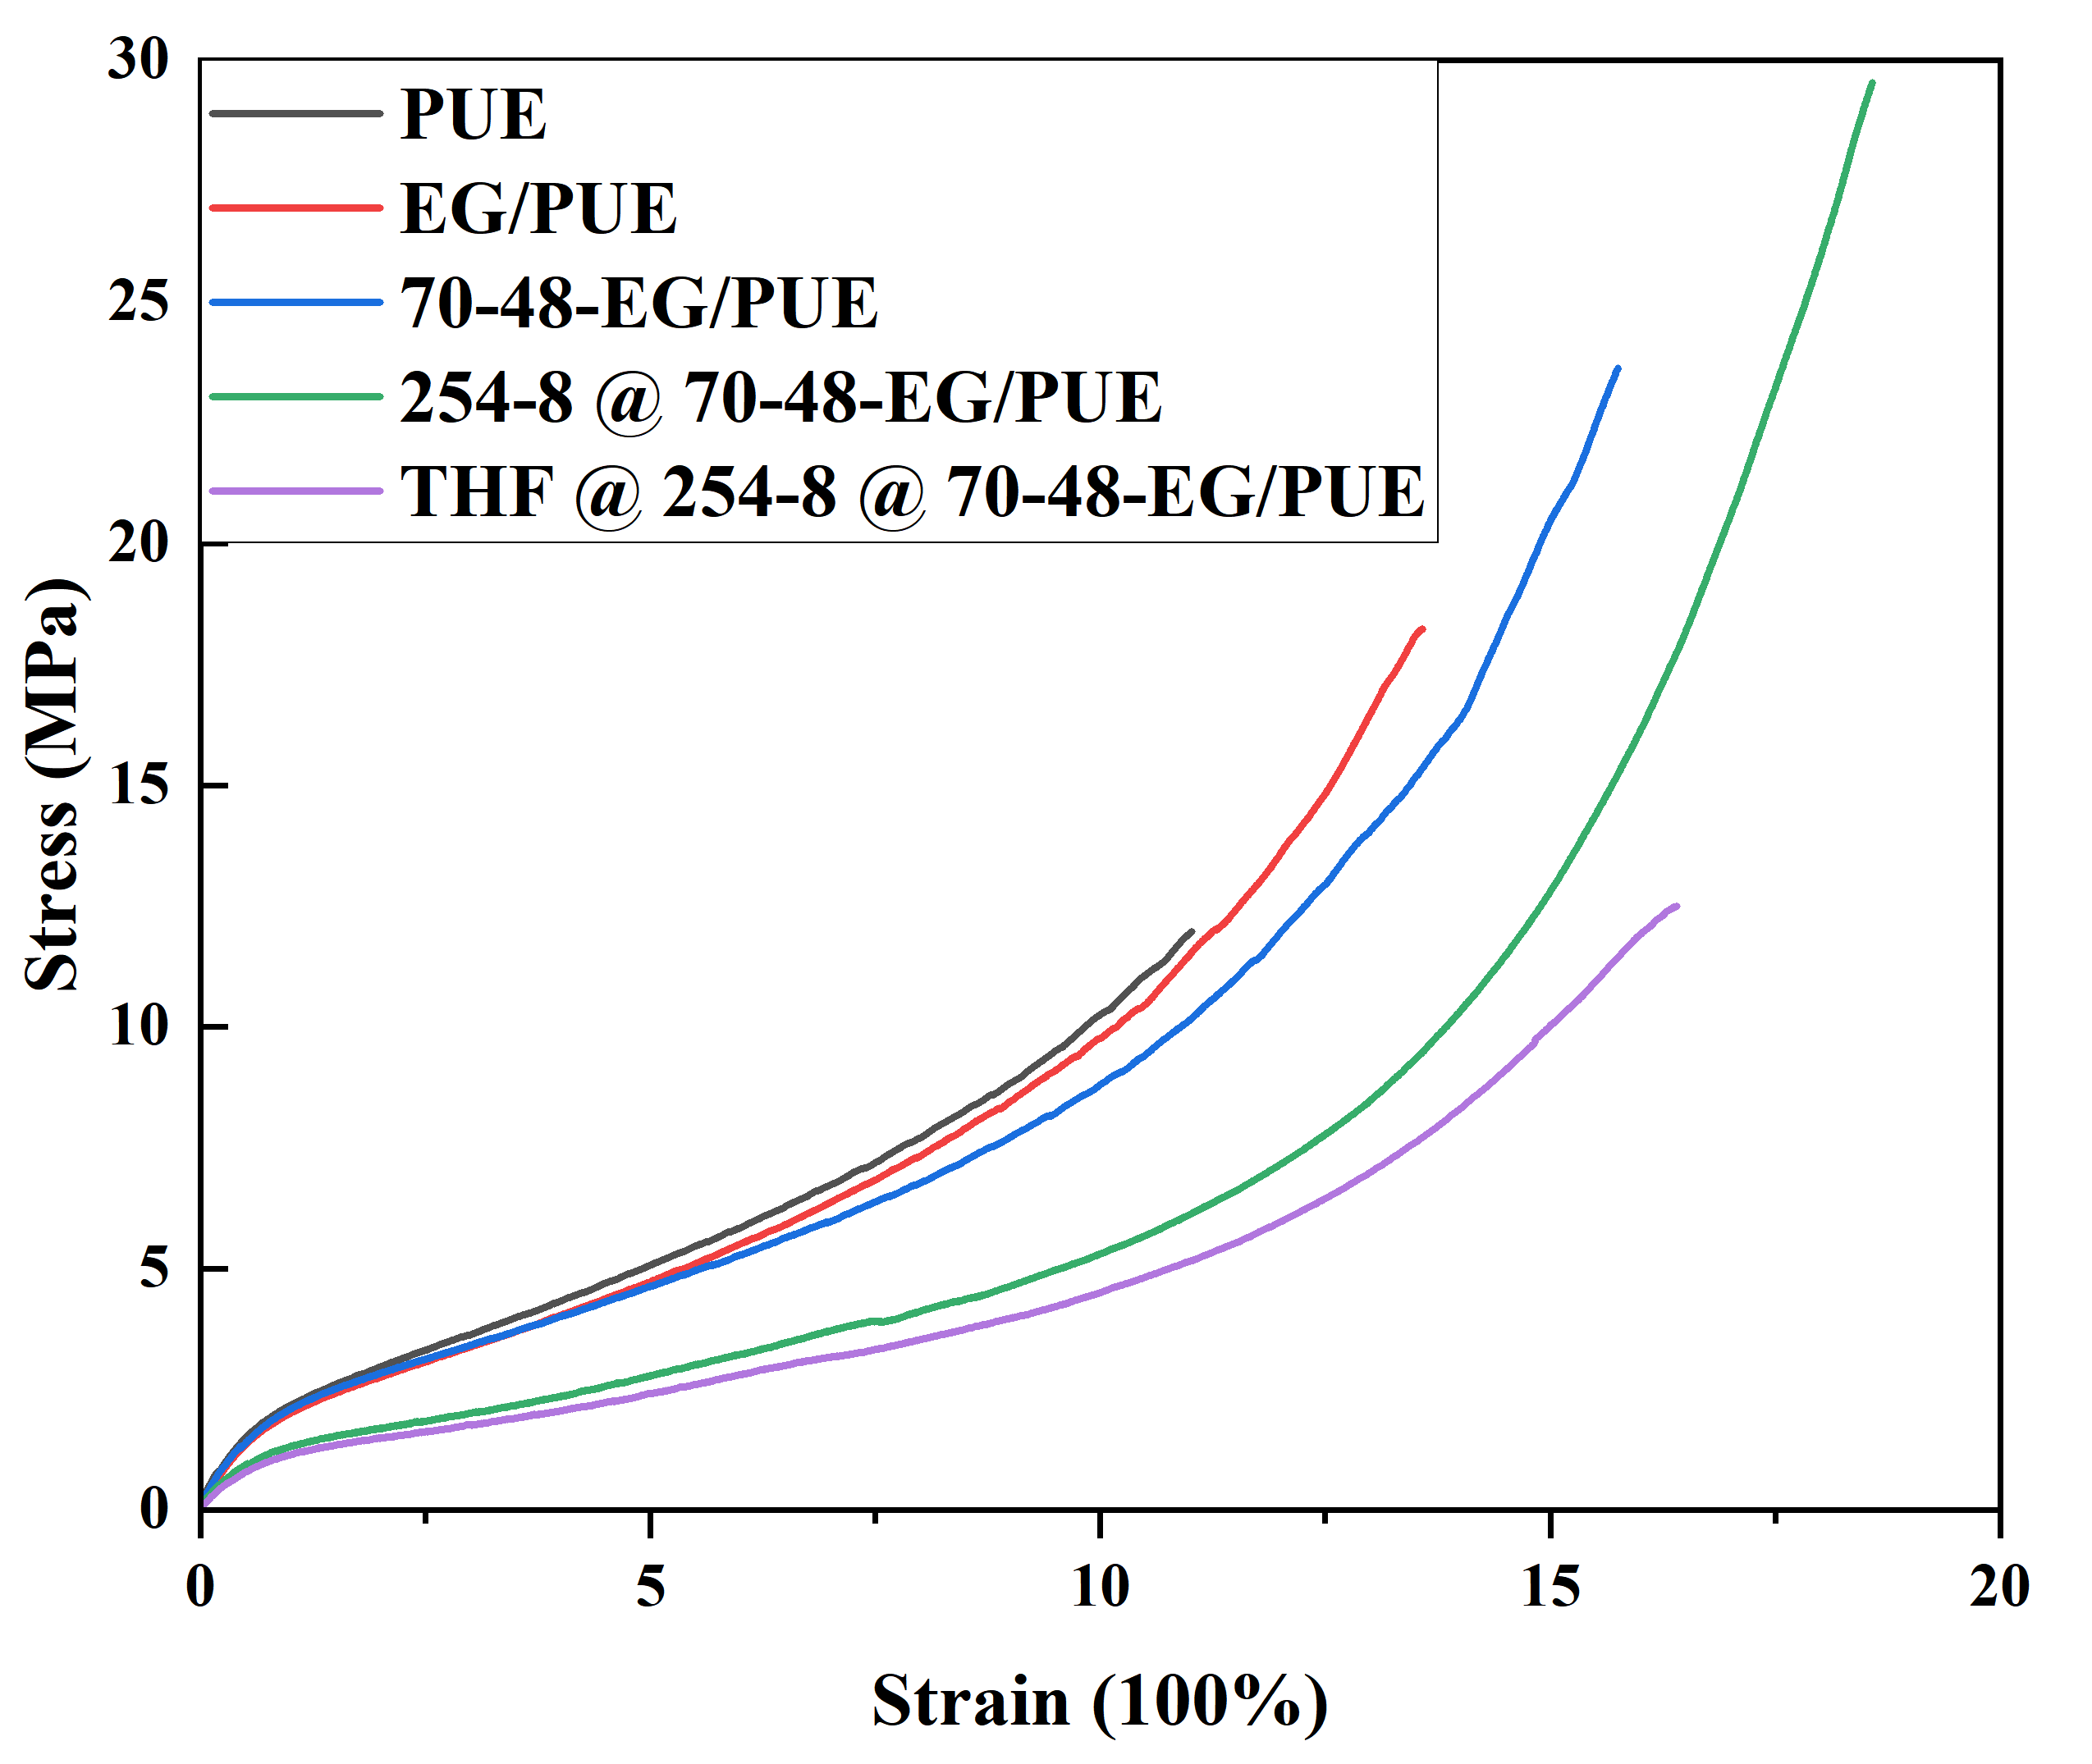
Figure S8 The representative stress-strain curves of PUE, EG/PUE, 70-48-EG/PUE, 254-8@70-48-EG/PUE and 254-8@70-48-EG/PUE soaked in THF solution for 24 h.

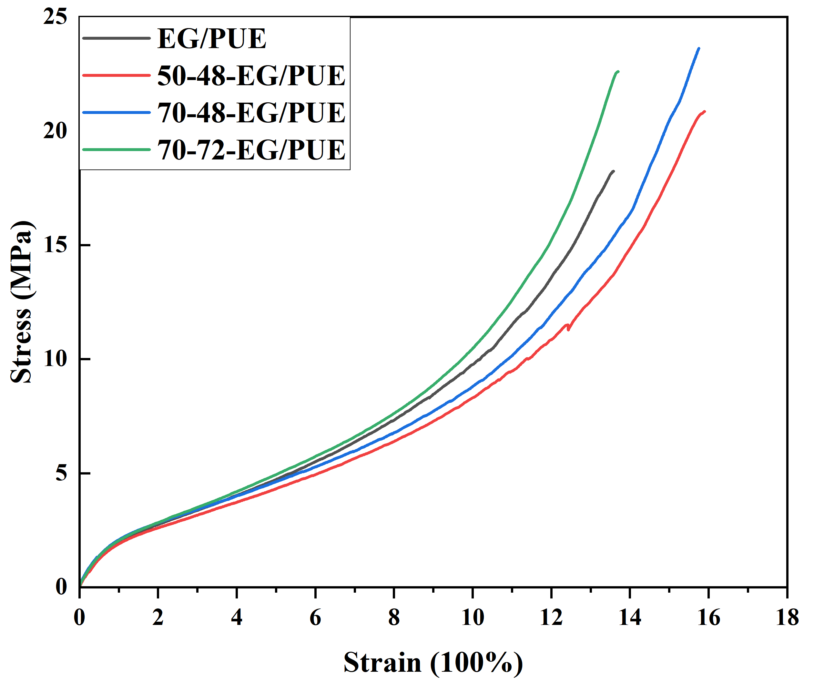
Figure S9 The representative stress-strain curves of EG/PUE, 50-48-EG/PUE, 70-48-EG/PUE and 70-72-EG/PUE samples, which indicates the greatest heat treatment temperature.

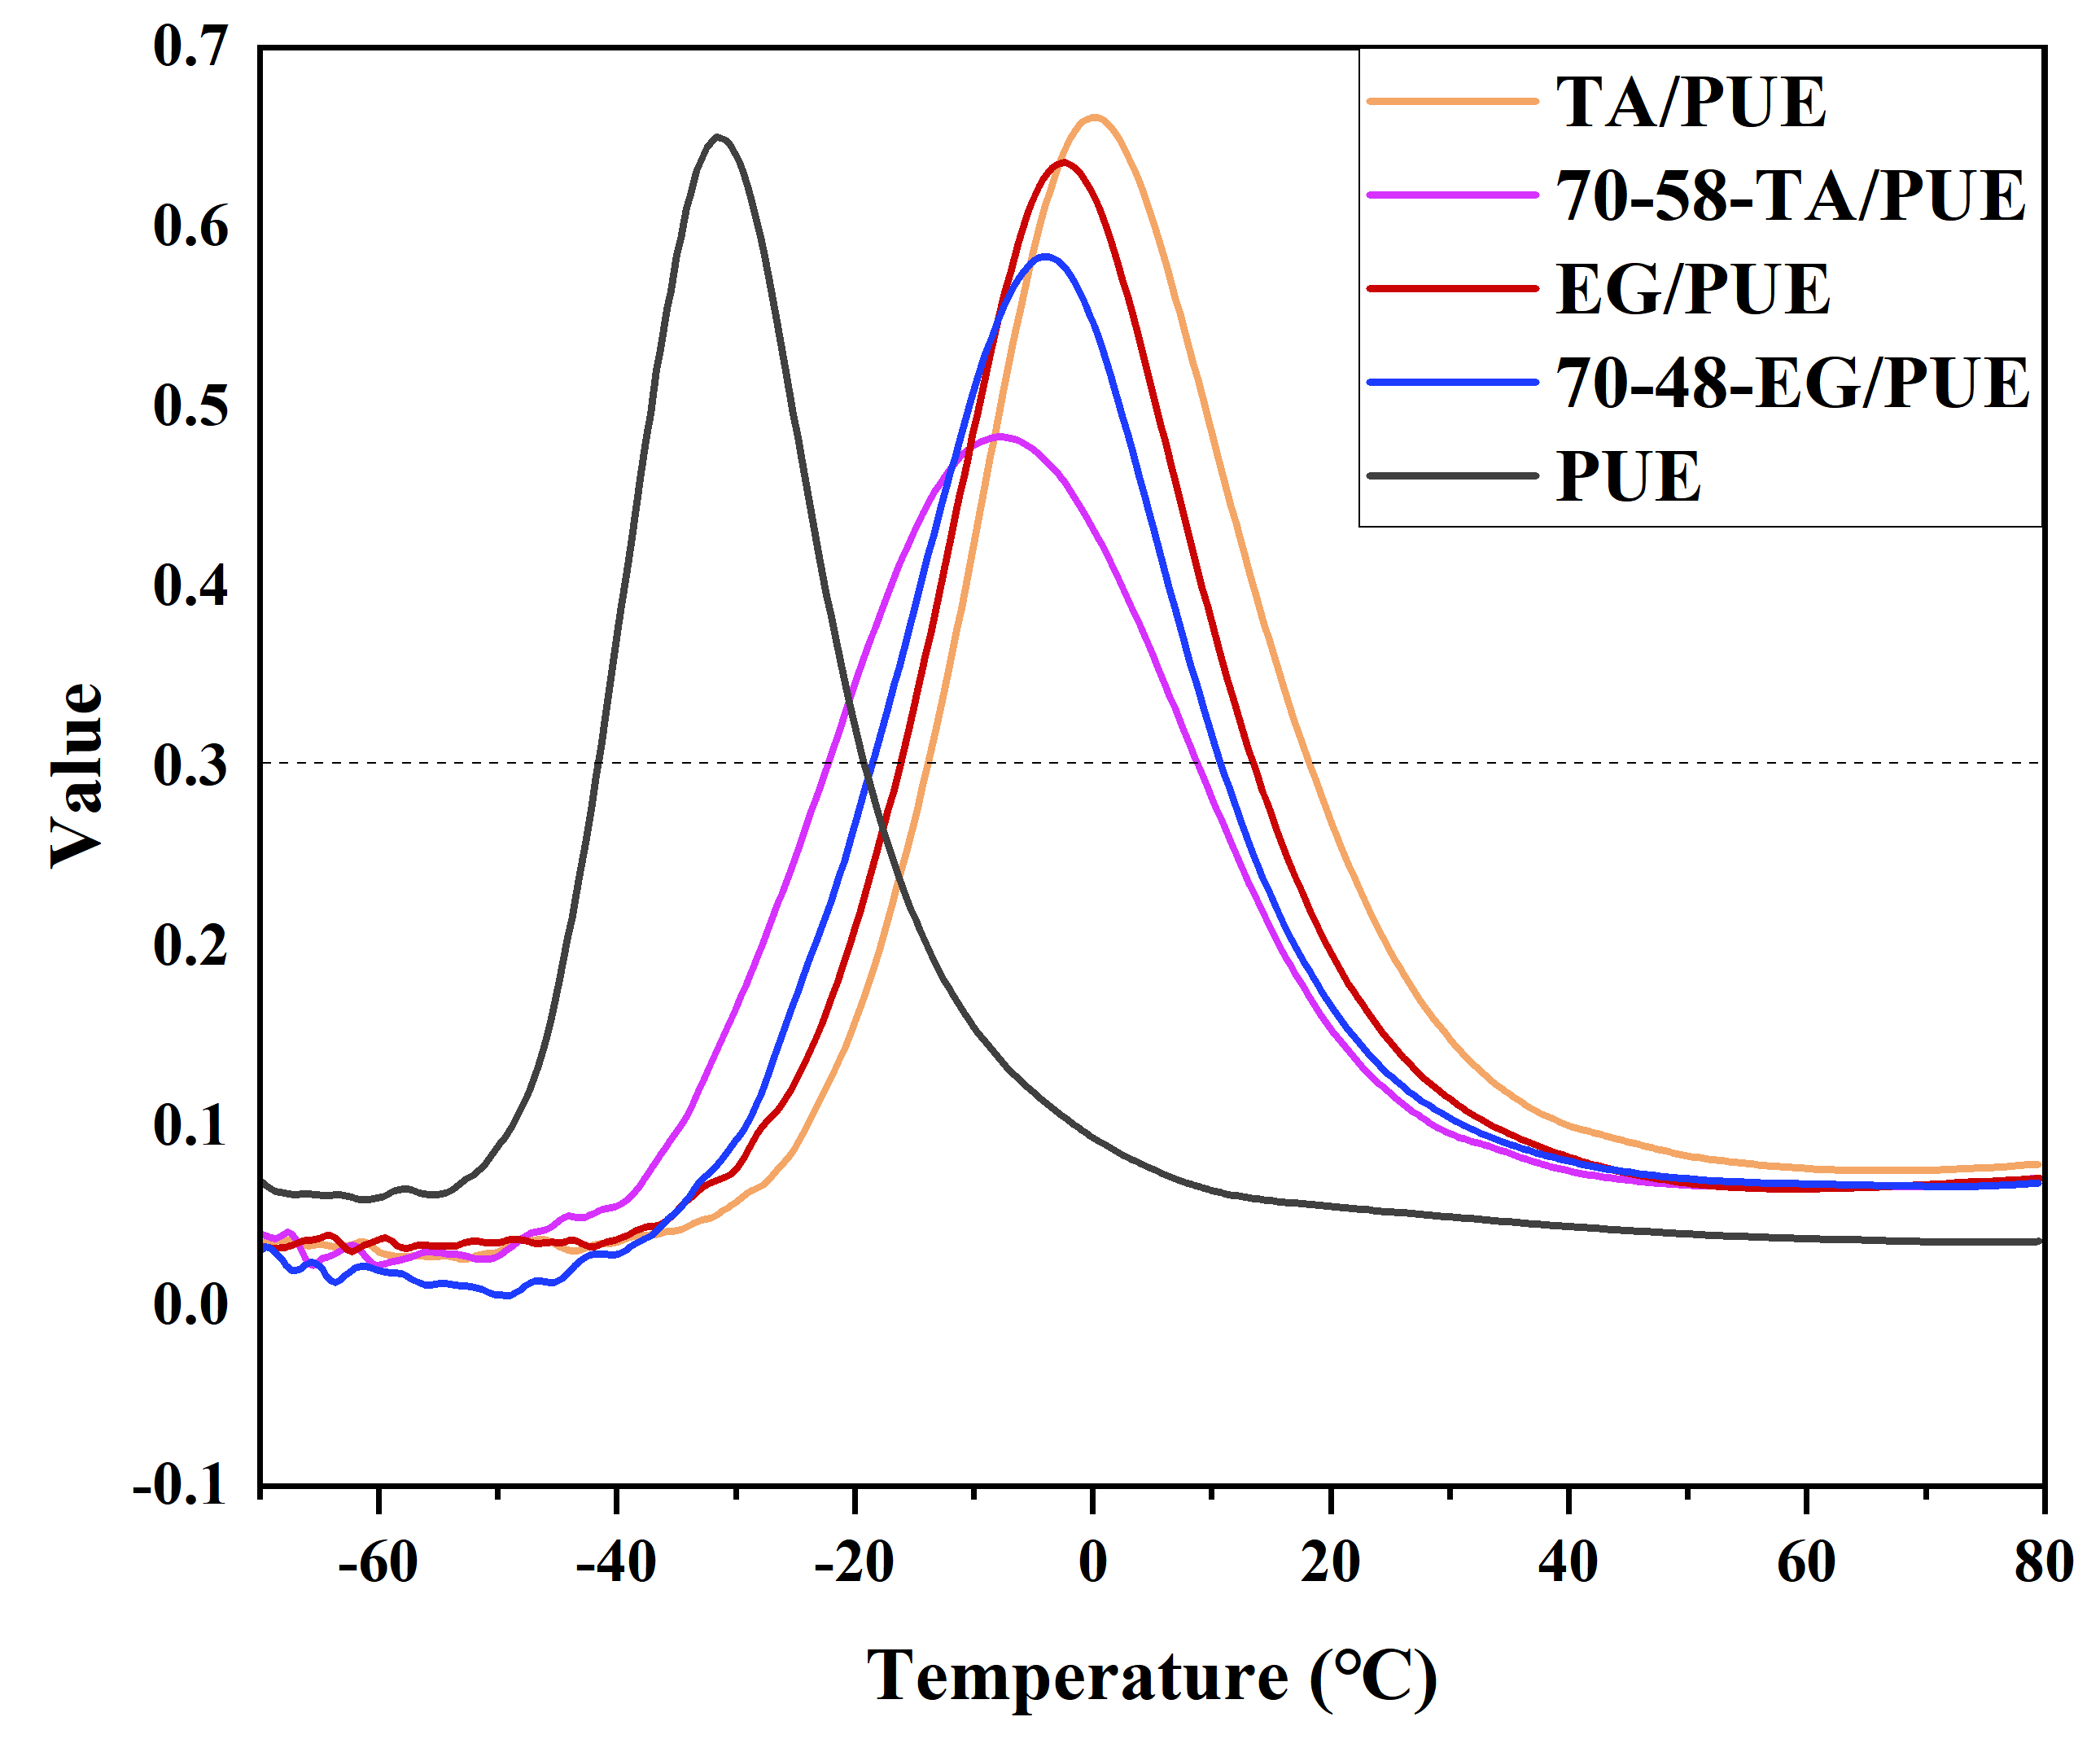
Figure S10 The DMA curves (tanσ, Y-axis: damping factor) of PUE, TA/PUE, 70-48-TA/PUE, EG/PUE and 70-48-EG/PUE.

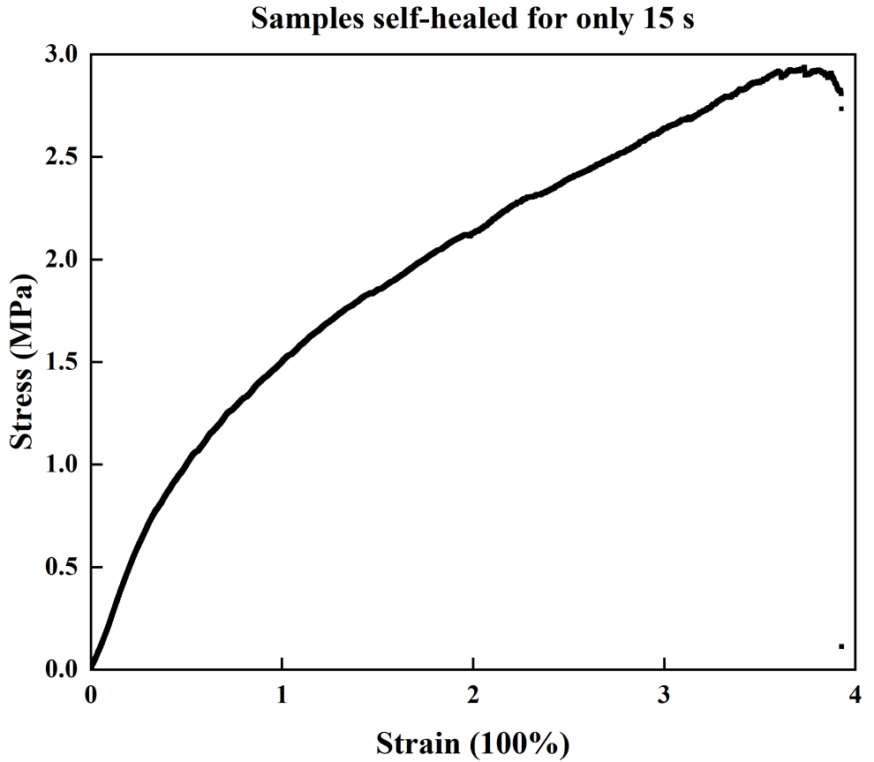
Figure S11 A typical stress-strain curve of polyphenol/PUE sample after a self-healing period for only 15 s.

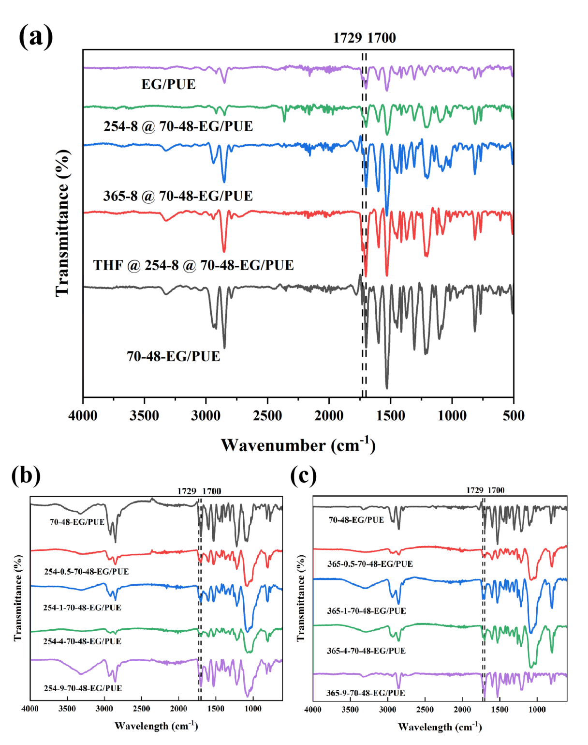
Figure S12 The FTIR spectra of (a) EG/PUE, 70-48-EG/PUE, 254-8-70-48-EG/PUE, 365-8-70-48-EG/PUE samples and 365-8-70-48-EG/PU soaked in THF solution for 24 h samples at the wavelength between 4000 to 500 cm⁻¹. The FTIR spectra of 70-48-EG/PUE exposed under UV radiation for 0 h, 0.5 h, 1 h, 4 h, 9 h under the UV wavelength of (b) 254 nm, (c) 365 nm.

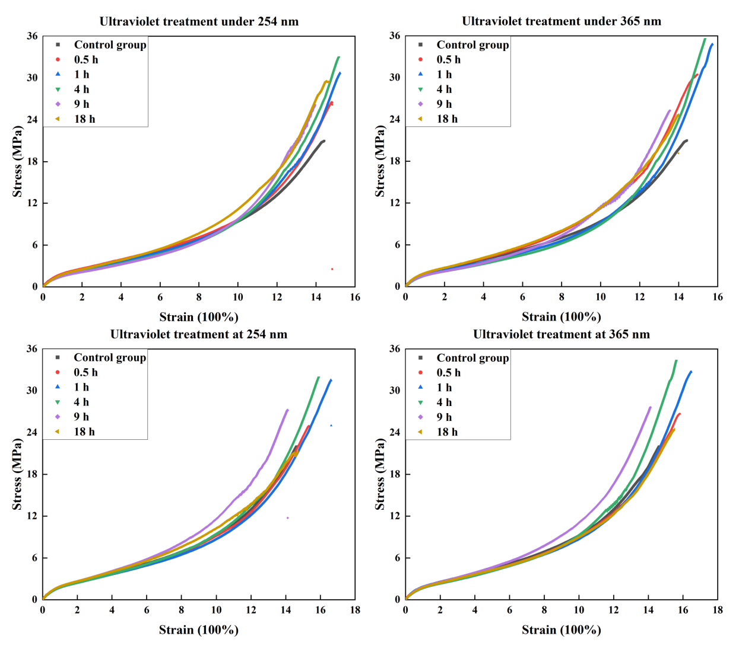
Figure S13 The representative stress-strain curves of heated samples radiated under the different wavelength of ultraviolet light for a period of time (0, 0.5, 1, 4, 9, 18 h): (a) 70-48-EG/PUE under 254 nm, (b) 70-48-EG/PUE under 365 nm, (c) 70-48-TA/PUE under 254 nm, (d) 70-48-TA/PUE under 365 nm

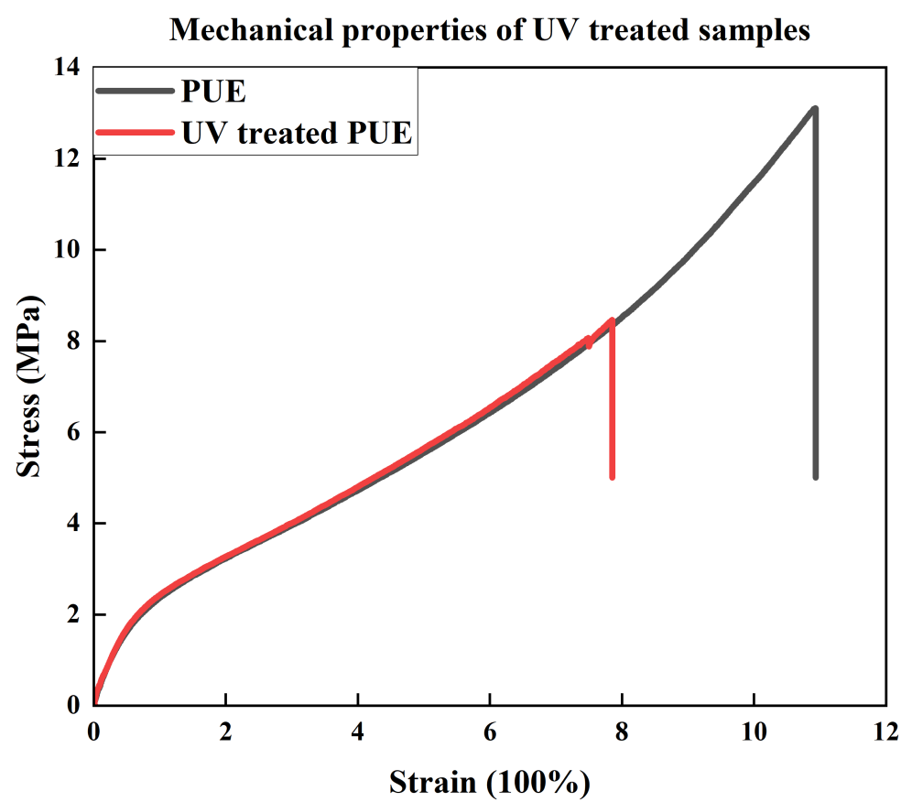
Figure S14 A representative stress-strain curve of PUE samples treated with UV radiation at wavelength of 254 or 365 nm.

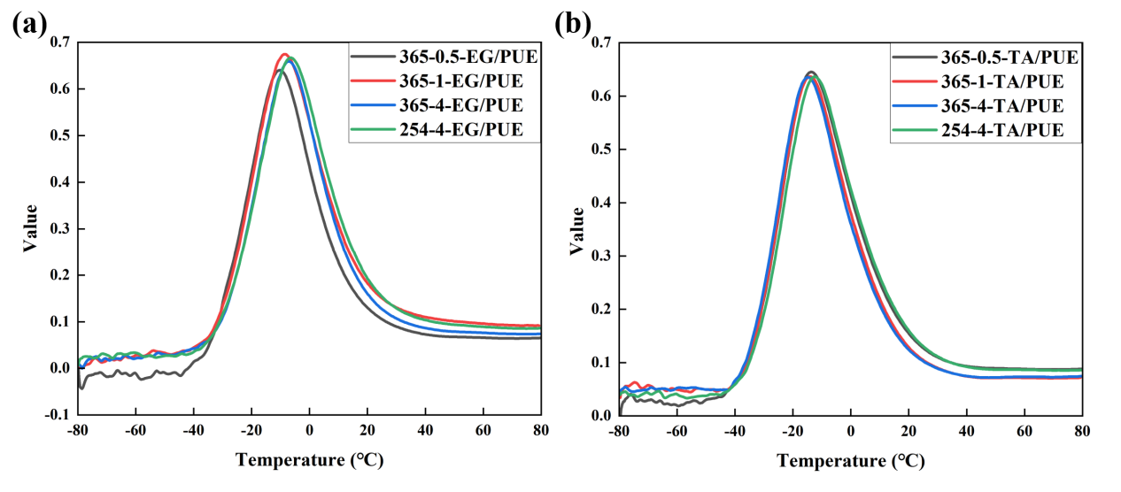
Figure S15 The DMA curves (tanσ, Y-axis: damping factor) of (a) 70-48-EG/PUE samples radiated ultraviolet light for a period of time(0.5, 1, 4 h), (b) 70-48-TA/PUE samples radiated ultraviolet light for a period of time(0.5, 1, 4 h).

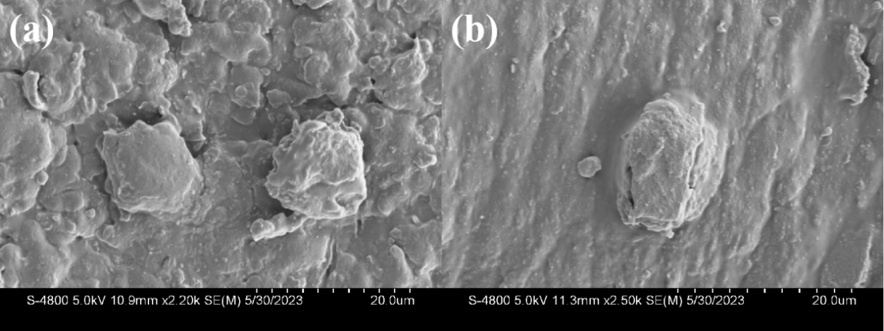
Figure S16 The FESEM images of EG/PUE samples before and after the UV radiation process. The size of polyphenol aggregates were hardly changed before and after UV radiation.

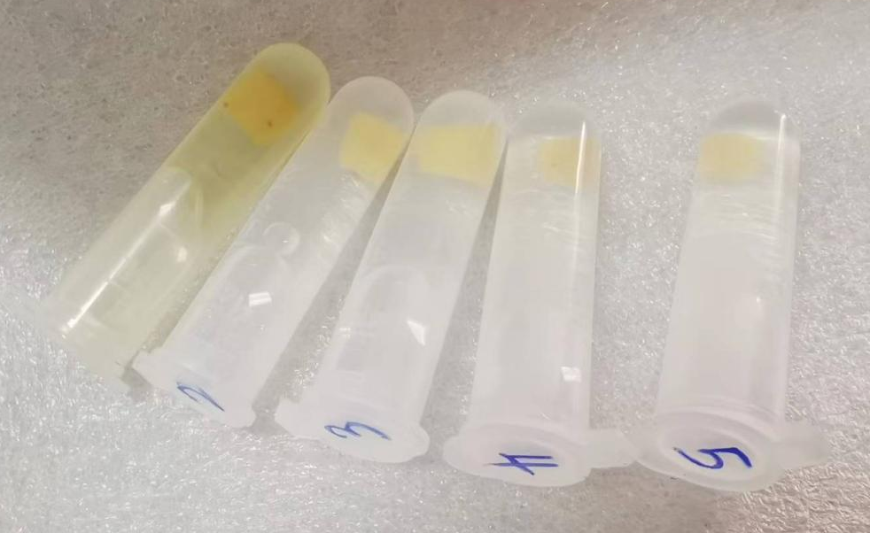
Figure S17 TA/PUE samples were soaked in solutions with different pH environment (a) pH= 12.38, (b) pH= 7.81, (c) pH= 6.97, (d) pH= 5.31, (e) pH= 1.09, which indicated the strong alkaline environment was able to remove polyphenols from the polyphenol/PUE systems.

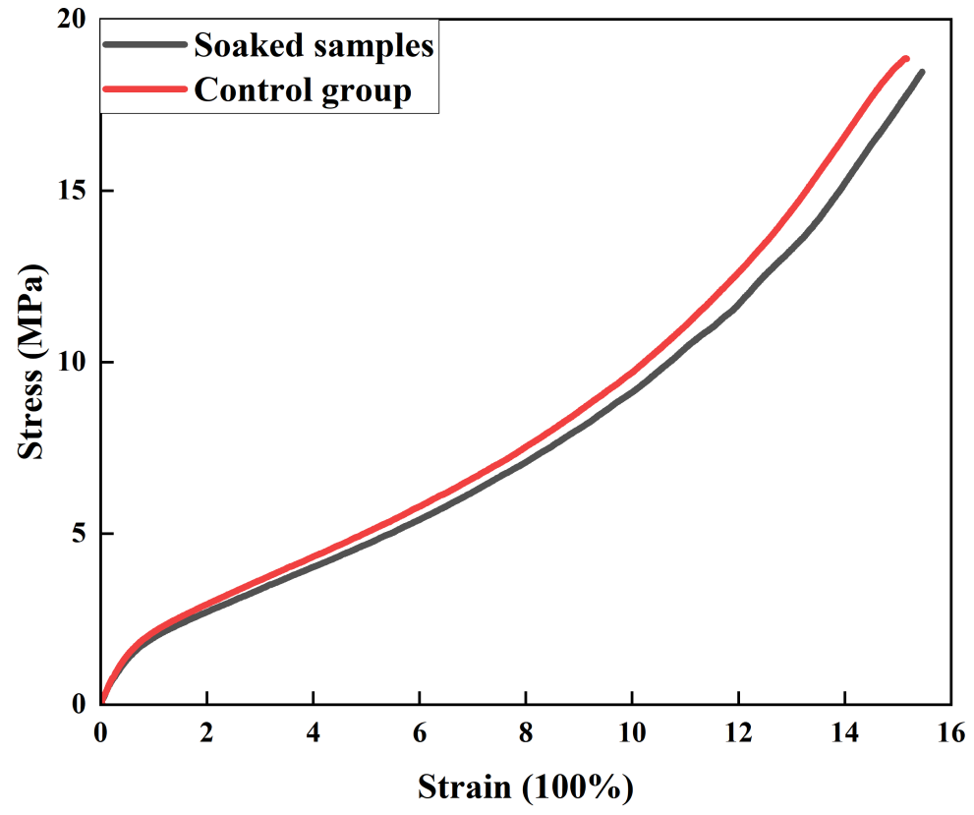
Figure S18 A representative stress-strain curve for PUE samples soaked in deionized water for a week

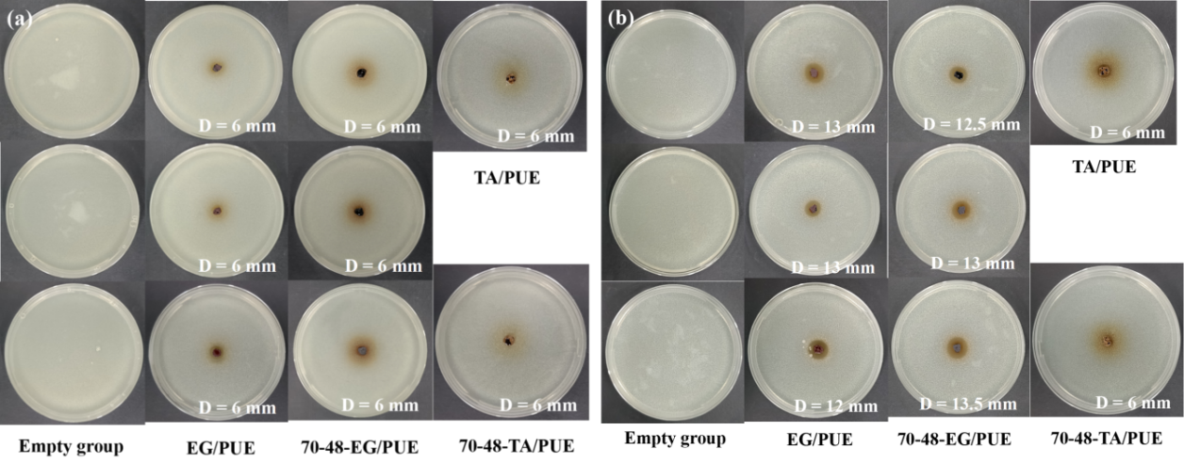
Figure S19 The image of bacteriostatic zones formed by EG/PUE, 70-48-EG/PUE, TA/PUE, 70-48-TA/PUE and empty group samples in (a) E.coil environment, (b) S.aureus environment, where D is diameter of bacteriostatic zone. The diameters of the tested samples mentioned in our work is 6 mm.

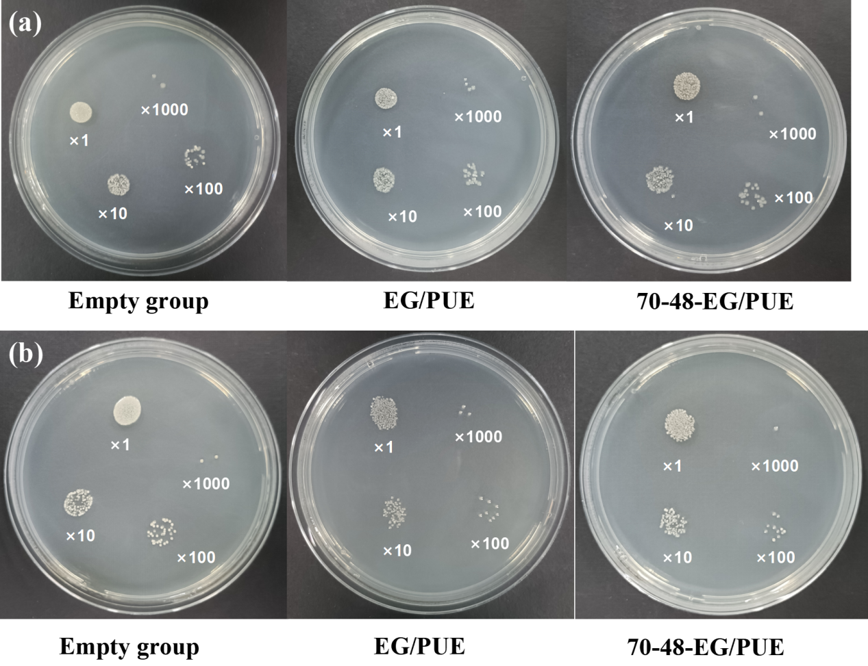
Figure S20 The image of spread plate method by soaking EG/PUE, 70-48-EG/PUE and empty group in (a) E.coil environment, (b) S.aureus environment with different concentrations (×1, ×10, ×100 or ×1000).

Sample | pH=12.38 | pH=7.81 | Deionized water(pH=6.97)
Average mass change fraction of TA/PUE (%) | 7.89 (±1.12) | 3.00 (±1.12) | 1.71 (±1.12)
Average mass change fraction of EG/PUE (%) | 3.83 (±0.25) | 1.20 (±1.18) | 0.27 (±0.03)

Sample | Deionized water(pH=6.97) | pH=5.31 | pH=1.09
Average mass change fraction of TA/PUE (%) | 1.71 (±1.12) | 1.93 (±0.13) | 2.31 (±0.18)
Average mass change fraction of EG/PUE (%) | 0.27 (±0.03) | 0.97(±0.01) | 0.29 (±0.10)
Table S1 The average results of the mass change of TA/PUE and EG/PUE samples soaked in the solution at different pH values for a week.

Sample | Average percentage of polyphenol (%)
TA/PUE | 12.21
EG/PUE | 21.54
Table S2 The results of mass content for polyphenols inside polyphenol/PUE samples by soaking PUE samples in saturated solution of polyphenols.

Sample | Element content of Na (%)
Diffused TA sodium salt from TA/PUE (pH=8) | 2.63
Diffused EG sodium salt from EG/PUE (pH=8) | 0.73
Table S3 The element content of Na in the TA/EG sodium salts (pH=8) by ICP equipment.

