Cyanophage distribution across European lakes of the temperate-humid continental climate zone assessed using PCR-based genetic markers

Aleksandra Jaskulska^{1,2}, Sigitas Šulčius³, Mikołaj Kokociński⁴, Judita Koreivienė³, Arnoldo Font Nájera^{1, 2}, Joanna Mankiewicz-Boczek²

1 Department of UNESCO Chair on Ecohydrology and Applied Ecology, Faculty of Biology and Environmental Protection, University of Łódź, 12/16 Banacha, 90-237, Łódź, Poland

2 European Regional Centre for Ecohydrology of the Polish Academy of Sciences, 3 Tylna, 90-364, Łódź, Poland

3 Laboratory of Algology and Microbial Ecology, Nature Research Centre, 2 Akademijos, LT-08412 Vilnius, Lithuania.

4 Department of Hydrobiology, Adam Mickiewicz University, 6 Uniwersytetu Poznańskiego, 61-614 Poznań, Poland

Correspondence

Joanna Mankiewicz-Boczek, European Regional Centre for Ecohydrology of the Polish Academy of Sciences, 3 Tylna, 90-364, Łódź, Poland. Email j.mankiewicz@erce.unesco.lodz.pl

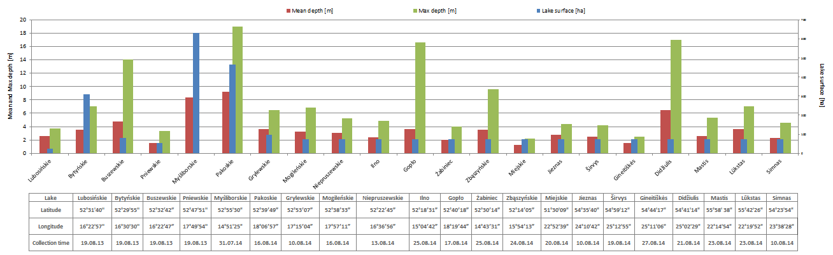
Fig. S1 Basic information about investigated site eg. mean and max lakes depth, lakes surface, lakes latitude, lakes longitude, collection time
Table S1 Physicochemical parameters and cyanobacterial composition in studied lakes.

Country | Lakes | Trophic state | pH | Cond [uS*cm¹⁻] | Temp [°C] | TN [mg*l¹⁻] | TP [mg*l¹⁻] | TN:TP ratio | CYAN [mg l⁻¹] | Dominant cyanobacteria and their biomass [mg L⁻¹]*
Poland | LUB | eutrophic | 8.81 | 676.20 | 23.20 | 1.55 | 0.470 | 3 | 40.47 | Planktothrix agardhii 38.33
Poland | BYT | eutrophic | 8.56 | 729.10 | 22.60 | 2.20 | 0.160 | 14 | 2.51 | Microcystis aeruginosa 1.35
Poland | BUS | eutrophic | 8.78 | 588.10 | 23.30 | 2.29 | 0.250 | 9 | 13.30 | Aphanizomenon gracile 5.32, Limnothrix redekei 2.13,  Limnothrix sp. 2.20, Planktothrix agardhii 1.85
Poland | PNI | eutrophic | 8.65 | 587.10 | 23.70 | 1.96 | 0.310 | 6 | 6.51 | Aphanizomenon gracile 2.28, Raphidiopsis raciborskii 1.43, Jaaginema subtilissimum 0.69, Limnothrix redekei 0.91
Poland | MYS | eutrophic | 8.50 | 593.60 | 25.10 | 1.70 | 0.150 | 11 | 0.10 | Aphanizomenon flos-aquae 0.09
Poland | PAL | eutrophic | 9.00 | 555.60 | 21.70 | 1.85 | 0.160 | 12 | 8.25 | Planktothrix agardhii 6.81
Poland | GRY | eutrophic | 8.50 | 680.10 | 27.00 | 1.05 | 0.060 | 18 | 0.38 | Raphidiopsis raciborskii 0.06, Jaaginema subtilissimum 0.14, Synechococcus salinarum 0.15
Poland | MOG | eutrophic | 7.40 | 596.80 | 21.60 | 2.45 | 0.020 | 123 | 13.70 | Planktothrix agardhii 10.75
Poland | NIE | eutrophic | 8.60 | 681.70 | 23.60 | 7.50 | 0.130 | 58 | 2.73 | Chrysosporum bergii 0.37, Jaaginema subtilissimum 0.55, Limnothrix vacuolifera 0.83, Planktolyngbya limnetica 0.33
Poland | ILN | eutrophic | 8.30 | 449.20 | 19.20 | 1.10 | 0.130 | 8 | 0.04 | Jaaginema subtilissimum 0.01, Limnothrix redekei 0.04
Poland | GOP | eutrophic | 7.50 | 537.40 | 22.30 | 2.35 | 0.020 | 118 | 13.85 | Planktothrix agardhii 8.58, Pseudanabaena limnetica 1.46
Poland | ZAB | eutrophic | 8.80 | 370.20 | 17.50 | 3.00 | 0.240 | 13 | 2.93 | Dolichospermum lemmermannii 0.42, Dolichospermum planctonicum0.44, Aphanizomenon gracile 0.81, Microcystis sp. 0.57
Poland | ZBA | eutrophic | 9.00 | 618.50 | 17.20 | 2.80 | 0.060 | 47 | 37.48 | Planktothrix agardhii 36.35
Poland | MIE | eutrophic | 8.70 | 326.00 | 21.40 | 1.50 | 0.050 | 30 | 10.31 | Aphanocapsa sp. 1.38, Planktolyngbya limnetica 5.60, Radiocystis geminata 1.10
Lithuania | JIE | hypertrophic | 8.53 | 383.00 | 27.20 | 1.66 | 0.049 | 34 | 10.22 | Pseudanabaena limnetica 3.80, Planktolyngbya limnetica 3.41, Microcystis viridis 0.89, Aphanizomenon gracile 0.63
Lithuania | SIR | hypertrophic | 7.81 | 447.00 | 20.50 | 1.28 | 0.055 | 23 | 3.83 | Aphanizomenon gracile 0.47, Planktothrix agardhii 1.23, Pseudanabaena limnetica 0.73
Lithuania | GIN | eutrophic | 8.61 | 251.00 | 16.30 | 1.62 | 0.062 | 26 | 11,51 | Woronichinia naegeliana 2.47, Planktolyngbya limnetica 2.96, Aphanizomenon gracile 3.19
Lithuania | DID | hypertrophic | 8.20 | 397.80 | 19.70 | 1.22 | 0.048 | 25 | 5.08 | Aphanizomenon kelbanii 0.73, Planktolyngbya sp. 2.27, Pseudanabaena limnetica 0.89
Lithuania | MAS | hypertrophic | 8.40 | 334.00 | 17.00 | 1.15 | 0.160 | 7 | 6,13 | Snowella sp. 3.26, Woronichinia compacta 1.73
Lithuania | LUK | meso-  eutrophic | 8.50 | 276.80 | 17.00 | 0.85 | 0.038 | 22 | 2.97 | Planktolyngbya limnetica 0.47, Pseudanabaena limnetica 0.89, Woronichinia naegeliana 0.56
Lithuania | SIM | hypertrophic | 9.01 | 326.00 | 27.80 | 1.24 | 0.079 | 16 | 27.91 | Aphanizomenon gracile 5.99, Cuspidothrix issachenkoi 15.88
pH - water pH, Cond – water conductivity of water, Temp. - water temperature, TN - total nitrogen, TP - total phosphorus, CYAN - total biomass of cyanobacteria; *dominant cyanobacteria – indicated the strains which constituted 10% of total cyanobacteria biomass

TABLE S2 Sequences of primers used in presented study
Biotic element | Targeting gene | Primer sequence (5'-3') |  | Annealing temperature [°C] | Length (together with primer sequences) [bp] | References
Cyanobacteria | Cyanobacteria | 16SSF | CGGACGGGTGAGTAACGCGTG | 58 | 258 | 62
Cyanobacteria | 16S rRNA* | 16SSR | CCCATTGCGGAAAATTCCCC | 58 | 258 | 62
Cyanobacteria | Microcystis spp. | 209F | ATGTGCCGCGAGGTGAAACCTAAT | 51 | 250 | 63
Cyanobacteria | 16S rRNA | 409R | TTACAATCCAAAGACCTTCCTCCC | 51 | 250 | 63
Cyanophages | psbA | Pro-psbA-1F | AACATCATYTCWGGTGCWGT | 50 | 740 | 64
Cyanophages | psbA | Pro-psbA-1R | TCGTGCATTACTTCCATACC | 50 | 740 | 64
Cyanophages | nblA | nblARTF | GTGAGTGCCATTCCTGC | 55 | 200-211 | 39
Cyanophages | nblA | nblARTR | TCTTCTTGATGATAGCCGC | 55 | 200-211 | 39
Cyanophages | g91_S** | SheathRTF | ACATCAGCGTTCGTTTCGG | 56 | 132 | 36
Cyanophages | g91_S** | SheathRTR | CAATCTGGTTAGGTAGGTCG | 56 | 132 | 36
Cyanophages | g91_L*** | g91 DRTPF1 | AGYGAGTTYCGCCTTAHTGT | 58 | 206 | 37
Cyanophages | g91_L*** | g91 DRTPR2 | GRTGAYTGRCGTACYARRGC | 58 | 206 | 37
* universal 16S rRNA gene sequence for cyanobacteria
** g91 gene fragment with the lenght of 132 bp
*** g91 gene fragment with the lenght of 206 bp

TABLE S3 Content of reagents used per PCR mixtures and description of PCR reaction conditions
Target genes |  | Cyanobacteria  16S rRNA** |  |  | Microcystis spp.  16S rRNA |  |  |  |  | psbA |  |  |  |  |  |  |  | nblA |  |  |  |  |  |  | g91_S*** |  |  |  |  |  |  | g91 gene_L****
Content of reagents per one gene PCR mixture | PCR buffer | 1x |  |  | 1x |  |  |  |  | 1x |  |  |  |  |  |  |  | 1x |  |  |  |  |  |  | 1x |  |  |  |  |  |  | 1x
Content of reagents per one gene PCR mixture | MgCl₂ | 3 mM |  |  | 3 mM |  |  |  |  | 3 mM |  |  |  |  |  |  |  | 3 mM |  |  |  |  |  |  | 3 mM |  |  |  |  |  |  | 3 mM
Content of reagents per one gene PCR mixture | Forward primers | 0.5 µM |  |  | 0.5 µM |  |  |  |  | 0.4 µM |  |  |  |  |  |  |  | 0.4 µM |  |  |  |  |  |  | 0.25 µM |  |  |  |  |  |  | 0.25 µM
Content of reagents per one gene PCR mixture | Reverse primers | 0.5 µM |  |  | 0.5 µM |  |  |  |  | 0.4 µM |  |  |  |  |  |  |  | 0.4 µM |  |  |  |  |  |  | 0.25 µM |  |  |  |  |  |  | 0.25 µM
Content of reagents per one gene PCR mixture | dNTPs | 0.2 mM |  |  | 0.2 mM |  |  |  |  | 0.2 mM |  |  |  |  |  |  |  | 0.2 mM |  |  |  |  |  |  | 0.2 mM |  |  |  |  |  |  | 0.2 mM
Content of reagents per one gene PCR mixture | BSA | 0.1 mg ml1- |  |  | 0.1 mg ml1- |  |  |  |  | 0.1 mg ml1- |  |  |  |  |  |  |  | 0.1 mg ml1- |  |  |  |  |  |  | 0.1 mg ml1- |  |  |  |  |  |  | 0.1 mg ml1-
Content of reagents per one gene PCR mixture | Taq polymerase | 1U |  |  | 1U |  |  |  |  | 0.85 U |  |  |  |  |  |  |  | 0.85 U |  |  |  |  |  |  | 1 U |  |  |  |  |  |  | 1 U
PCR steps | Temperature and time division | Temp  [°C] | Time* |  |  | Temp  [°C] | Time* |  | Temp  [°C] |  |  |  | Time* |  |  |  |  | Temp  [°C] |  | Time* |  |  |  |  | Temp  [°C] |  | Time* |  |  |  |  | Tempe  [°C] |  |  | Time*
PCR steps | Initial denaturation | 95 | 10 min |  |  | 95 | 10 min |  | 95 |  |  |  | 5 min |  |  |  |  | 95 |  | 5 min |  |  |  |  | 95 |  | 5 min |  |  |  |  | 95 |  |  | 5 min
PCR steps | Denaturation | 94 | 10 sec¹ |  |  | 94 | 10 sec¹ |  | 95 |  |  |  | 30 sec² |  |  |  |  | 95 |  | 30 sec² |  |  |  |  | 94 |  | 30 sec³ |  |  |  |  | 94 |  |  | 30 sec³
PCR steps | Annealing of primers | 58 | 30 sec¹ |  |  | 51 | 30 sec¹ |  | 55 |  |  |  | 30 sec² |  |  |  |  | 55 |  | 30 sec² |  |  |  |  | 56 |  | 30 sec³ |  |  |  |  | 56 |  |  | 30 sec³
PCR steps | Strand extension | 70 | 60 sec¹ |  |  | 70 | 60 sec¹ |  | 72 |  |  |  | 45 sec² |  |  |  |  | 72 |  | 45 sec² |  |  |  |  | 72 |  | 30 sec³ |  |  |  |  | 72 |  |  | 30 sec³
PCR steps | Final extension | 72 | 10 min |  |  | 72 | 10 min |  | 72 |  |  |  | 5 min |  |  |  |  | 72 |  | 5 min |  |  |  |  | 72 |  | 10 min |  |  |  |  | 72 |  |  | 10 min
*min - minutes, sec - seconds
¹ - stage repeated for 26 cycles
² - stage repeated for 34 cycles
³ - stage repeated for 30 cycles
** universal 16S rRNA gene sequence for cyanobacteria
*** g91 gene fragment with the lenght of 132 bp
**** g91 gene fragment with the lenght of 206 bp

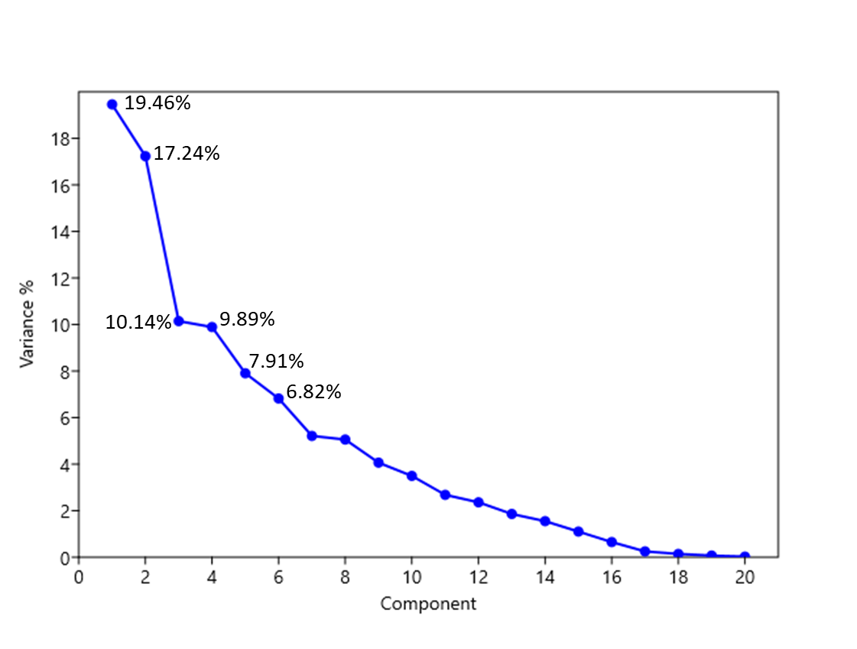
Fig. S3 Summary of principal components and their total variance (%) to explain the spatial distance (PCA) between 21 Polish and Lithuanian lakes.

Table S4 Description of PCA scores to plot the spatial distance between 21 Polish and Lithuanian lakes.
Country | Lake |  | PC 1 | PC 2 | Grouping
Poland | LUB |  | 4.1856 | 0.95 | A
Poland | BYT |  | 1.7033 | 0.54 | A
Poland | BUS |  | 4.068 | 0.80 | A
Poland | PNI |  | 4.1476 | 0.82 | A
Poland | MYS |  | -0.88939 | -0.85 | C
Poland | PAL |  | 1.2041 | -0.08 | A
Poland | GRY |  | -0.1574 | -1.44 | C
Poland | MOG |  | -0.83694 | -2.21 | C
Poland | NIE |  | 2.0785 | -2.49
Poland | ILN |  | -1.3378 | -1.38 | C
Poland | GOP |  | 0.48175 | -1.76 | C
Poland | ZAB |  | -0.34285 | -1.93 | C
Poland | ZBA |  | 0.8285 | -1.16 | C
Poland | MIE |  | -1.4343 | 1.37
Lithuania | JIE |  | -2.9652 | 4.28 | B
Lithuania | SIR |  | -1.7371 | -1.69 | C
Lithuania | GIN |  | -1.4177 | 2.85 | B
Lithuania | DID |  | -1.7745 | -1.08 | C
Lithuania | MAS |  | -2.7993 | -0.60
Lithuania | LUK |  | -3.1655 | -0.46
Lithuania | SIM |  | 0.16068 | 5.50 | B

Table S5 Description of PCA loadings (Pearson correlation r) for the different environmental variables used to explain the spatial distancing between 21 Polish and Lithuanian lakes.
Parameter | Variable |  | PC 1 | PC 2
Environmental factors | pH |  | 0.32826 | 0.46672
 | Conductivity (Cond.) |  | 0.69807 | -0.38933
 | Temperature (Temp.) |  | 0.32198 | 0.37879
 | TN |  | 0.37191 | -0.33512
 | TP |  | 0.71194 | 0.057194
 | Cyanobacterial Biomass (CYAN) |  | 0.38034 | 0.35261
Cyanophage genes | psbA |  | 0.51564 | 0.311
 | nblA |  | 0.56362 | 0.60583
 | g91_S |  | 0.4231 | 0.79374
 | g91_L |  | 0.22663 | 0.68897
Cyanobacterial biomass | Chrysosporum bergii |  | 0.49199 | -0.062073
 | Aphanizomenon gracile |  | 0.33695 | 0.62544
 | Cuspidothrix issatschenkoi |  | 0.0082554 | 0.60458
 | Raphidiopsis raciborskii |  | 0.62532 | -0.04905
 | Jaaginema subtilissimum |  | 0.8514 | -0.18826
 | Limnothrix obliqueacuminata |  | 0.36197 | -0.24887
 | Limnothrix redekei |  | 0.38151 | 0.071305
 | Microcystis aeruginosa |  | 0.071168 | 0.1485
 | Microcystis viridis |  | -0.39936 | 0.50322
 | Microcystis wesenbergii |  | -0.36868 | 0.71944
 | Planktolyngbya limnetica |  | -0.32491 | 0.47156
 | Planktothrix agardhii |  | 0.39348 | -0.095758
 | Pseudanabaena limnetica |  | -0.41471 | 0.28758
 | Synechococcus salinarum |  | 0.35222 | -0.23102
 | Woronichinia compacta |  | -0.30411 | 0.17423
 | Woronichinia naegeliana |  | -0.244 | 0.32206

Table S6 Description of statistical analysis for the PC1
1) Test for equal means
 | Sum of sqrs | df | Mean square | F | p (same)
Between groups: | 54.8415 | 2 | 27.4208 | 18.77 | 1.09E-04
Within groups: | 20.4513 | 14 | 1.4608 | Permutation p (n=99999)
Total: | 75.2928 | 16 | 0.00059
2) Levene´s test for homogeneity of variance, from means
p (same): | 0.2119 | Samples are normaly distributed
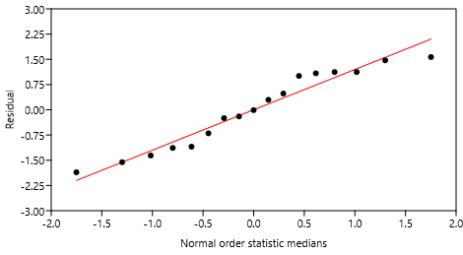
Residuals:

3) Tukey’s test
 | Group A | Group B | Group C
Group A |  | 4.76E-04 | 2.20E-04
Group B | 7.16 |  | 0.618
Group C | 7.767 | 1.346
 | Group A is significantly different from B and C
Significance p < 0.05 is highlighted in red.

Table S7 Description of statistical analysis for the PC2
1) Test for equal means
 | Sum of sqrs | df | Mean square | F | p (same)
Between groups: | 74.984 | 2 | 37.492 | 91.76 | 8.99E-09
Within groups: | 5.72052 | 14 | 0.408609 | Permutation p (n=99999)
Total: | 80.7046 | 16 | 1.00E-05
2) Levene´s test for homogeneity of variance, from means
p (same): | 0.06219 | p > 0.05, then data is normaly distributed
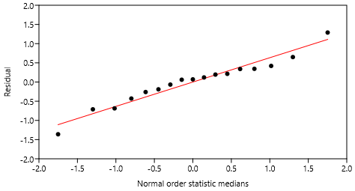
Residuals:

3) Tukey’s test
 | Group A | Group B | Group C
Group A |  | 5.83E-06 | 1.06E-04
Group B | 10.92 |  | 6.41E-09
Group C | 8.353 | 18.95
 | All groups are different between each other
Significance p < 0.05 is highlighted in red.

