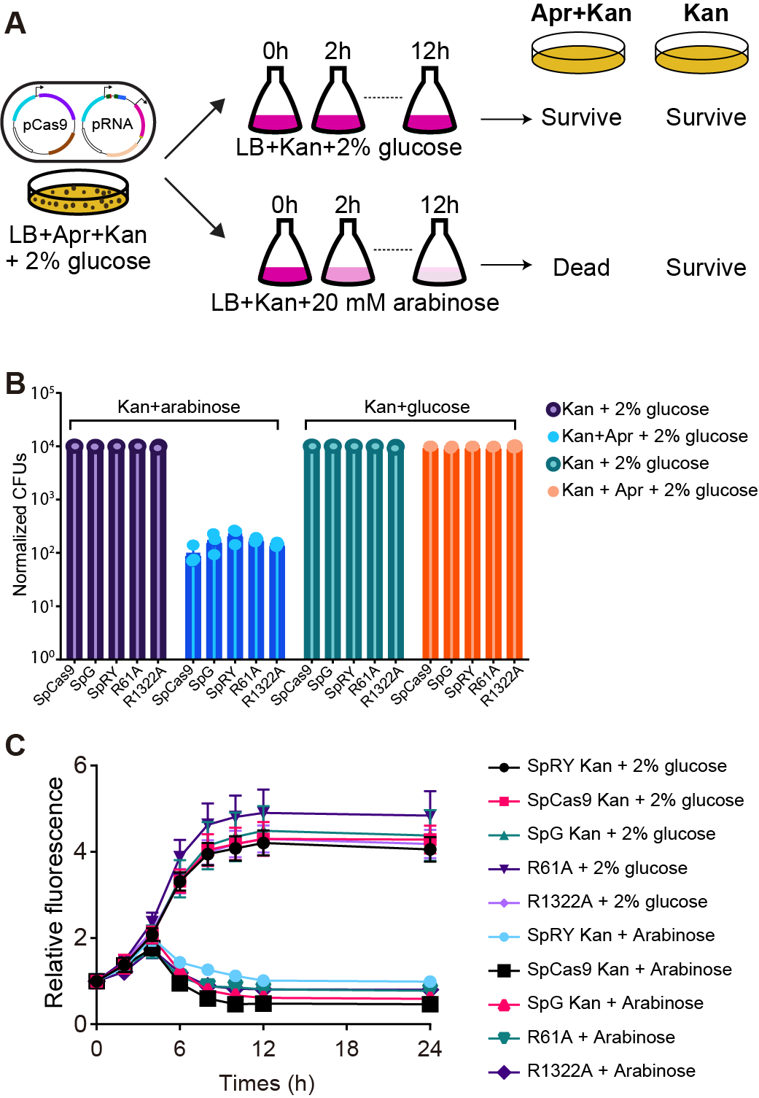
Figure S2. The in vivo target cleavage kinetic assay for SpCas9 variants. (A) The workflow of in vivo plasmid lost assay for SpCas9 variants. (B) The plasmid loss for SpCas9, SpG, SpRY, SpRY R61A, and SpRY R1322A. (C) The plasmid loss dynamics for SpCas9, SpG, SpRY, SpRY R61A, and SpRY R1322A with our without induction. Cas9 activity was inhibited by the addition of 2% glucose and Cas9 cleavage activity was initiated by the addition of 20 mM arabinose at t = 0 h.

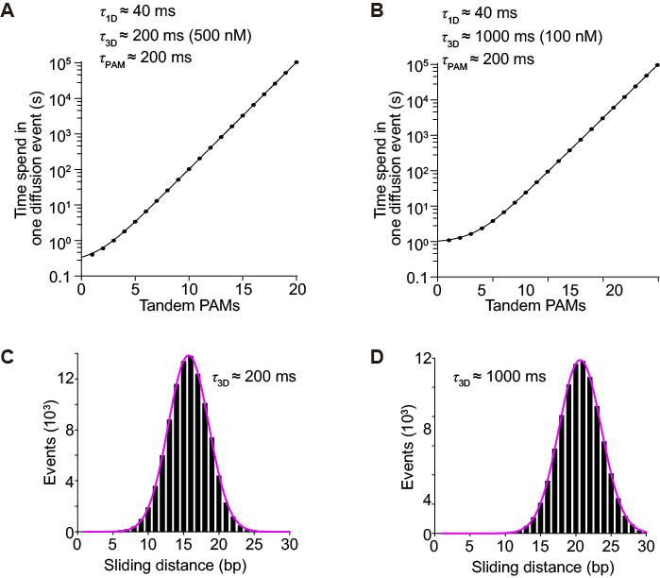
Figure S1. SpCas9 dwelling time and sliding distance simulation at different SpCas9 concentrations. (A-B) Predicted SpCas9 dwelling time on dsDNA as a function of PAM density within the sliding distance Done at a SpCas9 concentration of 0.5 μM (A) and 0.1 μM (B). (C-D) Monte Carlo simulated SpCas9 sliding distance per sliding for the most efficient target search at a SpCas9 concentration of 0.5 μM (C) and 0.1 μM (D).

Python code for Monte Carlo simulation

import random
import numpy as np
import time

t1 = 0.1 # 3D searcning time (s)
t2 = 0.16 # PAM reading time (s)
V = 100 # sliding rate（bp/s）
X = 2000000 # DNA length（bp）
N = 125000 # PAM numbers
D1 = 16 # PAM interval

num_trials = 10000 # simulation time

# D2 iteration
D2_values = np.arange(1, 101, 1)
min_avg_flights = float("inf") # minimum searching time
best_D2 = None # the best D2

for D2 in D2_values:

total_flights = 0 # total searching time

for i in range(num_trials):
bird_pos = random.uniform(0, X) # random position
num_flights = 0 # current searching time
direction = random.choice([-1, 1]) # direction

while True:
bird_pos += direction * D2

# PAM reading
if int(bird_pos / D1) % 2 == 1:
num_flights += 1
time.sleep(t2)

# find the target site
if bird_pos < 0 or bird_pos > X:
total_flights += num_flights
break

# sliding direction
if random.random() < 0.5:
direction = -direction

# 3D collision time
time.sleep(t1)
num_flights += 1

# average searching time
avg_flights = total_flights / num_trials

# the best D2
if avg_flights < min_avg_flights:
min_avg_flights = avg_flights
best_D2 = D2

print("the best D2：{}".format(best_D2))

Table S1: Plasmids used in this study.
Plasmids | Description | Primer | Source
YD001 | SpRY in F-plasmid | YC001-YC004 | This study
YD002 | SpRY with R61A in F-plasmid | YC001-YC006 | This study
YD005 | Cas9 in F-plasmid | YC001-YC004 | This study
YD006 | SpG in F-plasmid | YC001-YC004 | This study
YD011 | Target , sgRNA, Apr with A60T  H133Y and target in pSC101 | YC021-YC024 | This study
YD013 | RFP carrying a C-terminal  AANDENYALAA peptide tag in YD011 | YC025-YC028 | This study
YD018 | Cas9 expression vector  with N-terminal His₆-MBP-TEV site  tag in pSV272
YD019 | SpRY expression vector  with N-terminal His₆-MBP-TEV site  tag in pSV272 | YC115-YC118 | This study
YD020 | SpG expression vector with N-terminal His₆-MBP-TEV site  tag in pSV272 | YC115-YC118 | This study
YD021 | SpRY with R1322A in F-plasmid | YC001-YC004 YC128-YC129 | This study
YD023 | SpRY with R61A expression vector with N-terminal His₆-MBP-TEV site tag in pSV272 | YC115-YC118 | This study
YD024 | SpRY with R1322A expression vector with N-terminal His₆-MBP-TEV site tag in pSV272 | YC115-YC118 | This study

Table S2: Oligonucleotides used for plasmid construction and library preparation
Primer | Sequences 5’ to 3’ | Description
YC001 | ACGGTCTCGGGTATATCTCCTTAGAGCTCGAATTC | F-plasmid backbone
YC002 | ACGGTCTCAACGACGACATGTCAATACTTGC | F-plasmid backbone
YC003 | ACGGTCTCGTACCATGGACAAGAAGTACAGCATCG | SpRY
YC004 | ACGGTCTCATCGTTCAGTCGCCTCCCAGCTGAG | SpRY
YC005 | ACGGTCTCGCTCTTCAGCCGGGTTGCCTCGGCTG | SpRY with R61A
YC006 | ACGGTCTCGAGAGAACCGCCAGAAGAAGATACAC | SpRY with R61A
YC010 | ACGGTCTCACTGACAGGGCGGGGTTTTTTTTTCACCACCGACTATTTGCAACAGTGC | pSC101 backbone
YC013 | ACGGTCTCGCGTCTTTCTGTGACCCTCAGGCTACTGTCAGTCGCAGTGGTATGGAGAAACAGTAGAGAGTTG | pSC101 backbone
YC014 | ACGGTCTCGGACGAGGGTTTTCTGAGGGTCACAGAAAGACGGTTTTAGAGCTAGAAATAGCAAGTTAAAATAAG | Target ,sgRNA
YC015 | ACGGTCTCATCAGGGGCGGGGTTTTTTTTTAAAAGCACCGACTCGGTGCCAC | Target ,sgRNA
YC025 | ACGGTCTCATGTCCTTCCCGAGCGAAAACGGTCG | RFP with C terminal AANDENYALAA peptide tag
YC026 | ACGGTCTCGGCCTTTTTTATTTCACCTCAAACTGCTGCAGCGTAGTTTTCGTCGTTTGCTGCAGGCCTCTTGTACAGCTCGTCCATGCCG | RFP with C terminal AANDENYALAA peptide tag
YC027 | ACGGTCTCGAGGCACGTCAGATGACGTGCCTTTTTTCTTGTCGCAGAAAGGCCCACCCGAAGGTGAGCCTCAGCGAGCTGAAGAAAGAC | pSC101 backbone
YC028 | ACGGTCTCAGACAGTAAGACGGGTAAGCCTG | pSC101 backbone
YC115 | ACGGTCTCAATGGACAAGAAGTACAGCATCG | SpRY, SpRY with R61A, SpG, Cas9
YC116 | ACGGTCTCACCATCGAGGCTGCTCCCTGGAAATACAG | SpRY, SpRY with R61A, SpG
YC117 | ACGGTCTCGCTCGTCAGTCGCCTCCCAGCTGAGAC | pSV272 backbone
YC118 | ACGGTCTCGCGAGGCCGGTGCTTTGCAGGATC | pSV272 backbone
YC128 | ACGGTCTCAAGGGGCTCCCAGTCTGGTCAG | SpRY with R1322A
YC129 | ACGGTCTCACCCTGCAGCCTTCAAGTACTTTGACACCACCATC | SpRY with R1322A
YC035 | ACGGTCTCCTCAGTATGGAGAAACAGTAGAGAGTTGCG | pSC101 backbone
YC036 | ACGGTCTCGGTTTTAGAGCTAGAAATAGCAAGTTAAAATAAG GCTAGTCC | pSC101 backbone
YC037 | ACGGTCTCCCTGACACTGCCTCTGACAGTAGCC | Library
YC038 | GTCAGCATCTGGCTACGGTCTCG | Library

Table S3: Oligonucleotides used for Cleavage assays
FAM | Forward | GAGTGGAAGGATGCCACTGAGGGTCACAGAAAGAGGAGGTGCTGTCAAAATTGAGC
FAM | Reverse | GCTCAATTTTGACAGCACCTCCTCTTTCTGTGACCCTCAGTGGCATCCTTCCACTC
sgRNA | Forward | CTGAGGGTCACAGAAAGAGGGTTTTAGAGCTAGAAATAGCAAGTTAAAATAAGGCTAGTCCGTTATCAACTTGAAAAAGTGGCACCGAGTCGGTGCTTTT
sgRNA | Reverse | AAAAGCACCGACTCGGTGCCACTTTTTCAAGTTGATAACGGACTAGCCTTATTTTAACTTGCTATTTCTAGCTCTAAAACCCTCTTTCTGTGACCCTCAG
PAM 1 | Forward | CATGTACATAAATATTTTACACATAACGGCAATGTGCATACATTACAACATATGT
PAM 1 | Reverse | ACATATGTTGTAATGTATGCACATTGCCGTTATGTGTAAAATATTTATGTACATG
PAM 2 | Forward | CATGTACATAAATATTTTACAATGGCACGGCATGTTAATTGCACACAAACGCGCA
PAM 2 | Reverse | TGCGCGTTTGTGTGCAATTAACATGCCGTGCCATTGTAAAATATTTATGTACATG
PAM 4 | Forward | AGCTGCATAACGCGGGAAAATCCATTTATCTGCTTGATCTTCGGATGTTCCATTG
PAM 4 | Reverse | CAATGGAACATCCGAAGATCAAGCAGATAAATGGATTTTCCCGCGTTATGCAGCT
PAM 8 | Forward | GGCTGCACCACGCGGGAAAATCCATTTAGGTGCTTCCTCTTCGGATGTTCCATTG
PAM 8 | Reverse | CAATGGAACATCCGAAGAGGAAGCACCTAAATGGATTTTCCCGCGTGGTGCAGCC
PAM 16 | Forward | CAGGTCCAGGCTCCAGGCCTTGGTCCAGGACCTGGAACCAGGACCTGGTCCAATA
PAM 16 | Reverse | TATTGGACCAGGTCCTGGTTCCAGGTCCTGGACCAAGGCCTGGAGCCTGGACCTG

