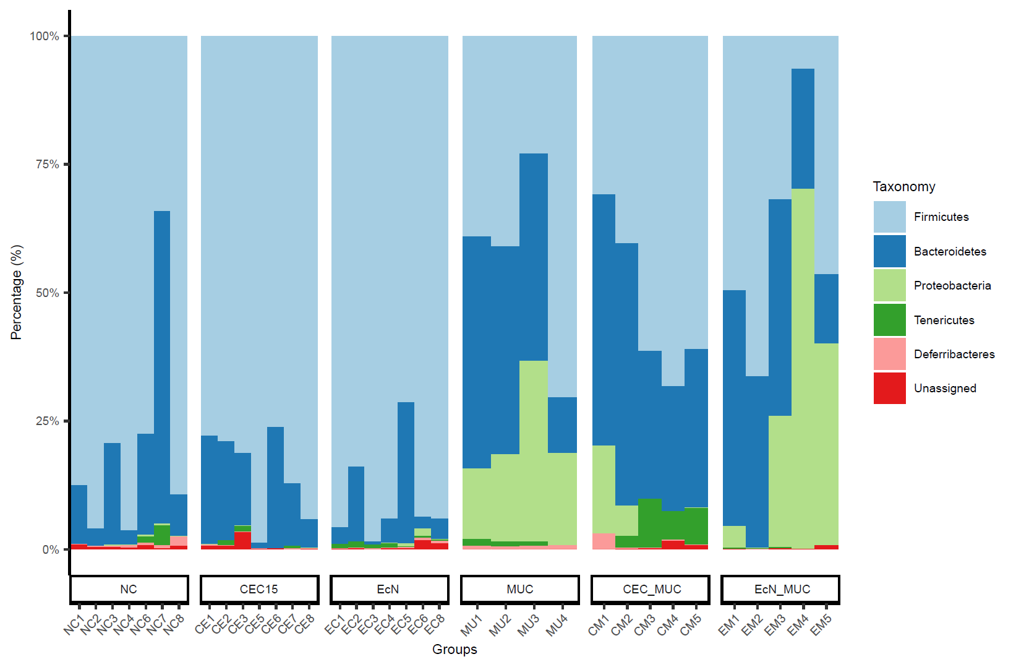
Supplementary Figure S6. Relative abundance at the phylum level from individual samples in each groups. (NC - negative control; CEC15 - healthy CEC15-treated; EcN - healthy EcN-treated; MUC - mucositis control; CEC_MUC - mucositis CEC15-treated; EcN_MUC - mucositis EcN-treated)

