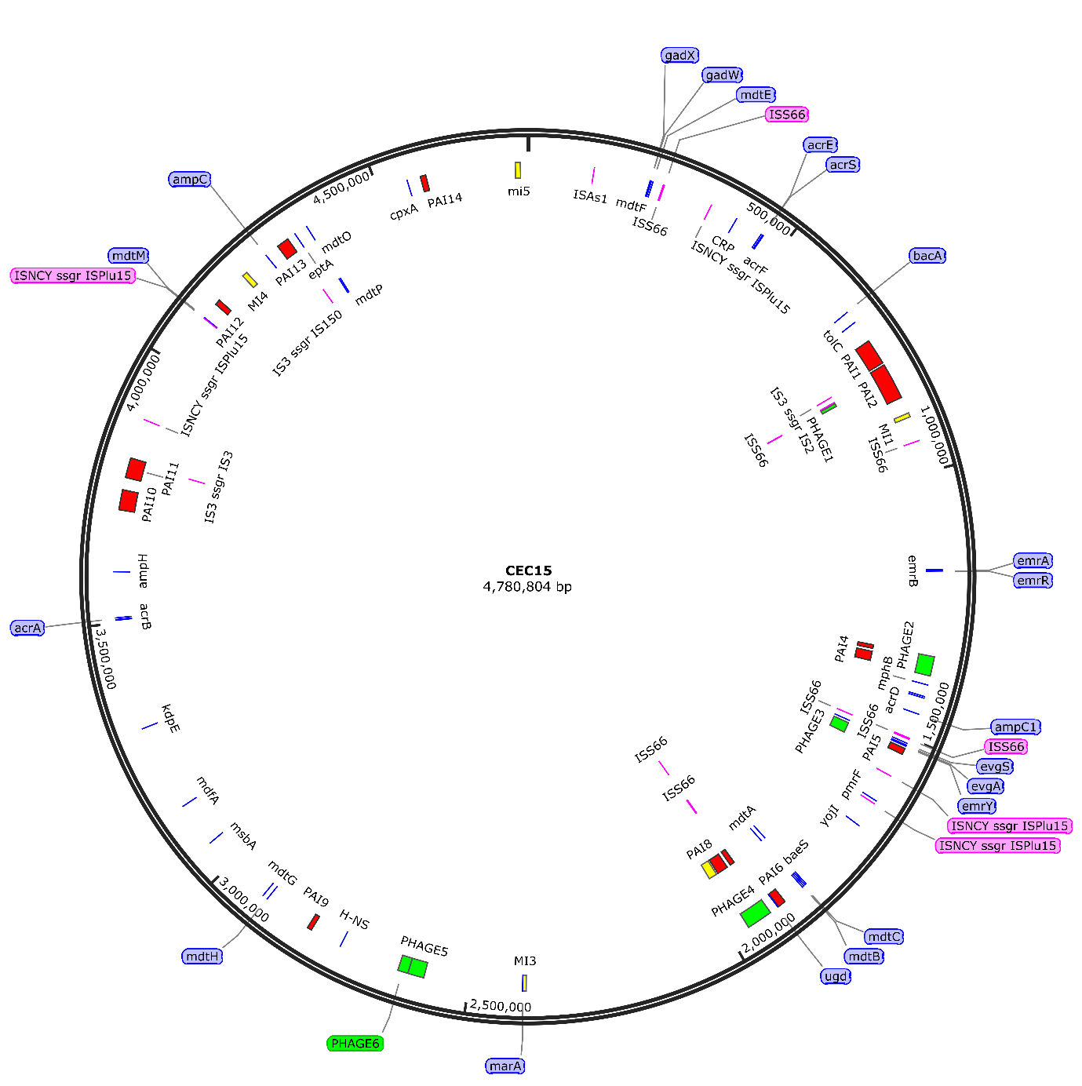
Supplementary Figure S1. Schematic circular representation of CEC15 genomic features. Pathogenicity Island (PAI) (red), Metabolic Island (MI) (yellow), Prophage regions (PHAGE) (green), Insertion elements (IS) (pink), and antibiotic resistance-related genes (blue) are represented in their respective position in the genome. Constructed using SnapGene Viewer software (from Insightful Science; available at snapgene.com).

