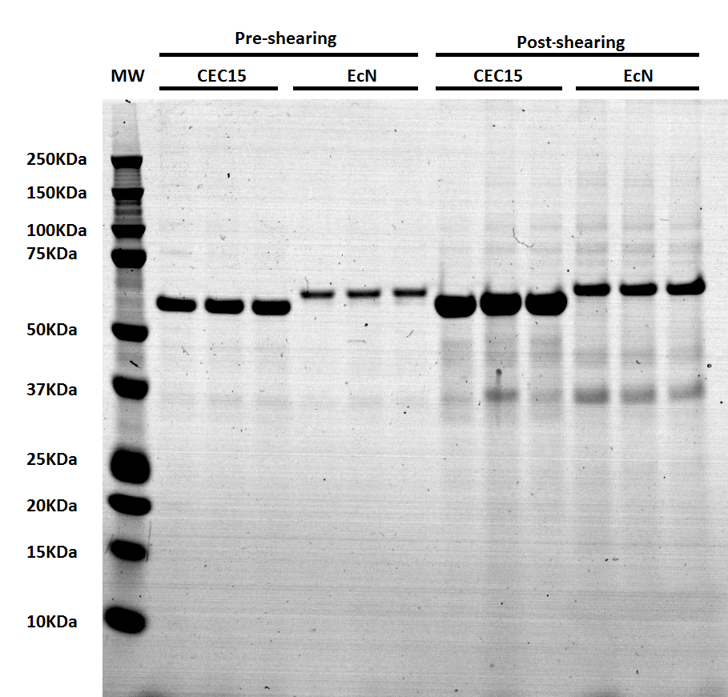
Supplementary figure S3. Pre- and post-shearing protein profile of CEC15 and EcN strains. Strains were grown overnight at 37 °C, without agitation, centrifuged, and resuspended in PBS at 1:100 the initial volume. One aliquot was collected for the pre-shearing and the samples were blended for 5 min at maximum speed with an waring blender (Waring 2-Speed Blender, Vican, USA). Aliquots pre- and post-shearing were centrifuged and the supernatant resolved in SDS-PAGE gradient gel (4-12%).

