Supplementary Material

For the article:
Improved hydrolysis of sewage sludge by air-assisted non-thermal plasma for enhanced biomethane recovery
Gerardo Oswaldo Ortiz Vanegas ¹ and Hyun-Woo Kim. ^{1,2*}
¹ Department of Environment and Energy, Jeonbuk National University,
567 Baekje-daero, Deokjin-gu, Jeonju 54896, Republic of Korea.
² Department of Environmental Engineering, Division of Civil, Environmental, Mineral Resources and Energy Engineering, Soil Environment Research Center, Jeonbuk National University, 567 Baekje-daero, Deokjin-gu, Jeonju 54896, Republic of Korea.

*Corresponding author: hyunwoo@jbnu.ac.kr

This supplementary material document contains additional information related with background calculations and data results obtained in this study.

Figures
Fig. S1 (a) NTP input power, (b) NTP electrical energy consumption measurement
(b)
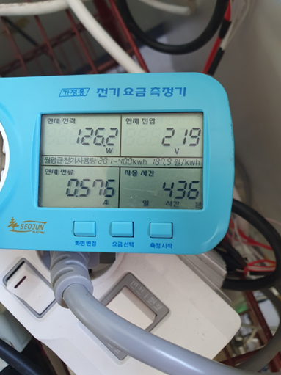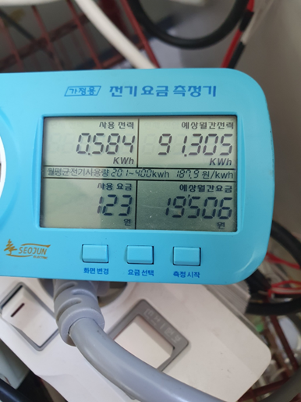
(a)

Fig. S2 CCD-RSM pH value

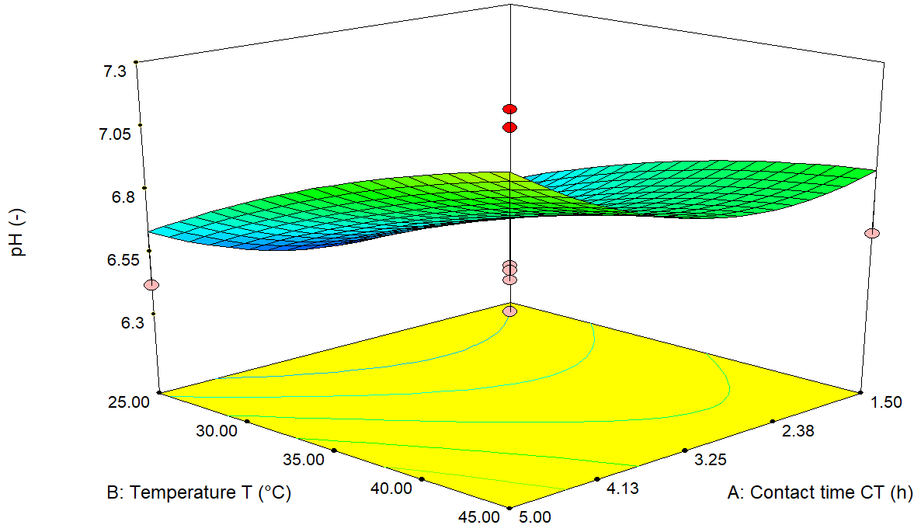

Tables
Table S1 Overall experimental design for serum bottle tests

Serum bottle ID | SIR | Substrate (mL) |  |  | Inoculum (mL) | AMM  (mL) | Trace metals  (mL) | Buffer solution  (mL) | Total volume  (mL)
Serum bottle ID | SIR | Distilled water  (Blank) | Raw PS and WAS  (Control) | NTP pretreated PS and WAS
Run 1-1 | 0.1 | 10.9 | 10.9 | - | 68.2 | 10.0 | 1.0 | 30.0 | 131.0
Run 1-2 | 0.1 | - | 12.4 | - | 77.6
Run 1-3 | 0.1 | - | - | 14.2 | 75.8
Run 1-4 | 0.1 | - | - | 14.2 | 75.8
Run 2-1 | 0.3 | 21.7 | 21.7 | - | 46.0 | 10.0 | 1.0 | 30.0 | 131.0
Run 2-2 | 0.3 | - | 29.1 | - | 60.9
Run 2-3 | 0.3 | - | - | 32.4 | 57.6
Run 2-4 | 0.3 | - | - | 32.4 | 57.6
Run 3-1 | 0.5 | 27.6 | 27.6 | - | 34.7 | 10.0 | 1.0 | 30.0 | 131.0
Run 3-2 | 0.5 | - | 39.9 | - | 50.1
Run 3-3 | 0.5 | - | - | 43.6 | 46.4
Run 3-4 | 0.5 | - | - | 43.6 | 46.4

Table S2 – Experimental design: NTP pretreatment final responses values
Run Order | CT  (h) | T  (°C) | VS  (mg L⁻¹) | TCOD  (mg L⁻¹) | SCOD  (mg L⁻¹) | DOC  (mg L⁻¹) | TDN  (mg L⁻¹) | C/N  (-) | FAN  (mg L⁻¹) | pH  (-)
1 | 1.50 | 25.00 | 12333.33 | 11571.40 | 1031.85 | 687.90 | 168.30 | 4.09 | 118.66 | 6.44
2 | 0.78 | 35.00 | 12866.67 | 13571.60 | 923.40 | 535.30 | 151.33 | 3.84 | 139.50 | 7.05
3 | 3.25 | 35.00 | 12210.73 | 13571.40 | 802.95 | 368.60 | 84.78 | 4.35 | 40.54 | 7.12
4 | 3.25 | 35.00 | 12160.14 | 9527.27 | 552.90 | 370.00 | 83.00 | 4.46 | 34.5 | 7.05
5 | 5.00 | 25.00 | 12041.81 | 12714.30 | 545.00 | 615.60 | 133.90 | 4.60 | 16.87 | 6.42
6 | 3.25 | 35.00 | 12180.35 | 13599.20 | 541.00 | 369.00 | 84.00 | 4.39 | 19.70 | 6.50
7 | 5.00 | 45.00 | 12266.67 | 12285.70 | 548.00 | 379.70 | 88.48 | 4.29 | 44.84 | 6.81
8 | 3.25 | 49.14 | 12333.33 | 9018.18 | 561.00 | 564.70 | 134.70 | 4.19 | 81.16 | 7.24
9 | 1.50 | 45.00 | 12300.00 | 14142.90 | 554.00 | 409.40 | 93.79 | 4.37 | 55.74 | 6.63
10 | 3.25 | 35.00 | 12148.92 | 14185.60 | 514.60 | 374.00 | 82.00 | 4.56 | 27.80 | 6.48
11 | 3.25 | 20.86 | 12400.00 | 14142.90 | 567.10 | 845.70 | 193.00 | 4.38 | 91.41 | 6.38
12 | 3.25 | 35.00 | 12207.11 | 15283.60 | 613.20 | 378.50 | 81.24 | 4.66 | 18.14 | 6.31
13 | 5.72 | 35.00 | 12135.41 | 9163.64 | 841.20 | 343.40 | 80.69 | 4.26 | 44.39 | 7.51

Table S3 SCOD – CCD-RMS ANOVA test
Source | Sum of Squares | Df | Mean Square | F Value | p-Value Prob>F
Model | 2.60E+005 | 5 | 52089.91 | 3.48 | 0.0674
CT (h) | 46375.10 | 1 | 46375.10 | 3.10 | 0.1219
T (°C) | 29218.72 | 1 | 29218.72 | 1.95 | 0.2052
CT × T | 57804.18 | 1 | 57804.18 | 3.86 | 0.0902
CT² | 1.09E+005 | 1 | 1.09E+005 | 7.29 | 0.0306
T² | 7950.05 | 1 | 7950.05 | 0.53 | 0.4899
Residual | 1.05E+005 | 7 | 14978.51 | - | -

Table S4 – TCOD – CCD-RMS ANOVA test
Source | Sum of Squares | Df | Mean Square | F Value | p-Value Prob>F
Model | 1.57E+007 | 5 | 3.14E+006 | 0.60 | 0.7051
CT (h) | 6.03E+006 | 1 | 6.03E+006 | 1.15 | 0.3197
T (°C) | 3.26E+006 | 1 | 3.26E+006 | 0.62 | 0.4572
CT × T | 2.25E+006 | 1 | 2.25E+006 | 0.43 | 0.5340
CT² | 2.78E+006 | 1 | 2.78E+006 | 0.53 | 0.4911
T² | 1.92E+006 | 1 | 1.92E+006 | 0.36 | 0.5648
Residual | 3.68E+007 | 7 | 5.26E+006 | - | -

Table S5 – C/N – CCD-RMS ANOVA test
Source | Sum of Squares | Df | Mean Square | F Value | p-Value Prob>F
Model | 0.45 | 5 | 0.09 | 4.83 | 0.0313
CT (h) | 0.13 | 1 | 0.13 | 7.06 | 0.0326
T (°C) | 0.01 | 1 | 0.01 | 0.59 | 0.4688
CT × T | 0.08 | 1 | 0.08 | 4.55 | 0.0704
CT² | 0.22 | 1 | 0.22 | 11.56 | 0.0114
T² | 0.02 | 1 | 0.02 | 1.17 | 0.3148
Residual | 0.13 | 7 | 0.019 | - | -

Table S6 – FAN – CCD-RMS ANOVA test
Source | Sum of Squares | Df | Mean Square | F Value | p-Value Prob>F
Model | 16533.40 | 5 | 3306.68 | 10.12 | 0.0042
CT (h) | 7637.70 | 1 | 7637.70 | 23.37 | 0.0019
T (°C) | 305.67 | 1 | 305.67 | 0.94 | 0.3657
CT × T | 2065.41 | 1 | 2065.41 | 6.32 | 0.0402
CT² | 4135.91 | 1 | 4135.91 | 12.66 | 0.0093
T² | 3231.38 | 1 | 3231.38 | 9.89 | 0.0163
Residual | 2287.61 | 7 | 326.80 | - | -

Table S7 – pH – CCD-RMS ANOVA test
Source | Sum of Squares | Df | Mean Square | F Value | p-Value Prob>F
Model | 0.76 | 5 | 0.15 | 1.00 | 0.4807
CT (h) | 0.08 | 1 | 0.082 | 0.54 | 0.4857
T (°C) | 0.40 | 1 | 0.40 | 2.66 | 0.1470
CT × T | 0.01 | 1 | 0.01 | 0.07 | 0.8047
CT² | 0.22 | 1 | 0.22 | 1.43 | 0.2708
T² | 0.02 | 1 | 0.02 | 0.16 | 0.7037
Residual | 1.06 | 7 | 0.15 | - | -

