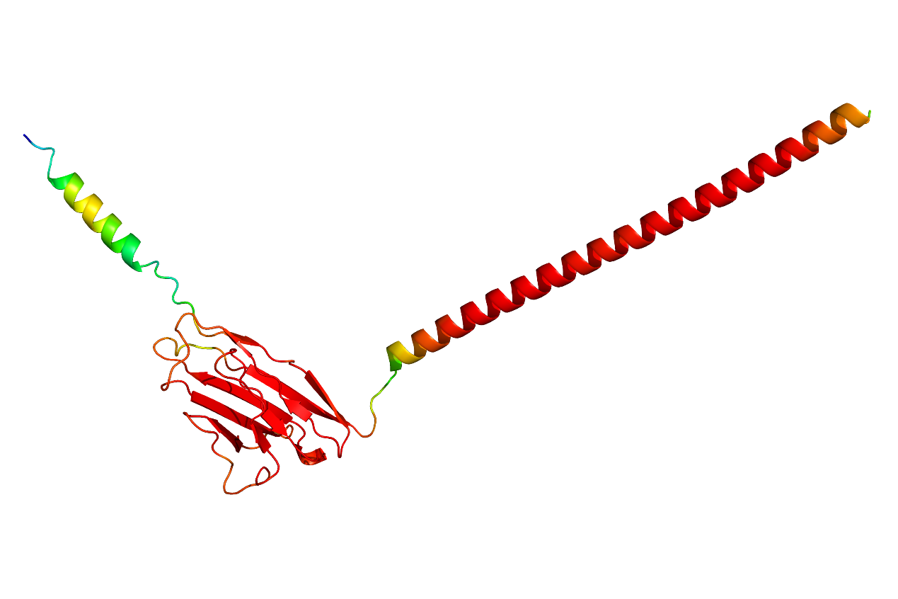
Figure S1. 3D structure of wild-type myelin protein zero-like 2 predicted by AlphaFold 2.1.
Orange and red structure: pLDDT (Model Confidence) > 70
Blue and green structure: pLDDT (Model Confidence) < 70
AlphaFold2.1 was used to predict the three-dimensional protein structure of MPZL2 (human), and the region (red structure) of pLDDT (Model Confidence) >70% occupied the vast majority of the protein.
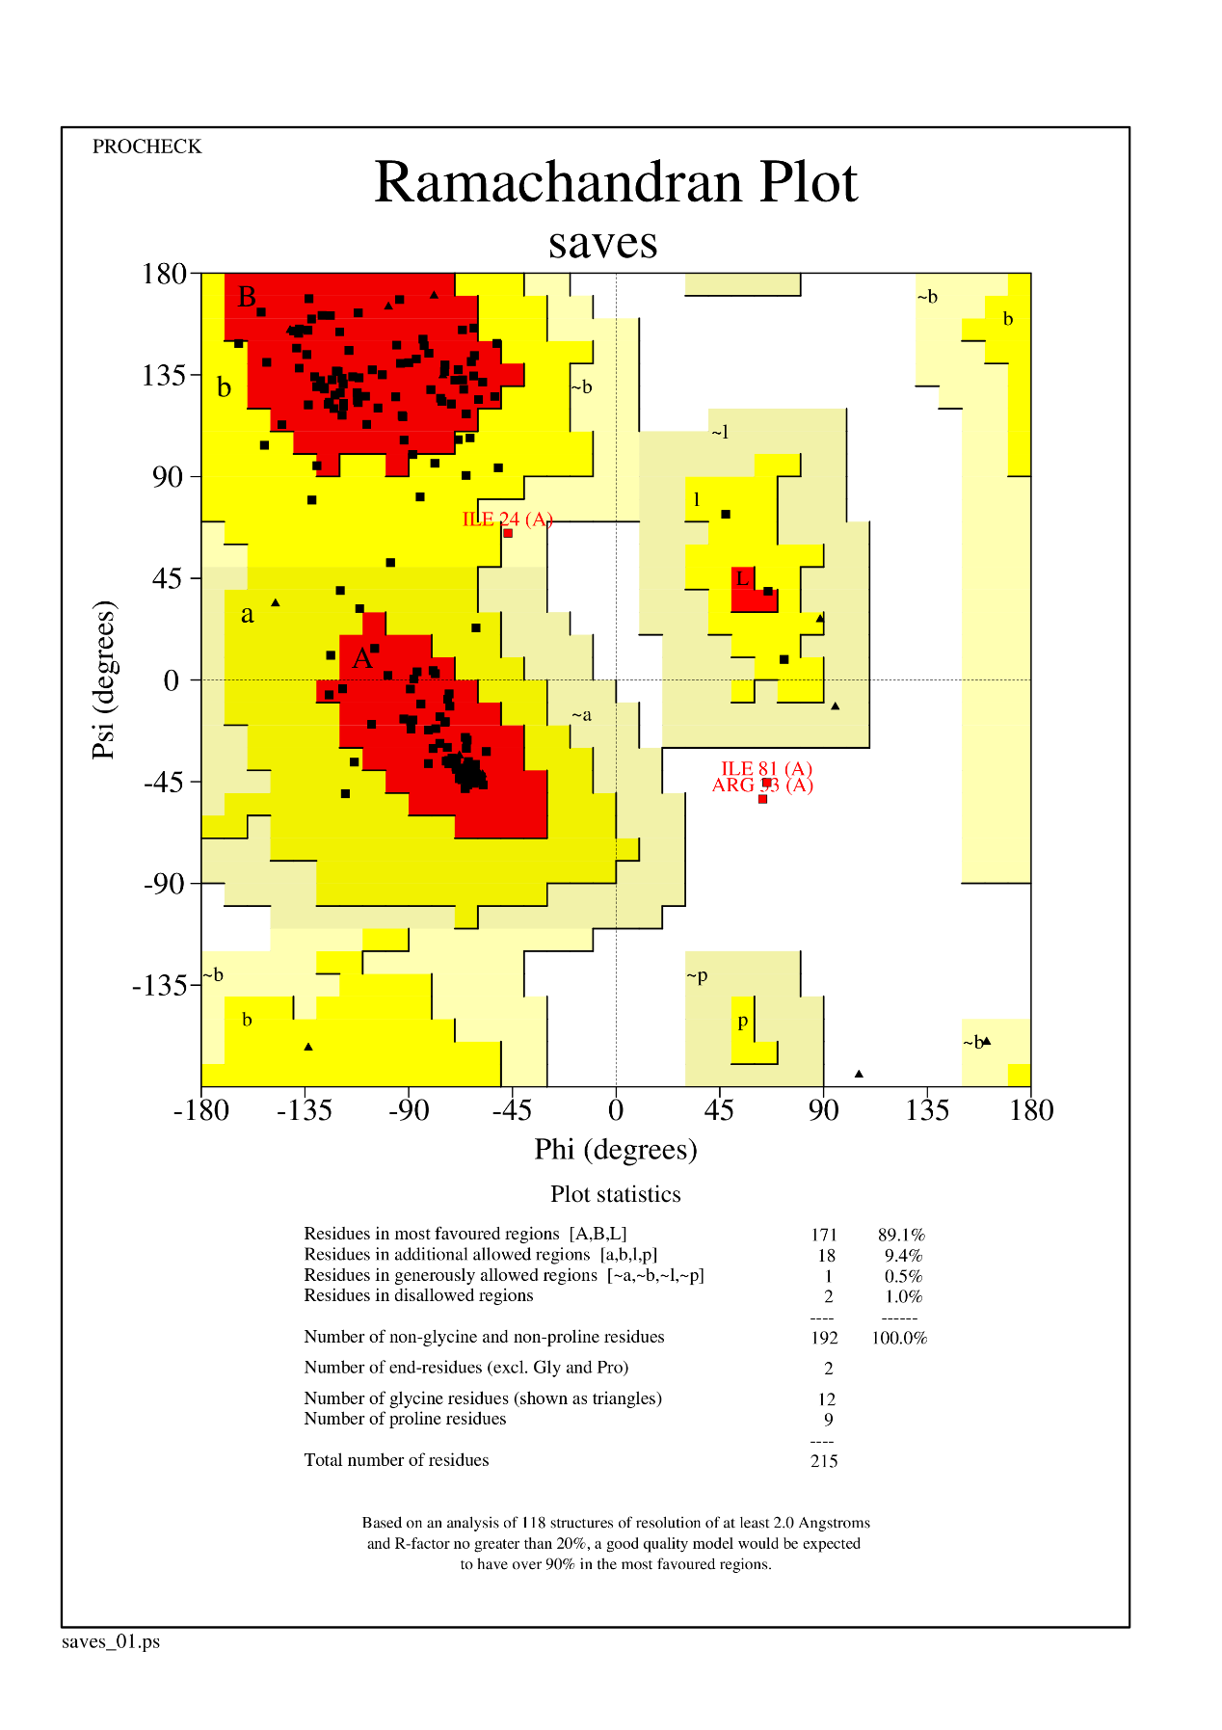
Figure S2. The evaluation result of 3D modeling structure of wild-type myelin protein zero-like 2.
The result of Ramachandran Plot showed that the number of atoms in the disallowed region were only 1.0%, while the number of atoms in the most favoured regions, additional allowed regions and generously allowed regions were up to 99.0%, indicating that most of the atoms of the wild-type protein were in the suitable domains，which further indicated the rationality and accuracy of the predicted protein structure.

