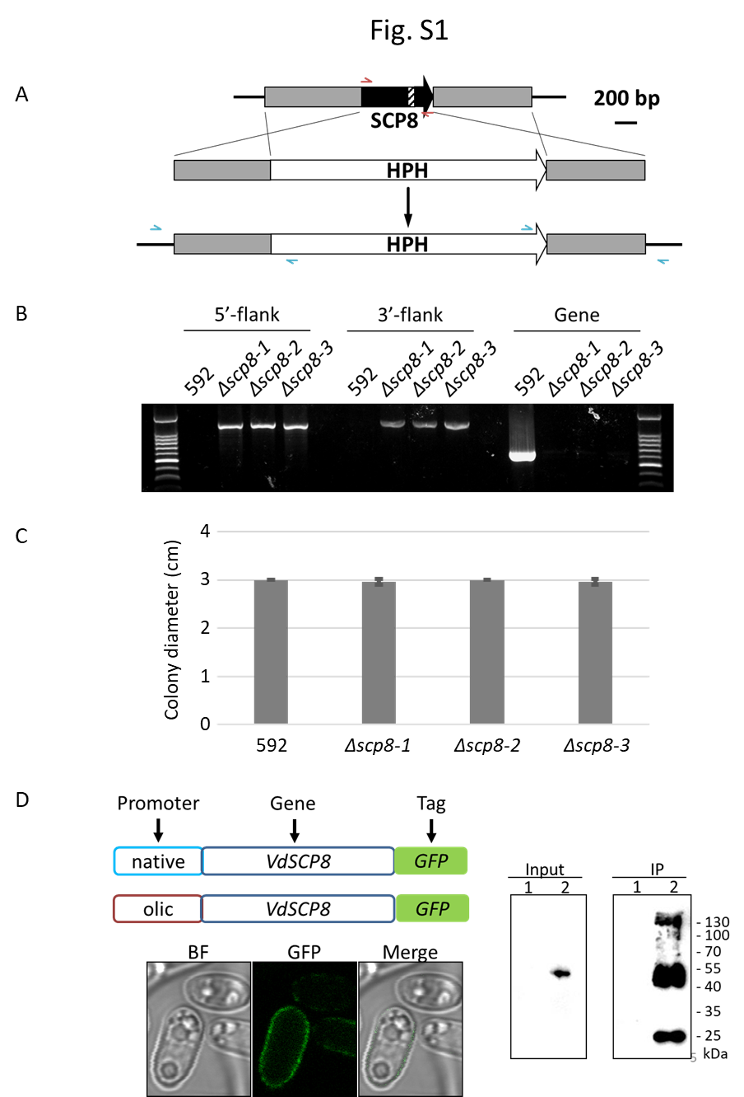
Fig. S1. VdSCP8 gene knockout and complemented transformants. A, SCP8 gene knockout strategy. B, Verification of SCP8 gene knockout mutants by genomic PCR. C, Colony diameter of Vd wild-type strain (592) and SCP8 knockout mutants Δscp8-1, Δscp8-2, Δscp8-3. D, Verification of SCP8 complemented transformants by observation of GFP fluorescence and GFP antibody (1, Vd wild-type, 2, C-Polic strain).

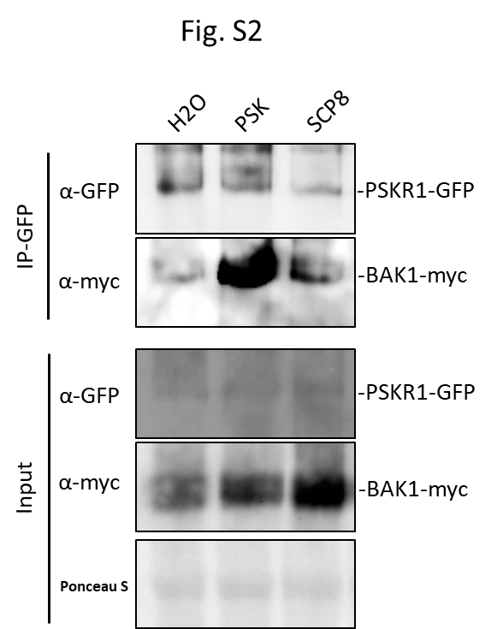
Fig. S2, Protein blot of co-immunoprecipitated protein samples from N. benthamiana co-expressing PSKR1-GFP and BAK1-myc infiltrated with H₂O, 1 µM PSK and 2 µM SCP8, respectively. Input and GFP-trap beads precipitated samples were detected by both anti-GFP and anti-myc antibodies.

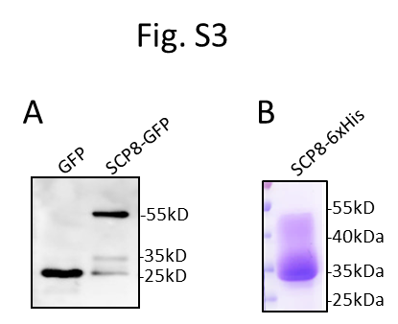
Fig. S3, VdSCP8 expressed in N. benthamiana and Pichia pastoris. A, Apoplastic fluids isolated from N. benthamiana transiently expressing GFP or SCP8-GFP, and detected by GFP antibody. B, C-terminal 6xHis-tagged SCP8 fusion protein isolated from Pichia pastoris on SDS gel stained by Coomassie brilliant blue.

