Extended Data Table 1 | Comparison among traffic detection techniques.
Technology | Ownership | Advantages | Disadvantages
Inductive-loop detectors | Traffic Police Department.  Highway agency. | Most consistently accurate detector in terms of traffic volume.  Low sensitivity to weather, traffic and environment variation.  Technologically mature and highly accepted among transport agencies. | High installation and maintenance cost.  Requires civil engineering.  Inability to directly measure speed and other information.
Surveillance cameras | Traffic Police Department.  Public Security Bureau. | Relatively low installation cost.  Advanced object recognition can classify vehicles into categories.  Detects pedestrian, bicycles in addition to cars.  Capacity of sending over real-time images to a monitor and control room. | Relatively low accuracy and reliability in terms of traffic volume.  Performance degradation with bad weather and during night time.
Floating car detectors | Traffic Police Department.  Highway agency.  Taxi company.  Ride-hailing company.  Navigation map company.  Bus company. | Low implementation cost since these detectors are often installed for other purposes.  Detailed vehicle trajectory information may contribute to coordination of traffic control.  Ability to directly measure trip origin-density and speed of road segments travelled. | Inability to directly measure traffic volume under low penetration rate.  Relying on cross-sector cooperation, the transaction costs may be high.  Privacy concerns.

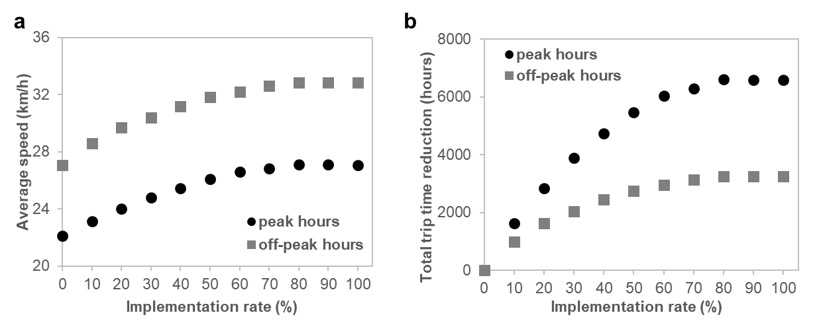
Extended Data Fig. 1 | Impacts of implementation rate of adaptive traffic control in Shanghai. a, Average travel speed over all trips. b, Per-hour reduction of travel time over all trips.

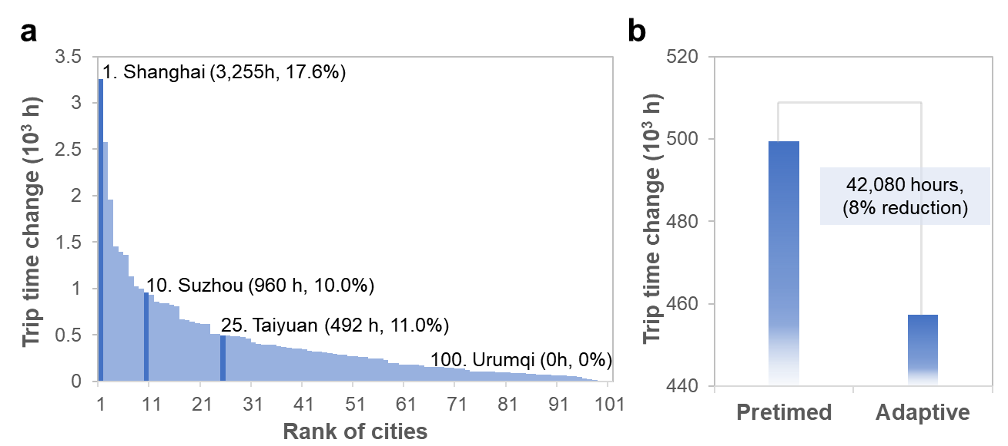

Extended Data Fig. 2 | Changes of trip time during off-peak hours. a, Histogram of per-hour trip time change, above the histogram, typical cities along with absolute and percent trip time changes are labeled. b, Total reduction of per-hour trip time change over the 100 cities.
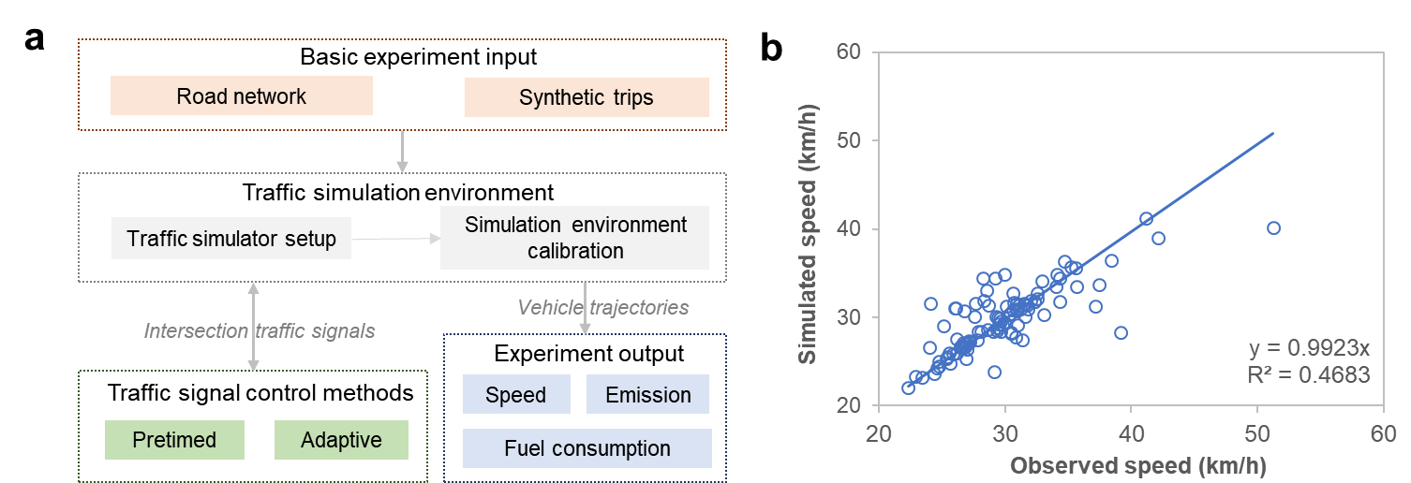
Extended Data Fig. 3 | Experiment setup. a, Experiment input, output and key modules. b, Correlation between observed and simulated city-scale average speed during peak hours, after calibration of simulation environment.

w

