Supplemental Figures
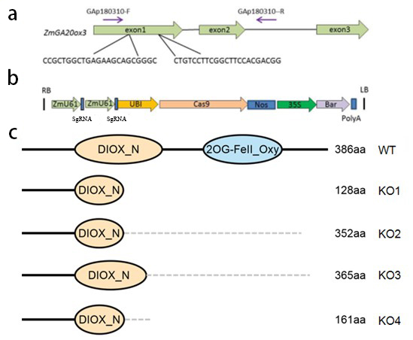
Supplementary Figure 1. ZmGA20ox3 gene editing material construction
a. Gene structure and sequences of ZmGA20ox target regions in wild type.
b. The CRISPR/Cas9 vector carrying dual guide RNA of ZmGA20ox3 gene.
c. All mutant alleles caused functional domain destruction of ZmGA20ox3, grey dash lines correspond to the mis-translation caused by frameshift in mutant alleles.

Supplementary Figure 2. Plant architecture of ZmGA20ox-KO plants and WT at the mature stage in greenhouse, Scale bar=10cm

Supplementary Figure 3. Loss of function of ZmGA20ox3 resulted in reduced plant height and ear height in maize selfing lines and inbred plants

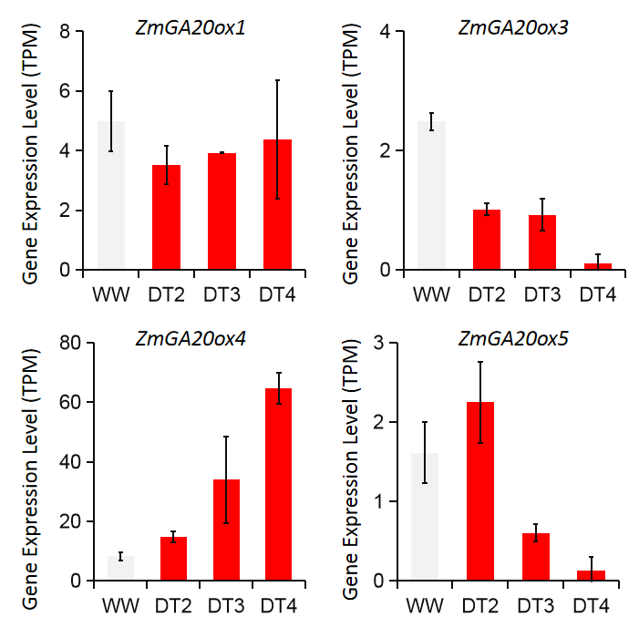
Supplementary Figure 4. The expression level of ZmGA20ox3 gradually decreased with the intensification of drought stress, and the data were collected from GSE124340 (Zhang et al., 2019)

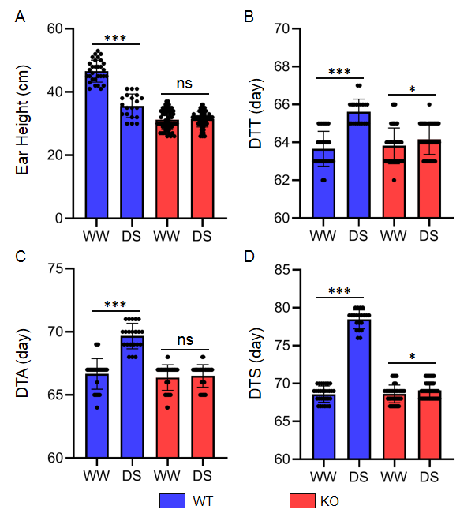
Supplemental Figure 5. Flowering time and ear height of ZmGA20ox3 KO plants were significantly less affected by drought than wild-type plants; DTA: Days to anthesis, DTT: Days to tasseling, DTS: Days to silking.

Supplemental Figure 6. Plant architecture of ZmGA20ox-KO plant and WT under normal water and drought stress in the field, Scale bar=10cm.

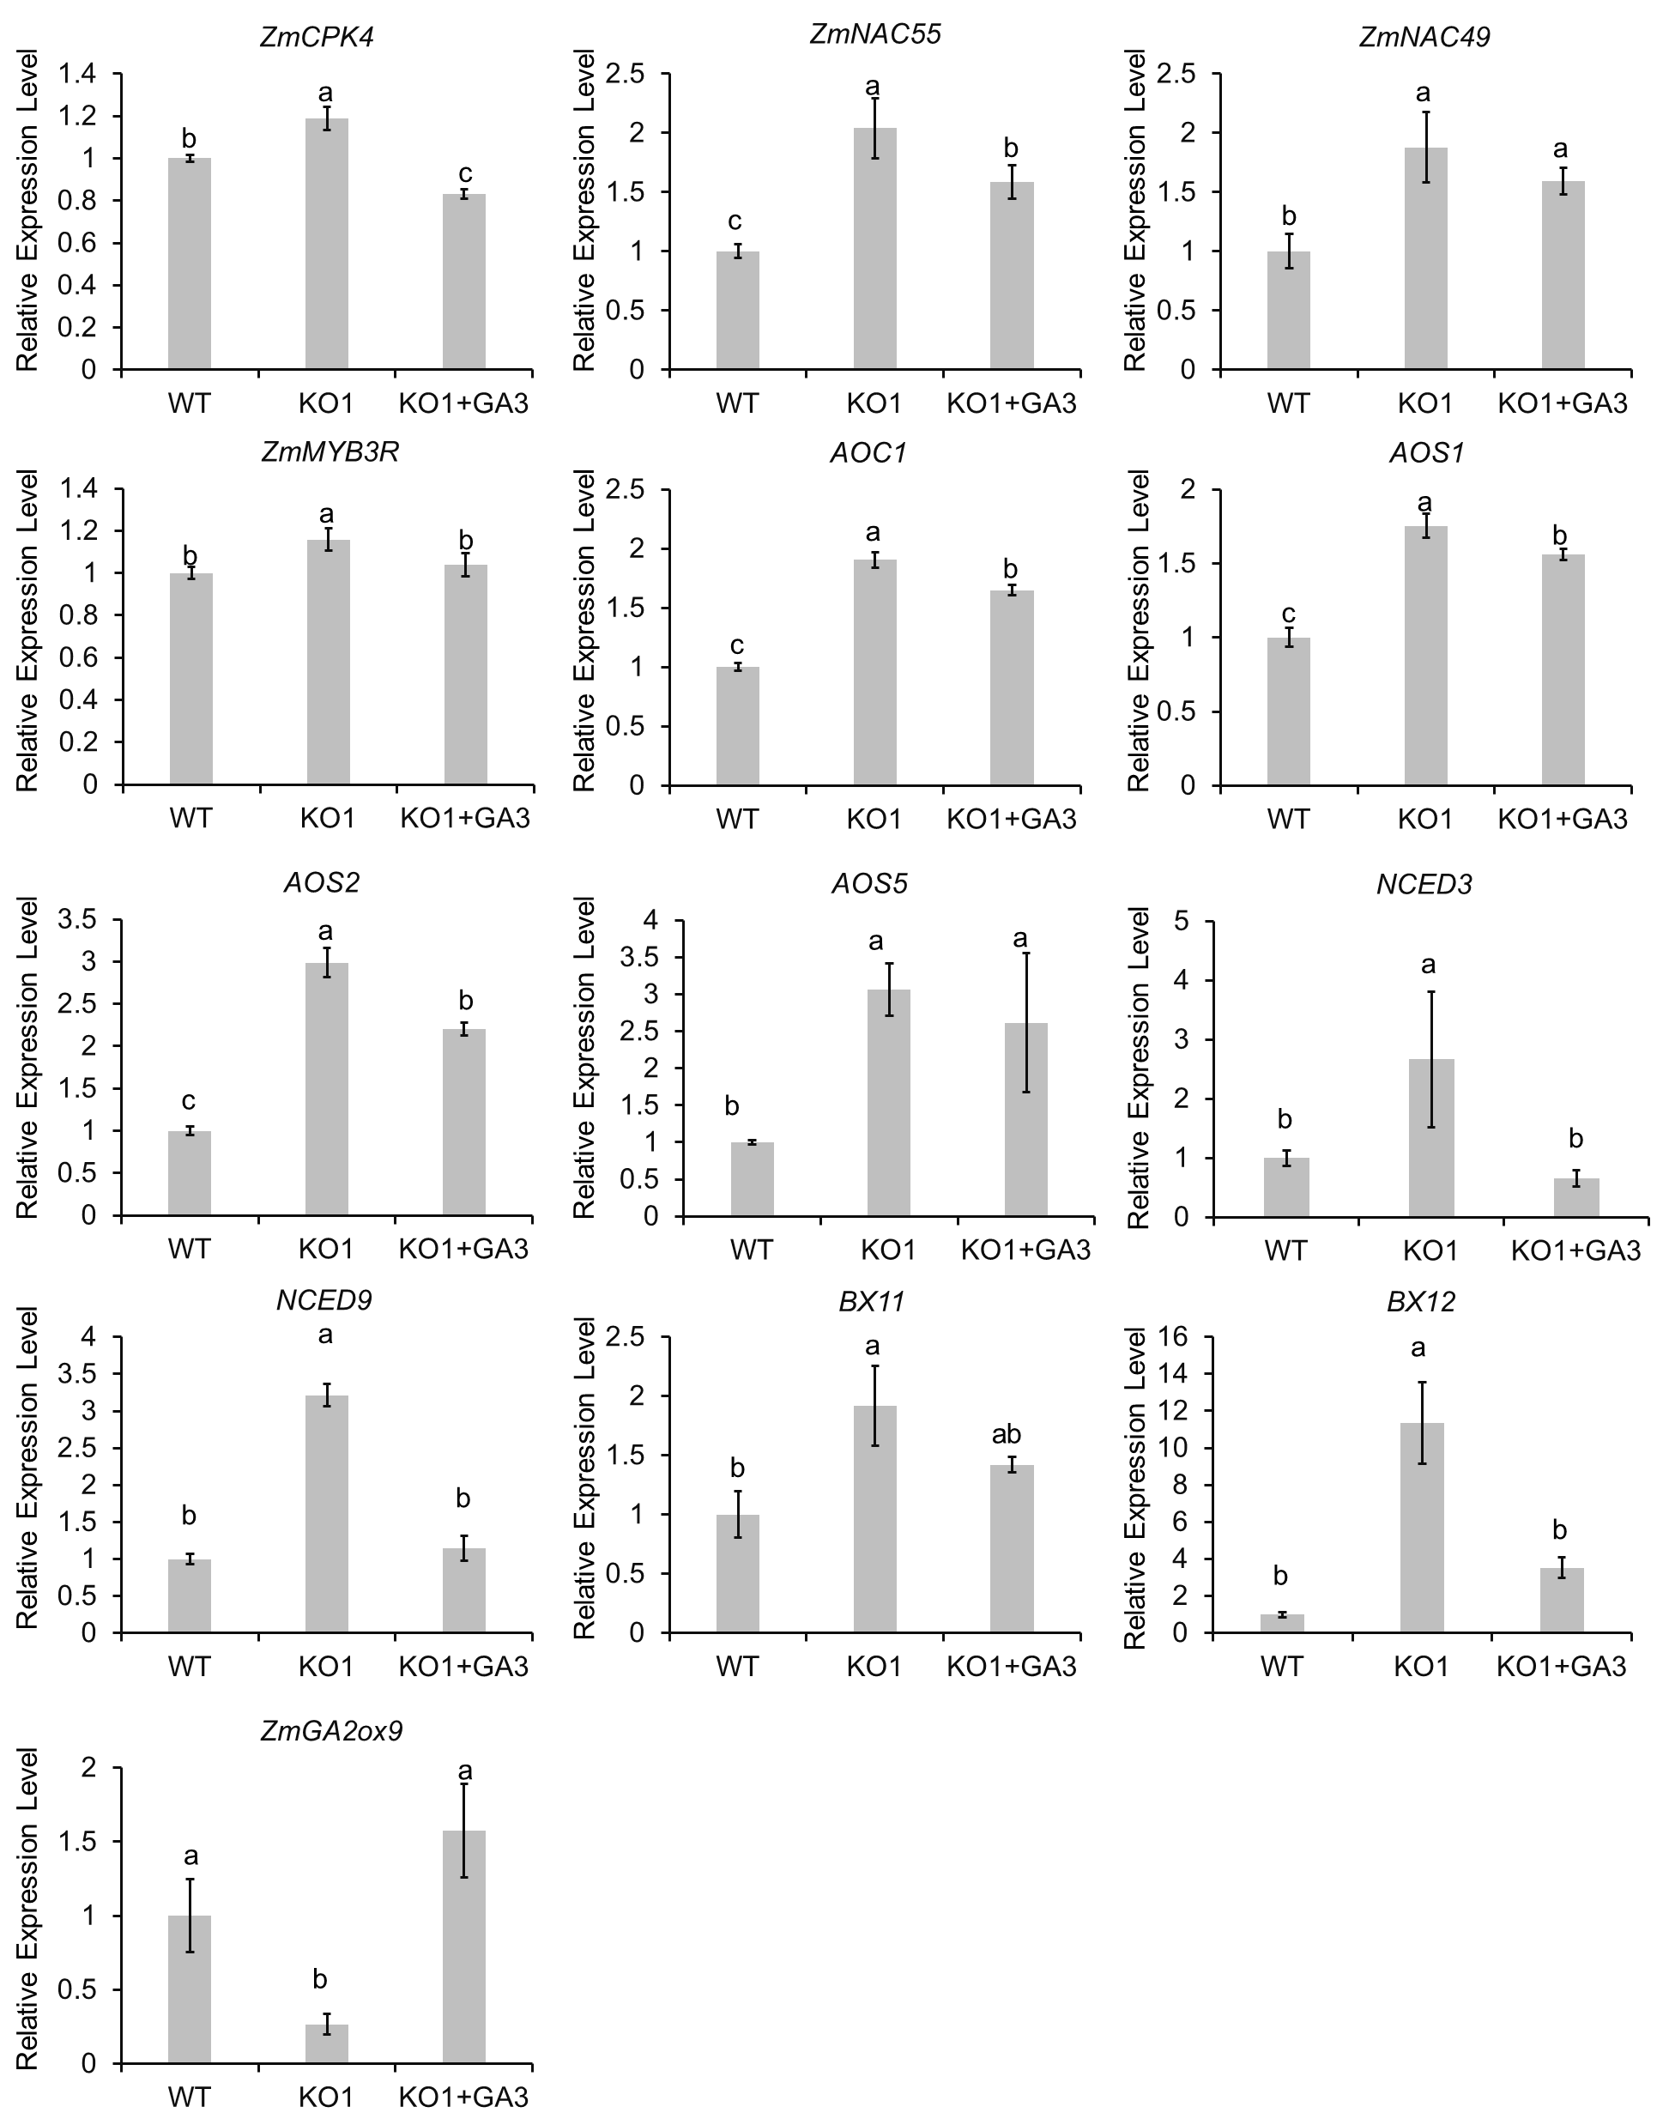
Supplemental Figure 7. The expression level of 13 genes from different pathway in WT, ZmGA20ox-KO without and with GA₃ (+GA3) treatment.

