Supplementary Information

1 Brooks-Gelman-Rubin diagnostic plots and trajectory density plots both show better model convergence (Fig S1 Fig S2). Ranking plots show that 1% tapinarof cream and calcipotriol were superior to placebo for each treatment, and 1% tapinarof cream was superior to calcipotriol(Fig S3). Nodal analysis forest plot showing P>0.05 between direct comparison, indirect comparison and net comparison results for 1% tapinarof cream and calcipotriol, with no statistical difference FigS4. The nodal analysis forest plot shows no statistical difference between the results of direct comparison, indirect comparison and network comparison between 1% tapinarof cream and calcipotriol, with good consistency(P>0.05) (Fig S5). Heterogeneity test forest plot results showed that direct comparisons between 1% tapinarof cream and calcipotriol were less direct comparisons for each course of treatment, 1 RCT at 4 weeks of treatment, 1 RCT at 8 weeks of treatment, and 2 RCTs at 12 weeks of treatment, and the results of direct comparisons (pair-wise) and network comparisons (network) were close for all other study groups, and the hypothesis of homogeneity was satisfied between them. Heterogeneity existed within the I²>50% group for P04 versus C04, P08 versus C08, T08 versus P08, and T12 versus P12 comparisons Fig S5.

Table S1 Treatments
id | description
P04 | Placebo4W
P08 | Placebo8W
P12 | Placebo12W
T04 | Tapinarof4W
T08 | Tapinarof8W
T12 | Tapinarof12W
C04 | Calcipotriol4W
C08 | Calcipotriol8W
C12 | Calcipotriol12W
4W：Course 4 weeks
8W：Course 8 weeks
12W：Course 12 weeks

Table S2 Data
 | study | treatment | responders | sampleSize
Dubertret 1992 | 1 | C04 | 46 | 62
Green 1994 | 2 | C04 | 15 | 25
Kaufmann 2002 | 3 | C04 | 107 | 480
Guenther 2002 | 4 | C04 | 115 | 227
Papp 2003 | 5 | C04 | 103 | 308
Fleming 2010 | 6 | C04 | 3 | 79
Langley 2011 | 7 | C04 | 12 | 184
Cai2020 | 8 | C04 | 51 | 169
Cai2020 | 8 | T04 | 113 | 344
Bissonnette2012 | 9 | T04 | 11 | 40
Stein Gold2021 | 10 | T04 | 5 | 34
Stein Gold2021 | 11 | T04 | 6 | 35
Lebwohl2021_1 | 12 | T04 | 48 | 340
Lebwohl2021_2 | 13 | T04 | 47 | 343
Dubertret 1992 | 1 | P04 | 11 | 62
Green 1994 | 2 | P04 | 4 | 24
Kaufmann 2002 | 3 | P04 | 16 | 157
Guenther 2002 | 4 | P04 | 19 | 206
Papp 2003 | 5 | P04 | 8 | 107
Fleming 2010 | 6 | P04 | 1 | 40
Langley 2011 | 7 | P04 | 1 | 91
Cai2020 | 8 | P04 | 13 | 173
Bissonnette2012 | 9 | P04 | 0 | 21
Stein Gold2021 | 10 | P04 | 1 | 30
Stein Gold2021 | 11 | P04 | 0 | 33
Lebwohl2021_1 | 12 | P04 | 2 | 170
Lebwohl2021_2 | 13 | P04 | 5 | 172
Harrington 1996 | 14 | C08 | 148 | 290
Barber1999 | 15 | C08 | 13 | 28
Jemec 2008 | 16 | C08 | 100 | 272
Fleming 2010 | 17 | C08 | 9 | 79
Langley 2011 | 18 | C08 | 33 | 184
Cai2020 | 19 | C08 | 101 | 169
Cai2020 | 19 | T08 | 203 | 344
Bissonnette2012 | 20 | T08 | 22 | 40
Stein Gold2021 | 21 | T08 | 15 | 34
Stein Gold2021 | 22 | T08 | 13 | 35
Lebwohl2021_1 | 23 | T08 | 96 | 340
Lebwohl2021_2 | 24 | T08 | 105 | 343
PhaseⅡtrial | 25 | T08 | 89 | 120
Harrington 1996 | 14 | P08 | 13 | 71
Barber1999 | 15 | P08 | 1 | 26
Jemec 2008 | 16 | P08 | 31 | 136
Fleming 2010 | 17 | P08 | 0 | 40
Langley 2011 | 18 | P08 | 5 | 91
Cai2020 | 19 | P08 | 42 | 173
Bissonnette2012 | 20 | P08 | 1 | 21
Stein Gold2021 | 21 | P08 | 0 | 30
Stein Gold2021 | 22 | P08 | 0 | 33
Lebwohl2021_1 | 23 | P08 | 4 | 170
Lebwohl2021_2 | 24 | P08 | 8 | 172
PhaseⅡtrial | 25 | P08 | 36 | 115
Fu2018 | 26 | C12 | 8 | 14
Cai2020 | 27 | C12 | 108 | 169
Fu2018 | 26 | T12 | 9 | 23
Cai2020 | 27 | T12 | 228 | 344
Bissonnette2012 | 28 | T12 | 27 | 40
Stein Gold2021 | 29 | T12 | 22 | 34
Stein Gold2021 | 30 | T12 | 20 | 35
Lebwohl2021_1 | 31 | T12 | 120 | 340
Lebwohl2021_2 | 32 | T12 | 138 | 343
Fu2018 | 26 | P12 | 4 | 13
Cai2020 | 27 | P12 | 58 | 173
Bissonnette2012 | 28 | P12 | 1 | 21
Stein Gold2021 | 29 | P12 | 5 | 30
Stein Gold2021 | 30 | P12 | 2 | 33
Lebwohl2021_1 | 31 | P12 | 10 | 170
Lebwohl2021_2 | 32 | P12 | 11 | 172
Highton 1995 | 33 | C04 | 67 | 124
Fleming 2010 | 34 | C04 | 3 | 79
Langley 2011 | 35 | C04 | 12 | 184
Cai2020 | 36 | C04 | 51 | 169
Highton 1995 | 33 | C08 | 87 | 124
Fleming 2010 | 34 | C08 | 9 | 79
Langley 2011 | 35 | C08 | 33 | 184
Cai2020 | 36 | C08 | 101 | 169
Cai2020 | 36 | C12 | 108 | 169
Cai2020 | 37 | T04 | 113 | 344
Bissonnette2012 | 38 | T04 | 11 | 40
Stein Gold2021 | 39 | T04 | 5 | 34
Stein Gold2021 | 40 | T04 | 6 | 35
Lebwohl2021_1 | 41 | T04 | 48 | 340
Lebwohl2021_2 | 42 | T04 | 47 | 343
Cai2020 | 37 | T08 | 203 | 344
Bissonnette2012 | 38 | T08 | 22 | 40
Stein Gold2021 | 39 | T08 | 15 | 34
Stein Gold2021 | 40 | T08 | 13 | 35
Lebwohl2021_1 | 41 | T08 | 96 | 340
Lebwohl2021_2 | 42 | T08 | 105 | 343
Cai2020 | 37 | T12 | 228 | 344
Bissonnette2012 | 38 | T12 | 27 | 40
Stein Gold2021 | 39 | T12 | 22 | 34
Stein Gold2021 | 40 | T12 | 20 | 35
Lebwohl2021_1 | 41 | T12 | 120 | 340
Lebwohl2021_2 | 42 | T12 | 138 | 343
Highton 1995 | 43 | P04 | 9 | 123
Fleming 2010 | 44 | P04 | 1 | 40
Langley 2011 | 45 | P04 | 1 | 91
Cai2020 | 46 | P04 | 13 | 173
Bissonnette2012 | 47 | P04 | 0 | 21
Stein Gold2021 | 48 | P04 | 1 | 30
Stein Gold2021 | 49 | P04 | 0 | 33
Lebwohl2021_1 | 50 | P04 | 2 | 170
Lebwohl2021_2 | 51 | P04 | 5 | 172
Highton 1995 | 43 | P08 | 23 | 123
Fleming 2010 | 44 | P08 | 0 | 40
Langley 2011 | 45 | P08 | 5 | 91
Cai2020 | 46 | P08 | 42 | 173
Bissonnette2012 | 47 | P08 | 1 | 21
Stein Gold2021 | 48 | P08 | 0 | 30
Stein Gold2021 | 49 | P08 | 0 | 33
Lebwohl2021_1 | 50 | P08 | 4 | 170
Lebwohl2021_2 | 51 | P08 | 8 | 172
Cai2020 | 46 | P12 | 58 | 173
Bissonnette2012 | 47 | P12 | 1 | 21
Stein Gold2021 | 48 | P12 | 5 | 30
Stein Gold2021 | 49 | P12 | 2 | 33
Lebwohl2021_1 | 50 | P12 | 10 | 170
Lebwohl2021_2 | 51 | P12 | 11 | 172

FigS1 Brooks-Gelman-Rubin diagnostic plot

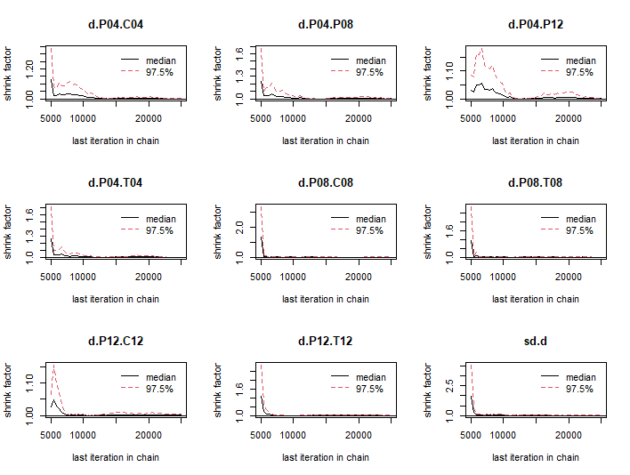

(1) The median value of the shrinkage factor tends to 1 and reaches stability after n iterations of calculation;
(2) 97.5% of the shrinkage factor tends to 1 and reaches stability after n iterations of calculation.
FigS2 Track density plot

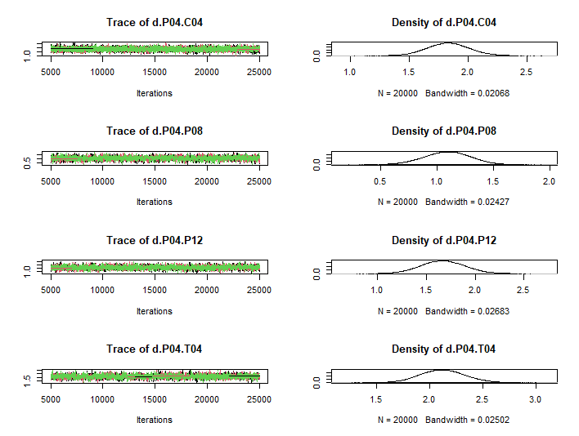
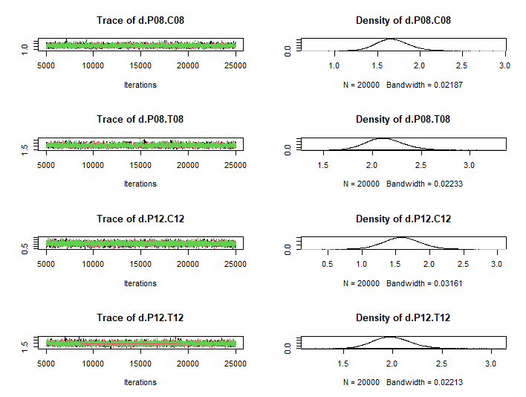
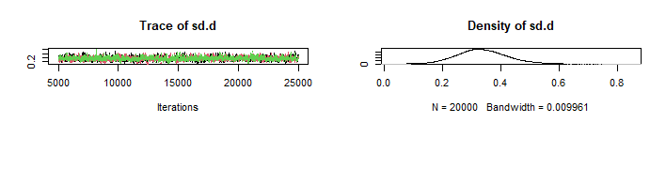
When the number of iterations reaches more than 5000, Markov Chain Monte Carlo (MCMC) chain fluctuations are stable and have good overlap; when the number of iterations reaches 20,000, Bandwith tends to 0 and reaches stability, indicating that the model converges better.
FigS3 Rankogram
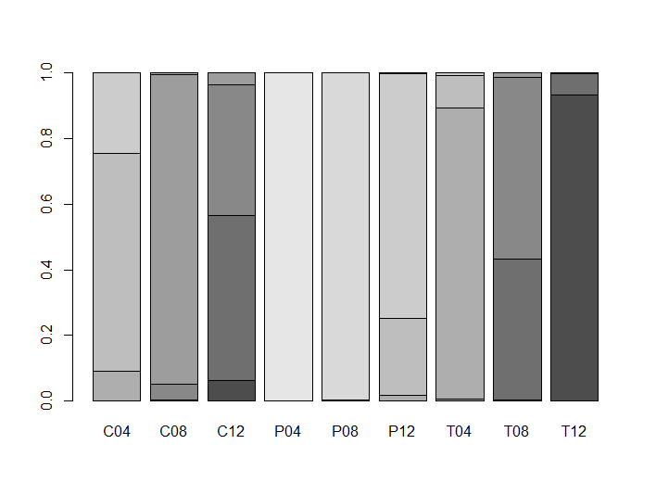
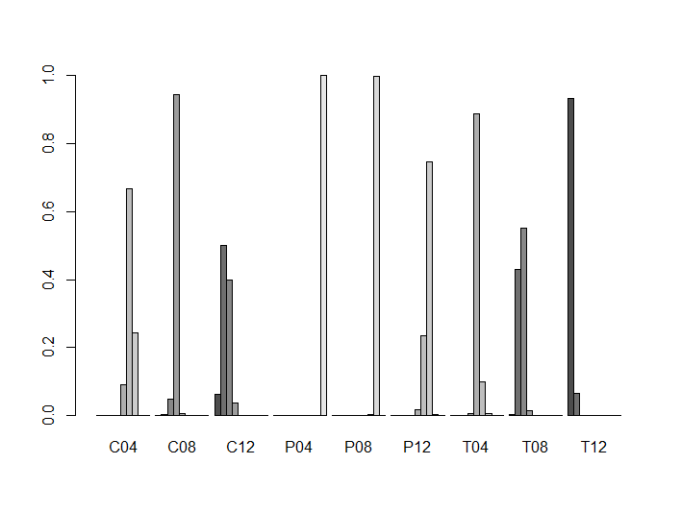
T12＞C12＞T08＞C08＞T04＞C04＞P12＞P08＞P04
T12 row first probability is the largest, P4 row ninth probability is the largest.
FigS4 Nodal analysis forest plot
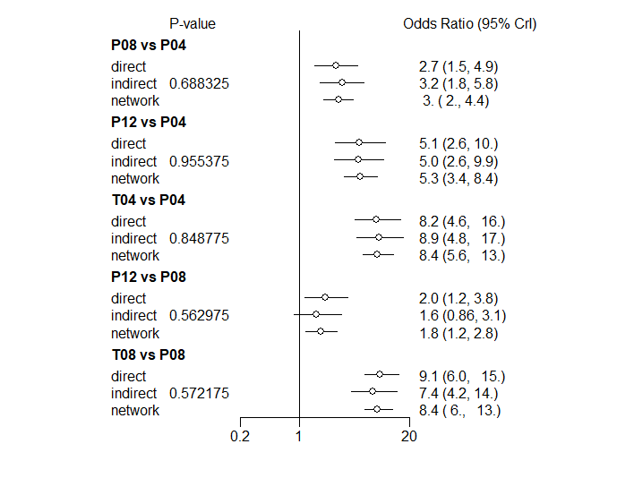
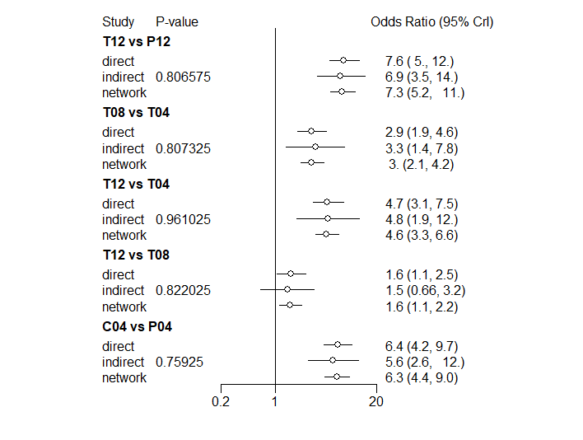
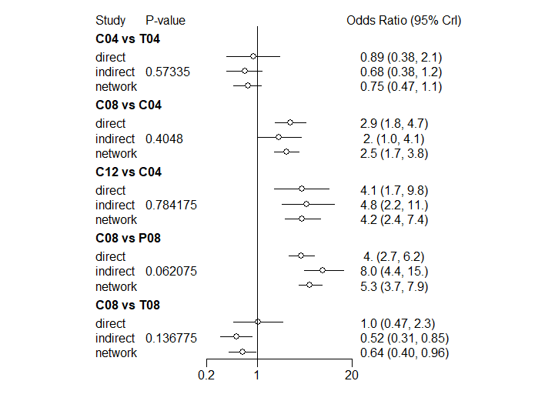
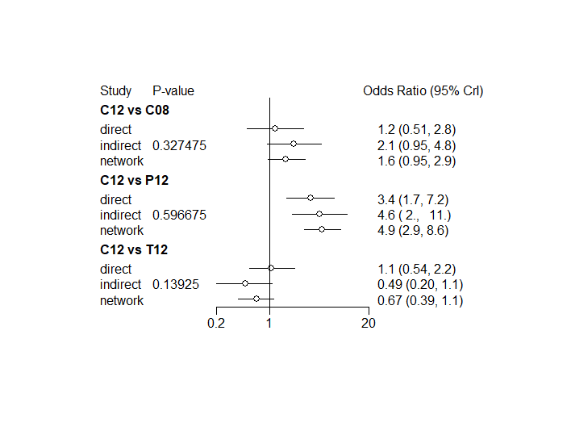

FigS5 Heterogeneity test forest plot
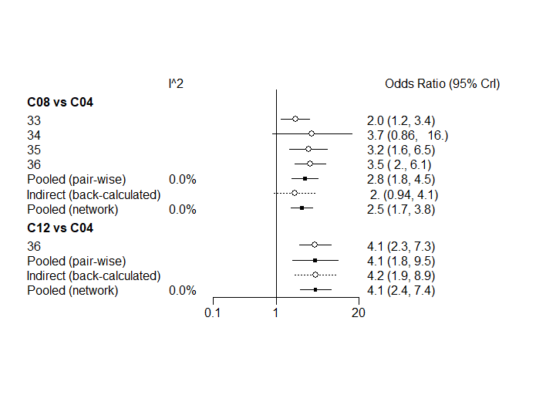

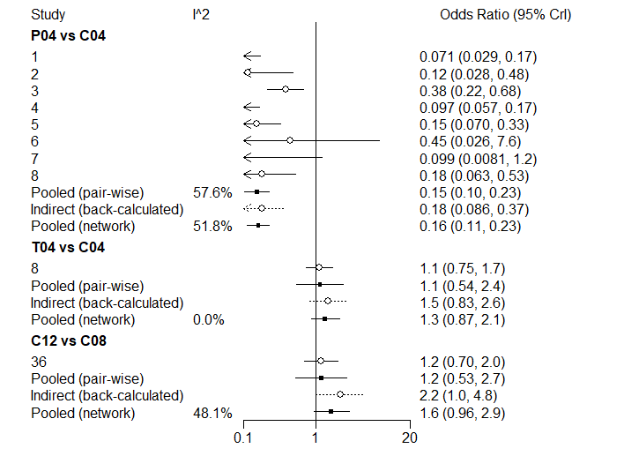
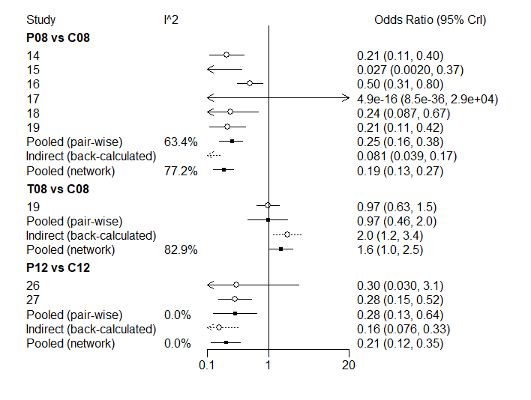
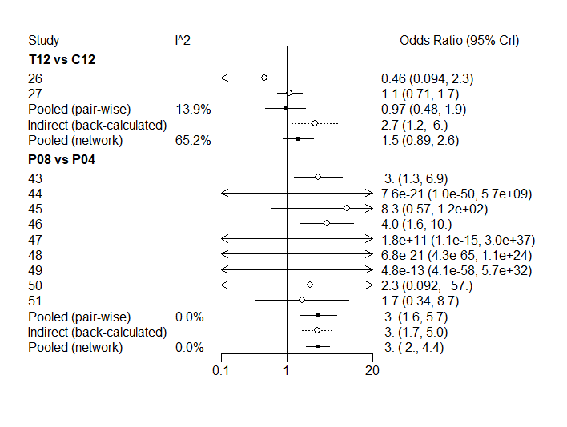
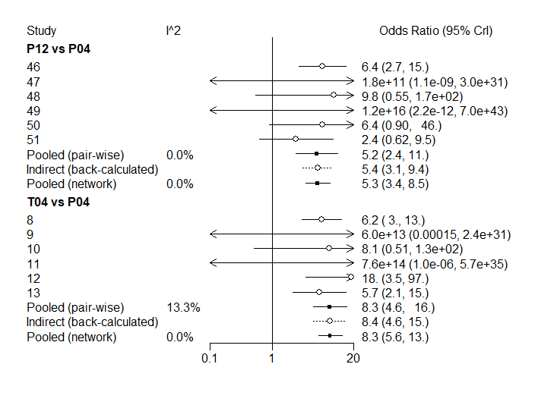

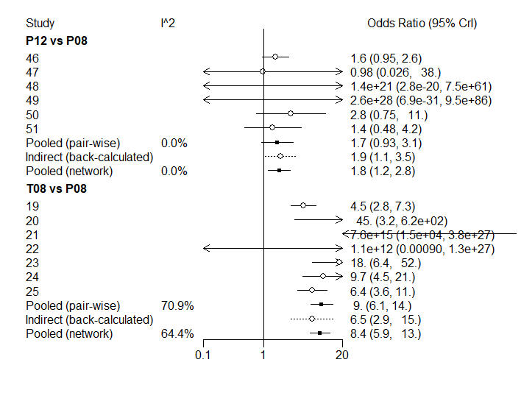

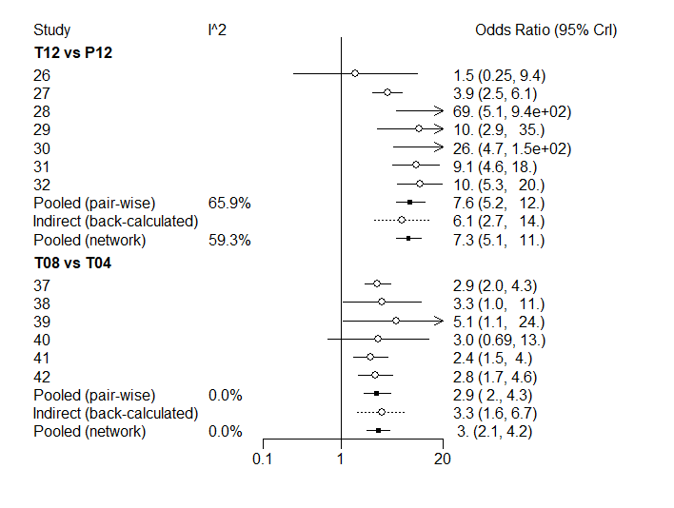
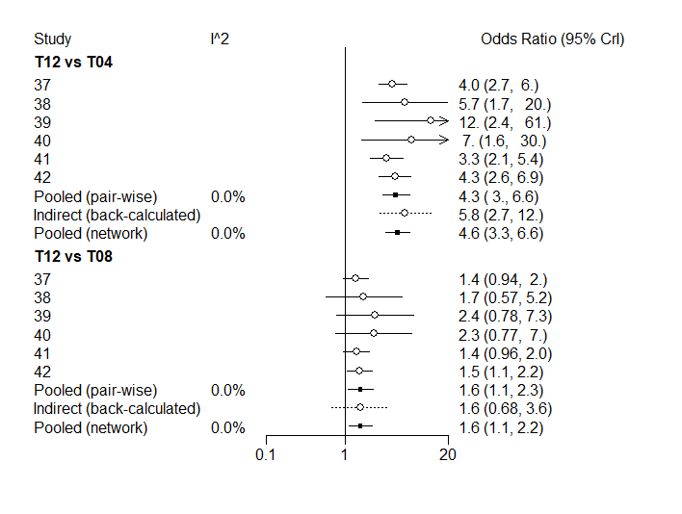

2 Brooks-Gelman-Rubin diagnostic plots and trajectory density plots both show better model convergence(Fig S6 Fig S7). Ranking plots also show that 1% tapinarof cream has a higher incidence of adverse events than calcipotriol and calcipotriol has a higher incidence than placebo(Fig S8). The nodal analysis forest plot shows no statistical difference between the results of direct comparison, indirect comparison and network comparison between 1% tapinarof cream and calcipotriol, with good consistency (P=0.3018>0.05) (Fig S9). Forest plot results of the heterogeneity test showed that there were only 2 direct comparisons between 1% tapinarof cream and calcipotriol, with I²<25% in each study group, and there was no heterogeneity in the comparisons. The results of direct comparison (pair-wise) and network comparison (network) were close and the hypothesis of homogeneity was satisfied between them (Fig S10).

Table S3 Treatments (Adverse event)
id | description
P | Placebo
T | Tapinarof
C | Calcipotriol
4W：Course 4 weeks
8W：Course 8 weeks
12W：Course 12 weeks

Table S4 Data (Adverse event)
 | study | treatment | responders | sampleSize
Staberg1989 | 1 | P | 1 | 10
Dubertret 1992 | 2 | P | 16 | 66
Green 1994 | 3 | P | 7 | 24
Highton 1995 | 4 | P | 21 | 138
Harrington 1996 | 5 | P | 20 | 87
Kang1998 | 6 | P | 0 | 15
Kaufmann 2002 | 7 | P | 21 | 157
Guenther 20020 | 8 | P | 26 | 208
Papp 2003 | 9 | P | 17 | 108
Fleming 2010 | 10 | P | 10 | 40
Levine 2010 | 11 | P | 11 | 48
Langley 2011 | 12 | P | 18 | 135
Fu2018 | 13 | P | 5 | 13
Cai2020 | 14 | P | 54 | 173
Bissonnette2012 | 15 | P | 11 | 21
Zang2016 | 16 | P | 3 | 12
Robbins2019 | 17 | P | 9 | 37
Robbins2019 | 18 | P | 11 | 38
Lebwohl2021_1 | 19 | P | 38 | 170
Lebwohl2021_2 | 20 | P | 45 | 172
Staberg1989 | 1 | C | 1 | 10
Dubertret 1992 | 2 | C | 14 | 66
Green 1994 | 3 | C | 5 | 25
Highton 1995 | 4 | C | 28 | 139
Harrington 1996 | 5 | C | 87 | 327
Kang1998 | 6 | C | 2 | 15
Kaufmann 2002 | 7 | C | 54 | 480
Guenther 20020 | 8 | C | 45 | 227
Papp 2003 | 9 | C | 53 | 308
Fleming 2010 | 10 | C | 8 | 79
Levine 2010 | 11 | C | 9 | 48
Langley 2011 | 12 | C | 35 | 266
Fu2018 | 13 | C | 3 | 14
Cai2020 | 14 | C | 61 | 169
Bissonnette2012 | 15 | T | 32 | 40
Zang2016 | 16 | T | 5 | 8
Fu2018 | 13 | T | 13 | 23
Cai2020 | 14 | T | 197 | 344
Robbins2019 | 17 | T | 27 | 38
Robbins2019 | 18 | T | 20 | 38
Lebwohl2021_1 | 19 | T | 171 | 340
Lebwohl2021_2 | 20 | T | 187 | 343

FigS6 Brooks-Gelman-Rubin diagnostic plot(Adverse event)
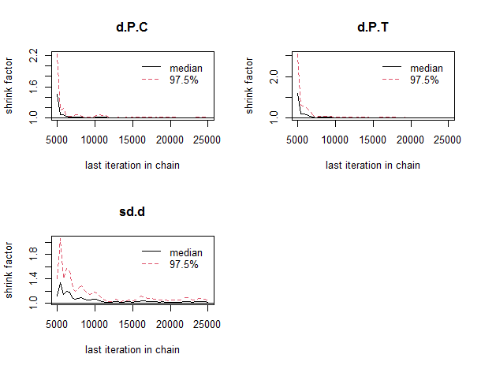

(1) The median value of the shrinkage factor tends to 1 and reaches stability after n iterations of calculation;
(2) 97.5% of the shrinkage factor tends to 1 and reaches stability after n iterations of calculation.

FigS7 Track density plot(Adverse event)
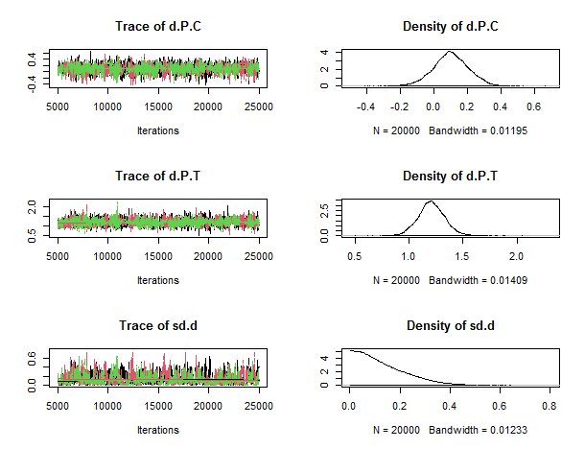

When the number of iterations reaches more than 5000, Markov Chain Monte Carlo (MCMC) chain fluctuations are stable and have good overlap; when the number of iterations reaches 20,000, Bandwith tends to 0 and reaches stability, indicating that the model converges better.

Fig S8 Rankogram(Adverse event)

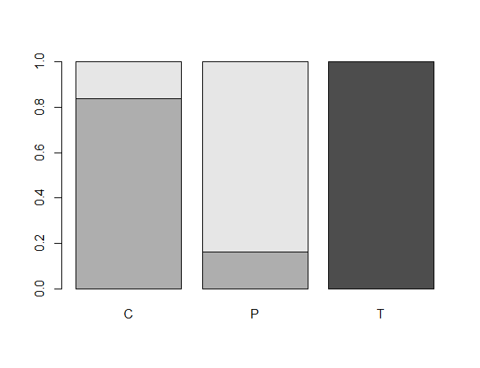
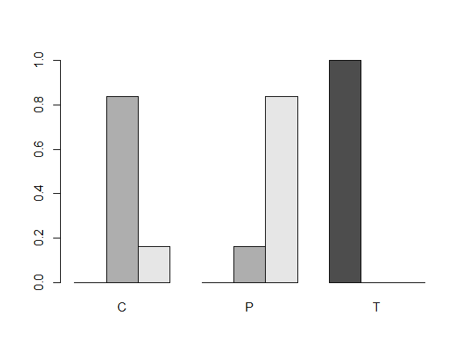
T＞C＞P

T has the highest probability of ranking first,
P has the highest probability of ranking third.

FigS9 Nodal analysis forest plot(Adverse event)
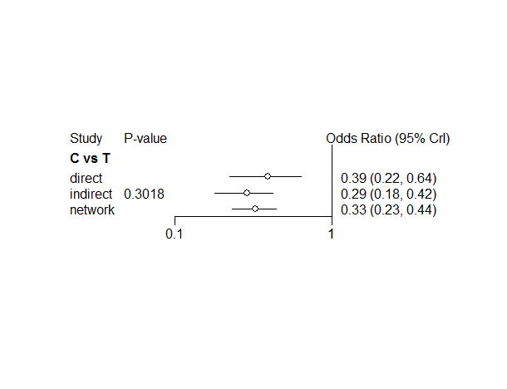

FigS10 Heterogeneity test forest plot (Adverse event)
