Forced degradation study of Febuxostat: Isolation and structural characterization of degradation products
Rajesh Kanagaddi^{a,b}, N Satyashree^{b}*, Naresh Kumar Katari^{c}, Suresh Salakolusuª, JNSRC Murtyª, Mahesh Rangaª, Muralidharan Kaliyaperumalª
Analytical data for DP-2:
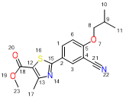
Exact Mass: 330.10
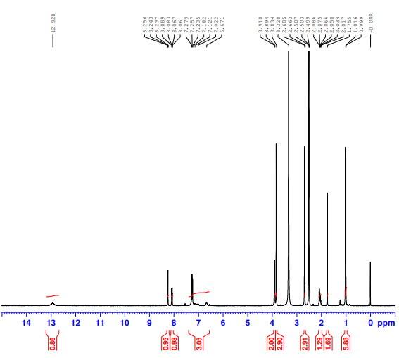
DP-2- ¹H NMR

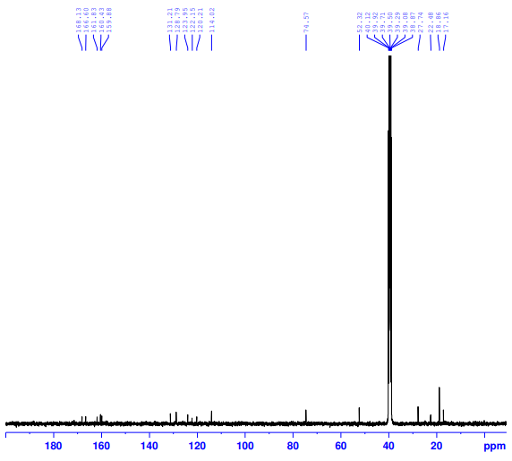
DP-2- ¹³C NMR
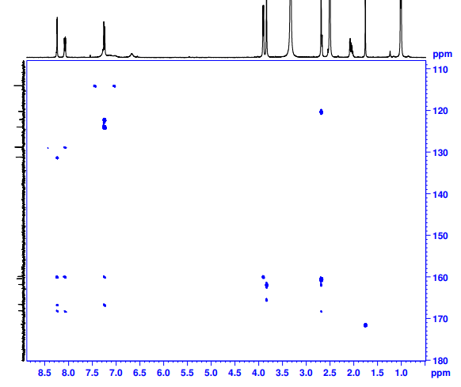
DP-2- HMBC NMR
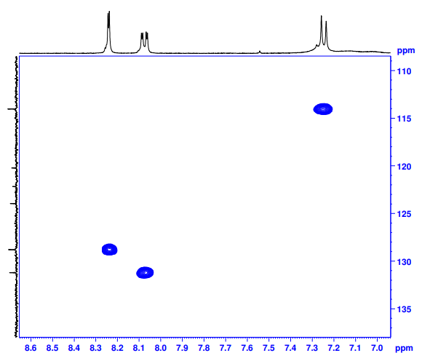
DP-2- HSQC NMR
Febuxostat- DP-2-HRMS
