Forced degradation study of Febuxostat: Isolation and structural characterization of degradation products
Rajesh Kanagaddi^{a,b}, N Satyashree^{b}*, Naresh Kumar Katari^{c}, Suresh Salakolusuª, JNSRC Murtyª, Mahesh Rangaª, Muralidharan Kaliyaperumalª
Analytical data for DP-3:
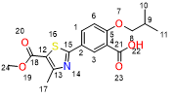
Exact Mass: 330.10
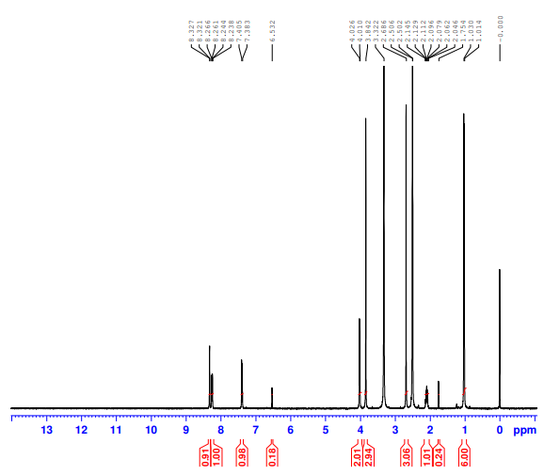
DP-3- ¹H NMR

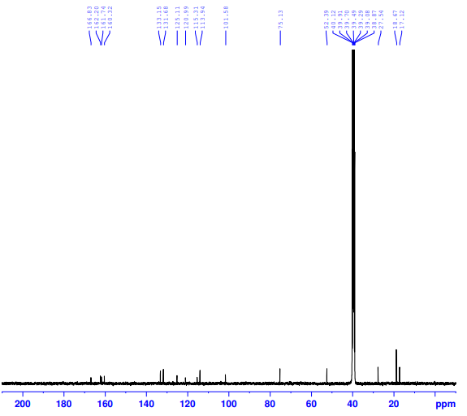
DP-3- ¹³C NMR

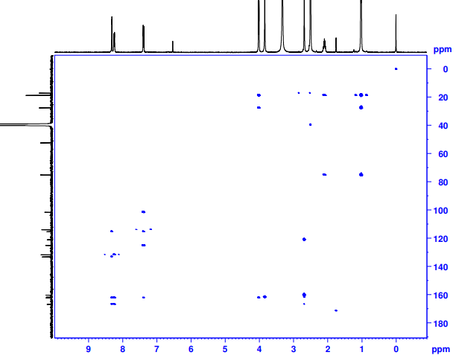
DP-3- HMBC NMR
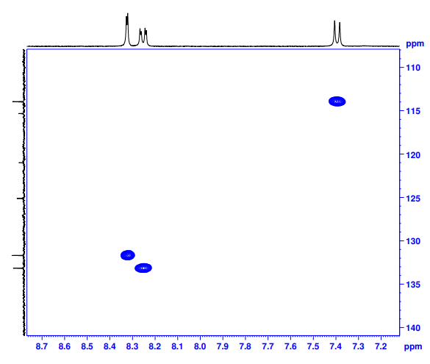
DP-3- HSQC NMR
Febuxostat- DP-3-HRMS
