Forced degradation study of Febuxostat: Isolation and structural characterization of degradation products
Rajesh Kanagaddi^{a,b}, N Satyashree^{b}*, Naresh Kumar Katari^{c}, Suresh Salakolusuª, JNSRC Murtyª, Mahesh Rangaª, Muralidharan Kaliyaperumalª
Analytical data for DP-1:
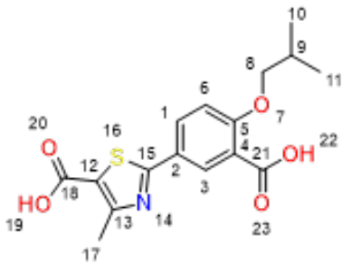
Exact Mass: 335.08
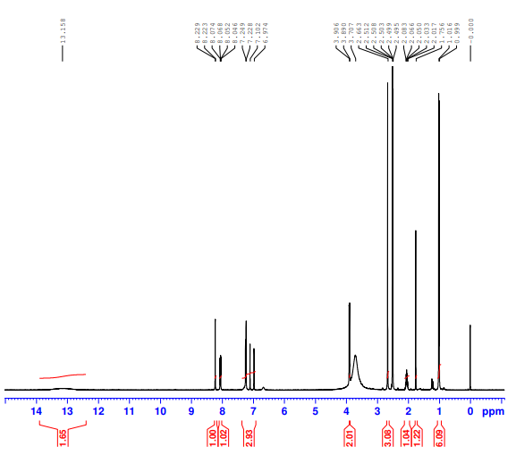
DP-1- ¹H NMR
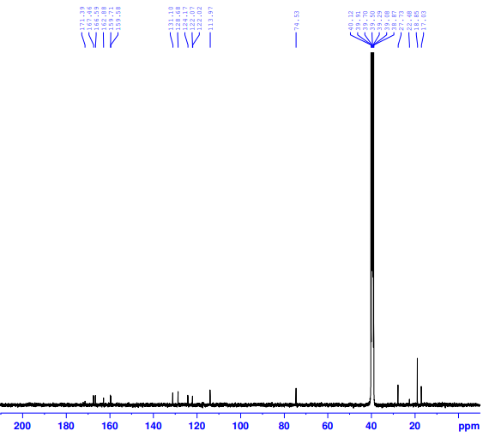
DP-1- ¹³C NMR

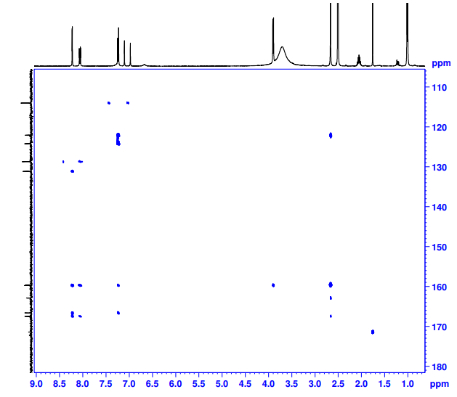
DP-1- HMBC NMR

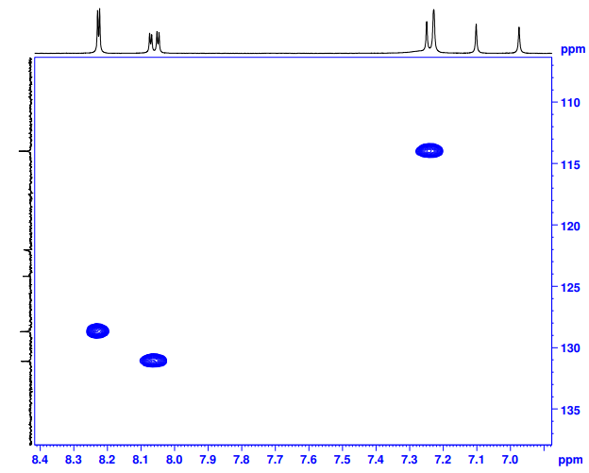
DP-1- HSQC NMR
Febuxostat- DP-1-HRMS
