Forced degradation study of Febuxostat: Isolation and structural characterization of degradation products
Rajesh Kanagaddi^{a,b}, N Satyashree^{b}*, Naresh Kumar Katari^{c}, Suresh Salakolusuª, JNSRC Murtyª, Mahesh Rangaª, Muralidharan Kaliyaperumalª
Analytical data for Febuxostat API:
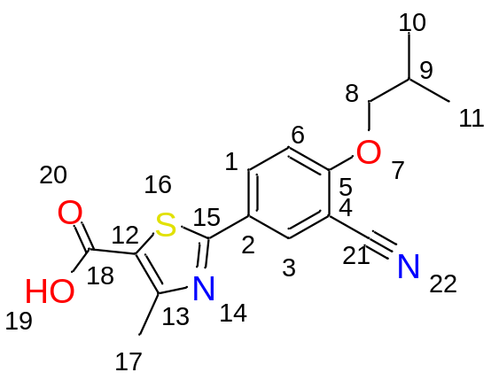
Exact Mass: 316.09
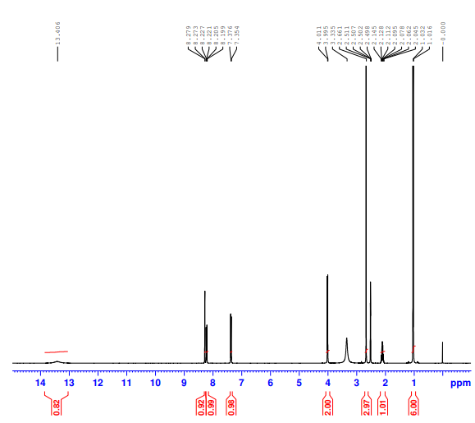
Febuxostat- API ¹H NMR

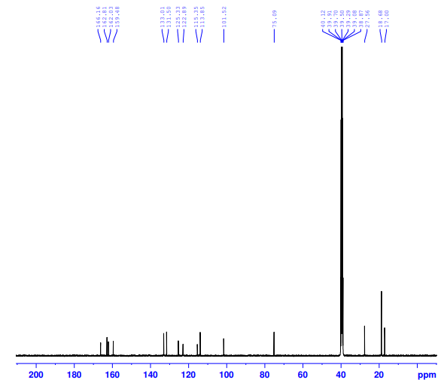
Febuxostat- API ¹³C NMR
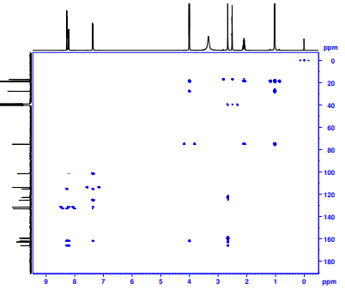
Febuxostat- API ¹³C HMBC
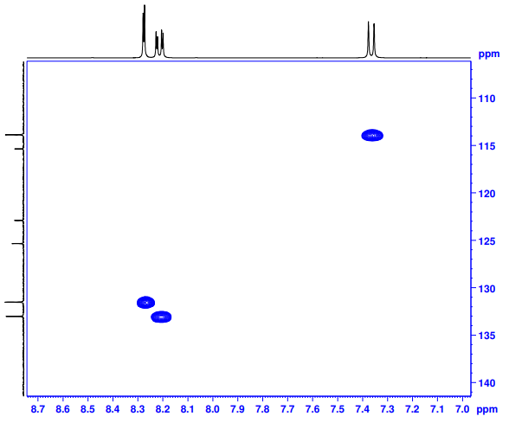
Febuxostat- API ¹³C HSQC

Febuxostat- API-HRMS
