Forced degradation study of Febuxostat: Isolation and structural characterization of degradation products
Rajesh Kanagaddi^{a,b}, N Satyashree^{b}*, Naresh Kumar Katari^{c}, Suresh Salakolusuª, JNSRC Murtyª, Mahesh Rangaª, Muralidharan Kaliyaperumalª
Analytical data for DP-4:
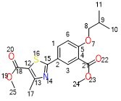
Exact Mass: 363.11
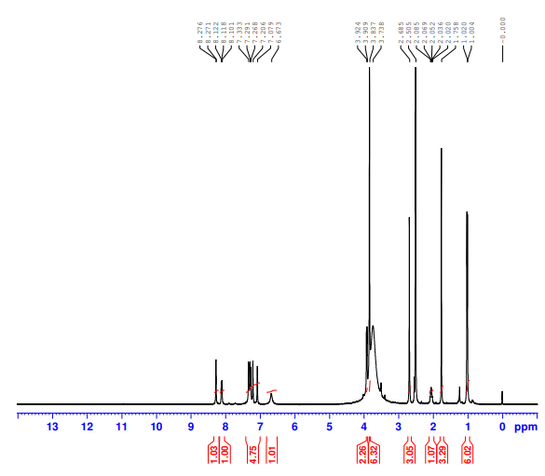
DP-4- ¹H NMR
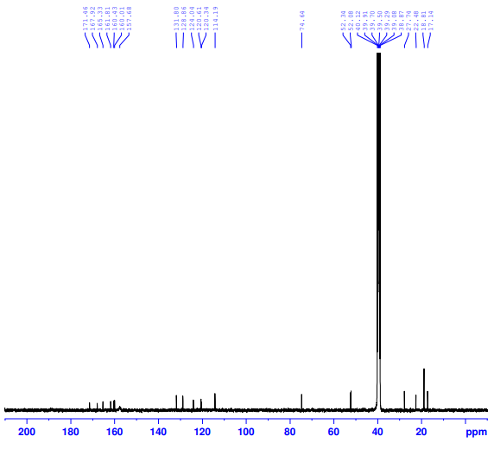
DP-4- ¹³C NMR

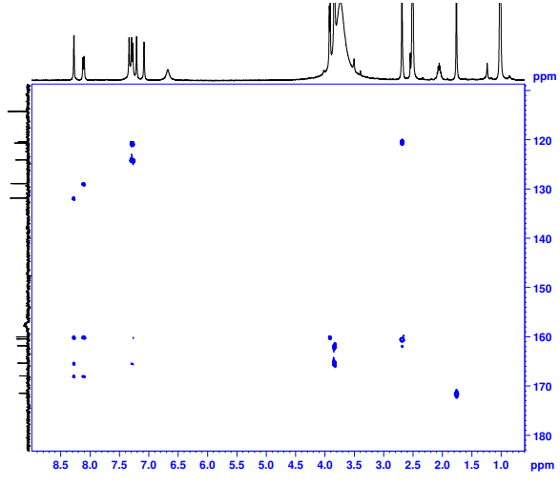
DP-4- HMBC NMR
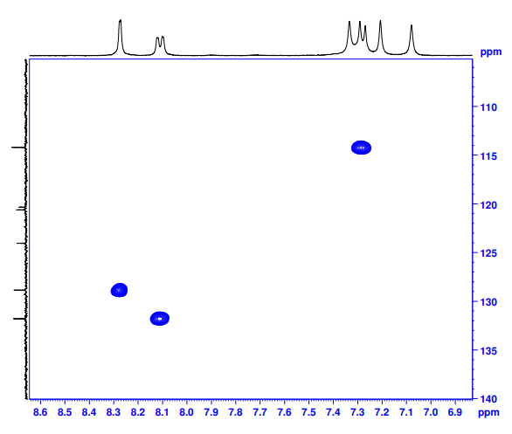
DP-4- HMBC NMR
Febuxostat- DP-2-HRMS
