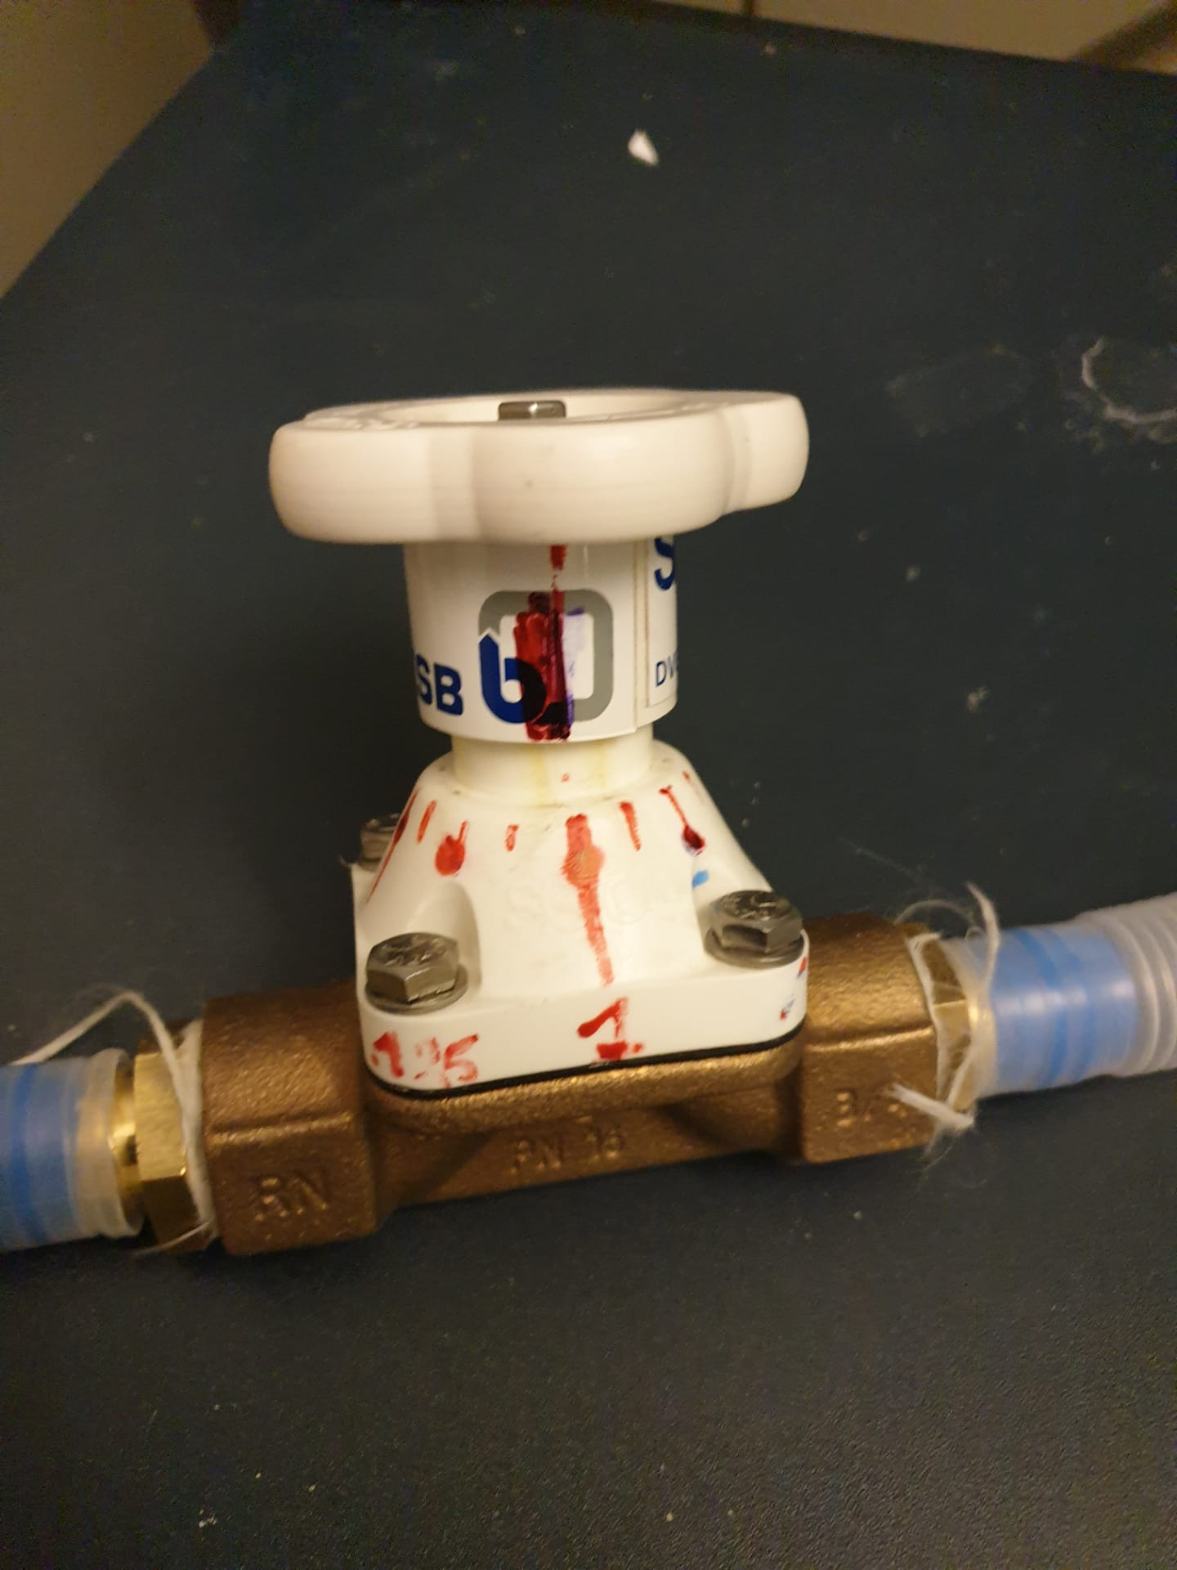
Supplemental figure 1. We used a diaphragm valve and marked it to reproduce the same level of valve closure in different experiments.

