Supplementary information for “Dust events control nitrogen cycling and nitrate/(per)chlorate relationships on Mars”
Wenshuo Mao¹, Xiaohui Fu^{1,5}*, Zhongchen Wu¹*, Jiang Zhang¹, Zongcheng Ling^{1,5}, Yang Liu², Yu-Yan Sara Zhao^{3,5}, Jiacheng Liu⁴, He Cui^{6,9}, Hitesh G. Changela^{7,8}, Yuheng Ni¹, Fabao Yan¹⁰, Joseph R. Michalski⁴

¹Shandong Key Laboratory of Optical Astronomy and Solar-Terrestrial Environment, School of Space Science and Physics, Institute of Space Sciences, Shandong University, Weihai, China
²State Key Laboratory of Space Weather, National Space Science Center, Chinese Academy of Sciences, Beijing, China
³International Center for Planetary Science, College of Earth Science, Chengdu University of Technology, Chengdu, China.
⁴Deparment of Earth Sciences and Laboratory for Space Research, The University of Hong Kong, Hong Kong, China.
⁵CAS Center for Excellence in Comparative Planetology, Hefei, China
⁶College of Life Sciences,Wuchang University of Technology,Wuhan,China
⁷J’Heyrovski Institute of Physical Chemistry, Czech Academy of Sciences, Prague, Czech Republic
⁸Department of Earth & Planetary Science, University of New Mexico, Albuquerque, New Mexico, USA
⁹Technical Center of Qingdao Customs, Qingdao, China.
¹⁰School of Mechanical Electrical and Information Engineering, Shandong University, Weihai, China

*Corresponding author. Email: fuxh@sdu.edu.cn; z.c.wu@sdu.edu.cn

This word file includes:

Figure S1. Raman spectra of the NaCl phases and ESD products with various simulation gas.
Figure S2. Mid-IR spectra of the NaCl phases and ESD products with various simulation gas.
Figure S3. The relationship between nitrate and (per)chlorate on Mars, Earth and other extraterrestrial samples
Figure S4. Schematic diagram of the SDU Mars chamber used for the ESD experiments.
Table S1. The content of NO₃⁻, ClO₃⁻ and ClO₄⁻ formed in the ESD products.

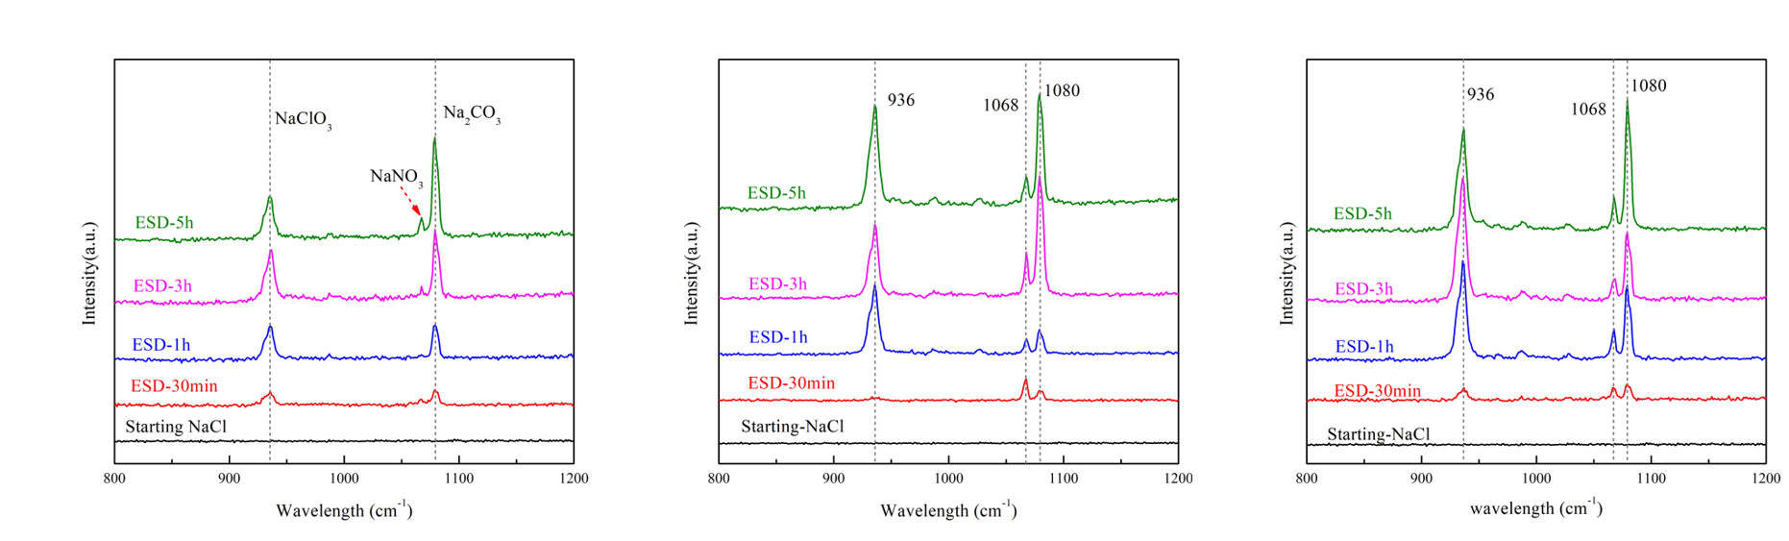
Figure S1. Raman spectra of the NaCl phases and ESD products with different simulation gas. a) Mars atmosphere simulation gas; b) 90% CO₂ with 10% N₂; c) 80% CO₂ with 20% N₂. The newly formed oxychloride, nitrate and carbonates after the ESD process show Raman peaks in the range (900-1200cm⁻¹).

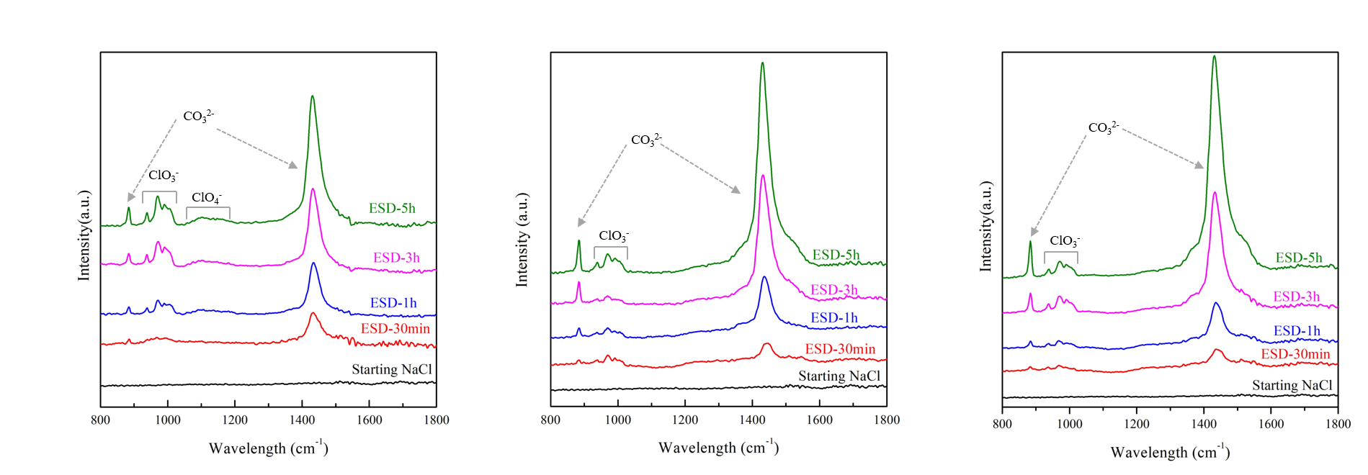
Figure S2. Mid-IR spectra of the NaCl phases and ESD products with different simulation gas. a) Mars atmosphere simulation gas; b) 90% CO₂ with 10% N₂; c) 80% CO₂ with 20% N₂. The newly formed oxychloride, and carbonates after the ESD process show Mid-IR spectra in the range (800-1600 cm⁻¹).

Figure S3. The relationship between nitrate and (per)chlorate on Mars, Earth and other extraterrestrial samples. Measurements at Gale crater indicate that nitrate/(per)chlorate ratio on Mars is lower than other extraterrestrial samples and Earth. Our experimentally obtained nitrate/(per)chlorate ratio is 0.28 ± 0.19 which is similar to the measurements at Gale crater (0.23 ± 0.12). The figure is modified from Stern et al¹.
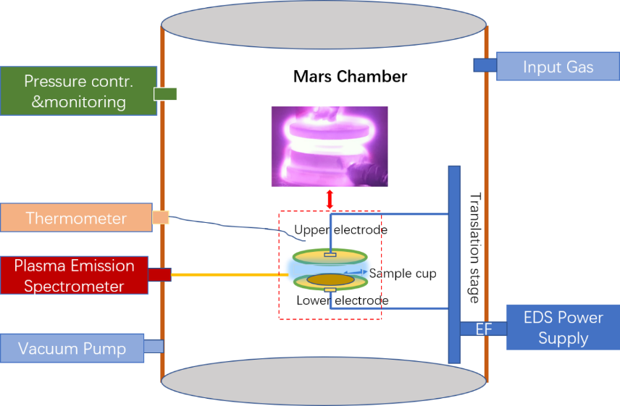
Figure S4. Schematic diagram of the Mars chamber used for the ESD experiments with an inset photo of the two copper electrodes showing a plasma generated by the ESD. A SiO₂ glass cell filled with powdered sample rested on the lower electrode. ‘EF’ represents electronic feedthrough.

Table S1 The content of NO₃⁻, ClO₃⁻ and ClO₄⁻ formed in the ESD products.
Sample | Total mass(g) | NO₃²⁻(nmol) | ClO₃⁻(nmol) | ClO₄⁻(nmol) | ClO_{x}⁻ yield (%) | NO₃²⁻/ClO_{x}⁻ molar ratios
MASG-ESD-30min | 0.2651 | 0.2905 | 1.156 | 0.0074 | 2.55E-02 | 0.25±0.0173
MASG-ESD-30min | 0.2634 | 0.3060 | 0.965 | 0.0073 | 2.14E-02 | 0.31±0.0228
MASG-ESD-1h | 0.2669 | 0.3083 | 1.598 | 0.0189 | 3.50E-02 | 0.19±0.0020
MASG-ESD-1h | 0.2671 | 0.3164 | 1.232 | 0.0121 | 2.70E-02 | 0.25±0.0065
MASG-ESD-3h | 0.2649 | 0.3615 | 3.743 | 0.0769 | 8.27E-02 | 0.09±0.0001
MASG-ESD-3h | 0.2632 | 0.3474 | 5.232 | 0.0754 | 1.16E-01 | 0.07±0.0001
MASG-ESD-5h | 0.2618 | 0.3755 | 5.236 | 0.1137 | 1.17E-01 | 0.07±0.0001
MASG-ESD-5h | 0.2638 | 0.4072 | 6.666 | 0.1320 | 1.48E-01 | 0.06±0.0001
2%-N2-ESD-30min | 0.2604 | 0.3116 | 0.957 | 0.0068 | 2.15E-02 | 0.32±0.0272
2%-N2-ESD-1h | 0.2600 | 0.2993 | 1.124 | 0.0108 | 2.53E-02 | 0.26±0.0087
2%-N2-ESD-3h | 0.2670 | 0.3478 | 4.956 | 0.0706 | 1.09E-01 | 0.07±0.0001
2%-N2-ESD-5h | 0.2628 | 0.3686 | 5.665 | 0.1262 | 1.26E-01 | 0.06±0.0001
10%-N2-ESD-30min | 0.2671 | 0.3050 | 0.832 | 0.0055 | 1.82E-02 | 0.36±0.0453
10%-N2-ESD-30min | 0.2663 | 0.3643 | 0.941 | 0.0048 | 2.07E-02 | 0.39±0.0620
10%-N2-ESD-1h | 0.2613 | - | 1.005 | 0.0123 | 2.25E-02 | -
10%-N2-ESD-1h | 0.2646 | 0.4125 | 1.302 | 0.0128 | 2.88E-02 | 0.31±0.0073
10%-N2-ESD-3h | 0.2617 | 0.4407 | 2.705 | 0.0484 | 6.05E-02 | 0.16±0.0003
10%-N2-ESD-3h | 0.2657 | 0.4706 | 3.532 | 0.0550 | 7.78E-02 | 0.13±0.0002
10%-N2-ESD-5h | 0.2617 | 0.4137 | 2.090 | 0.0366 | 4.67E-02 | 0.19±0.0006
10%-N2-ESD-5h | 0.2651 | - | 3.302 | 0.0693 | 7.29E-02 | -
20%-N2-ESD-30min | 0.2633 | 0.2779 | 0.640 | 0.0021 | 1.42E-02 | 0.43±0.3685
20%-N2-ESD-30min | 0.2621 | 0.2846 | 0.515 | 0.0024 | 1.15E-02 | 0.55±0.3547
20%-N2-ESD-1h | 0.2740 | 0.4824 | 0.574 | 0.0073 | 1.23E-02 | 0.83±0.0576
20%-N2-ESD-1h | 0.2623 | 0.5706 | 0.729 | 0.0057 | 1.63E-02 | 0.78±0.0910
20%-N2-ESD-3h | 0.2637 | 0.4545 | 1.582 | 0.0226 | 3.51E-02 | 0.28±0.0021
20%-N2-ESD-3h | 0.2626 | 0.4483 | 1.444 | 0.0174 | 3.22E-02 | 0.31±0.0039
20%-N2-ESD-5h | 0.2729 | 0.4156 | 1.317 | 0.0272 | 2.82E-02 | 0.31±0.0015
20%-N2-ESD-3h | 0.2642 | 0.4549 | 1.522 | 0.0228 | 3.37E-02 | 0.29±0.0022

Reference
1 Stern, J. C. et al. The nitrate/(per)chlorate relationship on Mars. Geophysical Research Letters 44, 2643-2651, doi:10.1002/2016gl072199 (2017).

