Supplementary Information

for
His₁-tagged DM or DDM detergent micelles are reversibly conjugated by nickel ions

Mitra Lal ¹, Ellen Wachtel ², Soumyaranjan Pati ³,
Irishi. N. N. Namboothiri ³ and Guy Patchornik ^{1*}

¹ Department of Chemical Sciences, Ariel University, 70400, Ariel, Israel.
² Faculty of Chemistry, Weizmann Institute, Rehovot 761001, Israel.

³ Department of Chemistry, Indian Institute of Technology Bombay, Powai, Mumbai
400076, India.

*Corresponding author:
Email: guyp@ariel.ac.il

Section S1. NMR spectral analysis of (S)-2-decanamido-3-(1H-imidazol-4-yl)propanoic acid (compound 3 in Figure 1B). Off white Solid; Yield 650 mg, 35%; mp 131-133 ºC; IR (KBr, cm⁻¹) 3153 (s), 2922 (vs), 2851 (vs), 1725 (s), 1714 (s), 1635 (vs), 1601 (vs), 1466 (m), 1399 (vs), 1252 (m), 1181 (m), 851 (m), 628 (m); ¹H NMR (Acetone-d₆, 400 MHz) δ 0.92 (t, J = 8.3 Hz, 3H), 1.32-1.36 (unresolved m, 12H), 1.64 (quint, J = 9.1 Hz, 2H), 2.27 (t, J = 9.1 Hz, 2H), 3.02-3.04 (unresolved m, overlaps with H₂O, 1H), 3.35-3.36 (unresolved m, 1H), 4.61, 4.65 (ABqd, J = 14.8 Hz, the upper half and lower half are further split into d with J = 8.5 and 6.0, respectively, 2H), 7.06 (s, 1H), 7.62 (d, J = 8.5 Hz, 1H), 7.82 (s, 1H); ¹³C NMR (D₂O, 100) δ 13.7, 22.5, 25.5, 27.6, 29.1, 29.2, 29.3, 29.4, 31.8, 35.9, 54.2, 116.7, 130.1, 133.1, 175.1, 176.5; HRMS (ES+) calculated for C₁₆H₂₈N₃O₃ (MH⁺) 310.2125, found 310.2124.

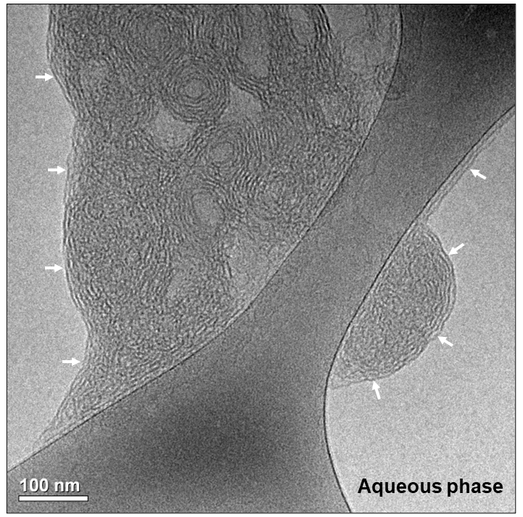
Figure S1: Cryo-TEM image of DDM micelles (1.25 mM detergent) conjugated with 1 mM [(bathophenanthroline)₃:Fe²⁺] complex. [1] Arrows indicate well-defined amorphous ice /detergent micellar aggregate interface. Scale bar – 100 nm.

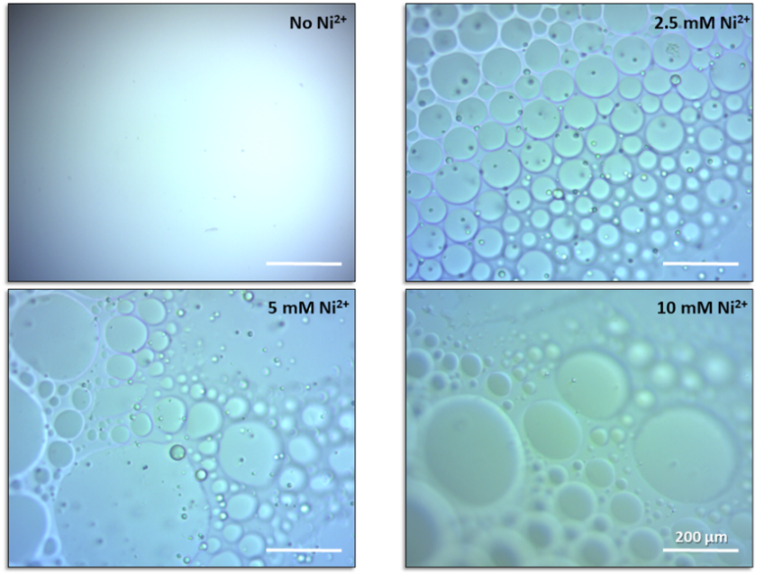
Figure S2: Effect of Ni²⁺ concentration on conjugation of His₁-tagged DM micelles. Light microscope images of phase separation of oil rich globules containing 10 mM DM detergent, incubated for 1 h at 19°C with 1 mM His₁-C10, 0-10 mM Ni²⁺, 15 wt% PEG-6000 in 40 mM Tris buffer, pH 8. The scale bar in all panels indicates 200 μm.

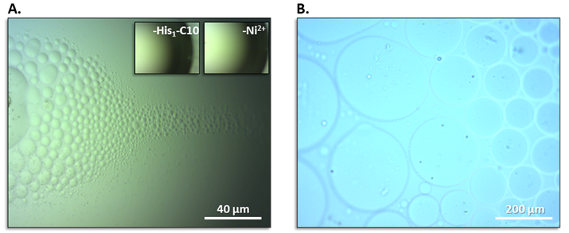
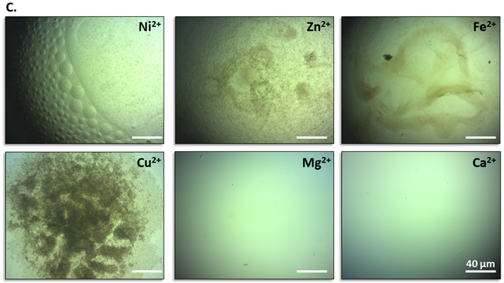
Figure S3: A. Light microscope images of DDM (10 mM detergent) incubated with 1 mM His₁-C10, 10 wt% PEG-6000 and 2.5 mM Ni²⁺ in 40 mM Tris buffer at pH 8 following 1 hour incubation at 19°C. Inset shows control samples devoid of either the amphiphilic chelator (His₁-C10) or Ni²⁺ cations; B. Magnification of A; C. As in A, but with 2.5 mM divalent cations other than Ni²⁺.

1. Patchornik, G., et al., Cryo-TEM structural analysis of conjugated nonionic engineered-micelles. Soft Matter, 2014. 10(27): p. 4922-8.

