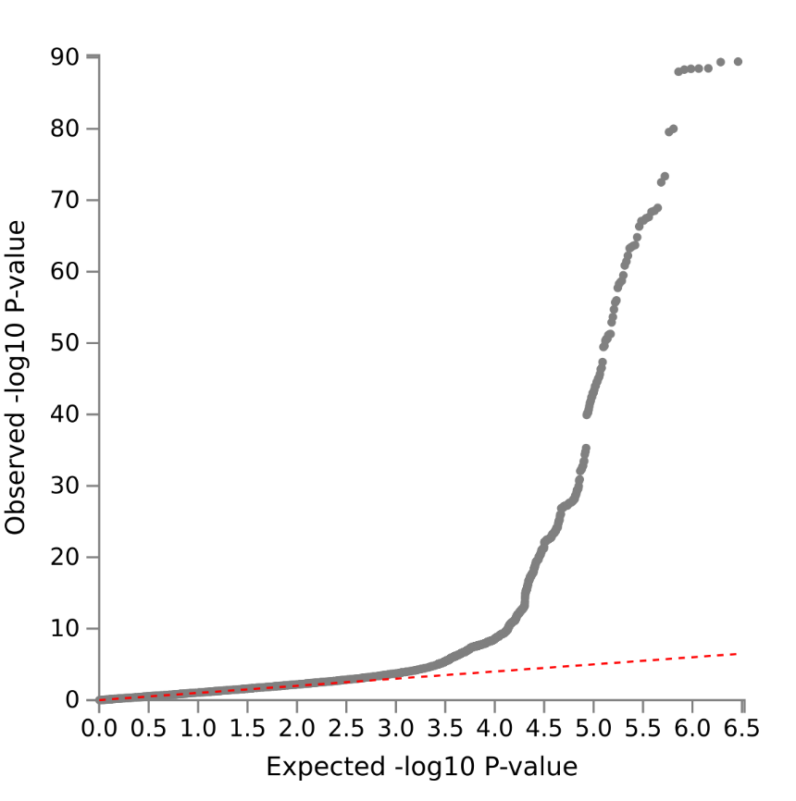
Figure 1. QQ Plot based on the meta-analysis of normal tension glaucoma (NTG) with an estimated genetic inflation of 1.08.
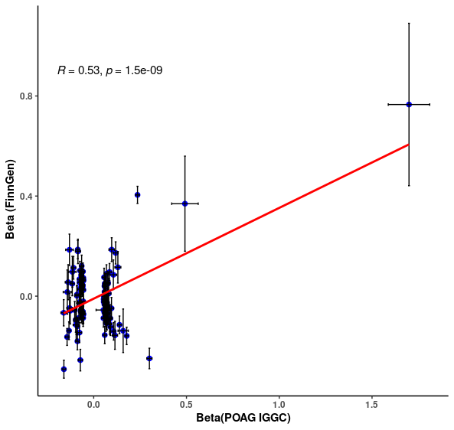
Figure 2. Correlation of the allele effect estimates between POAG risk loci and FinnGen NTG.

