Supplementary materials

Effects of forest age and seasonal changes on soil community diversity in Chinese fir plantations
Yuxin Hu ^{1,2}, Hanyue Chen¹, Yihang Jiang¹, Jianguo Zhang¹, Xiongqing Zhang^{1,2,}*

1 State Key Laboratory of Efficient Production of Forest Resources, Key Laboratory of Tree Breeding and Cultivation of the National Forestry and Grassland Administration, Research Institute of Forestry, Chinese Academy of Forestry, Beijing 100091, China

2 Collaborative Innovation Center of Sustainable Forestry in Southern China, Nanjing Forestry University, Nanjing, 210037, P. R. China

*Corresponding author: Xiongqing Zhang
Email: xqzhang85@caf.ac.cn. Tel: 0086-10-62888309. Fax: 86-10-62872015.

Table S1 Site characteristics of the Chinese fir plantation. They are over-mature forest (51a), mature forest (27a), near-mature forest (20a), middle-aged forest (14a), and young forest (8a).
Type | Age (a) | Elevation (m) | Slope (°) | Aspects | Mean tree height (m) | Mean DBH (cm) | Density (trees/hm²)
young forest (YOF) | 8 | 111 | 26 | Southeast、South | 7.37 | 10.11 | 3333
middle-aged forest (MIF) | 14 | 107 | 30 | Southeast | 14.40 | 11.46 | 3294
near-mature forest (NMF) | 20 | 118 | 21 | Southeast | 18.49 | 21.37 | 3067
mature forest (MAF) | 27 | 108 | 28 | Southeast、South | 18.22 | 19.03 | 2589
over-mature forest (OMF) | 51 | 116 | 25-30 | Southeast、South | 18.02 | 20.90 | 1968

Table S2 Basic climate information of the Chinese fir plantation in summer, autumn, and winter.
 | Average monthly temperature (℃) | Maximum monthly temperature (℃) | Monthly minimum temperature (℃) | Average monthly air humidity (%) | Average monthly precipitation (mm)
Summer | 26.20 | 29.86 | 23.39 | 94.58 | 754.60
Autumn | 22.29 | 26.25 | 18.87 | 91.95 | 265.50
Winter | 7.09 | 23.27 | -1.27 | 91.10 | 285.50

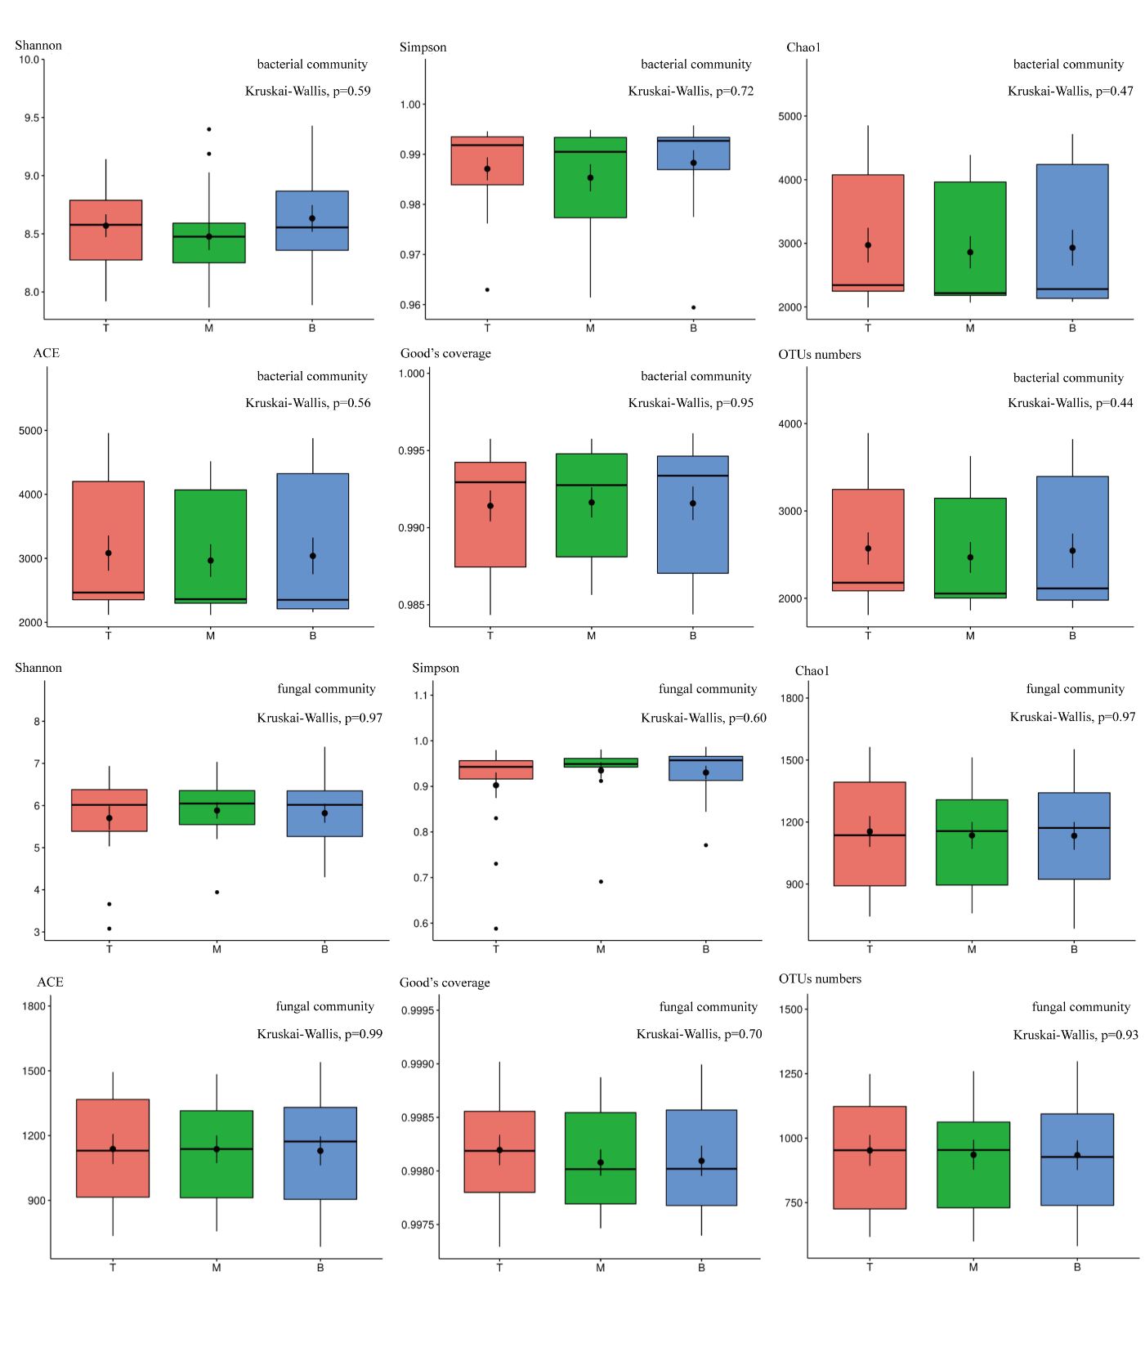
Figure S3 Test for differences of Alpha diversity index and OTUs numbers of microorganisms in different layers. T=0-20cm, middle=20-40cm, bottom=40-60cm layer, separately. Each Alpha diversity index showed no significant difference.

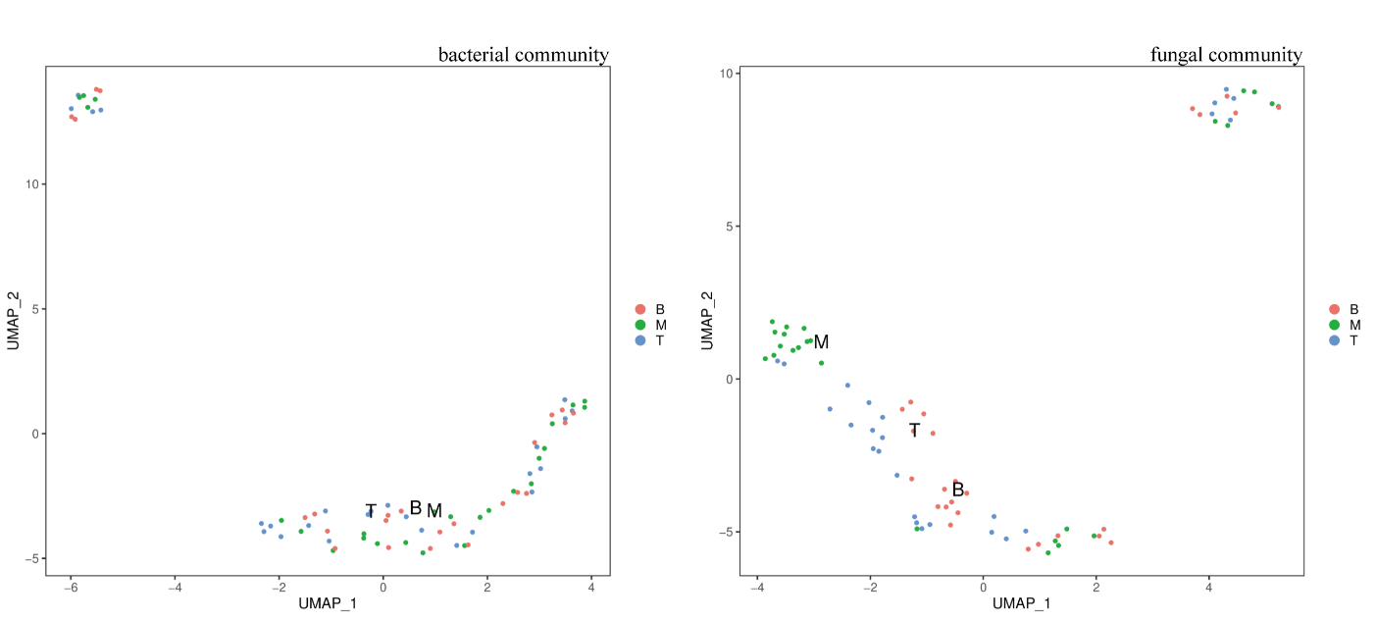
Figure S4 UMAP cluster analysis of Beta diversity of microbial communities in different forest layers. Soil samples were collected from a 60 cm long vertical profile that corresponded to depths of 0–20cm, 20–40cm and 40–60cm, represent by T, M and B.

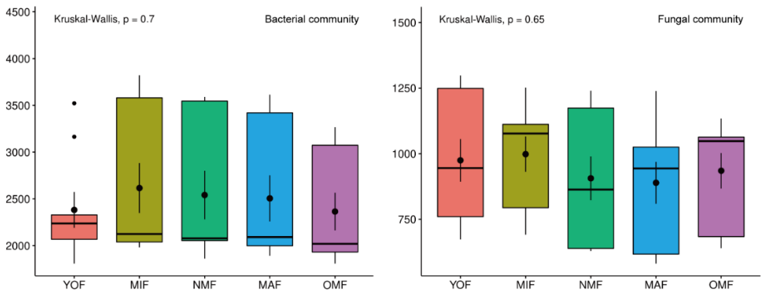
Fig. S5 Differences in the number of soil microbial communities in different forest ages at OTU levels (OMF = overmature forest, MAF = mature forest, NMF = near mature forest, MIF = middle-aged forest, YOF = young forest)

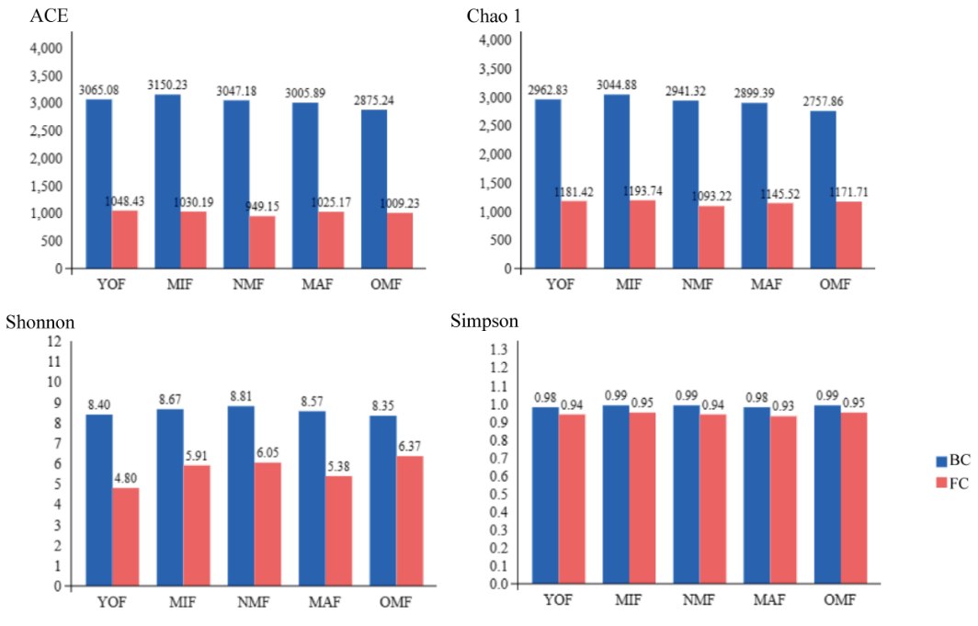
Fig. S6 Microbial Alpha diversity index of different forest ages (BC = bacterial community, FC = fungal community, OMF = over-mature forest, MAF = mature forest, NMF = near mature forest, MIF = middle-aged forest, YOF = young forest)

Table S7 Inter-group difference test of microbial communities in different forest ages
Classify | Groups | Means | F-value | R² | P-value
Bacterial Communities | YOF-MIF-NMF-MAF-OMF | 0.0354 | 3.2132 | 0.5518 | 0.001
Fungal Communities | YOF-MIF-NMF-MAF-OMF | 0.1509 | 2.4698 | 0.4944 | 0.001
* OMF = overmature forest, MAF = mature forest, NMF = near mature forest, MIF = middle-aged forest, YOF = young forest

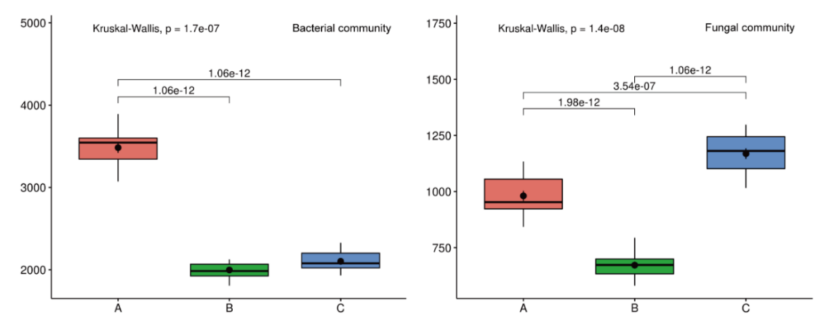
Fig. S8 Test for differences in the number of microorganisms in different seasons at the OTU level. (A = summer, B = autumn, and C = winter)

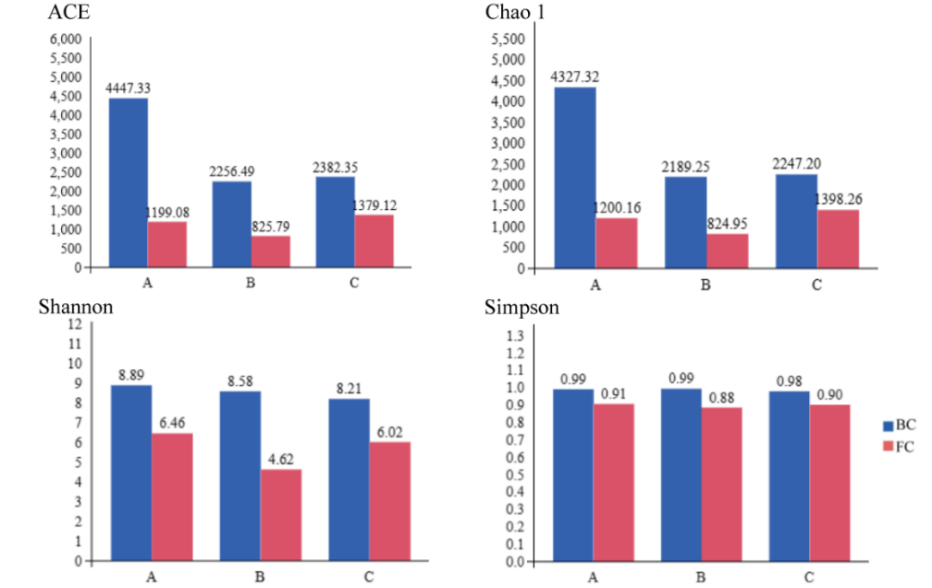
Fig. S9 Alpha diversity indicators of microorganisms. (A = summer, B = autumn, and C = winter; BC=bacterial community, FC=fungal community)

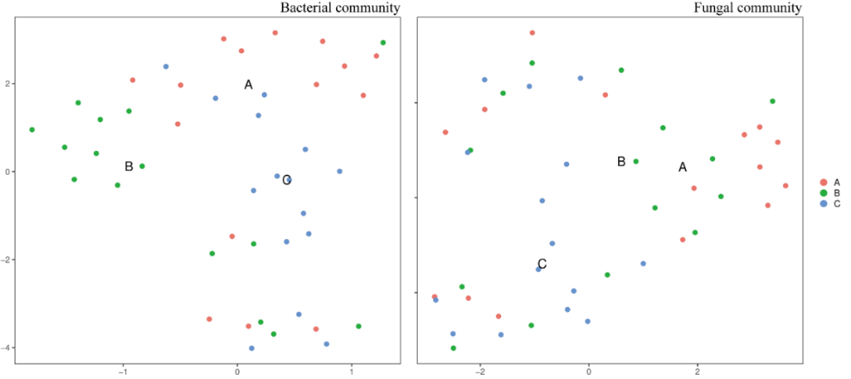
Fig. S10 UMAP cluster analysis of Beta diversity of microbial communities of different seasons. (A = summer, B = autumn, and C = winter)

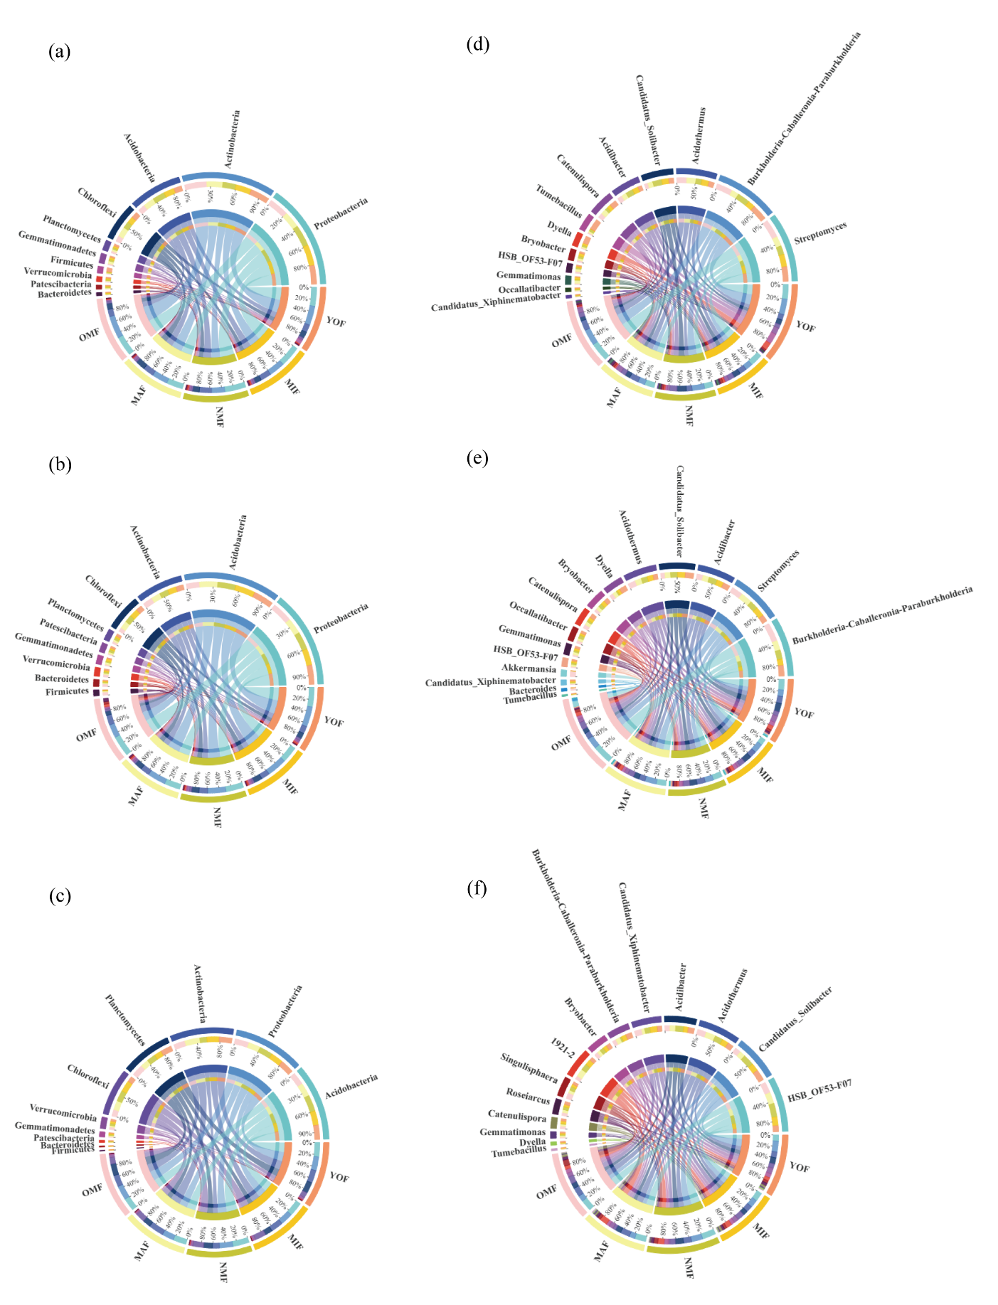
Figure S11 Figure of cluster species composition circus of bacterial community: (a) Spring bacterial community at the phylum level, (b) Autumn bacterial community at the phylum level, (c) Winter bacterial community at the phylum level, (d) Spring bacterial community at the genus level, (e) Autumn bacterial community at the genus level, (f) Winter bacterial community at the genus level.

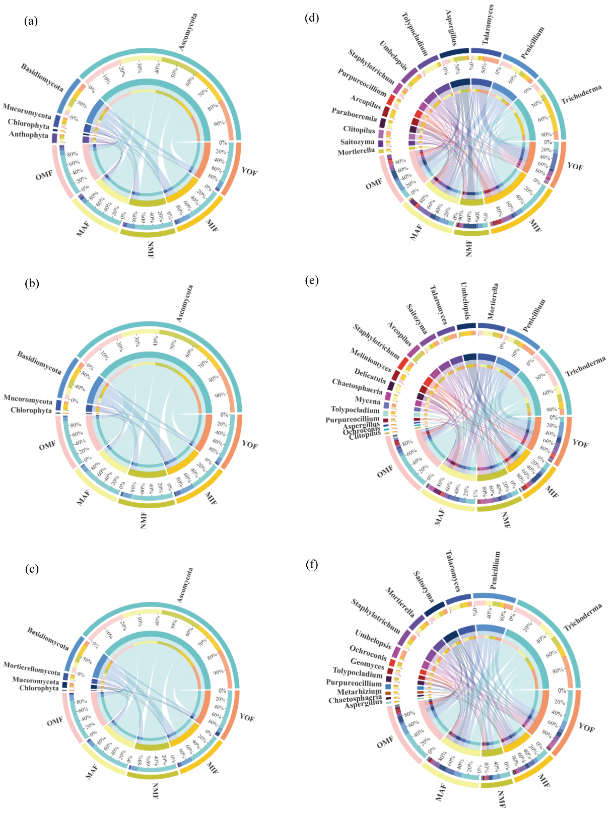
Figure S12 Figure of cluster species composition circus of fungal community: (a) Spring fungal community at the phylum level, (b) Autumn fungal community at the phylum level, (c) Winter fungal community at the phylum level, (d) Spring fungal community at the genus level, (e) Autumn fungal community at the genus level, (f) Winter fungal community at the genus level.

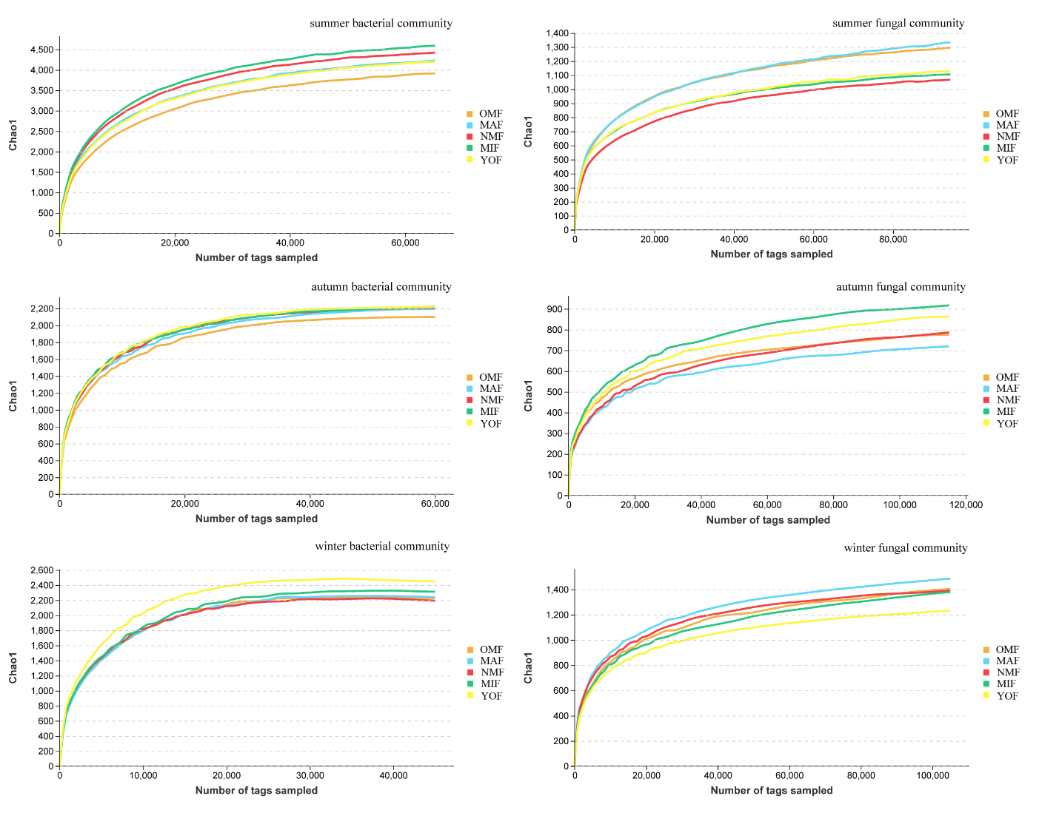
Figure S13 Rarefaction curves of Chao1 of the microbial community in different seasons. (OMF = over-mature forest, MAF = mature forest, NMF = near-mature forest, MIF = middle-aged forest, YOF = young forest).

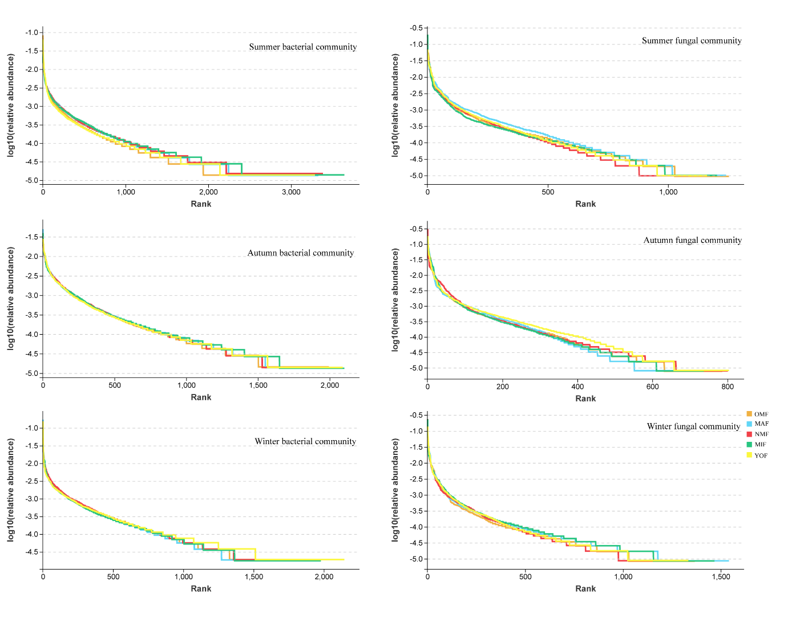
Fig. S14 Rank Abundance curves of the microbial community in different seasons. (OMF = overmature forest, MAF = mature forest, NMF = near mature forest, MIF = middle-aged forest, YOF = young forest)

