Supplementary Information

Thermal treatment of water-soluble particles formed by
compounds composed of carbon nanobelts and C₆₀ molecules
Shunji Kurosu^{1,2}, Sayaca Hata³, Tomofumi Ukai^{1,2}, Yuta Mashiko²,
Sieun Choi², Takanobu Minakawa², Yuri Tanuma^{1,4} and Toru Maekawa^{1,2,}*
¹ Bio-Nano Electronics Research Centre, Toyo University, 2100, Kujirai, Kawagoe, Japan
² Graduate School of Interdisciplinary New Science, Toyo University, 2100, Kujirai, Kawagoe, Japan
³ Graduate School of Science and Engineering, Toyo University, 2100, Kujirai, Kawagoe, Japan
⁴ Jožef Stefan Institute, Jamova 39, 1000 Ljubljana, Slovenia
* Corresponding author: maekawa@toyo.jp

--------------------------------------------------------------------

Fig. S1 Time variation of the weight of a particle and the temperature during thermal treatment. The temperature was raised up to 600 °C at a rate of 15.9 K min⁻¹ and kept at 600 °C for 1 h with the flow of N₂ gas. Then, the temperature was decreased naturally down to room temperature. The weight was calibrated with a precision scale.

Fig. S2 Time variation of the turbidity of the solution of particles dispersed in distilled water. The intensity of the transmitted light of 700 nm wavelength through the whole solution confined in a glass container was measured. The turbidity was defined as $\left(1-{I_{trans}}/{I_{in}}\right)×100 \%$, where $I_{in}$ and $I_{trans}$ are, respectively, the intensities of the incident and transmitted light.

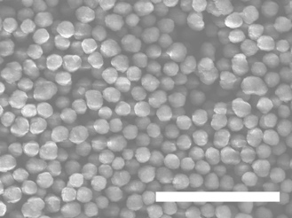

Fig. S3 SEM image of particles formed by compounds composed of (6,6)CNBs and C₆₀ molecules. The particles were thermally treated at 500 °C for 1 h. The scale bars represent 5 µm. A charge-up phenomenon occurred.

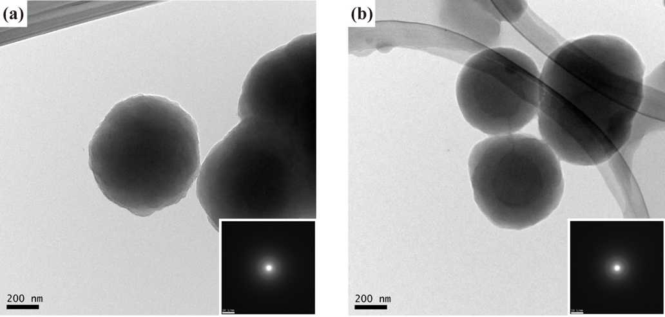

Fig. S4 TEM images of particles composed of (6,6)CNBs and C₆₀ molecules. Selected area electron diffraction (SAED) patterns are also shown. (a) Particles before thermal treatment. (b) Particles after thermal treatment at 600 °C. The scale bars represent 200 nm.

Fig. S5 XRD spectra of particles formed by compounds composed of (6,6)CNBs and C₆₀ molecules.

Fig. S6 Absorption spectra by particles dispersed in ethanol.

Fig. S7 Mass spectra of the components forming particles. (a) Before thermal treatment. (b) After thermal treatment at 600 °C.

Fig. S8 Opened ribbon calculated by PM6. Gray and white circles represent carbon and hydrogen atoms. A ribbon terminated with a square is most stable. The decomposition energy $E=3.12 eV$. The scale bar represents 0.4 nm.
(a)
(b)

Fig. S9 Configurations formed by compounds; C₆₀-CNB-C₆₀, obtained by PM6. (a) Configuration formed by two compounds. The formation energy $E=- 0.56 eV$. (b) Configuration formed by three compounds. $E=- 0.82 eV$. The scale bars represent 0.4 nm.

Video S1 (Video S1.mp4) Monodispersibility of the particles in distilled water. The particles were thermally treated at 600 °C for 1 h and dispersed in distilled water.

