Supplementary Information
Nanoforest of metal single atoms
Yan Sun^{1,‡}, Yipeng Zang^{2,‡}, Bowen He^{3,‡}, Geyu Lin¹, Lei Yang¹, Chengshuo Shen^{4,*}, Liwei Chen³, Xi Liu^{3,*}, Huibin Qiu^{1,*}
¹School of Chemistry and Chemical Engineering, Zhangjiang Institute for Advanced Study, Frontiers Science Center for Transformative Molecules, State Key Laboratory of Metal Matrix Composites, Shanghai Jiao Tong University, Shanghai 200240, P. R. China
²State Key Laboratory of Catalysis, Dalian National Laboratory for Clean Energy, Dalian Institute of Chemical Physics, Chinese Academy of Sciences, Dalian 116023, P. R. China
³In situ Centre for Physical Science, Frontiers Science Center for Transformative Molecules, School of Chemistry and Chemical Engineering, Shanghai Jiao Tong University, Shanghai 200240, P. R. China.
⁴School of Chemistry and Chemical Engineering, Zhejiang Sci-Tech University, Xiasha Campus, Hangzhou 310018, P. R. China.
*Corresponding author. E-mail: hbqiu@sjtu.edu.cn; liuxi@sjtu.edu.cn; shenchengshuo@zstu.edu.cn
‡ These authors contributed equally to this work.

Supplementary data
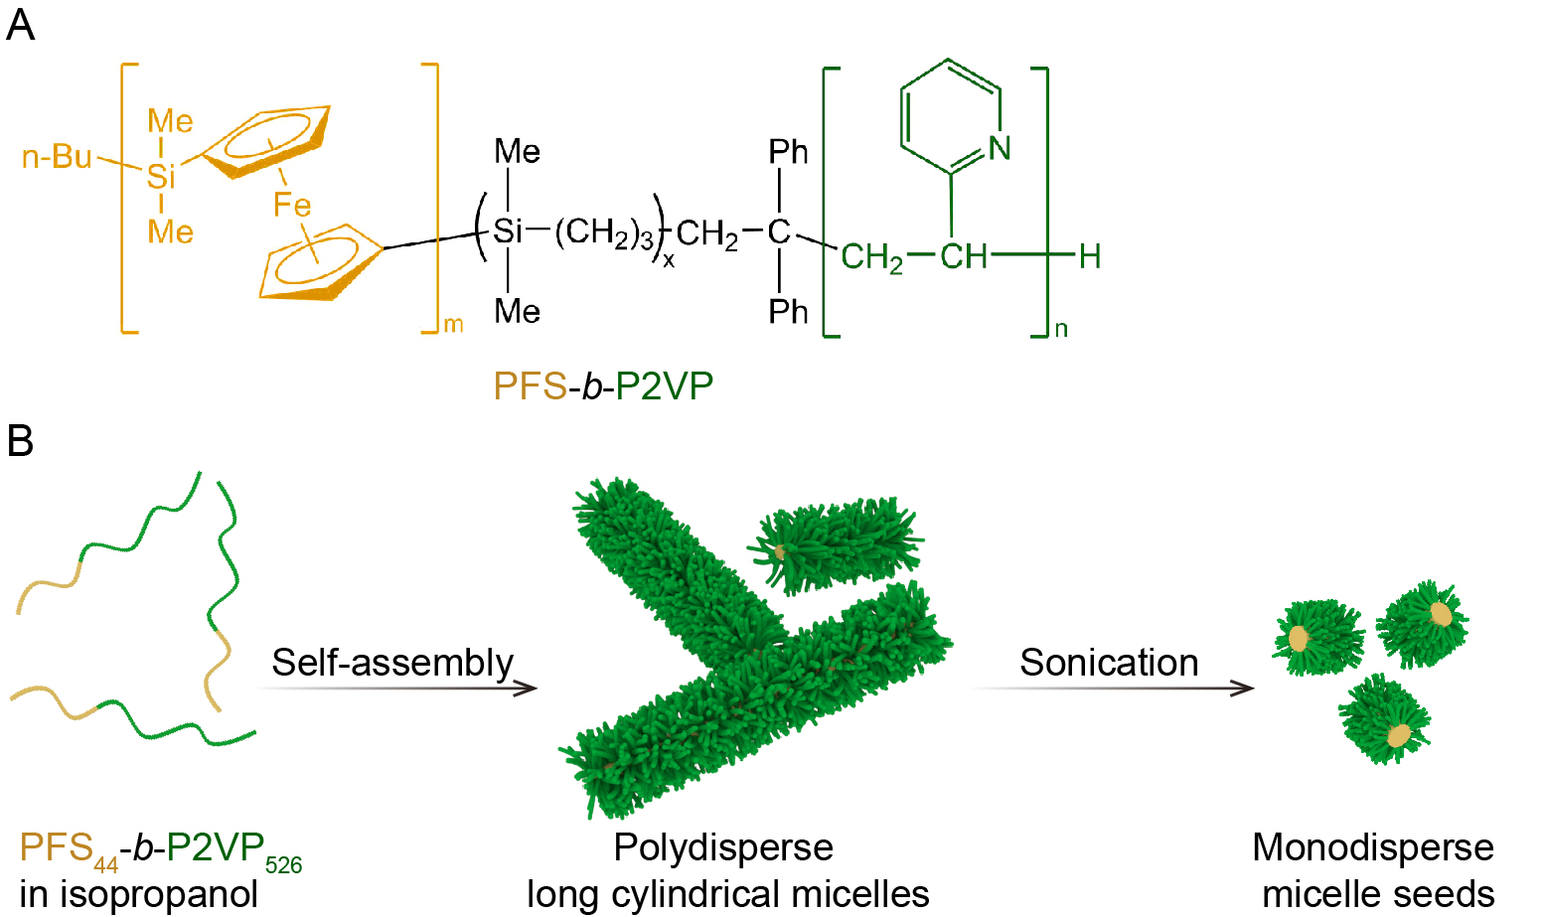
Figure S1. Preparation of PFS₄₄-b-P2VP₅₂₆ micelle seeds. (A) Molecular structure of PFS-b-P2VP block copolymers. (B) Schematic illustration for the preparation of PFS₄₄-b-P2VP₅₂₆ micelle seeds.

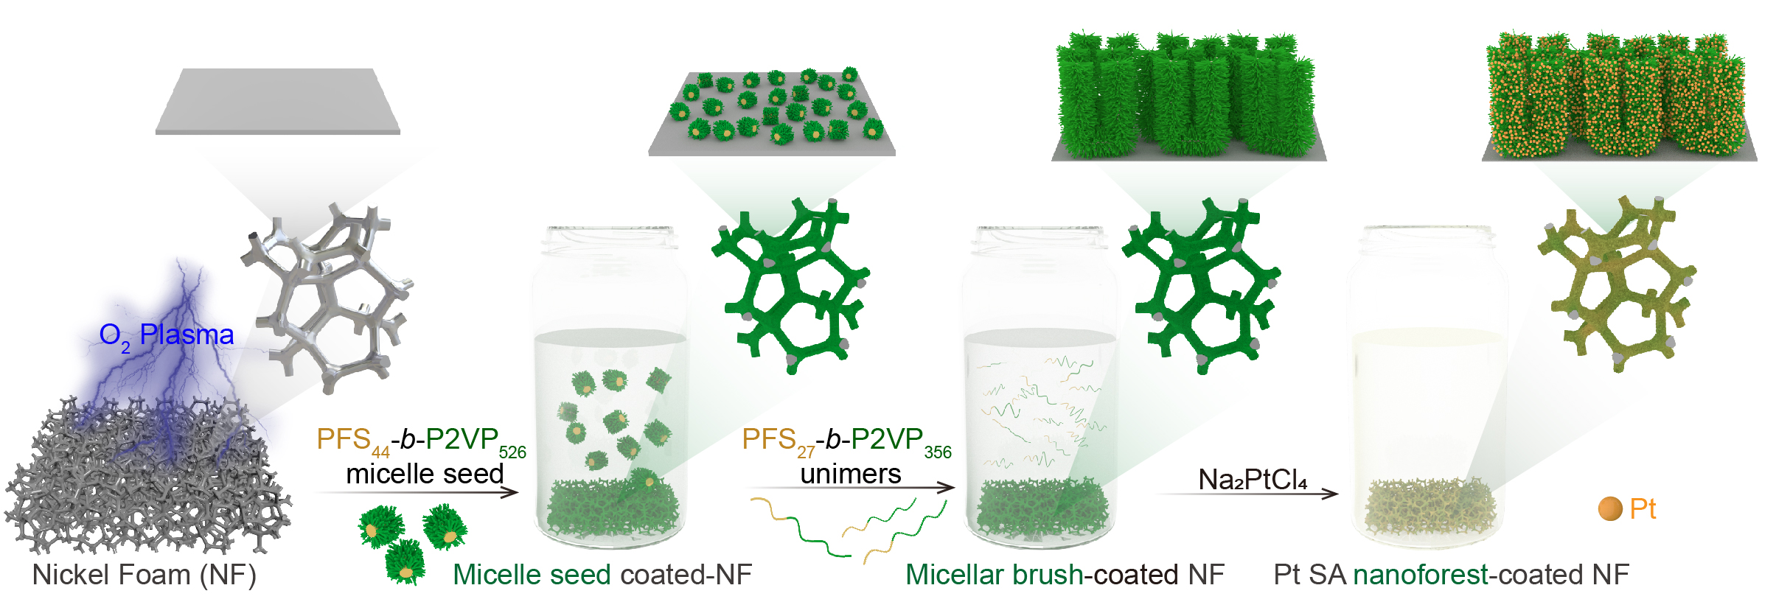
Figure S2. Formation of Pt SA nanoforest on nickel foam. Schematic illustration for the growth of PFS₂₇-b-P2VP₃₅₆ micellar brushes on a piece of nickel foam via surface-initiated living self-assembly and the further formation of Pt SA nanoforest via simple immersion in a solution of metal ion precursor.

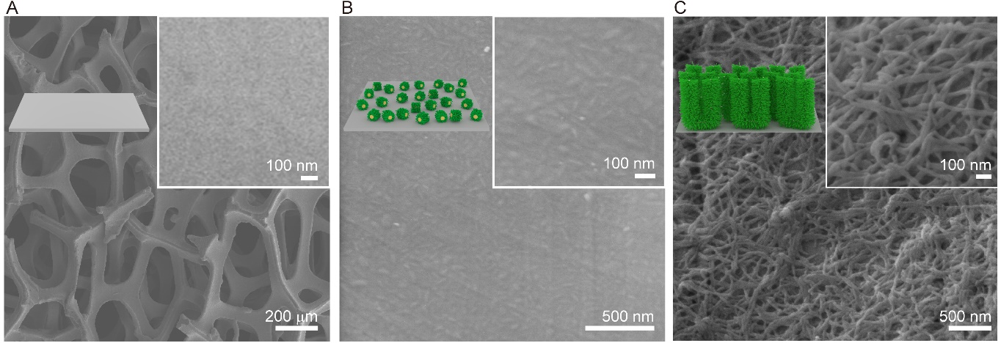
Figure S3. Morphology of naked, micelle seed-coated, and micellar brush-coated nickel foams. SEM images of (A) naked nickel foam, (B) PFS₄₄-b-P2VP₅₂₆ micelle seed-coated nickel foam (for micelle seeds, L_{n} = 75 nm, L_{w}/L_{n} = 1.03, where L_{n} and L_{w} are the number- and weight-average lengths, respectively), (C) PFS₂₇-b-P2VP₃₅₆ micellar brush-coated nickel foam.

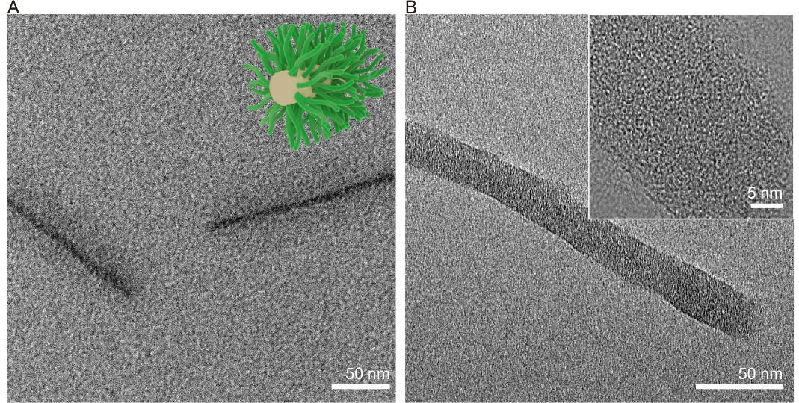
Figure S4. Structure of micellar brush and Pt SA nanoforest. (A) TEM image of cylindrical micelles detached by sonication from the PFS₂₇-b-P2VP₃₅₆ micellar brush grown on nickel foam. (B) TEM images of a nanofiber detached from the Pt SA nanoforest grown on nickel foam.
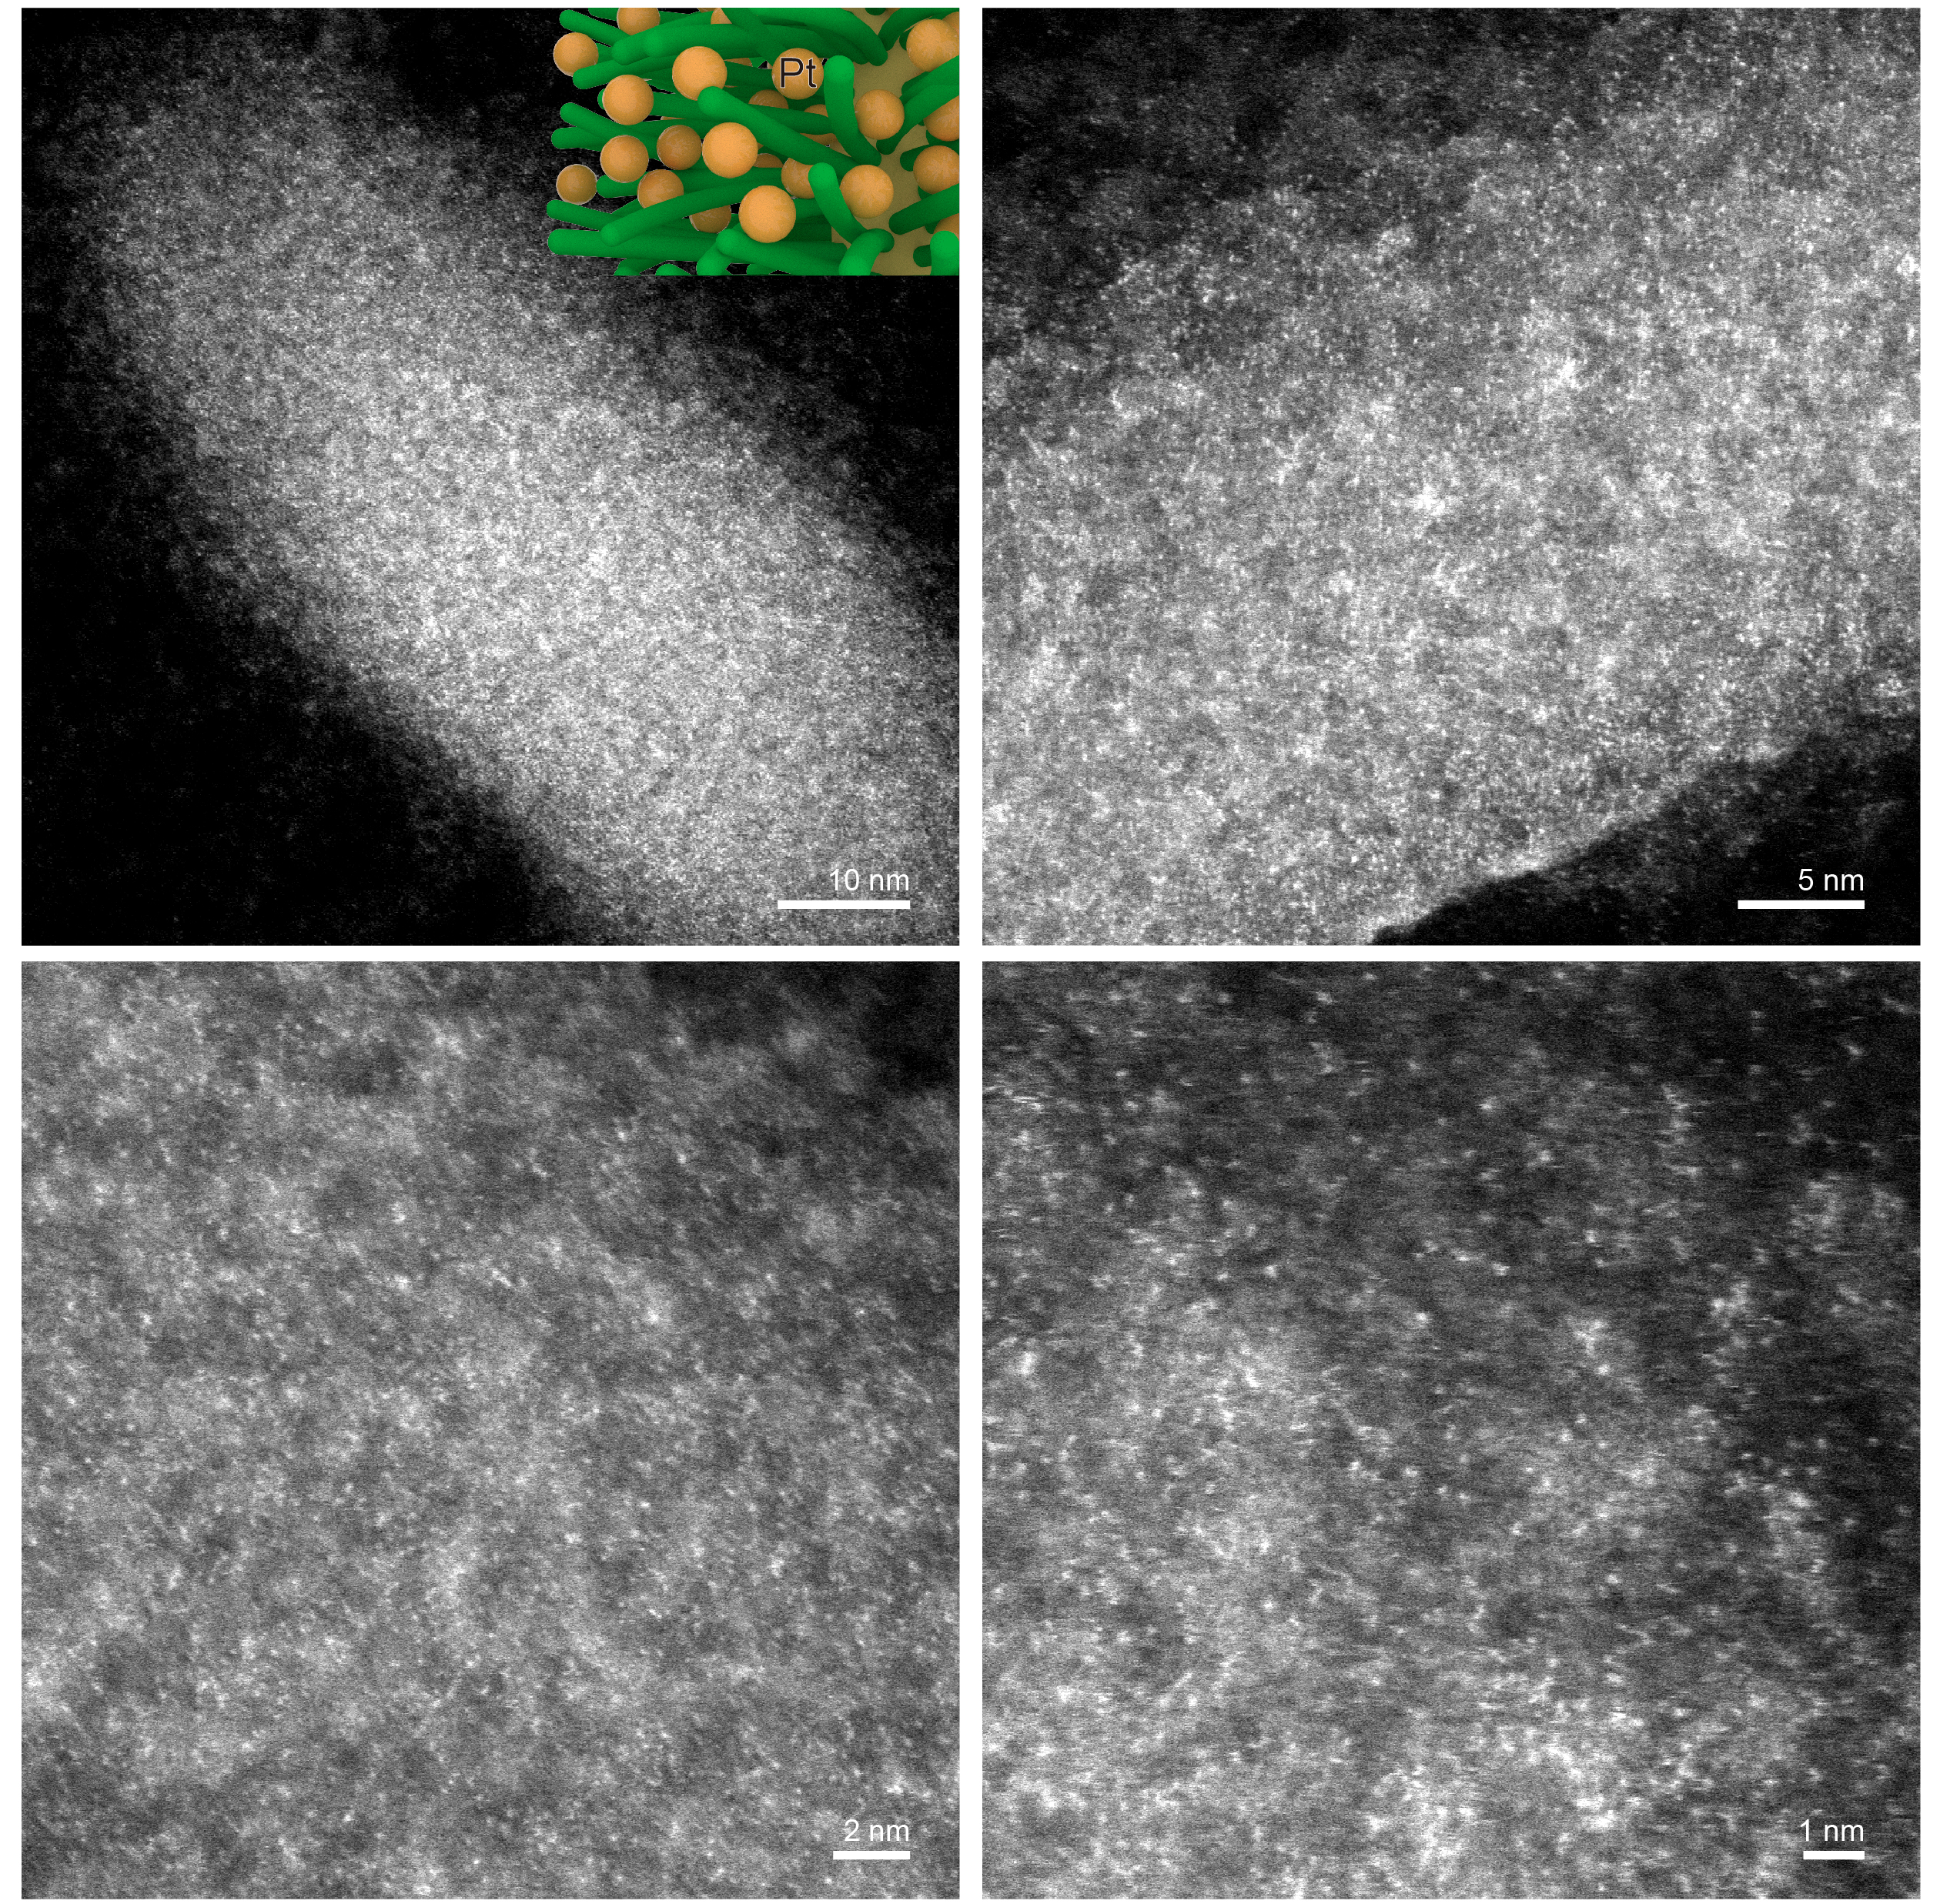
Figure S5. Fine structure of Pt SA nanoforest. AC-ADF-STEM images of Pt SA nanoforest under different magnifications. No Pt cluster or agglomerate was observed.

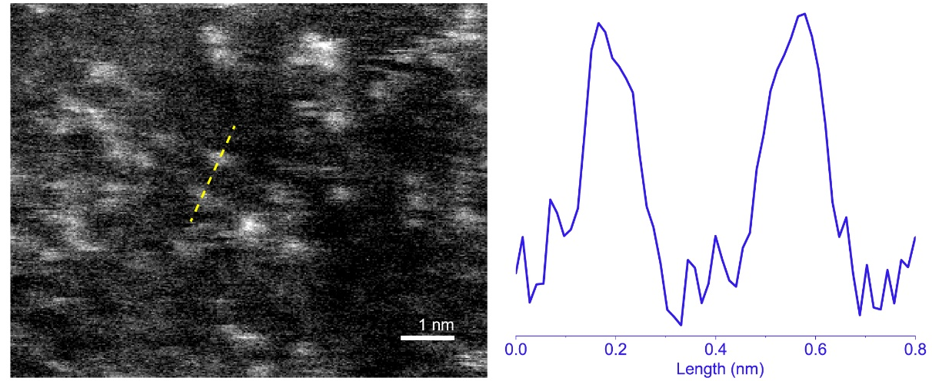
Figure S6. Size analysis of Pt SAs. Zoom-in AC-ADF-STEM image of Pt SA nanoforest and intensity profile of Pt atoms along the dashed yellow line.

Figure S7. Estimation of content of PFS₂₇-b-P2VP₃₅₆ micellar brush. UV-vis spectra of a typical solution with the addition of PFS₂₇-b-P2VP₃₅₆ unimers for the growth of micellar brushes and that retained after the removal of the micellar brush-coated nickel foam. The mass of PFS₂₇-b-P2VP₃₅₆ in the resulting micellar brush (M_{micellar bursh}) majorly equals (the contribution of the micelle seeds was ignored in consideration of their short length) to the reduced/converted unimers in the solution, which was calculated by the intensities of the UV absorption at 263 nm of the original (A₀) and terminal (A) solutions, namely:
$$M_{micellar bursh}=\left(1-\frac{A}{A_{0}}\right)×M_{unimers}$$
where M_{unimers} is the total mass of added unimers.
The mass of Pt SA (M_{Pt}) was determined by ICP-MS analysis. The loading of Pt (and other metals) was calculated as: $\frac{M_{Pt}}{M_{micellar brush}}×100\%$.

Table S1. Comparison of metal loading in Pt SA nanoforest and previously reported Pt SA-based materials (estimated by ICP-MS).
Catalyst | Metal loading (wt%) | Ref.
Pt SA nanoforest | 28.4 | This work
Pt SACs/PCN | 24 | ¹
Pt SAC | 11.41 | ²
Pt₁/NPC | 3.8 | ³
Pt SA-NT-nickel foam | 1.76 | ⁴
Pt/VS₂/CP | 1.13 | ⁵
Pt-PVP/TNR@GC | 1.76 | ⁶
K₂PtCl₄@NC-M | 1.92 | ⁷
Pt-AC/DG | 1.01 | ⁸
Co-Pt-NC | 0.16 | ⁹
Pt SASs/AG | 0.44 | ¹⁰
Pt SA/m-WO_{3-x} | 0.42 | ¹¹
Pt₁/OLC | 0.27 | ¹²
Pt/np-Co_{0.85}Se | 1.03 | ¹³
Pt/f-MWCNTs | 0.323 | ¹⁴

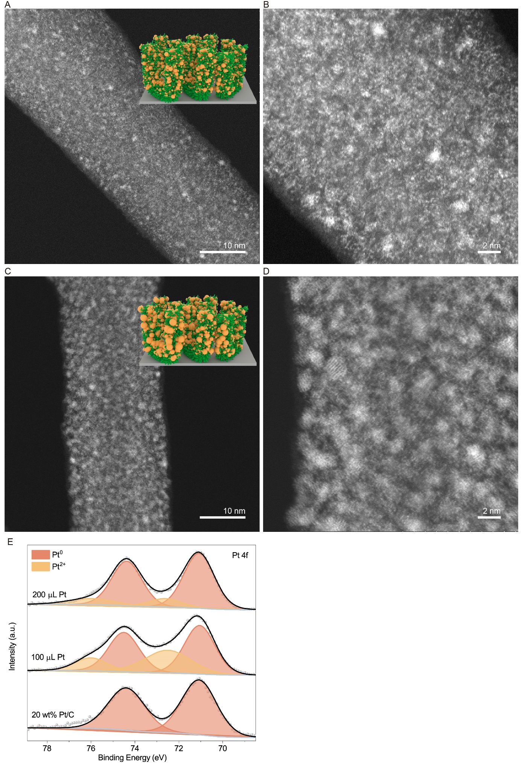
Figure S8. Pt catalyst-decorated micellar brush formed at higher Na₂PtCl₄ feeding amount. AC-ADF-STEM images of Pt catalyst-decorated micellar brush obtained by adding (A and B) 100 and (C and D) 200 μL of an aqueous solution of Na₂PtCl₄ (10 mg mL⁻¹). Pt clusters and nanoparticles were observed. (E) XPS spectra of Pt 4f of the above samples and 20 wt% Pt/C.
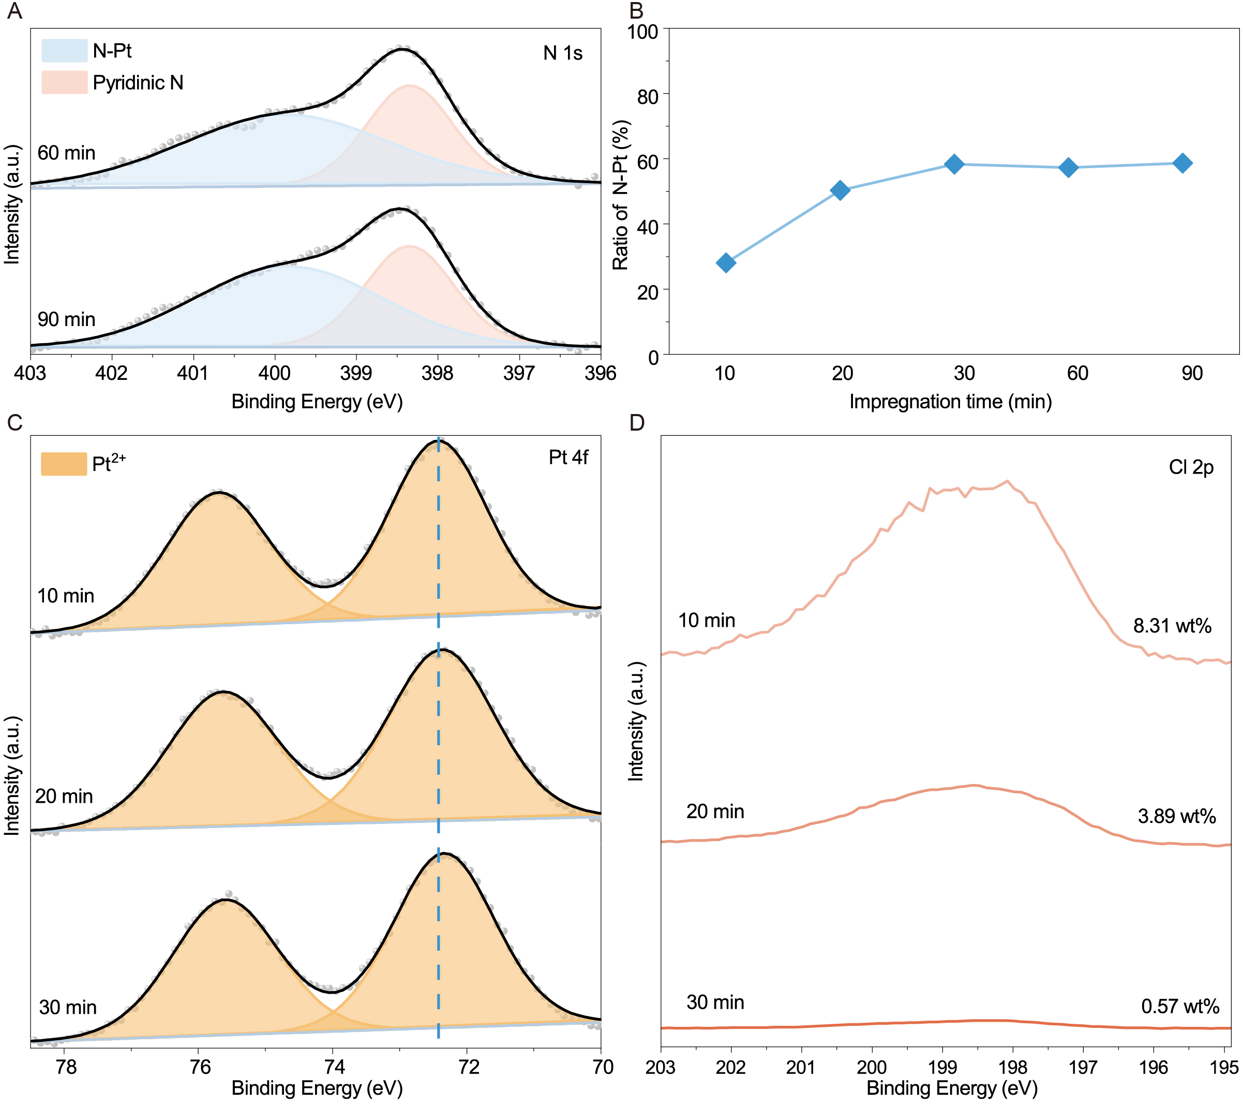
Figure S9. XPS analysis of Pt SA-decorated micellar brushes obtained at different immersion time. (A) XPS spectra of N 1s for samples obtained with an immersion time of 60 and 90 min. (B) Ratio of N-Pt coordination in Pt SA-decorated micellar brushes obtained at different immersion time. (C and D) XPS spectra of Pt 4f (C) and Cl 2p (D) for Pt SA-decorated micellar brushes obtained at different immersion time.

Ratio of N-Pt coordination (R) was calculated via the following equation:
$$R=\frac{A(N-Pt)}{A\left(N-Pt\right)+A(Pyridinic N)}$$
where A is the area of a specific single.

Figure S10. XAS analysis of Pt SA nanoforest. Normalized Pt L-edge XANES spectra of Pt foil and Pt SA nanoforest. The white line intensity of Pt SA nanoforest was higher than that of Pt foil, indicative of a positive valence state of Pt.

Table S2. Structural parameters of Pt SA nanoforest extracted from EXAFS fitting.
Catalyst | Path | R (Å) | N_{coord} | σ² (Å²) | △E₀ (eV) | R_{f} (%)
Pt | Pt-N | 2.11 | 3.7 | 0.0062 | 9.1 | 1.6

where R is the distance between absorber and backscatter atoms, N_{coord} is the coordination number, σ² is Debye–Waller factor, △E₀ is the edge-energy shift, and R_{f} is the goodness of fit.

Table S3. Metal ion precursors (10 mg mL⁻¹) for the synthesis of metal SA nanoforest.
Element | Metal ion precursor | Solvent | Element | Metal ion precursor | Solvent
Mg | Mg(NO₃)₂⋅6H₂O | H₂O | Al | Al(NO₃)₃⋅9H₂O | H₂O
Ca | Ca(NO₃)₂⋅4H₂O | H₂O | Sc | ScCl₃ | H₂O
Cr | Cr(NO₃)₃⋅9H₂O | H₂O | Mn | Mn(NO₃)₂⋅4H₂O | H₂O
Fe | Fe(NO₃)₃⋅9H₂O | H₂O | Co | Co(NO₃)₂⋅6H₂O | H₂O
Ni | Ni(NO₃)₂⋅6H₂O | H₂O | Cu | Cu(NO₃)₂⋅3H₂O | H₂O
Zn | Zn(NO₃)₂⋅6H₂O | H₂O | Ga | Ga(NO₃)₃ | H₂O
Sr | Sr(NO₃)₂⋅4H₂O | H₂O | Y | Y(NO₃)₃⋅6H₂O | H₂O
Mo | (NH₄)₂MoO₄⋅4H₂O | H₂O | Ru | RuCl₃ | H₂O
Rh | RhCl₃ | H₂O | Pd | Na₂PdCl₄ | H₂O
Ag | AgNO₃ | H₂O | Cd | CdCl₂ | H₂O
In | InCl₃ | H₂O | Cs | CsNO₃ | H₂O
Ba | Ba(NO₃)₂ | H₂O | Ce | Ce(NO₃)₃⋅6H₂O | H₂O
Gd | Gd(NO₃)₃⋅6H₂O | H₂O | Er | Er(NO₃)₃⋅6H₂O | H₂O
Hf | HfCl₃ | H₂O | Ta | TaCl₅ | Ethanol
W | (NH₄)₆W₇O₂₄⋅6H₂O | H₂O | Ir | Na₂IrCl₆ ⋅6H₂O | H₂O
Pt | Na₂PtCl₄ | H₂O | Au | HAuCl₄ | H₂O
Pb | Pb(NO₃)₂ | H₂O

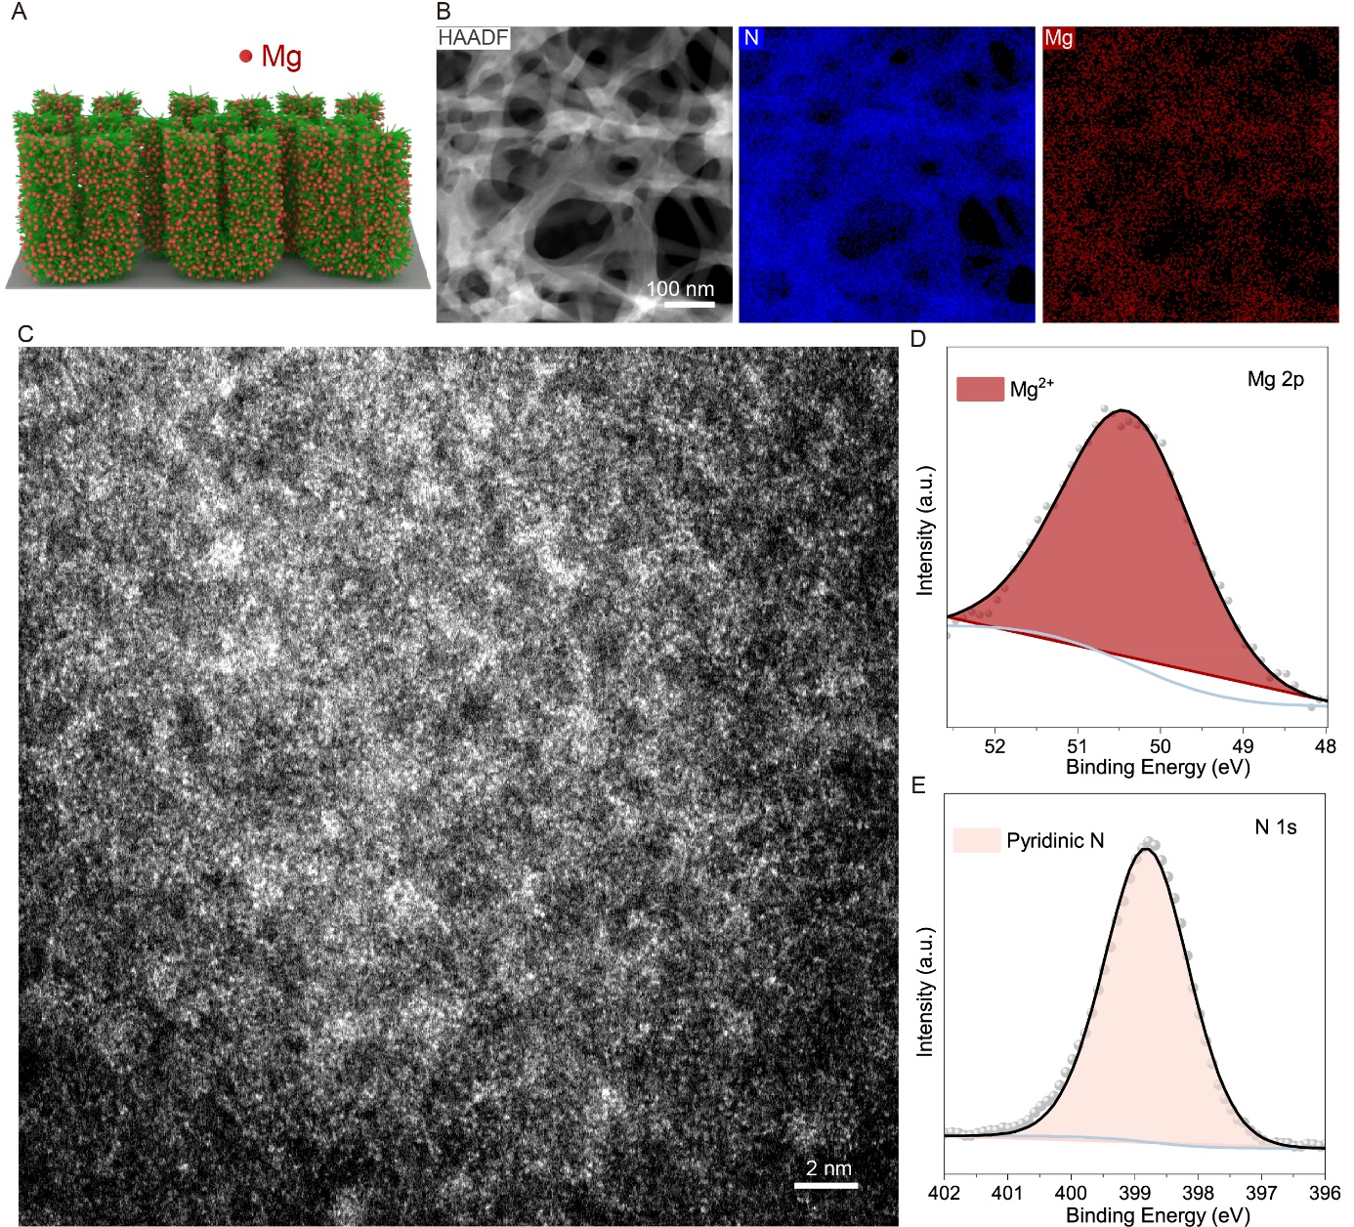
Figure S11. Structure characterization of Mg SA nanoforest. (A) Schematic illustration of Mg SA nanoforest. (B) HAADF-STEM image and corresponding element mapping of Mg and N. (C) AC-ADF-STEM image of Mg SA nanoforest. (D and E) XPS spectra of (D) Mg 2p and (E) N 1s.
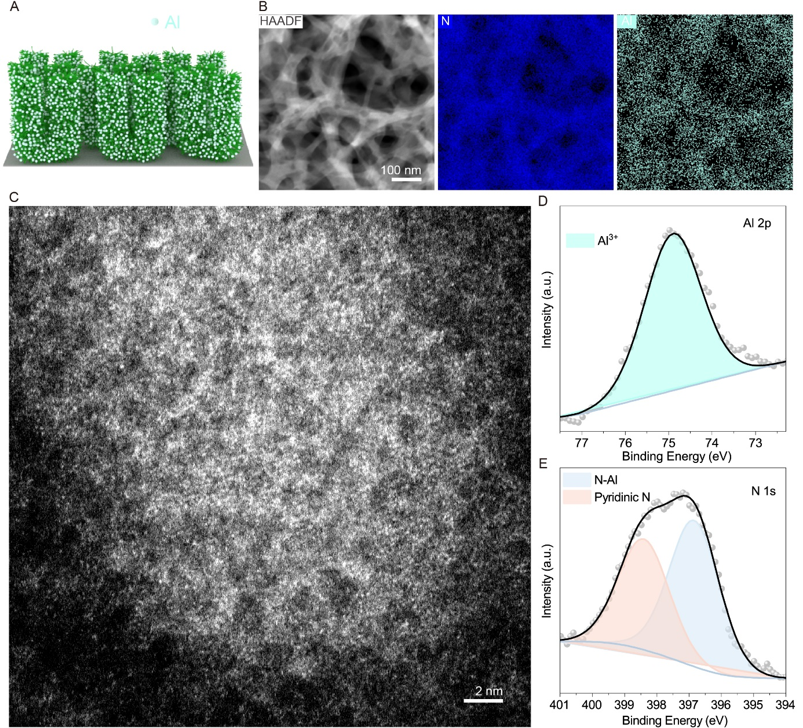
Figure S12. Structure characterization of Al SA nanoforest. (A) Schematic illustration of Al SA nanoforest. (B) HAADF-STEM image and corresponding element mapping of Al and N. (C) AC-ADF-STEM image of Al SA nanoforest. (D and E) XPS spectra of (D) Al 2p and (E) N 1s.

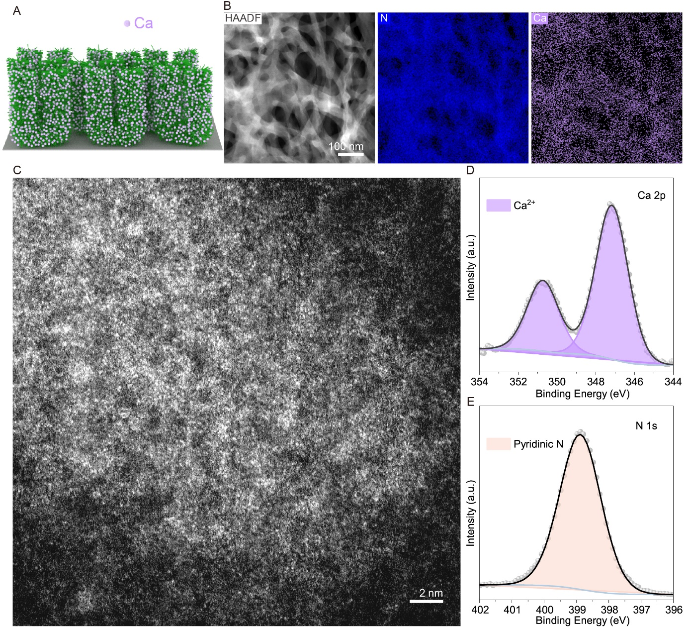
Figure S13. Structure characterization of Ca SA nanoforest. (A) Schematic illustration of Ca SA nanoforest. (B) HAADF-STEM image and corresponding element mapping of Ca and N. (C) AC-ADF-STEM image of Ca SA nanoforest. (D and E) XPS spectra of (D) Ca 2p and (E) N 1s.
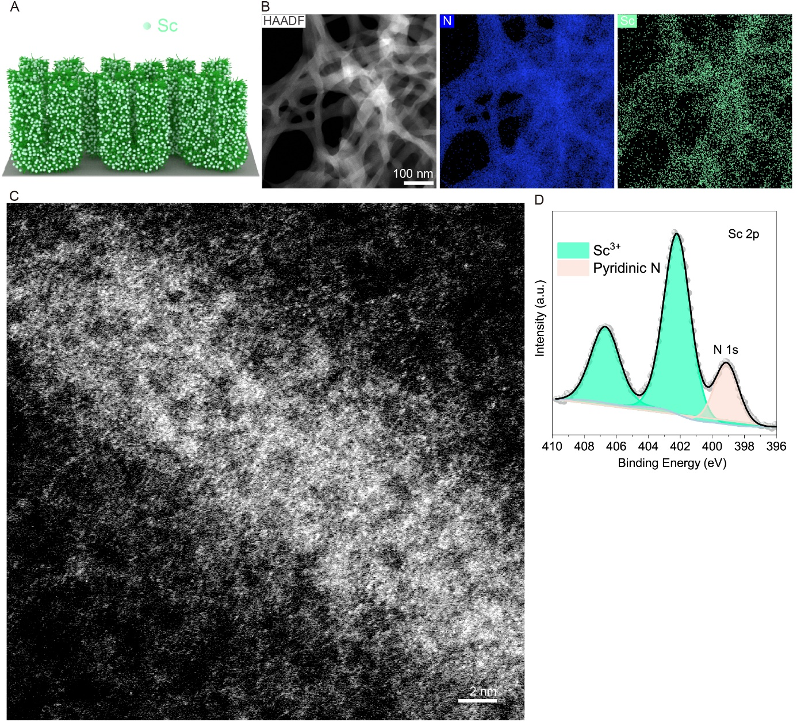
Figure S14. Structure characterization of Sc SA nanoforest. (A) Schematic illustration of Sc SA nanoforest. (B) HAADF-STEM image and corresponding element mapping of Sc and N. (C) AC-ADF-STEM image of Sc SA nanoforest. (D) XPS spectra of Sc 2p and N 1s.
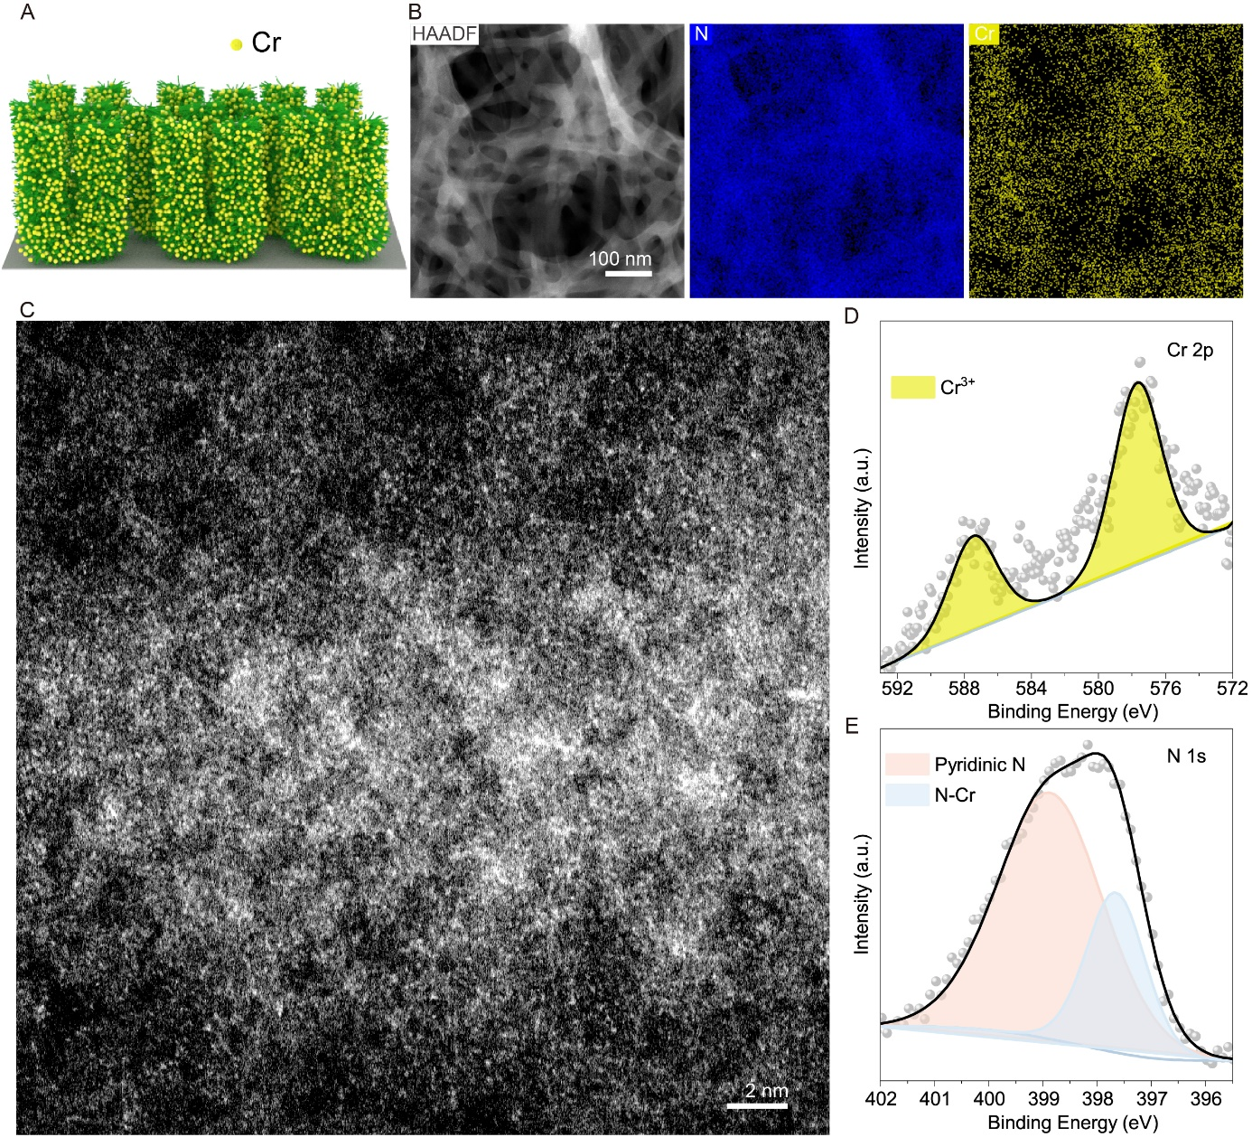
Figure S15. Structure characterization of Cr SA nanoforest. (A) Schematic illustration of Cr SA nanoforest. (B) HAADF-STEM image and corresponding element mapping of Cr and N. (C) AC-ADF-STEM image of Cr SA nanoforest. (D and E) XPS spectra of (D) Cr 2p and (E) N 1s.

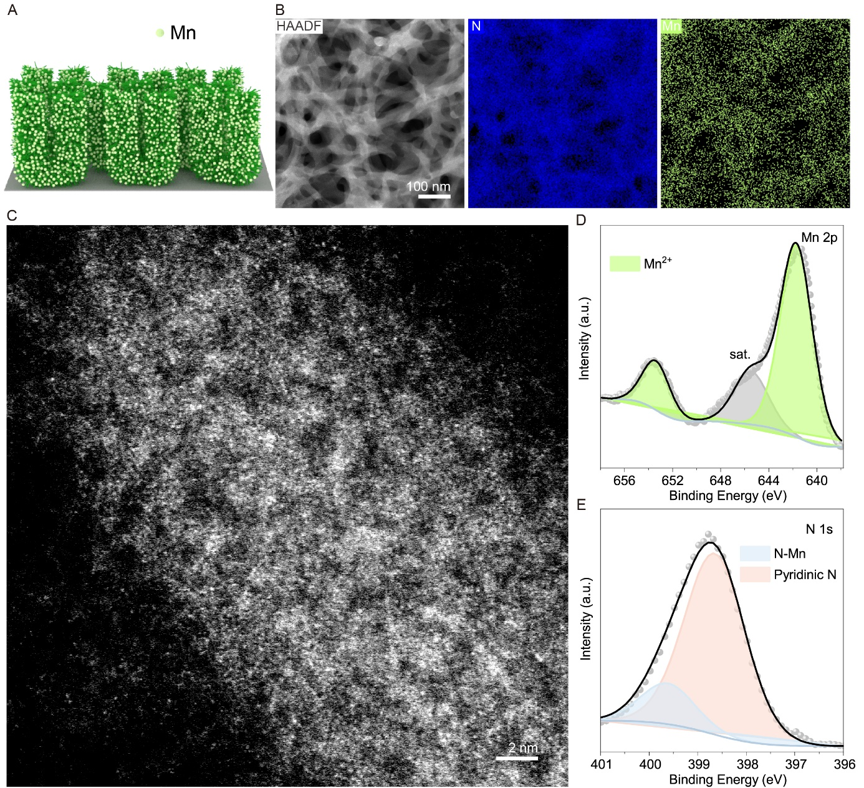
Figure S16. Structure characterization of Mn SA nanoforest. (A) Schematic illustration of Mn SA nanoforest. (B) HAADF-STEM image and corresponding element mapping of Mn and N. (C) AC-ADF-STEM image of Mn SA nanoforest. (D and E) XPS spectra of (D) Mn 2p and (E) N 1s.
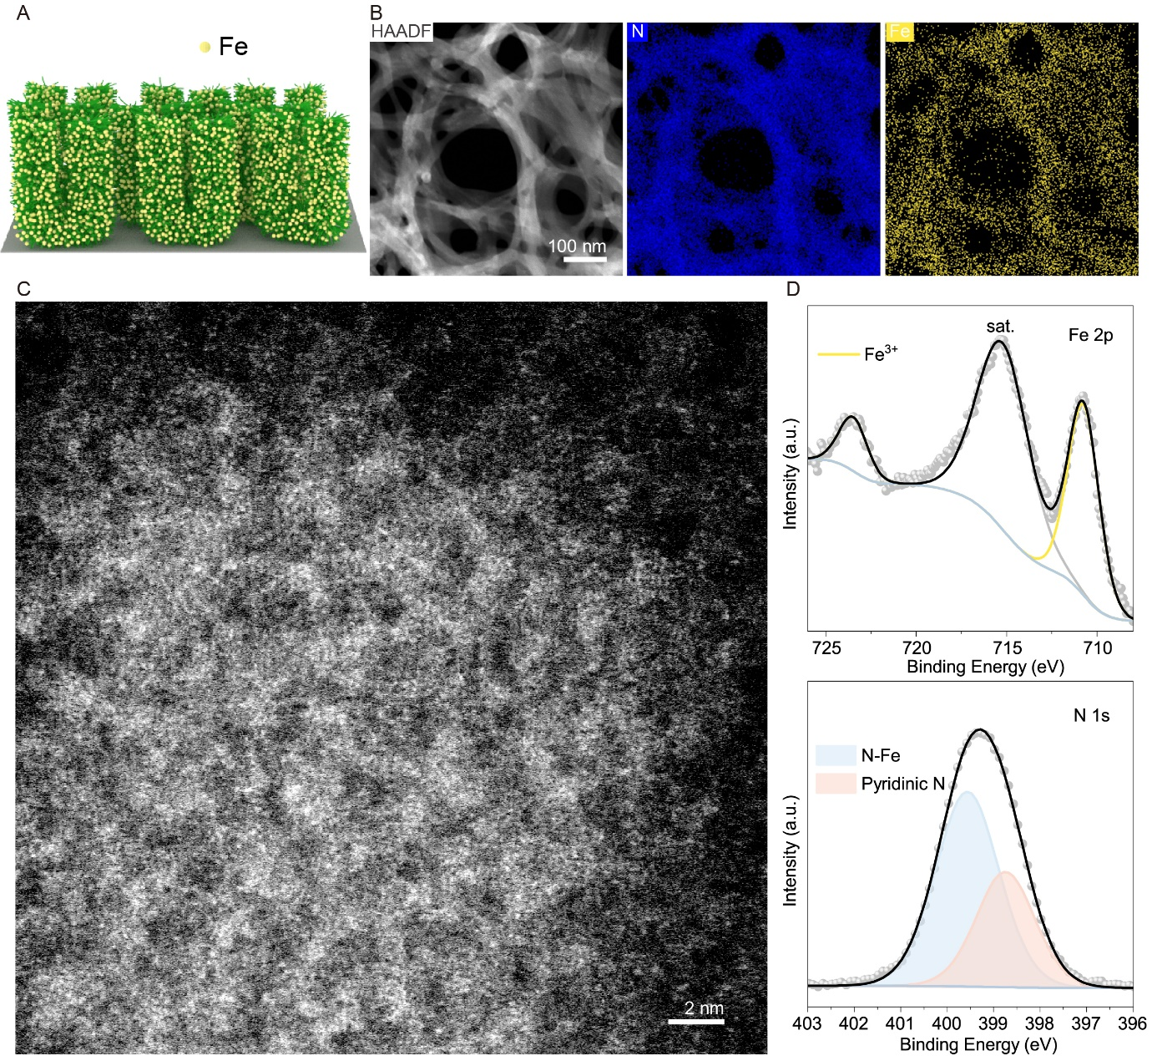
Figure S17. Structure characterization of Fe SA nanoforest. (A) Schematic illustration of Fe SA nanoforest. (B) HAADF-STEM image and corresponding element mapping of Fe and N. (C) AC-ADF-STEM image of Fe SA nanoforest. (D and E) XPS spectra of (D) Fe 2p and (E) N 1s.
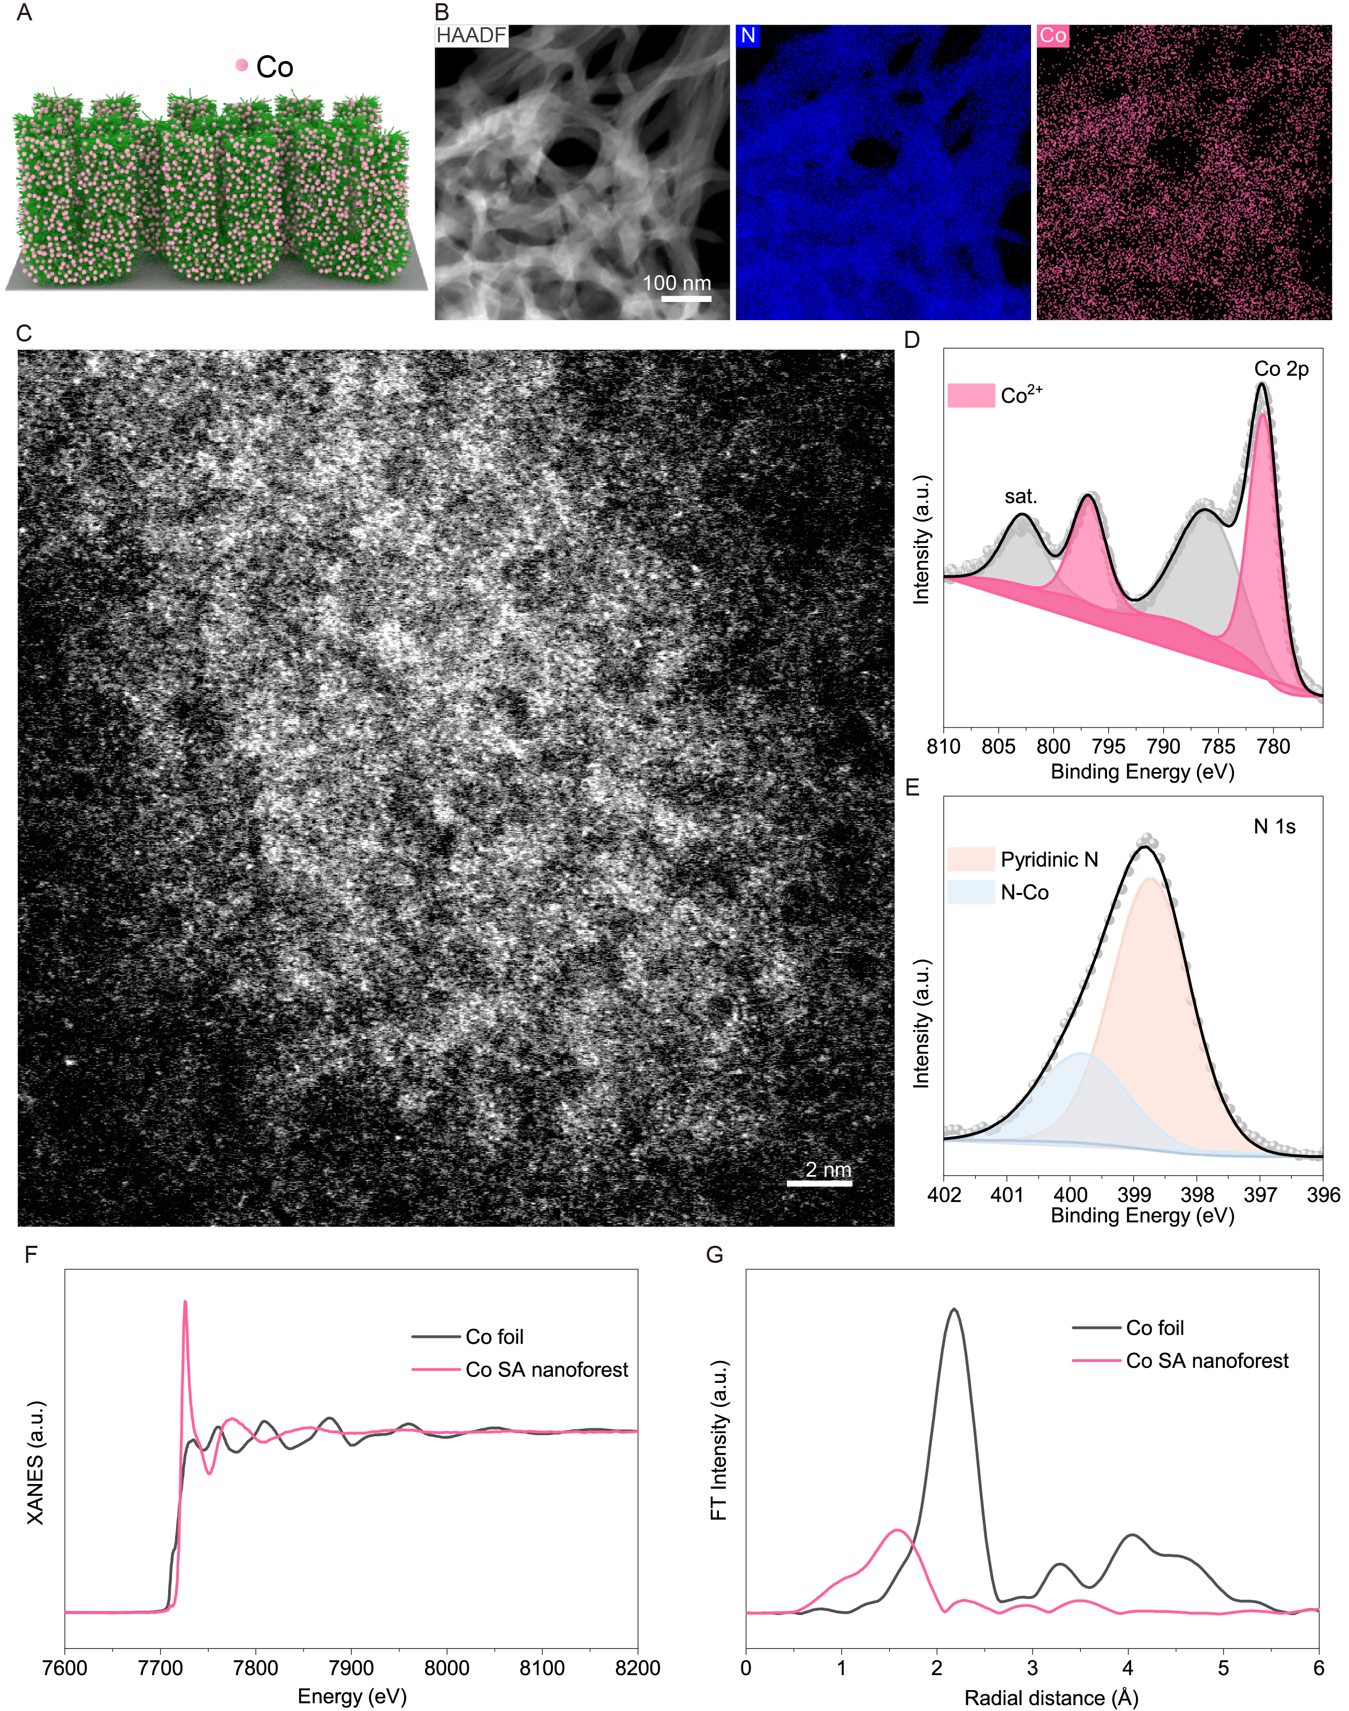
Figure S18. Structure characterization of Co SA nanoforest. (A) Schematic illustration of Co SA nanoforest. (B) HAADF-STEM image and corresponding element mapping of Co and N. (C) AC-ADF-STEM image of Co SA nanoforest. (D and E) XPS spectra of (D) Co 2p and (E) N 1s. (F) Normalized XANES spectra for Co K-edge. (G) FT-EXAFS spectra of Co SA nanoforest and Co foil.
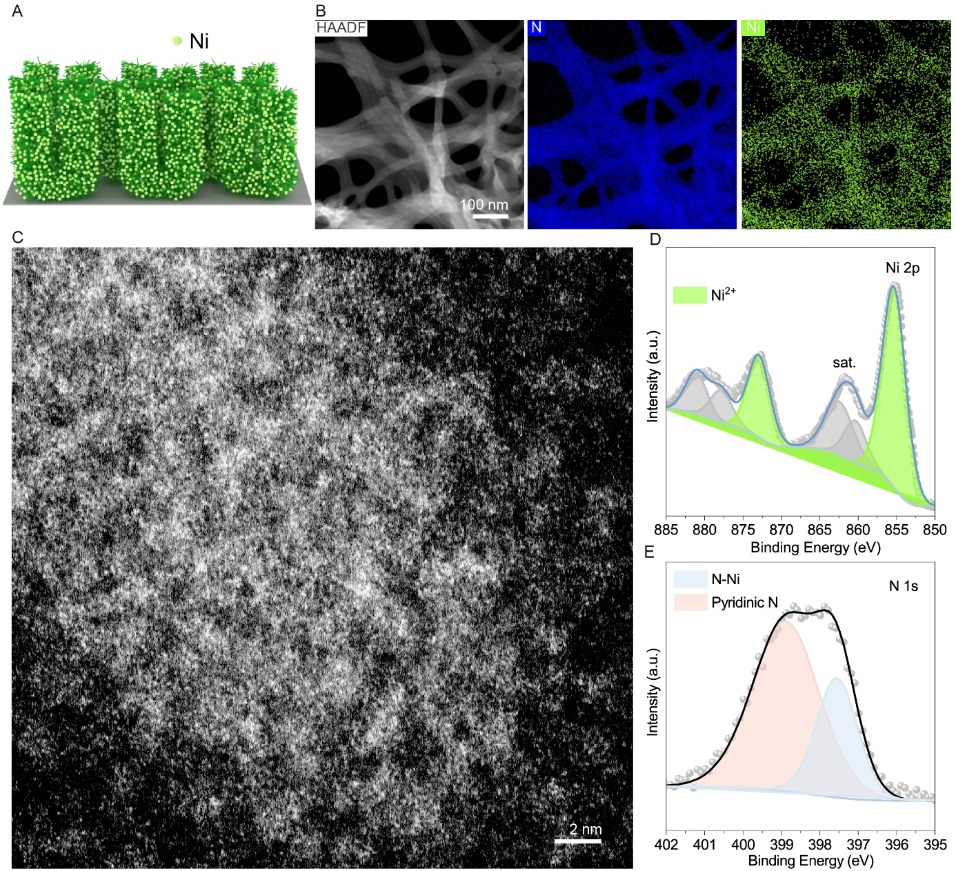
Figure S19. Structure characterization of Ni SA nanoforest. (A) Schematic illustration of Ni SA nanoforest. (B) HAADF-STEM image and corresponding element mapping of Ni and N. (C) AC-ADF-STEM image of Ni SA nanoforest. (D and E) XPS spectra of (D) Ni 2p and (E) N 1s.
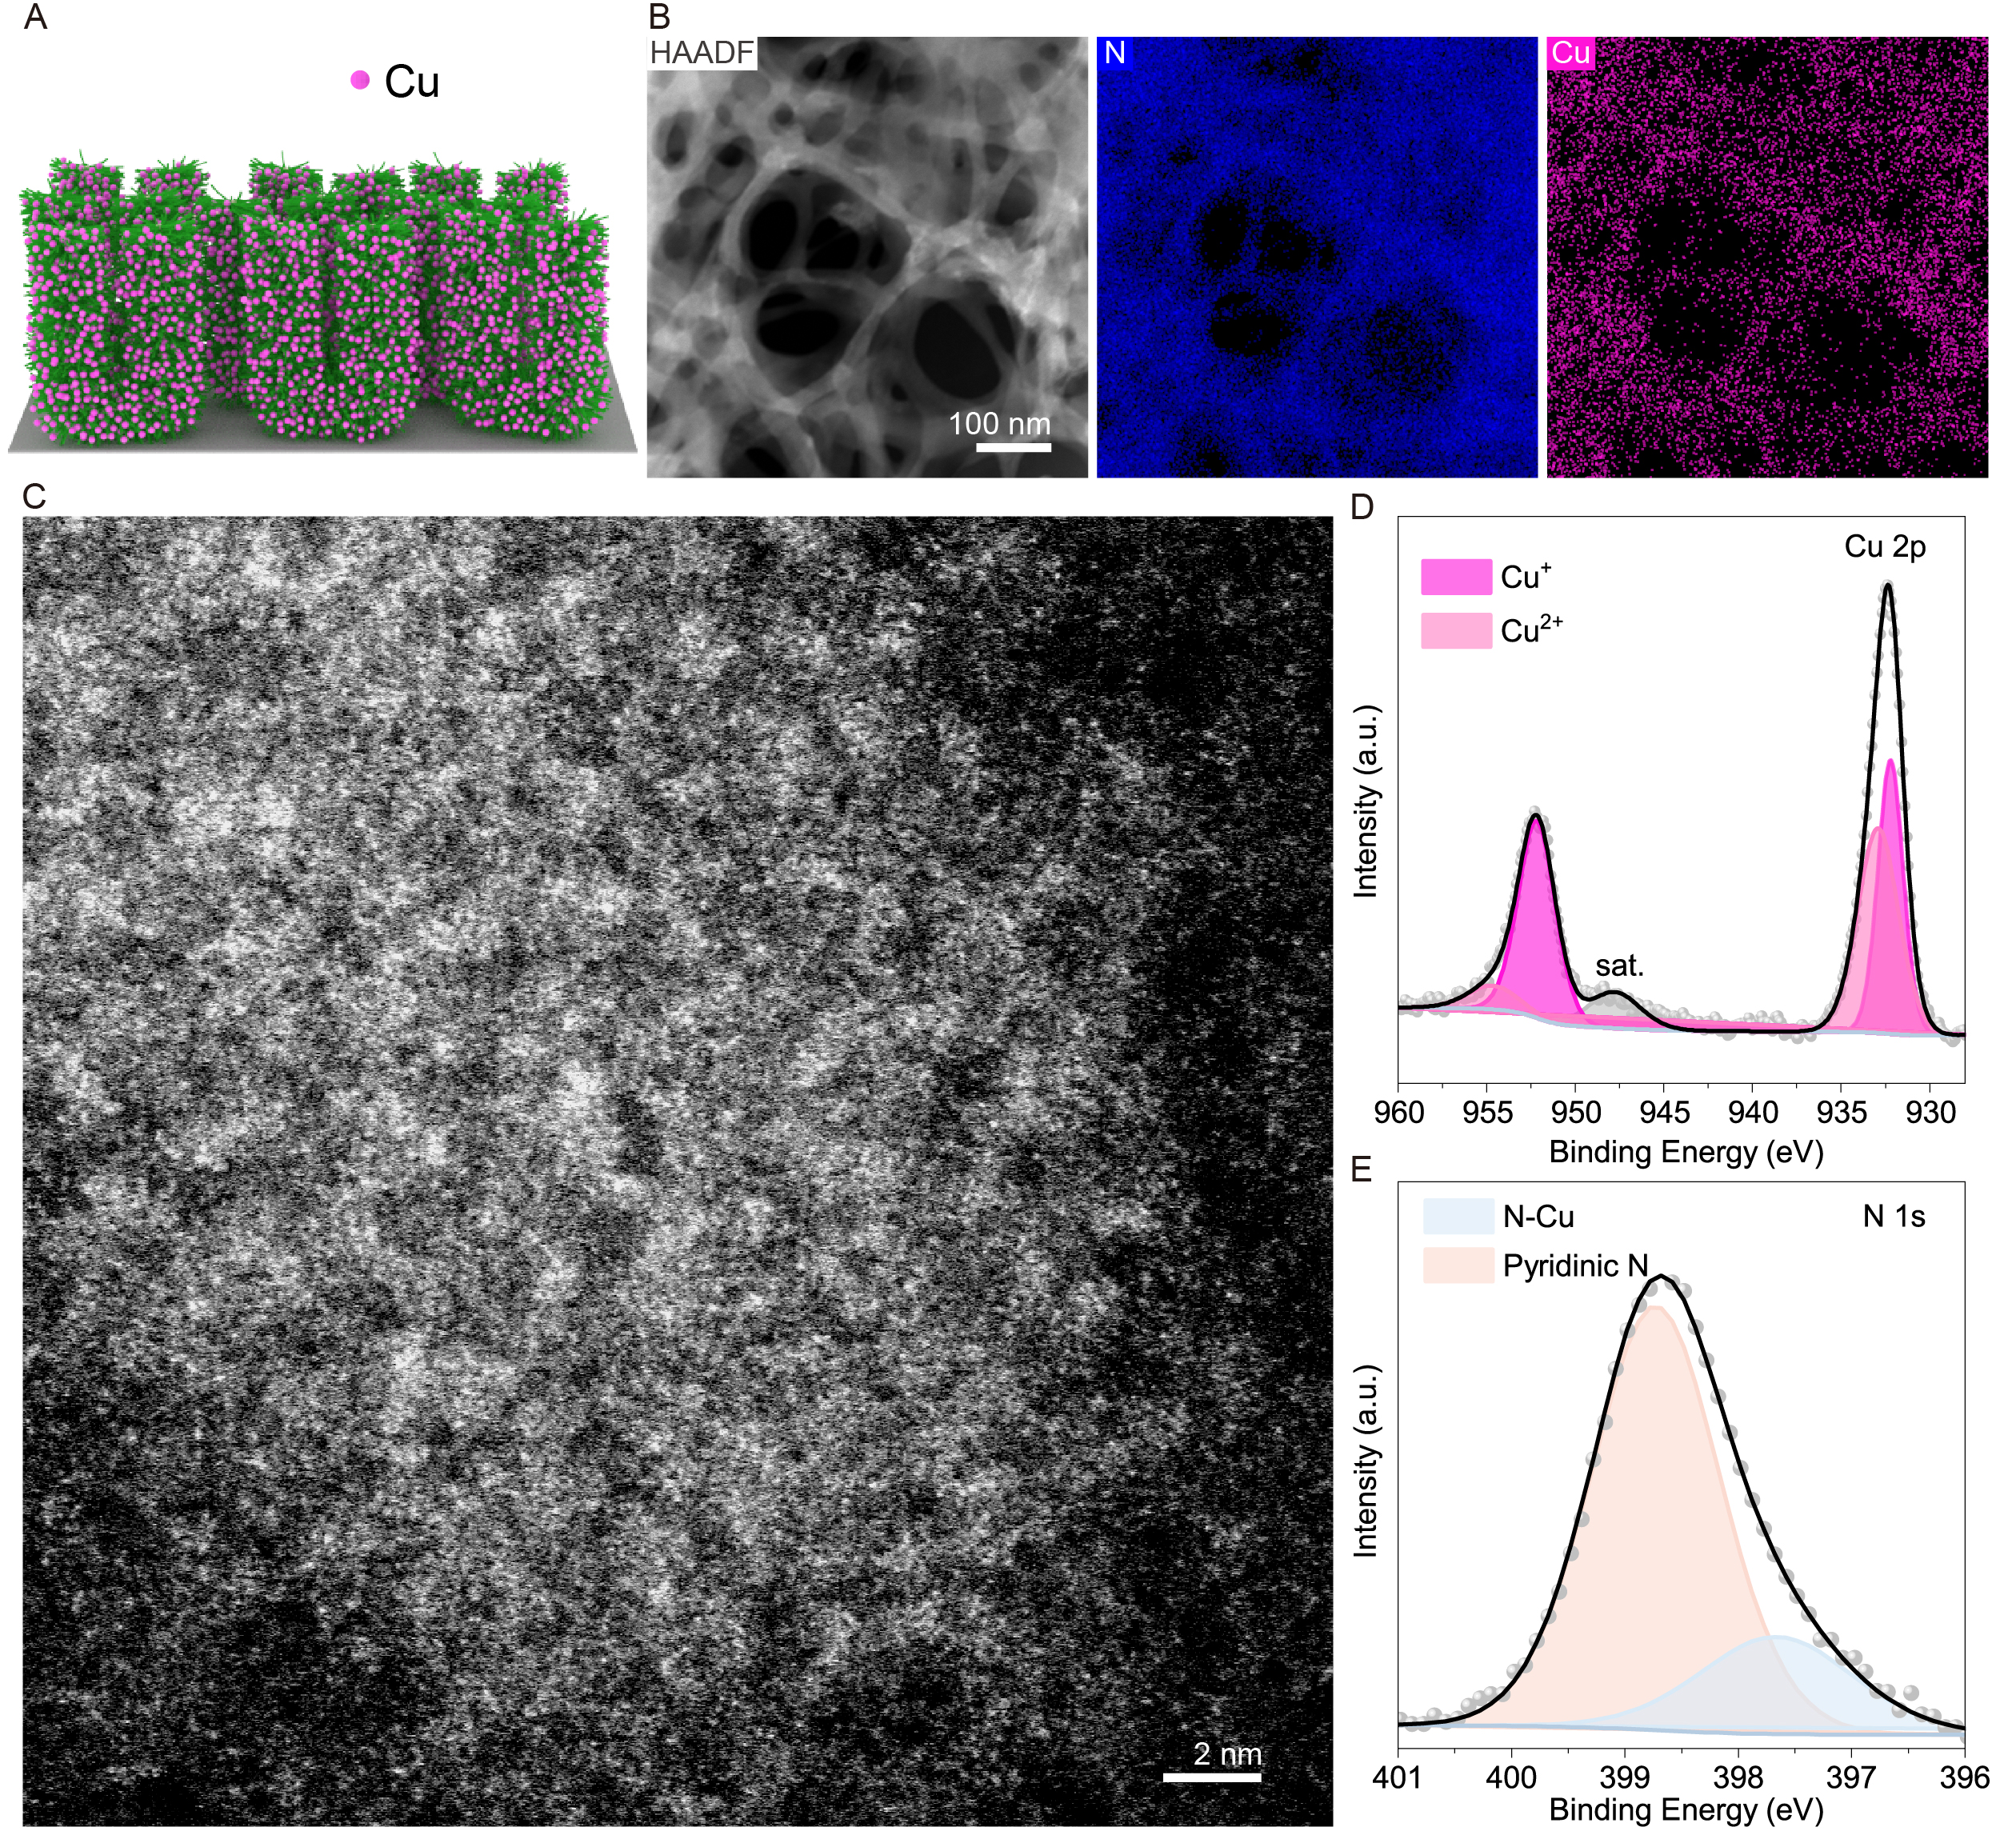
Figure S20. Structure characterization of Cu SA nanoforest. (A) Schematic illustration of Cu SA nanoforest. (B) HAADF-STEM image and corresponding element mapping of Cu and N. (C) AC-ADF-STEM image of Cu SA nanoforest. (D and E) XPS spectra of (D) Cu 2p and (E) N 1s.
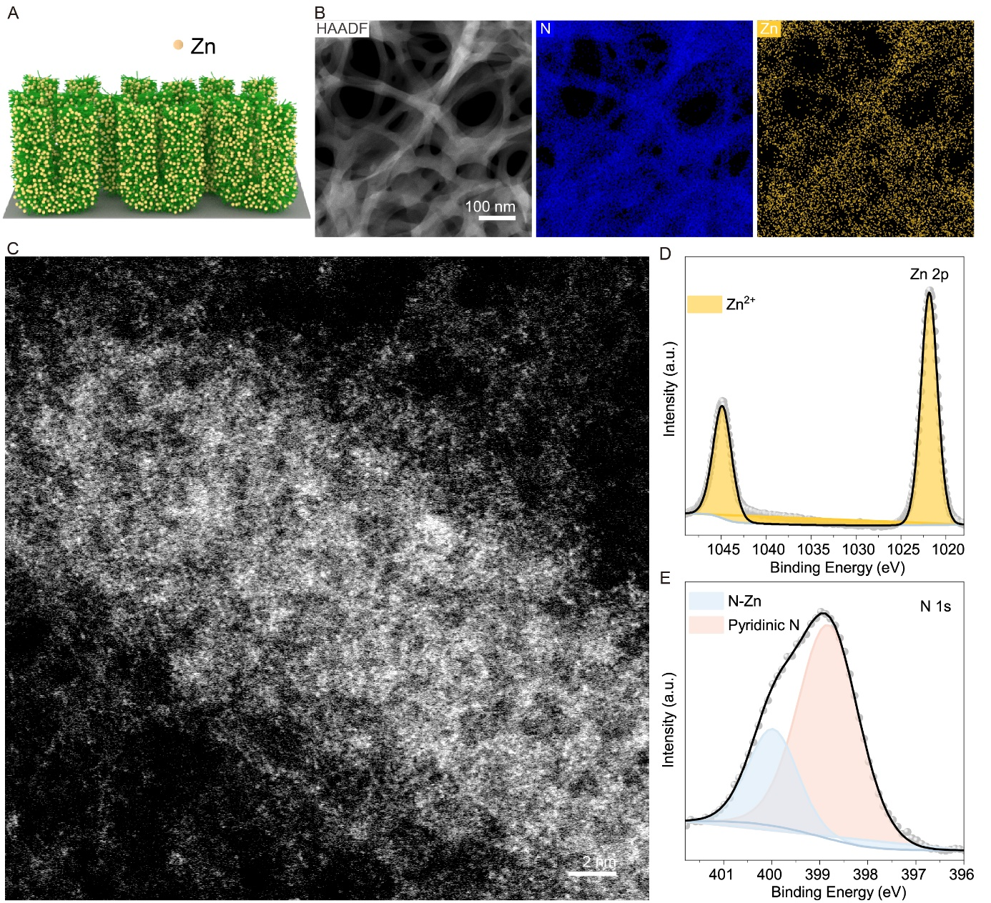
Figure S21. Structure characterization of Zn SA nanoforest. (A) Schematic illustration of Zn SA nanoforest. (B) HAADF-STEM image and corresponding element mapping of Zn and N. (C) AC-ADF-STEM image of Zn SA nanoforest. (D and E) XPS spectra of (D) Zn 2p and (E) N 1s.
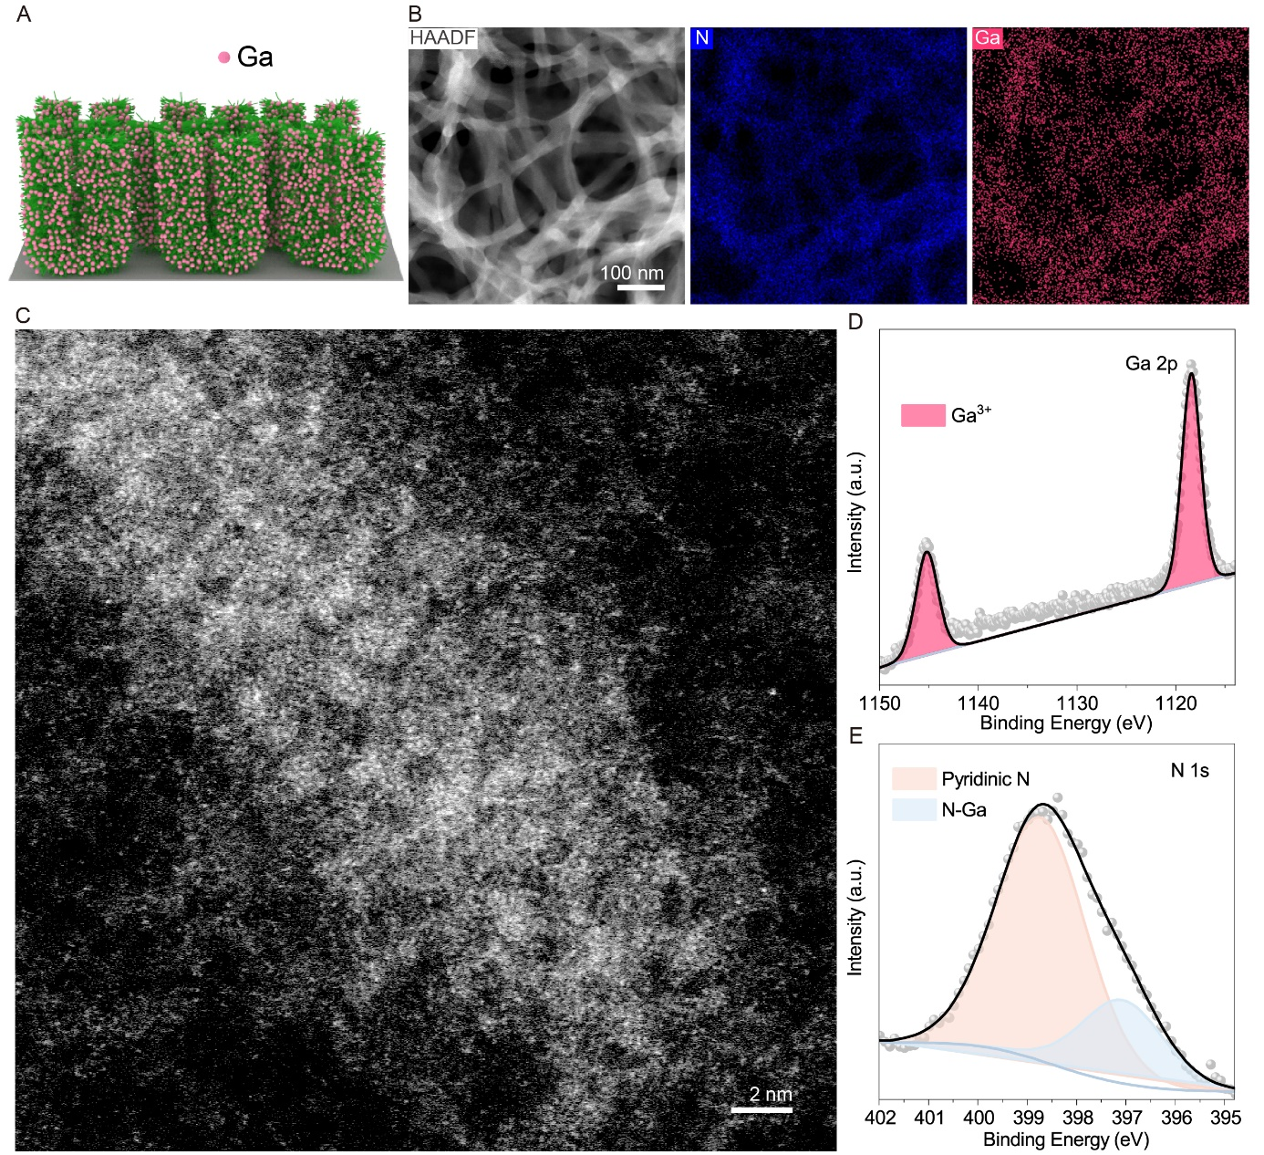
Figure S22. Structure characterization of Ga SA nanoforest. (A) Schematic illustration of Ga SA nanoforest. (B) HAADF-STEM image and corresponding element mapping of Ga and N. (C) AC-ADF-STEM image of Ga SA nanoforest. (D and E) XPS spectra of (D) Ga 2p and (E) N 1s.

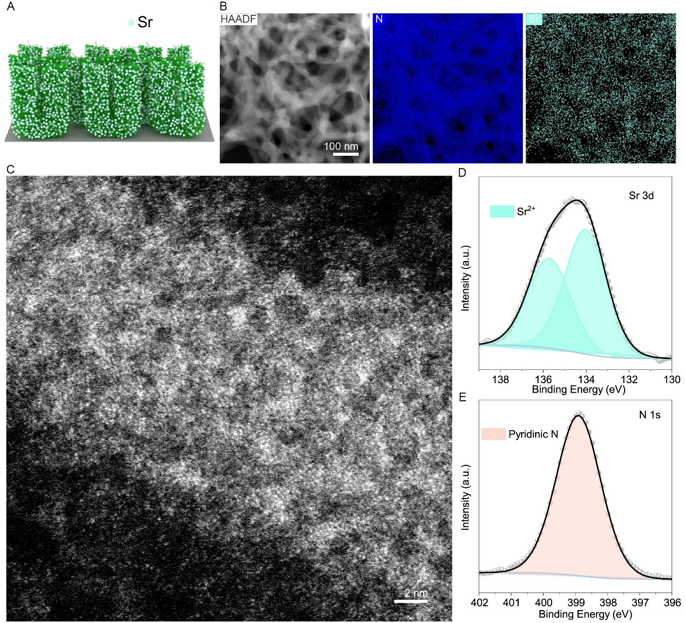
Figure S23. Structure characterization of Sr SA nanoforest. (A) Schematic illustration of Sr SA nanoforest. (B) HAADF-STEM image and corresponding element mapping of Sr and N. (C) AC-ADF-STEM image of Sr SA nanoforest. (D and E) XPS spectra of (D) Sr 3d and (E) N 1s.
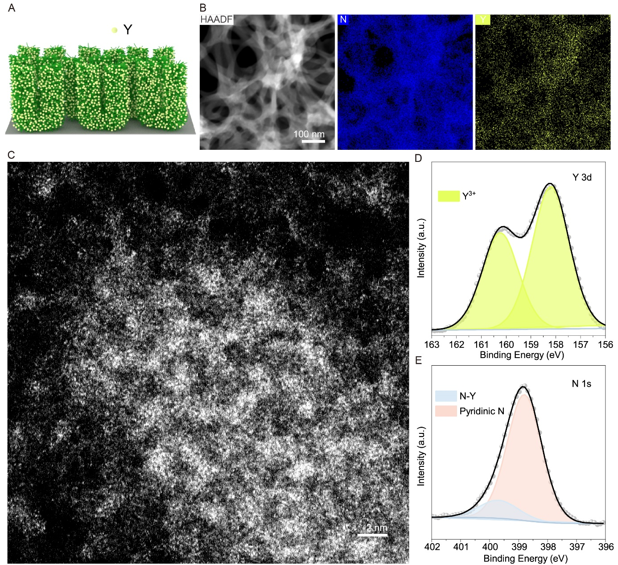
Figure S24. Structure characterization of Y SA nanoforest. (A) Schematic illustration of Y SA nanoforest. (B) HAADF-STEM image and corresponding element mapping of Y and N. (C) AC-ADF-STEM image of Y SA nanoforest. (D and E) XPS spectra of (D) Y 3d and (E) N 1s.
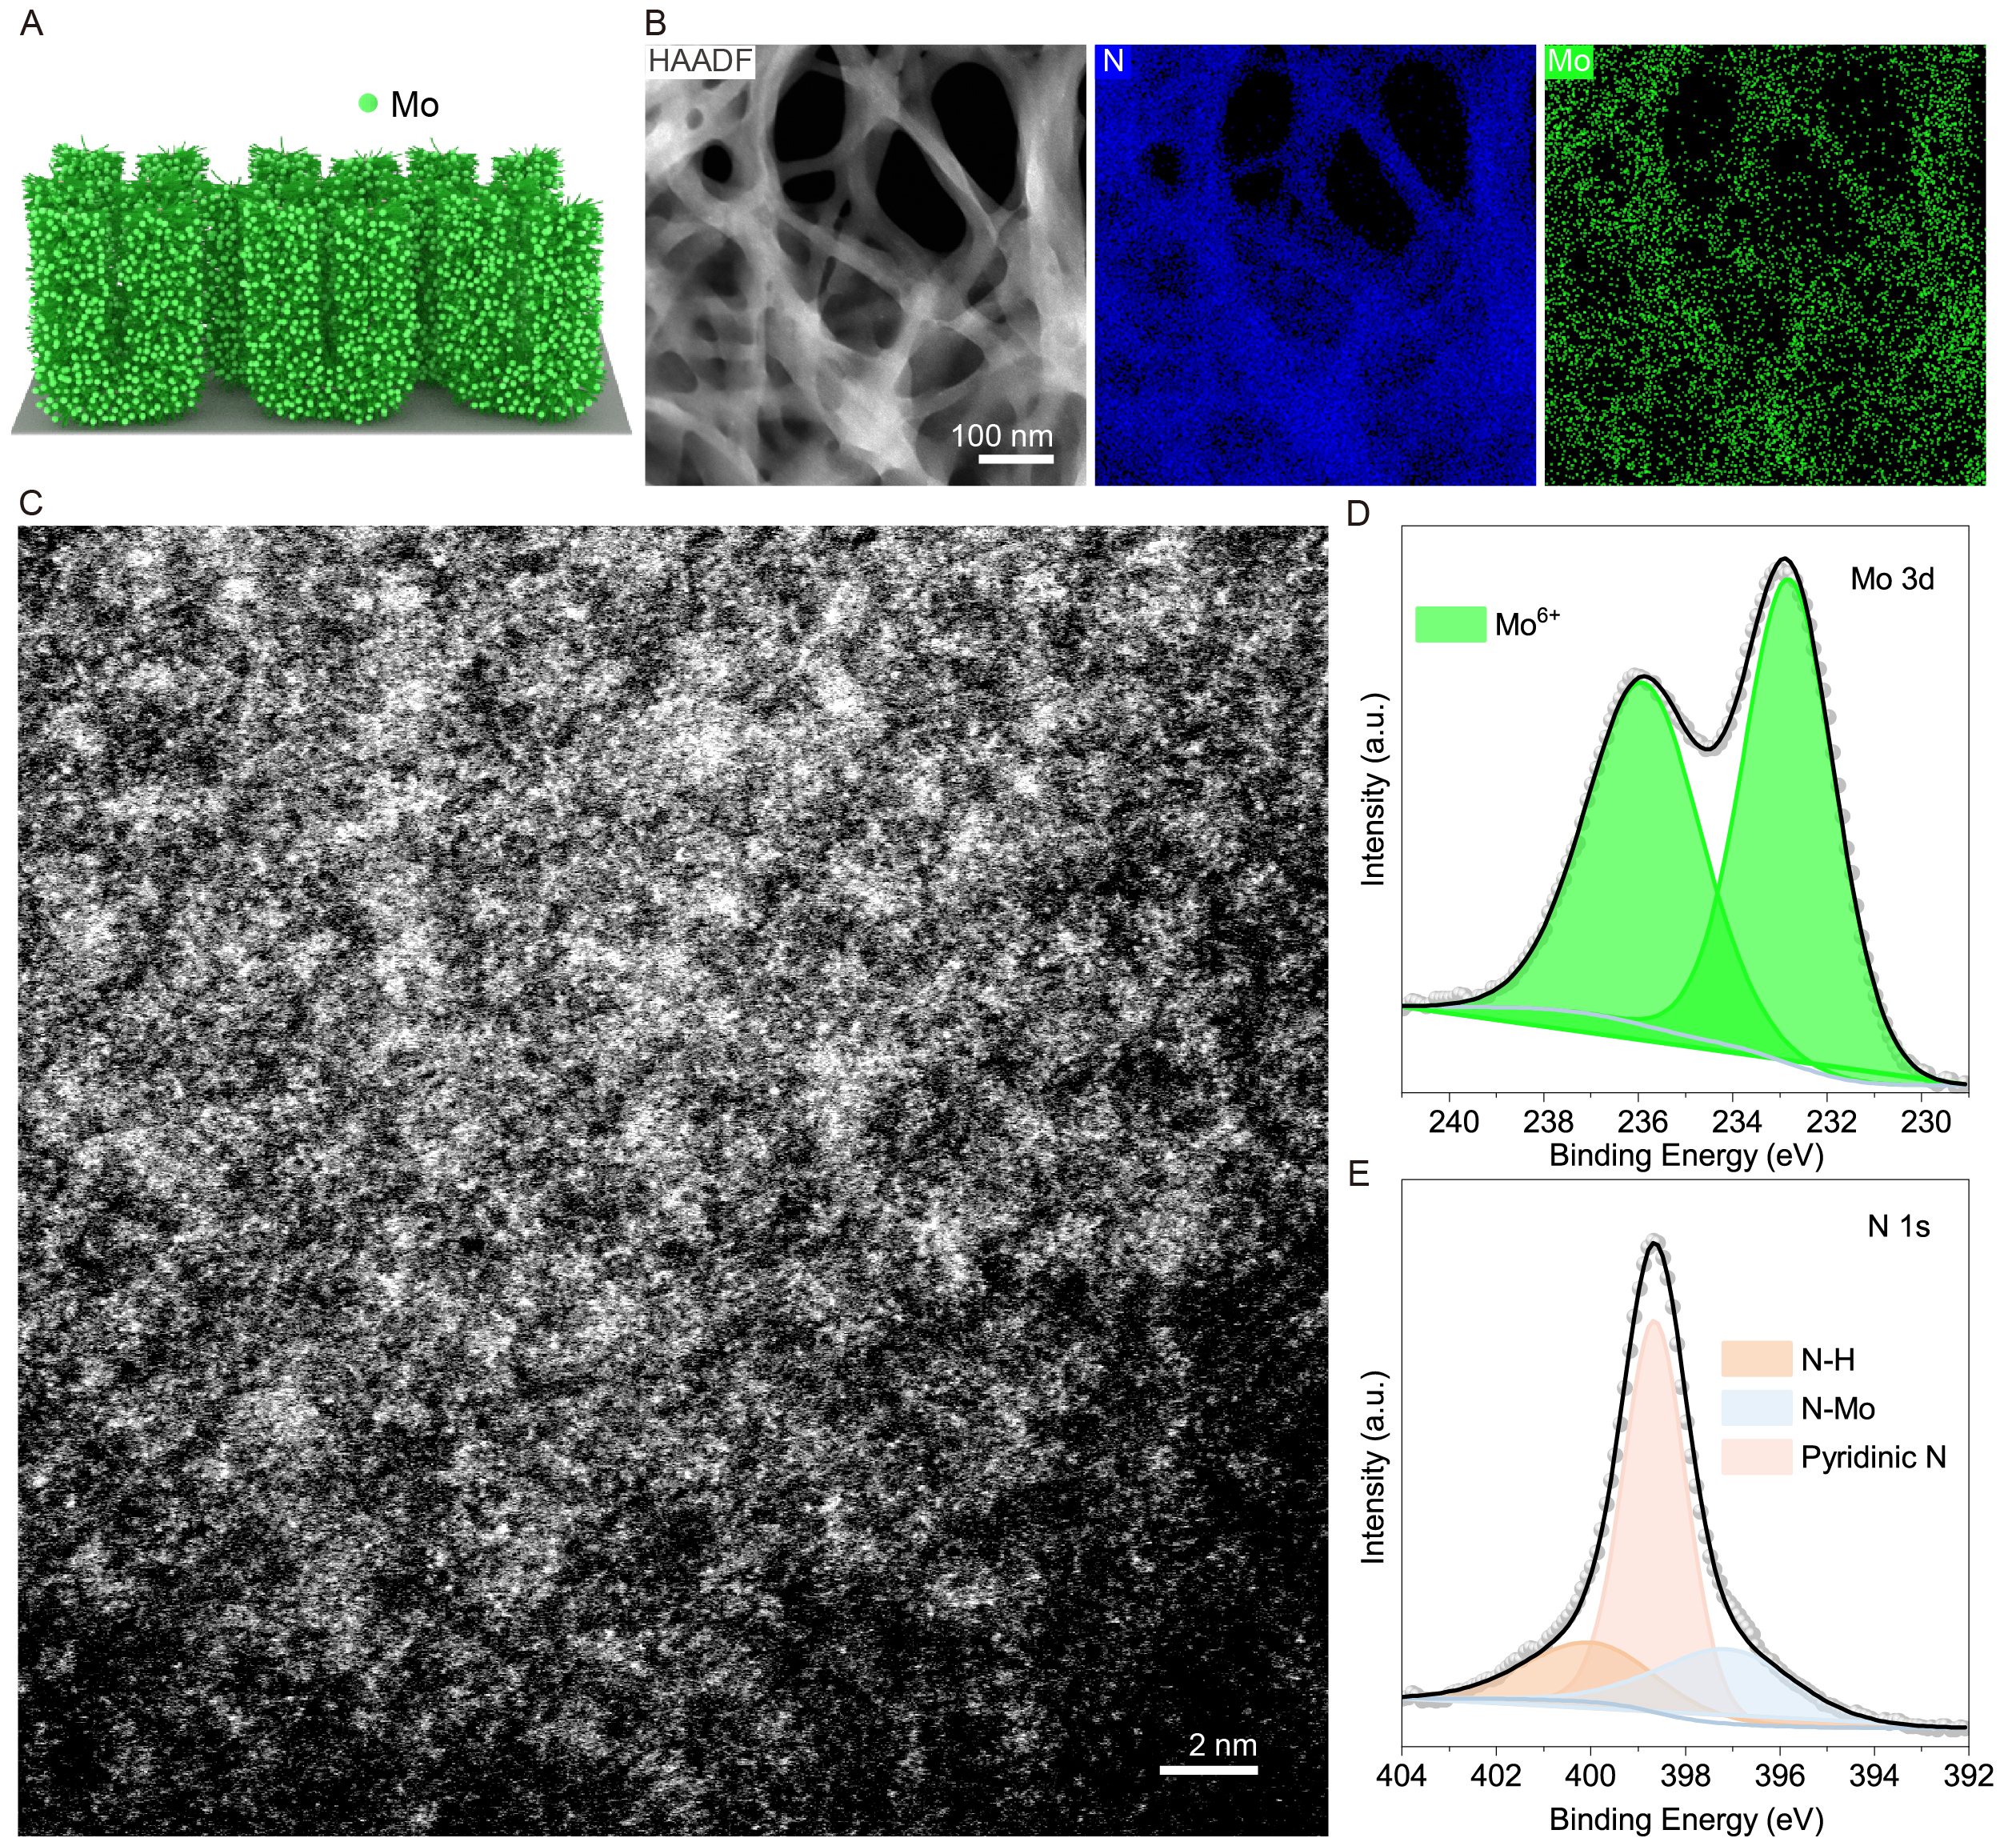
Figure S25. Structure characterization of Mo SA nanoforest. (A) Schematic illustration of Mo SA nanoforest. (B) HAADF-STEM image and corresponding element mapping of Mo and N. (C) AC-ADF-STEM image of Mo SA nanoforest. (D and E) XPS spectra of (D) Mo 3d and (E) N 1s.
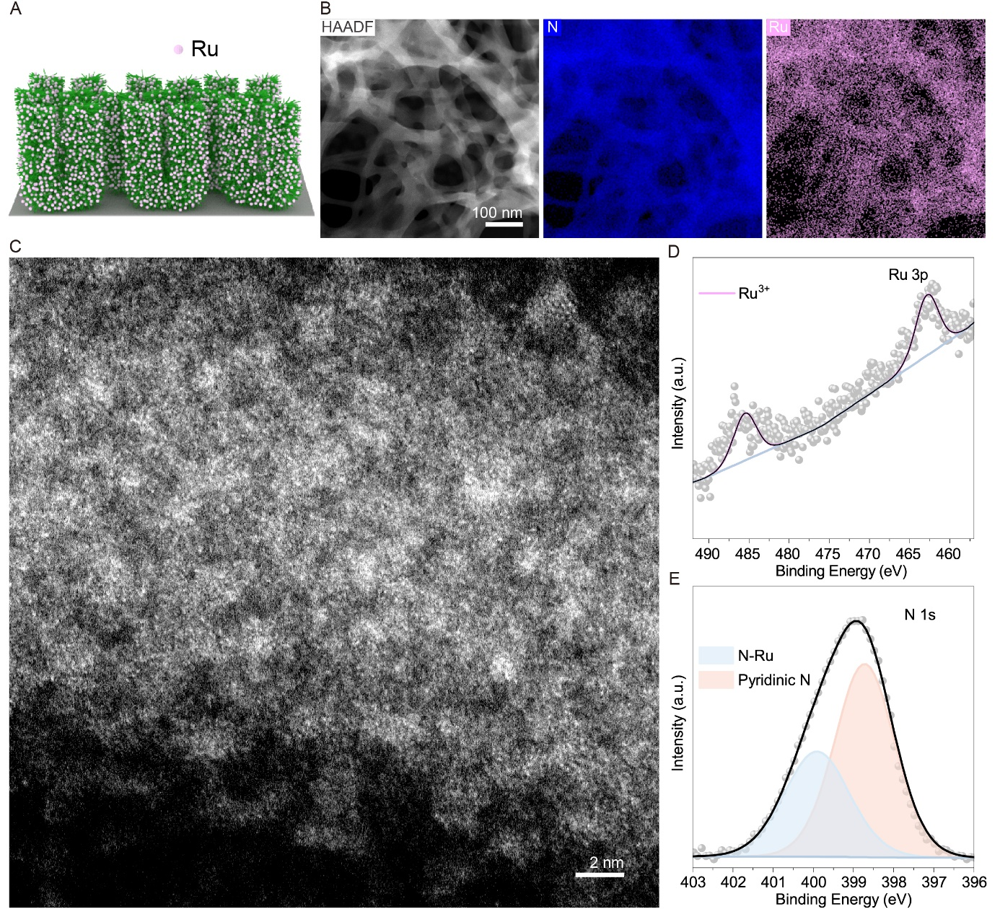
Figure S26. Structure characterization of Ru SA nanoforest. (A) Schematic illustration of Ru SA nanoforest. (B) HAADF-STEM image and corresponding element mapping of Ru and N. (C) AC-ADF-STEM image of Ru SA nanoforest. (D and E) XPS spectra of (D) Ru 3p and (E) N 1s.
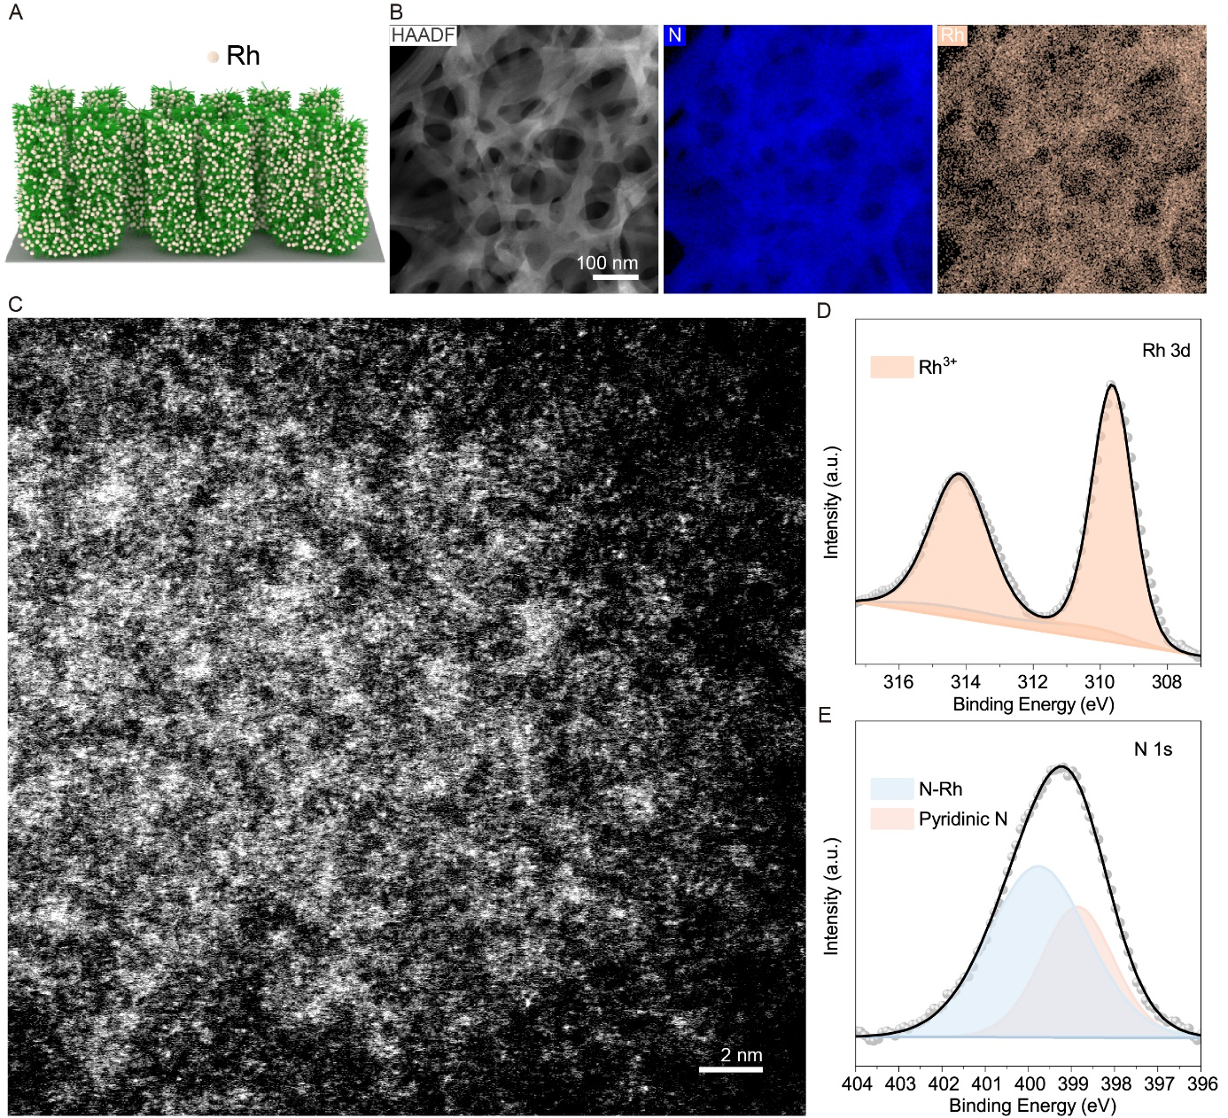
Figure S27. Structure characterization of Rh SA nanoforest. (A) Schematic illustration of Rh SA nanoforest. (B) HAADF-STEM image and corresponding element mapping of Rh and N. (C) AC-ADF-STEM image of Rh SA nanoforest. (D and E) XPS spectra of (D) Rh 3d and (E) N 1s.
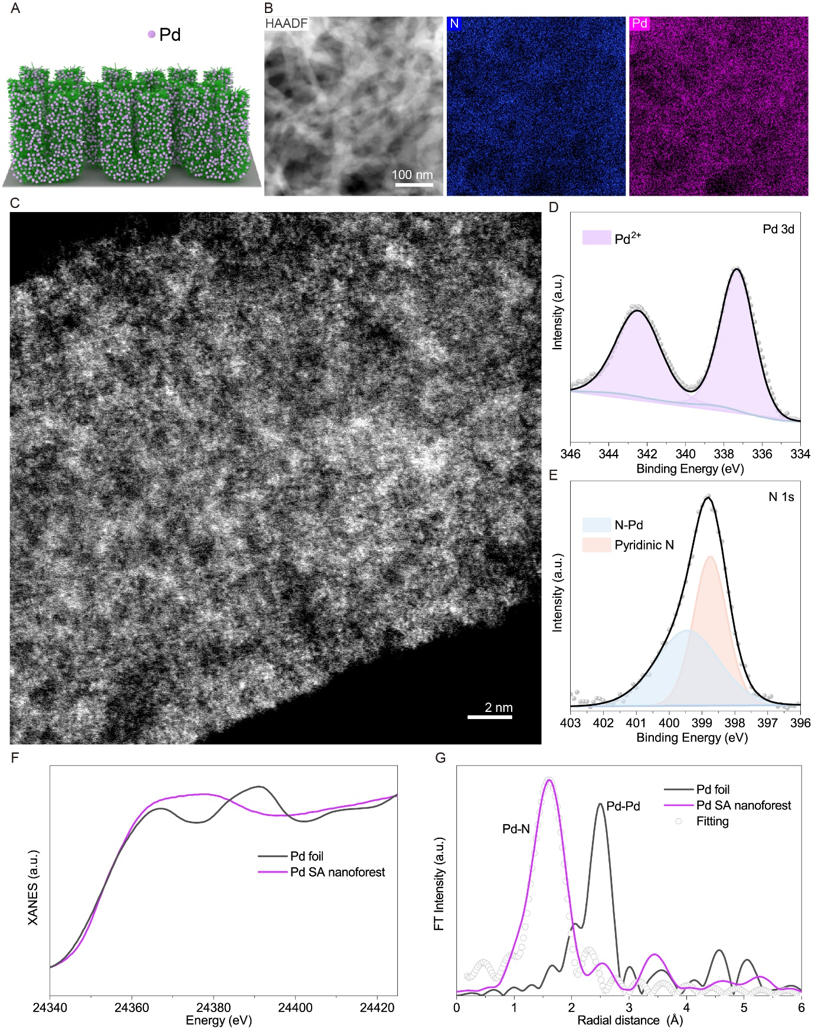
Figure S28. Structure characterization of Pd SA nanoforest. (A) Schematic illustration of Pd SA nanoforest. (B) HAADF-STEM image and corresponding element mapping of Pd and N. (C) AC-ADF-STEM image of Pd SA nanoforest. (D and E) XPS spectra of (D) Pd 3d and (E) N 1s. (F) Normalized XANES spectra for Pd K-edge. (G) FT-EXAFS spectra for Pd SA nanoforest and Pd foil, and corresponding EXAFS fitting curve of Pd SA nanoforest for R-space.
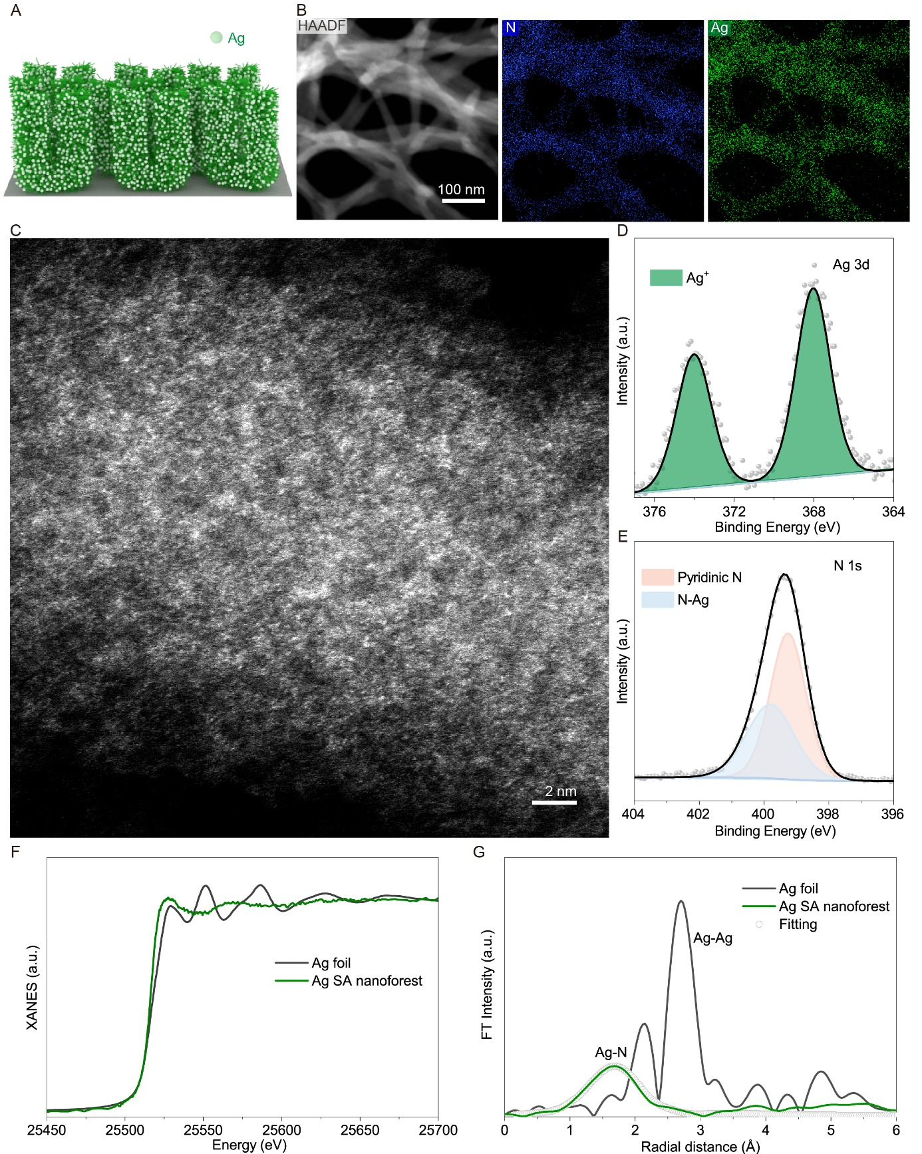 Figure S29. Structure characterization of Ag SA nanoforest. (A) Schematic illustration of Ag SA nanoforest. (B) HAADF-STEM image and corresponding element mapping of Ag and N. (C) AC-ADF-STEM image of Ag SA nanoforest. (D and E) XPS spectra of (D) Ag 3d and (E) N 1s. (F) Normalized XANES spectra for Ag K-edge. (G) FT-EXAFS spectra for Ag SA nanoforest and Ag foil, and corresponding EXAFS fitting curve of Ag SA nanoforest for R-space.

Table S4. Structural parameters of Pd SA nanoforest and Ag SA nanoforest extracted from EXAFS fitting.
Catalyst | Path | R (Å) | N_{coord} | σ² (Å²) | △E₀ (eV) | R_{f} (%)
Pd | Pd-N | 2.01 | 3.8 | 0.0032 | 8.9 | 1.7
Ag | Ag-N | 2.01 | 2.2 | 0.0061 | 4.8 | 1.9

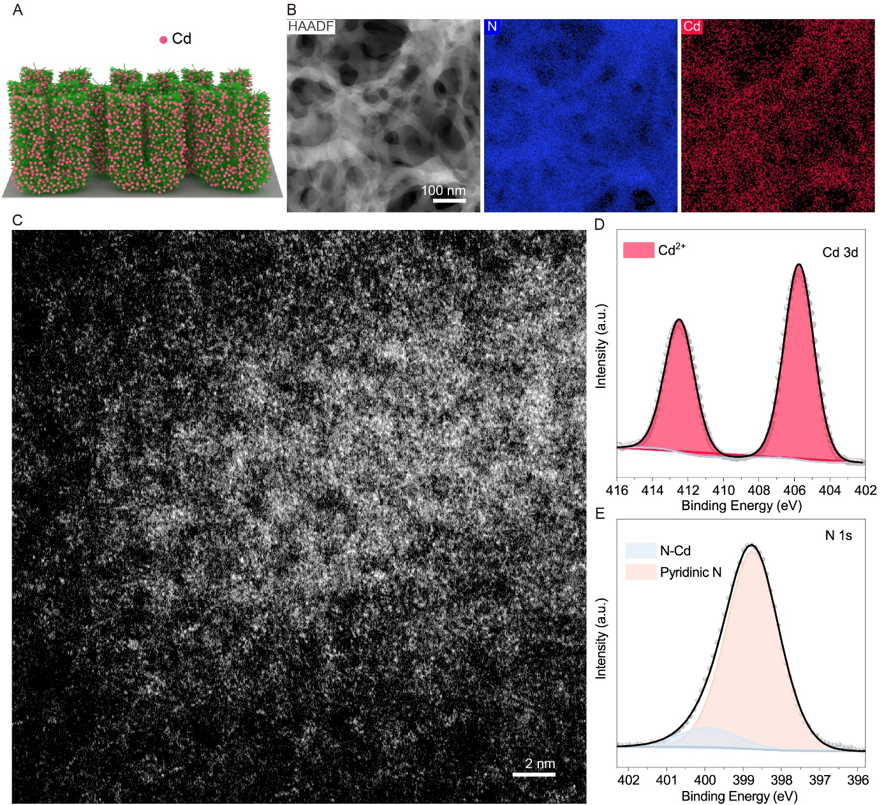
Figure S30. Structure characterization of Cd SA nanoforest. (A) Schematic illustration of Cd SA nanoforest. (B) HAADF-STEM image and corresponding element mapping of Cd and N. (C) AC-ADF-STEM image of Cd SA nanoforest. (D and E) XPS spectra of (D) Cd 3d and (E) N 1s.

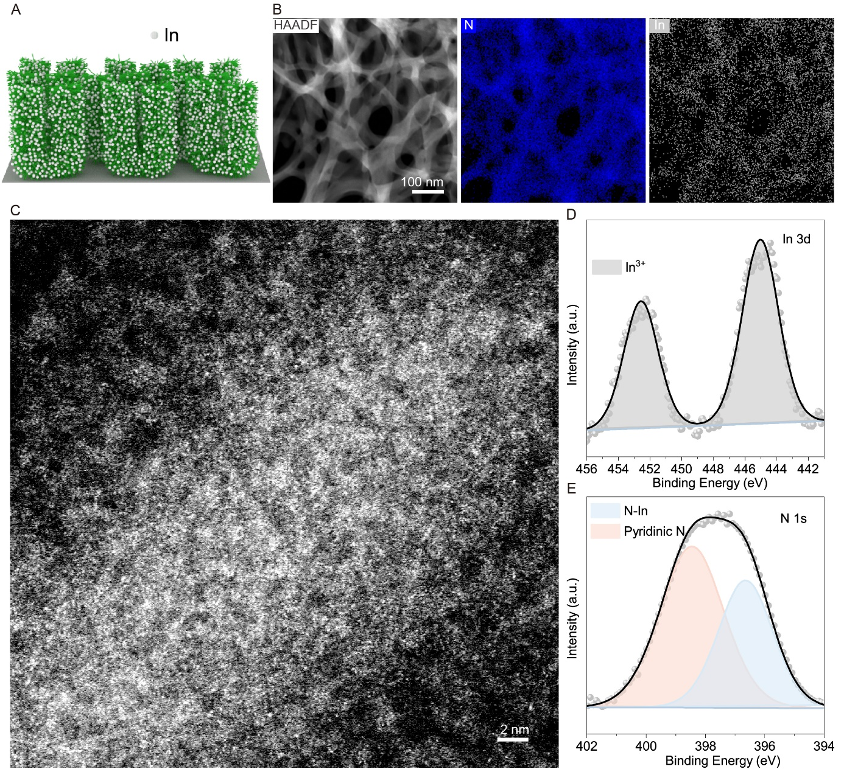
Figure S31. Structure characterization of In SA nanoforest. (A) Schematic illustration of In SA nanoforest. (B) HAADF-STEM image and corresponding element mapping of In and N. (C) AC-ADF-STEM image of In SA nanoforest. (D and E) XPS spectra of (D) In 3d and (E) N 1s.
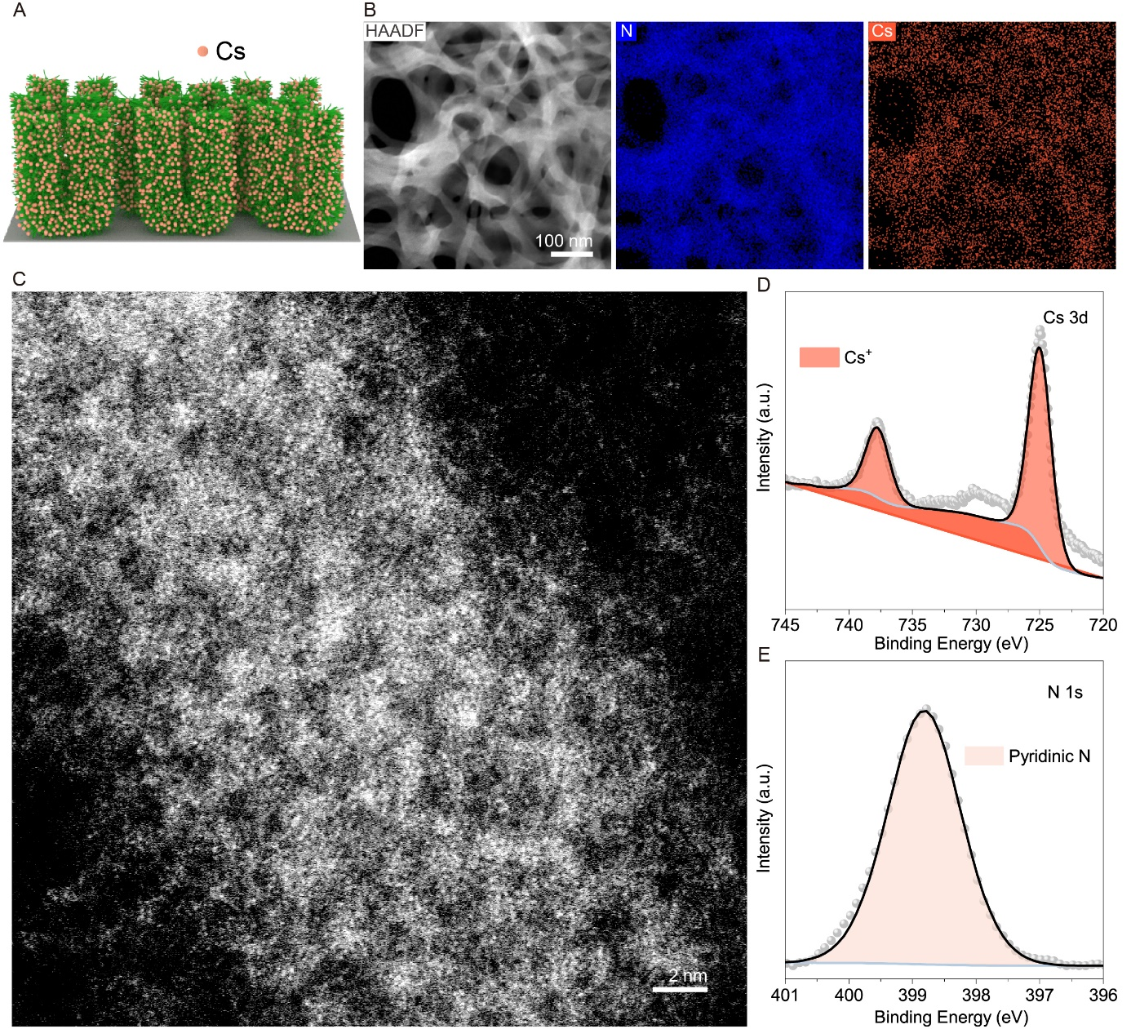
Figure S32. Structure characterization of Cs SA nanoforest. (A) Schematic illustration of Cs SA nanoforest. (B) HAADF-STEM image and corresponding element mapping of Cs and N. (C) AC-ADF-STEM image of Cs SA nanoforest. (D and E) XPS spectra of (D) Cs 3d and (E) N 1s.
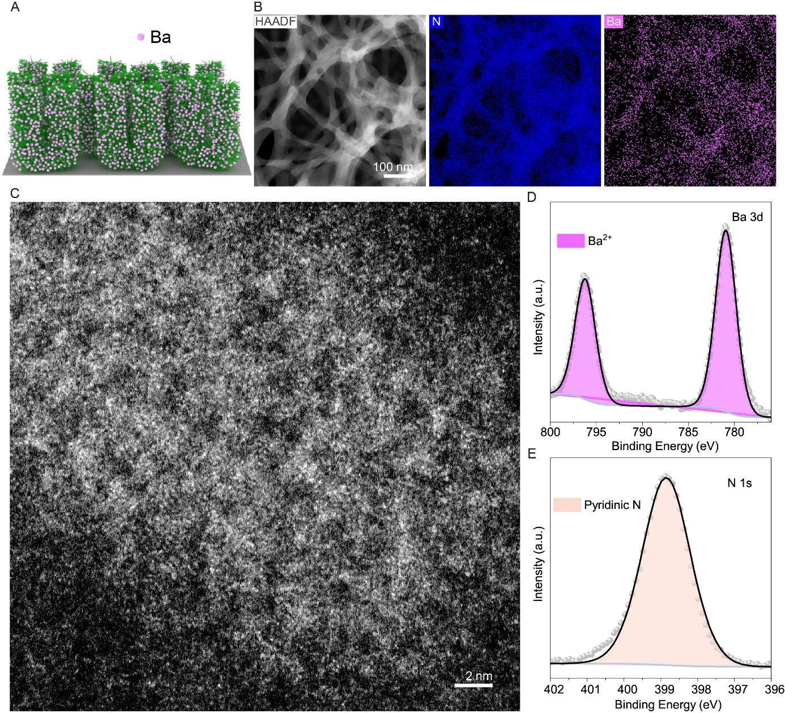
Figure S33. Structure characterization of Ba SA nanoforest. (A) Schematic illustration of Ba SA nanoforest. (B) HAADF-STEM image and corresponding element mapping of Ba and N. (C) AC-ADF-STEM image of Ba SA nanoforest. (D and E) XPS spectra of (D) Ba 3d and (E) N 1s.
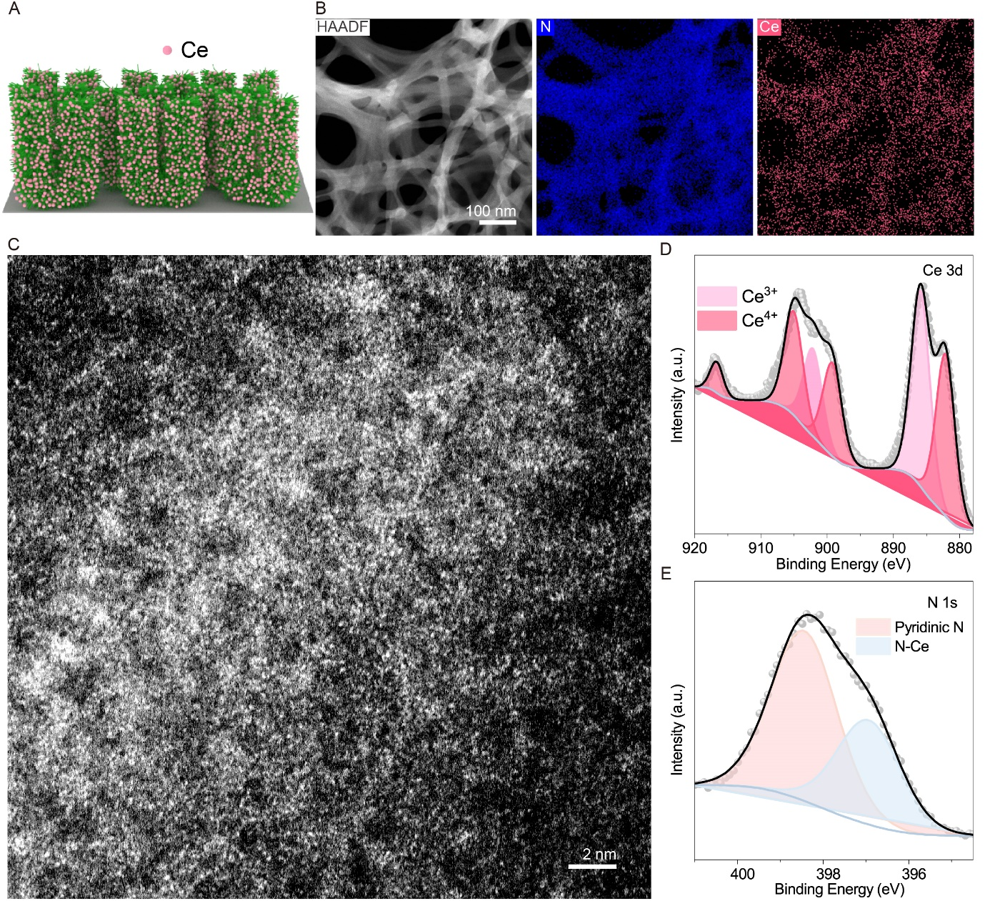
Figure S34. Structure characterization of Ce SA nanoforest. (A) Schematic illustration of Ce SA nanoforest. (B) HAADF-STEM image and corresponding element mapping of Ce and N. (C) AC-ADF-STEM image of Ce SA nanoforest. (D and E) XPS spectra of (D) Ce 3d and (E) N 1s.
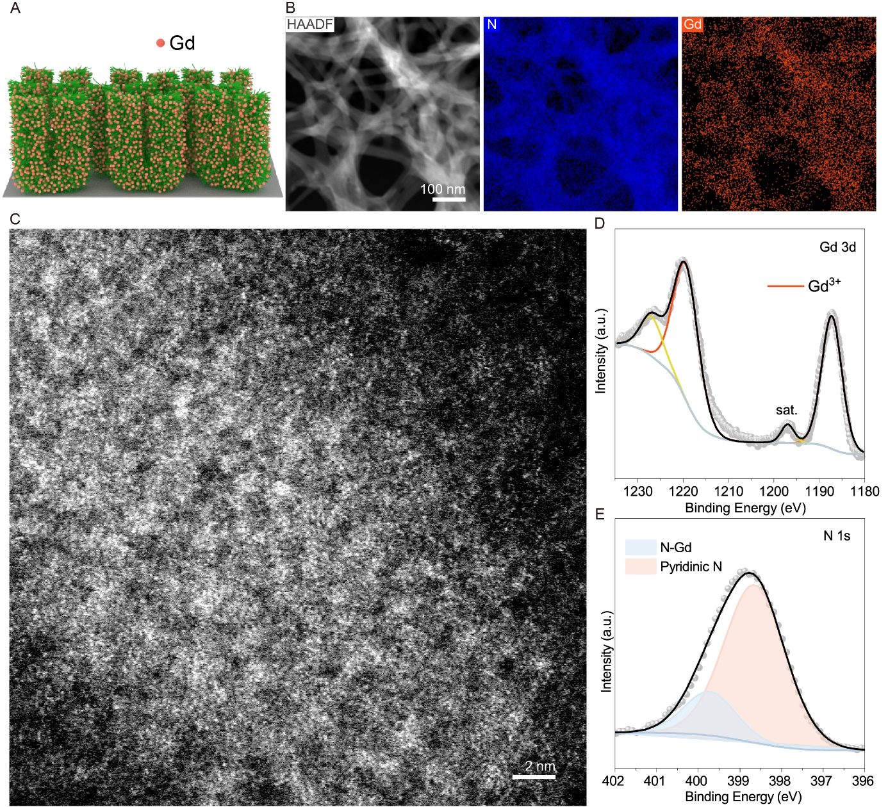
Figure S35. Structure characterization of Gd SA nanoforest. (A) Schematic illustration of Gd SA nanoforest. (B) HAADF-STEM image and corresponding element mapping of Gd and N. (C) AC-ADF-STEM image of Gd SA nanoforest. (D and E) XPS spectra of (D) Gd 3d and (E) N 1s.
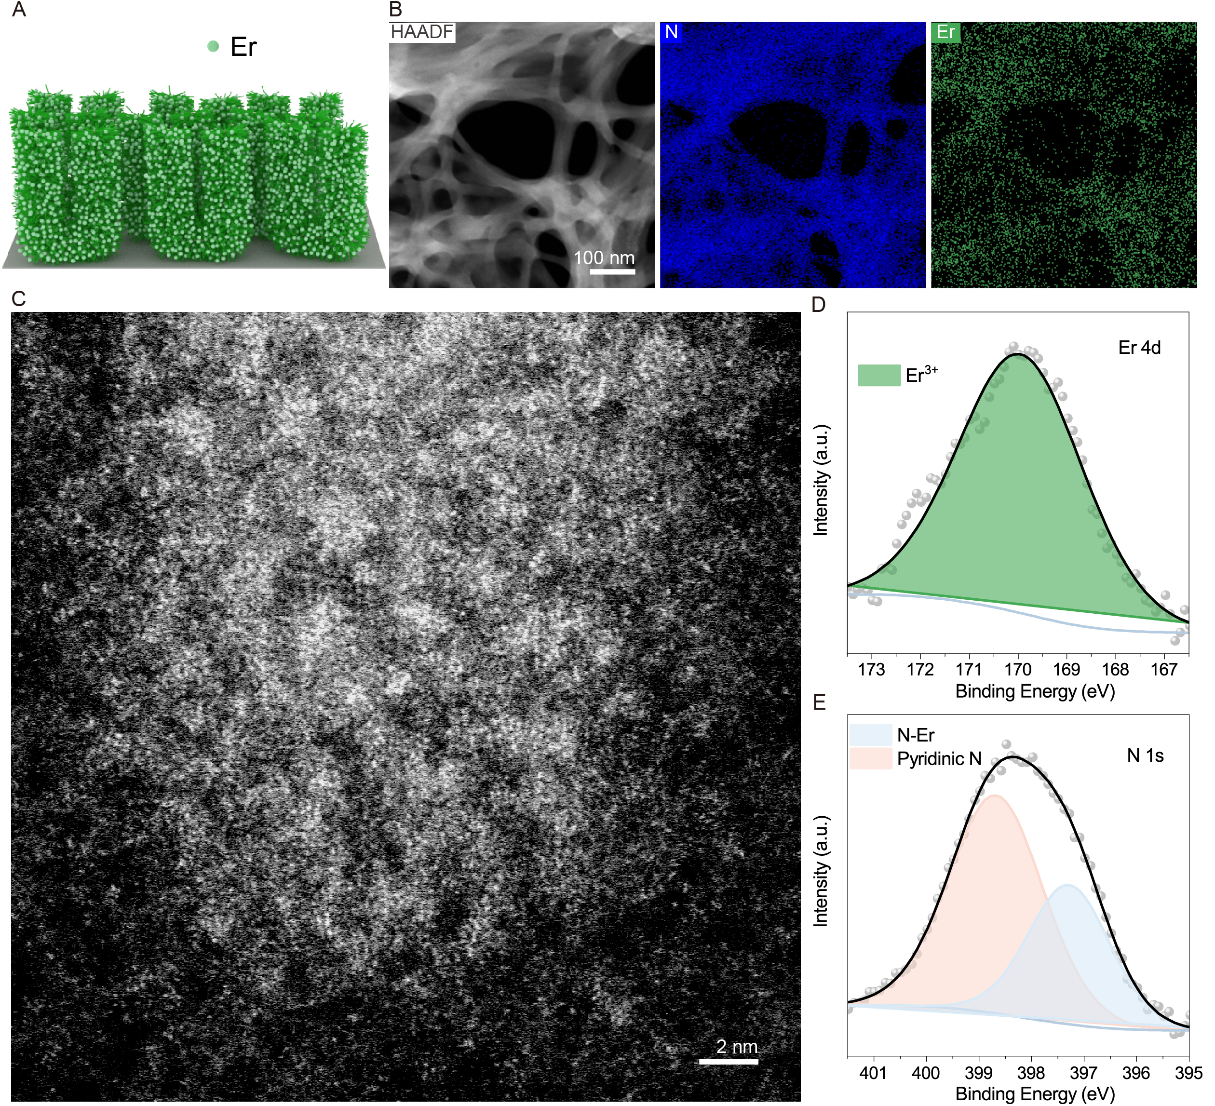
Figure S36. Structure characterization of Er SA nanoforest. (A) Schematic illustration of Er SA nanoforest. (B) HAADF-STEM image and corresponding element mapping of Er and N. (C) AC-ADF-STEM image of Er SA nanoforest. (D and E) XPS spectra of (D) Er 4d and (E) N 1s.
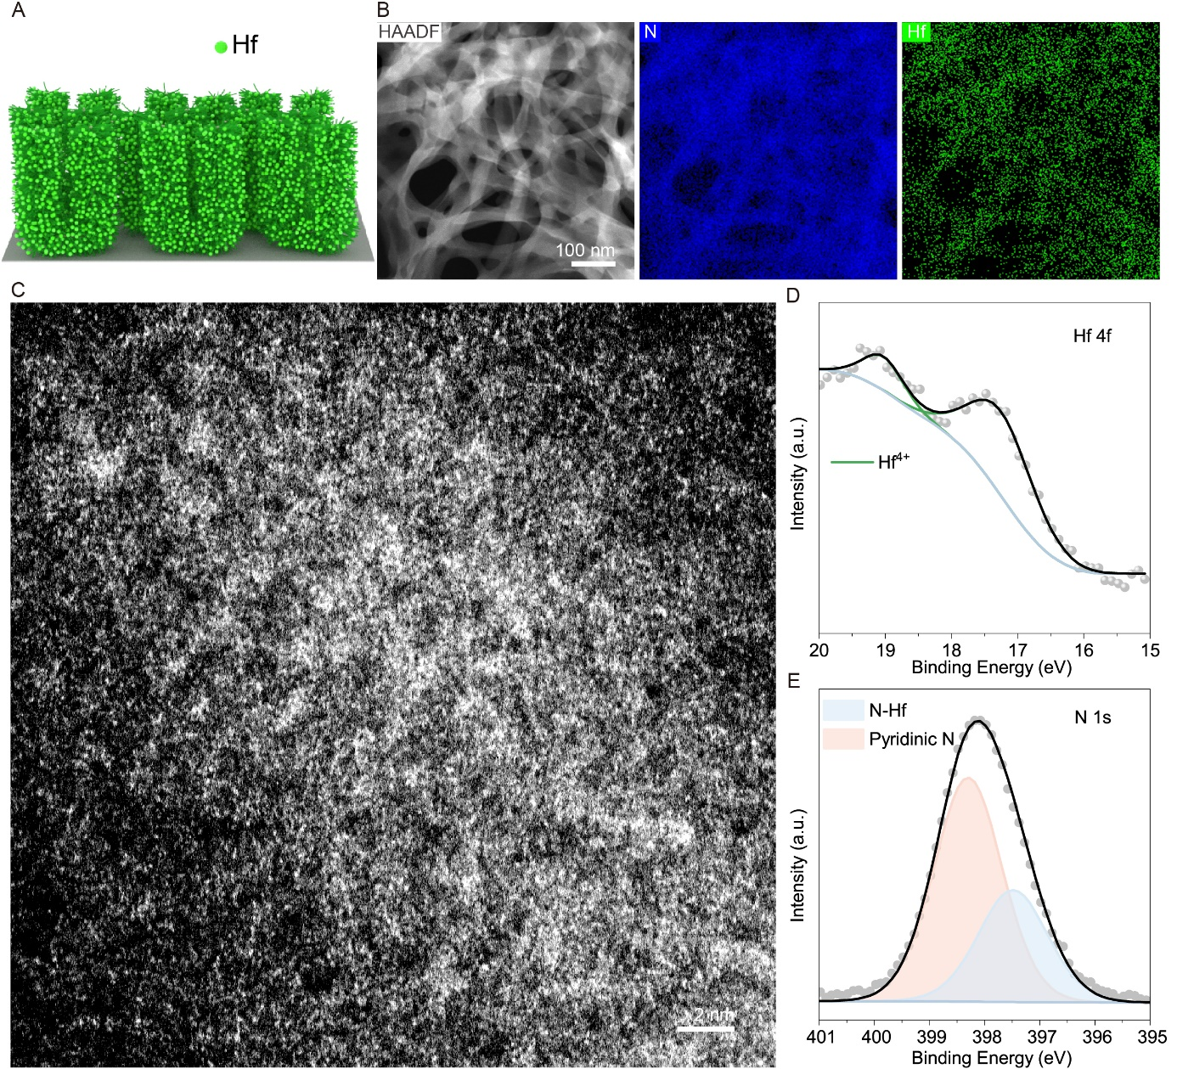
Figure S37. Structure characterization of Hf SA nanoforest. (A) Schematic illustration of Hf SA nanoforest. (B) HAADF-STEM image and corresponding element mapping of Hf and N. (C) AC-ADF-STEM image of Hf SA nanoforest. (D and E) XPS spectra of (D) Hf 4f and (E) N 1s.
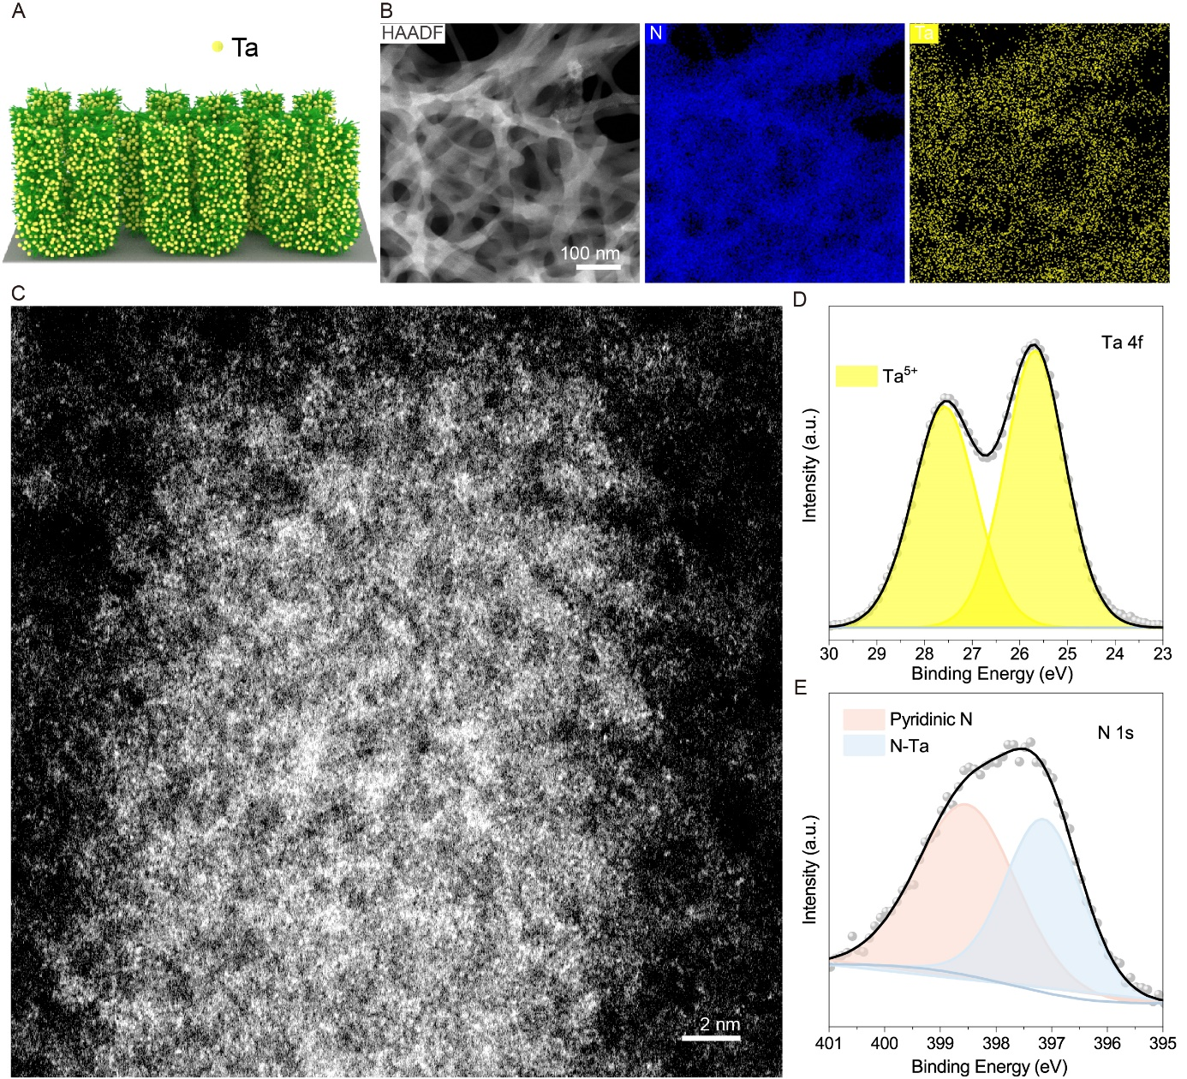
Figure S38. Structure characterization of Ta SA nanoforest. (A) Schematic illustration of Ta SA nanoforest. (B) HAADF-STEM image and corresponding element mapping of Ta and N. (C) AC-ADF-STEM image of Ta SA nanoforest. (D and E) XPS spectra of (D) Ta 4f and (E) N 1s.
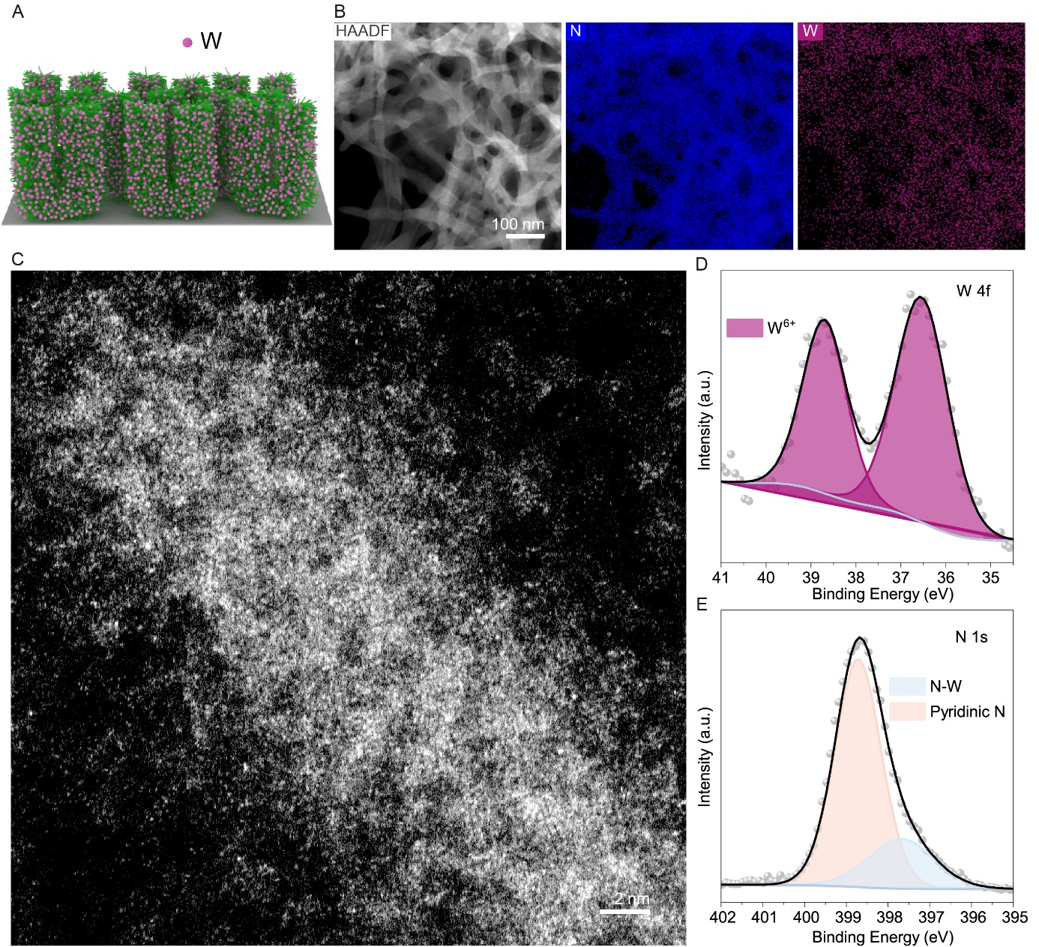
Figure S39. Structure characterization of W SA nanoforest. (A) Schematic illustration of W SA nanoforest. (B) HAADF-STEM image and corresponding element mapping of W and N. (C) AC-ADF-STEM image of W SA nanoforest. (D and E) XPS spectra of (D) W 4f and (E) N 1s.
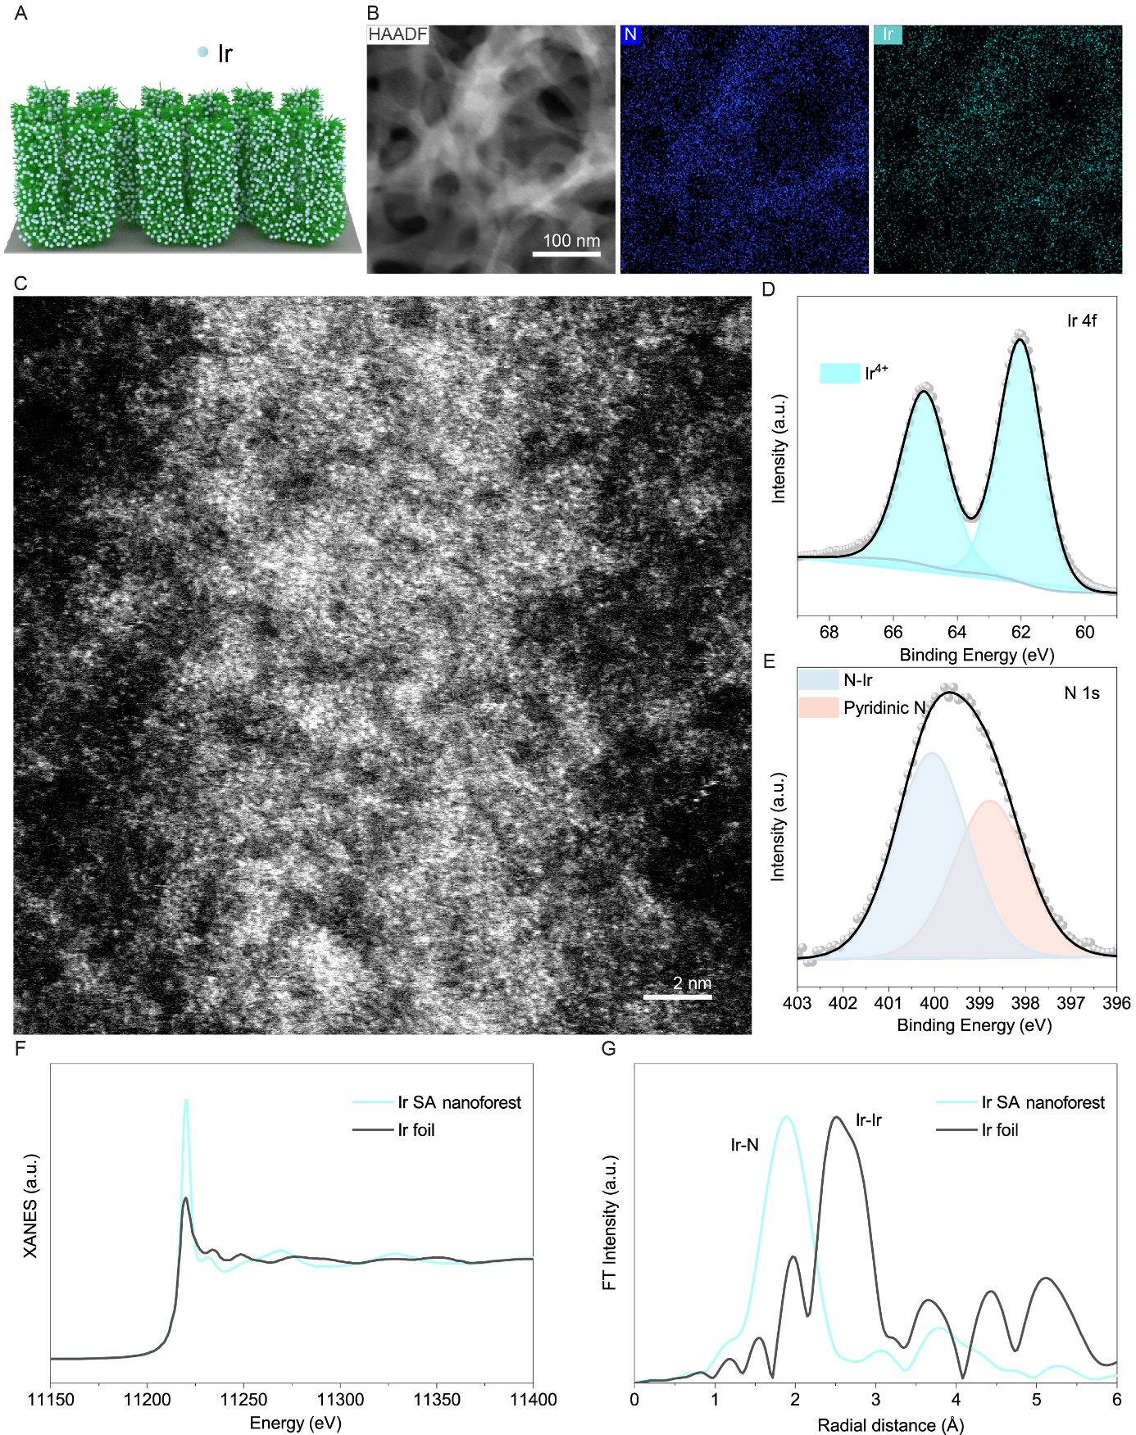
Figure S40. Structure characterization of Ir SA nanoforest. (A) Schematic illustration of Ir SA nanoforest. (B) HAADF-STEM image and corresponding element mapping of Ir and N. (C) AC-ADF-STEM image of Ir SA nanoforest. (D and E) XPS spectra of (D) Ir 4f and (E) N 1s. (F) Normalized XANES spectra for Ir L-edge. (G) FT-EXAFS spectra of Ir SA nanoforest and Ir foil.

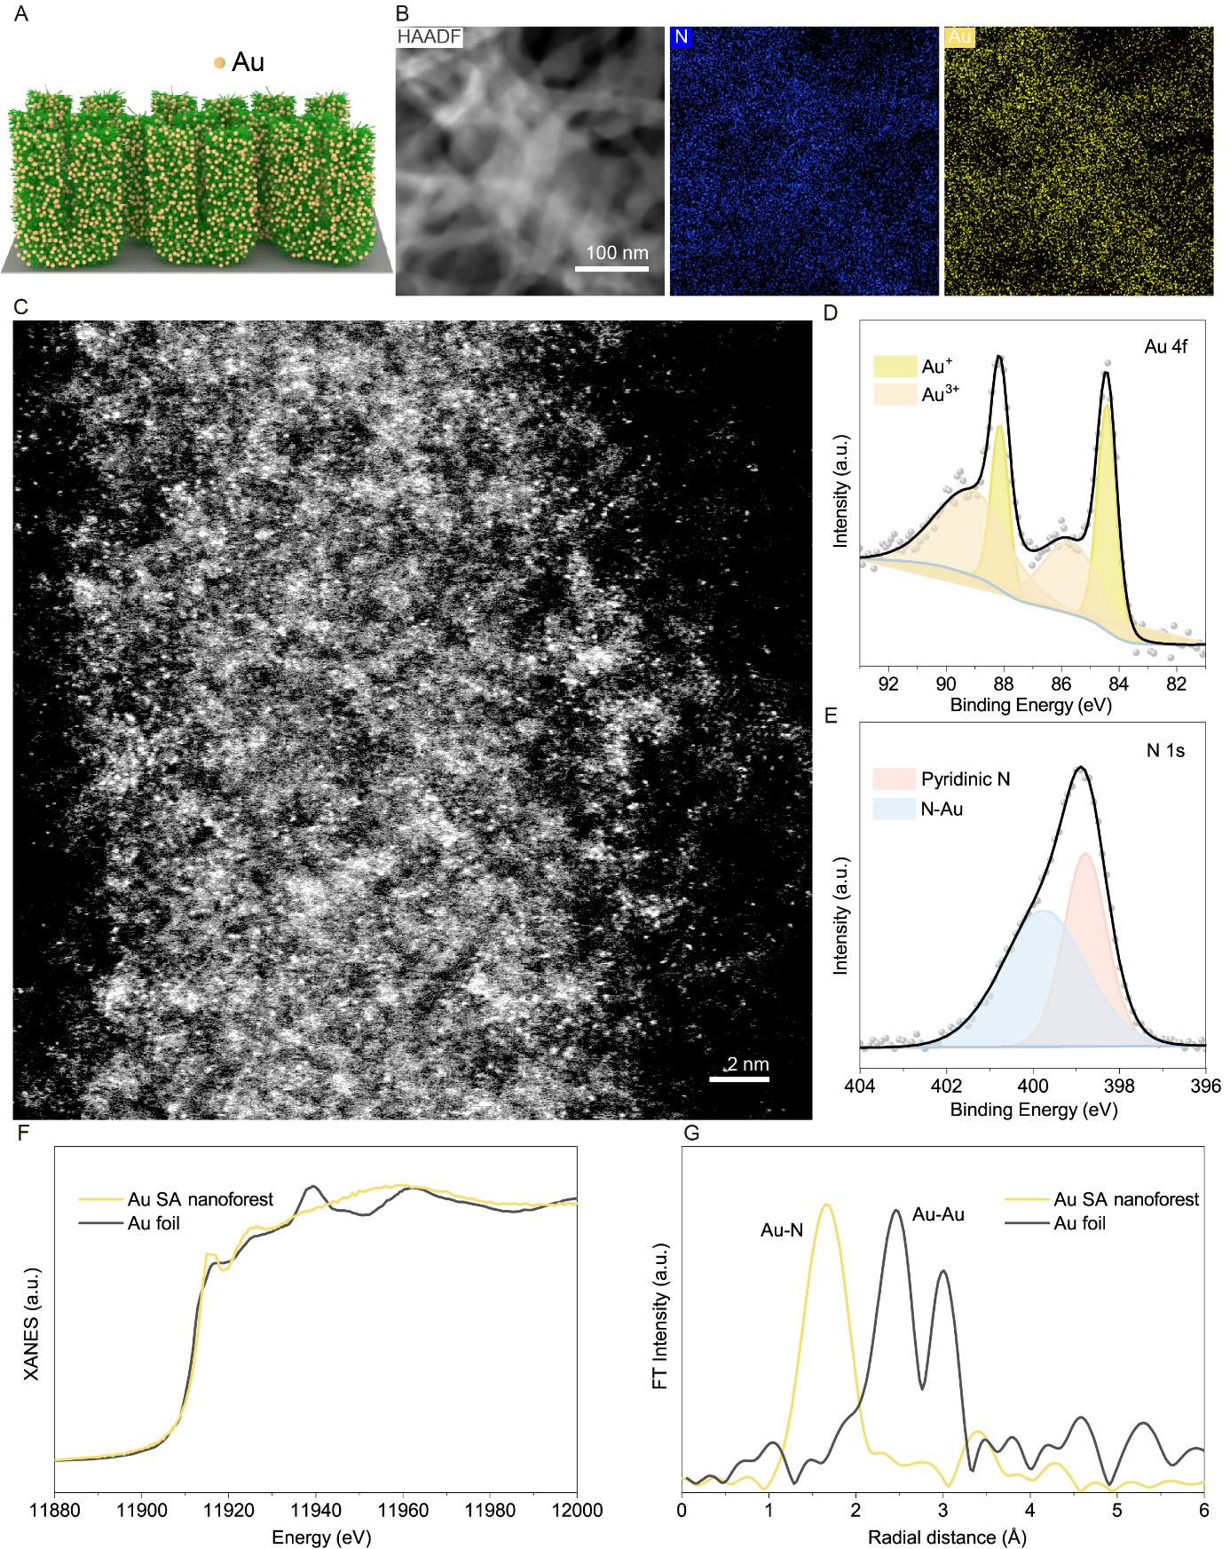
Figure S41. Structure characterization of Au SA nanoforest. (A) Schematic illustration of Au SA nanoforest. (B) HAADF-STEM image and corresponding element mapping of Au and N. (C) AC-ADF-STEM image of Au SA nanoforest. (D and E) XPS spectra of (D) Au 4f and (E) N 1s. (F) Normalized XANES spectra for Au L-edge. (G) FT-EXAFS spectra of Au SA nanoforest and Au foil.

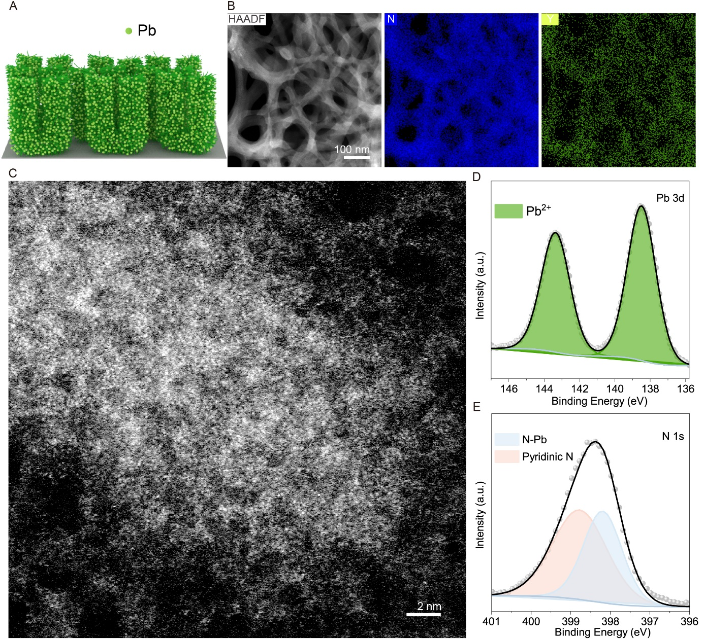
Figure S42. Structure characterization of Pb SA nanoforest. (A) Schematic illustration of Pb SA nanoforest. (B) HAADF-STEM image and corresponding element mapping of Pb and N. (C) AC-ADF-STEM image of Pb SA nanoforest. (D and E) XPS spectra of (D) Pb 3d and (E) N 1s.

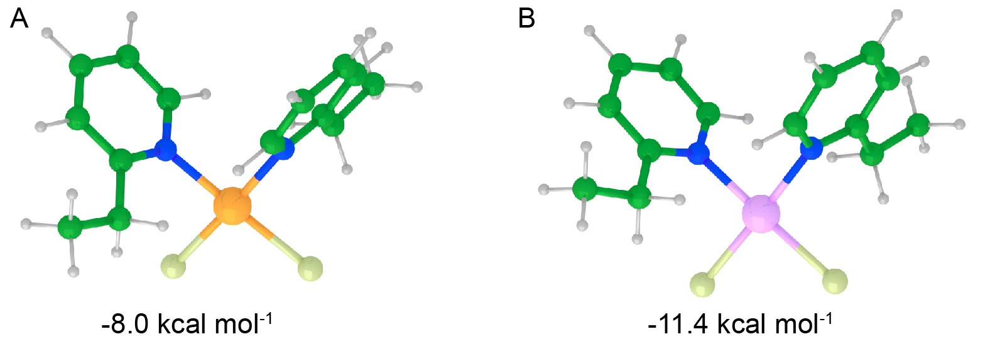
Figure S43. Free energy of cis-isomers. DFT calculation of free energy for the substitution of the second Py group at the cis position during the formation of (A) Pt and (B) Pd SA nanoforests.
Figure S44. SEM image of Pt nanoparticles (NPs) formed on nickel foam in the absence of micellar brushes. To prepare the sample, a piece of naked nickel foam was immersed in 10 mL of a mixture of 1:1 (v/v) isopropanol/deionized water and then 50 μL of an aqueous solution of Na₂PtCl₄ (10 mg mL⁻¹) was added. After 30 min, the resulting sample was washed with deionized water and isopropanol, and finally dried under nitrogen flow.

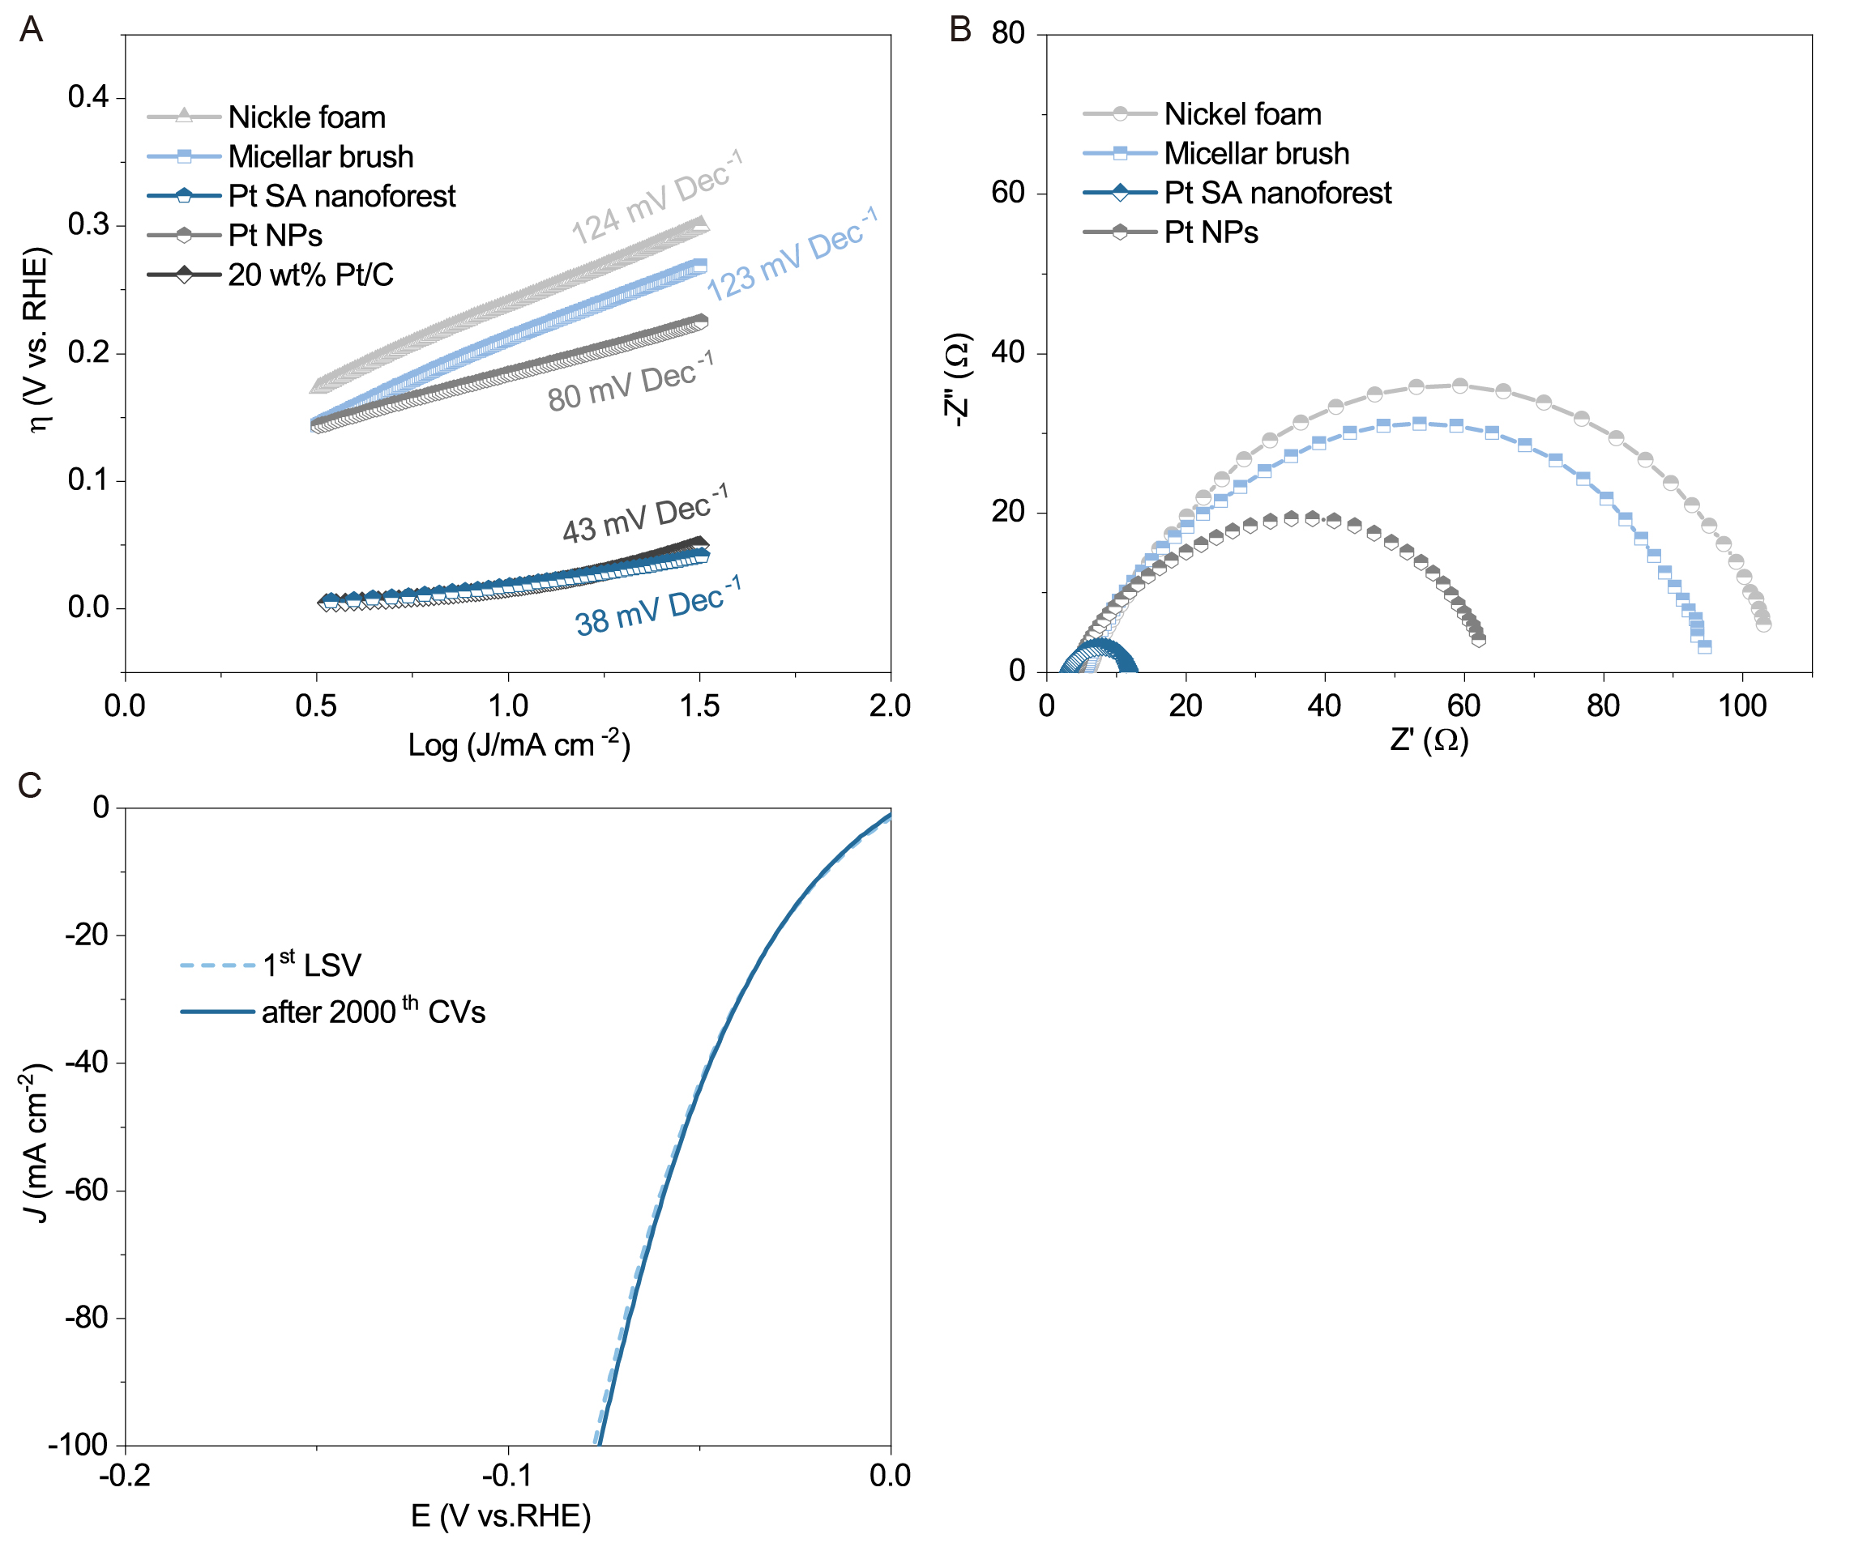
Figure S45. Electrochemical HER performance. (A) Tafel plots and (B) EIS Nyquist plots of the catalysts. (C) The initial and 2000th polarization curves of Pt SA nanoforest.
Table S5. Comparison of mass activities of Pt SA nanoforest decorated on nickel foam and previously reported Pt SA-based catalysts.
Catalysts | Electrolyte | Overpotential (mV) | Mass activity (A mg_{Pt}⁻¹) | Ref.
Pt SA nanoforest | 1.0 M KOH | 50 | 25.9 | This work
Pt₁/NPC | 0.5 M H₂SO₄ | 25 | 2.86 | ³
Pt-VP/TNR@GC | 0.5 M H₂SO₄ | 50 | 16.53 | ⁶
K₂PtCl₄@NC-M | 0.5 M H₂SO₄ | 20 | 5.7 | ⁷
Pt SA/m-WO_{3-x} | 0.5 M H₂SO₄ | 50 | 12.8 | ¹¹
Pt₁/OLC | 0.5 M H₂SO₄ | 38 | 7.4 | ¹²
Pt SA-NT-nickel foam | 1 M PBS | 50 | 0.07 | ⁴
Pt/np-Co_{0.85}Se | 1 M PBS | 100 | 1.32 | ¹³
Pt-AC/DG | 0.1 M HClO₄ | 50 | 15.55 | ⁸
Pt/MVF | 1.0 KOH | 50 | 1.71 | ¹⁵
BPed-Pt/GR | 1.0 KOH | 50 | 2.5 | ¹⁶
Pt₅/HMCS | 1.0 KOH | 70 | 3.23 | ¹⁷
PtNi-O/C | 1.0 KOH | 70 | 7.23 | ¹⁸
PtIr/IrOx NWs/C | 1.0 KOH | 70 | 7.74 | ¹⁹
Pt/MMC | 1.0 KOH | 80 | 2.16 | ²⁰
20 wt%  Pt/Ni(HCO₃)₂ | 1.0 KOH | 100 | 1.77 | ²¹
Pt1-Mo₂C-C | 1.0 KOH | 155 | 7.14 | ²²
Pt-SA/MXene | 1.0 KOH | 100 | 23.5 | ²³
CoPt-Pt_{SA}/NDPCF | 1.0 KOH | 50 | 19.3 | ²⁴
Pt_{SA}-NiO/Ni | 1.0 KOH | 100 | 20.6 | ²⁵
Pt/A-NiCo LDH | 1.0 KOH | 100 | 8.93 | ²⁶

Figure S46. Electrochemical HER performance for Pt-decorated micelle seeds on nickel foam. LSV curve of Pt catalyst-decorated micelle seeds on nickel foam. To prepare the sample, the micelle seed-coated nickel foam was immersed in 10 mL of a mixture of 1:1 (v/v) isopropanol/deionized water and then 50 μL of an aqueous solution of Na₂PtCl₄ (10 mg mL⁻¹) was added. After 30 min, the resulting sample was washed with deionized water and isopropanol, and finally dried under nitrogen flow.

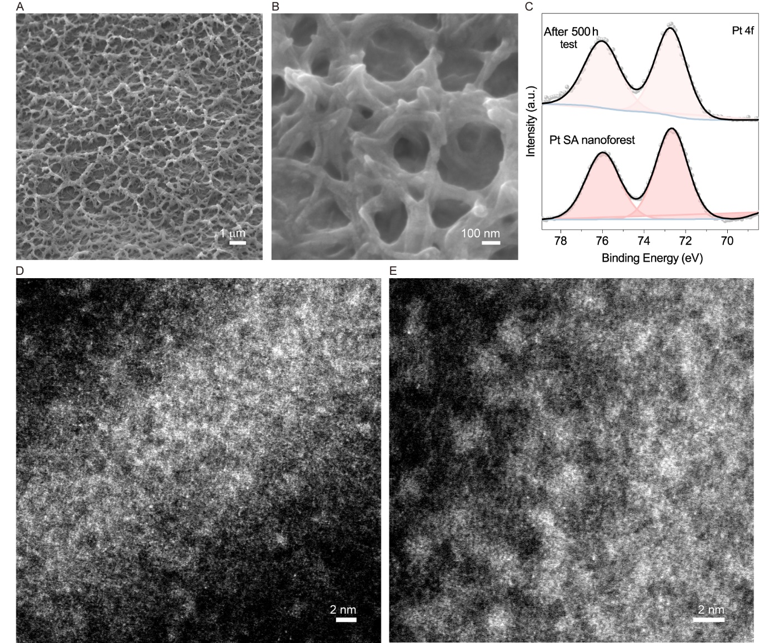
Figure S47. Characterization of Pt SA nanoforest after durability testing. (A, B) SEM, (C) XPS spectra of Pt 4f, (D, E) AC-ADF-STEM images of Pt SA nanoforest after testing for 500 h in an aqueous solution of KOH (1.0 M) at 100 mA cm⁻².

Figure S48. FT-EXAFS spectra of Pt SA nanoforest after durability testing. FT-EXAFS spectra of Pt SA nanoforest before and after testing for 240 h in an aqueous solution of KOH (1.0 M) at 100 mA cm⁻². The main peak (at ~1.57 Å) corresponding to the N-coordinated Pt atoms retained after the long-term test, indicating a high stability of the single atoms and their coordination status.

Table S6. Elemental contents determined by XPS for Pt SA nanoforest before and after testing for 500 h in an aqueous solution of KOH (1.0 M) at 100 mA cm⁻².

Sample Identifier | Name | Position | FWHM | Area/ (T*MFP) | Mass Conc (%)
Pt nanoforest | C 1s | 284.8512 | 1.7181 | 3026.294 | 51.94
Pt nanoforest | O 1s | 532.3512 | 2.4565 | 768.688 | 7.35
Pt nanoforest | N 1s | 399.3512 | 1.8374 | 428.832 | 5.87
Pt nanoforest | Pt 4f | 72.3125 | 1.9436 | 1040.126 | 26.05
Pt nanoforest | Si 2p | 102.7512 | 1.7055 | 144.242 | 5.76
Pt nanoforest | Fe 2p | 708.1512 | 1.0589 | 356.378 | 3.13
After 500 h test | C 1s | 284.8356 | 1.7408 | 3153.805 | 52.15
After 500 h test | O 1s | 532.0356 | 2.4963 | 950.787 | 7.76
After 500 h test | N 1s | 399.3456 | 2.4545 | 424.855 | 5.96
After 500 h test | Pt 4f | 72.3103 | 2.073 | 1834.463 | 25.50
After 500 h test | Si 2p | 102.3356 | 1.7719 | 159.701 | 5.44
After 500 h test | Fe 2p | 708.1752 | 1.0353 | 303.826 | 3.18
The content of Pt only decreased very slightly after the long-term test, again indicating a high stability of the single atoms.

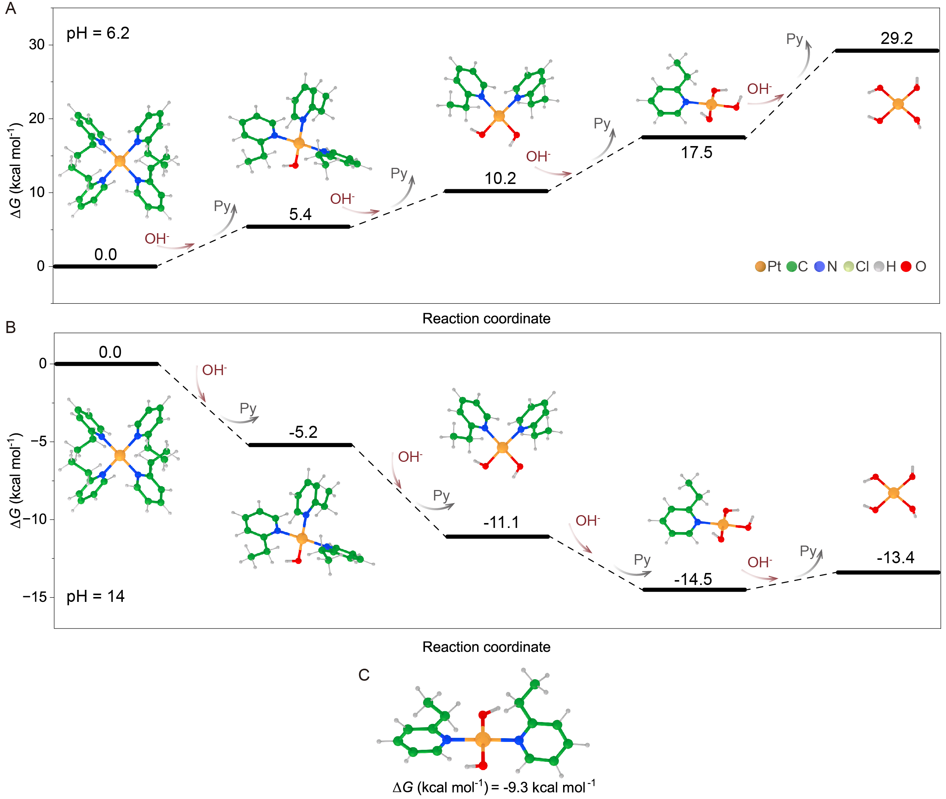
Figure S49. Transformation of Pt SA nanoforest in the presence of OH⁻. (A, B) DFT calculation of the energy pathway for the transformation from Py-coordinated Pt SA nanoforest to OH⁻-substituted species at pH = 6.2 (A) and 14 (B). (C) DFT calculation of free energy for the substitution of the second OH⁻ at the cis position at pH = 14.

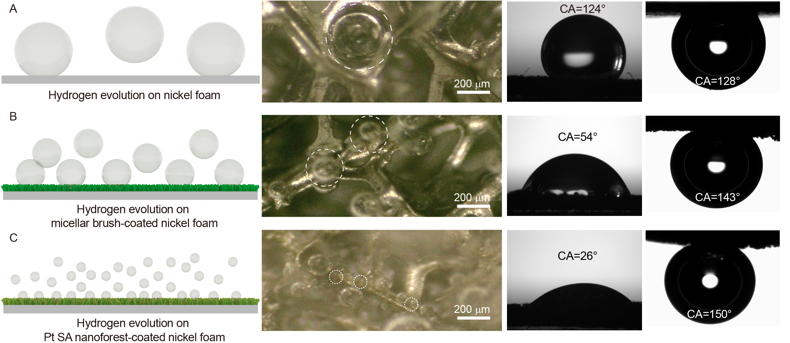
Figure S50. Surface feature of Pt SA nanoforest-coated nickel foam. Schematic illustration and optical photographs showing the release of hydrogen bubbles from (A) nickel foam, (B) micellar brush-coated nickel foam (at -0.1 vs. RHE) and (C) Pt SA nanoforest-coated nickel foam (at -0.05 vs. RHE), and the corresponding static-water-droplet contact angle and air-bubble contact angle.

To explore the application of SA nanoforests to other electrochemical processes, we investigated the formation of Ag and Au SA nanoforest-decorated graphene oxide (GO) sheets (Figure S51), respectively, for electrochemical CO₂ reduction reaction (CO₂RR, Figures S52 and S53, subfigure A). HAADF-STEM and corresponding element maps revealed the uniform dispersion of N and two metals in the micellar brush (Figures S52 and S53, subfigure B). AC-ADF-STEM images showed that the Au and Ag elements were atomically dispersed in the micellar brush (Figures S52 and S53, subfigure E). XPS spectra of the two metal SAs showed a positive valance state without metallic signal (Figures S52 and S53, subfigure C). XPS spectra of N 1s confirmed the coordination between the metal and nitrogen atoms (Figures S52 and S53, subfigure D). The emergence of a new single at 401.6 eV indicated the formation of N-O bond, which can be attributed to the interaction between the micelle seeds and GO sheets. The loading of Ag and Au SAs was determined by ICP-MS analysis to be 17.34 wt% and 26.52 wt%, respectively.
The CO₂RR performance of Ag and Au SA nanoforests was evaluated using a standard flow cell with three electrode configurations. For the Ag SA nanoforest, the maximum Faradaic efficiency (FE) for the conversion of CO₂ to CO reached 90% at -0.61 V (vs. RHE, Figure S52F). And the FE of C₁ was over 90% at a wide potential range from -0.61 to -1.2 V (vs RHE). Moreover, the high current density for C₁ formation was 383 mA cm⁻² at -1.31 V (vs. RHE), while the corresponding partial current density of CO formation was 287 mA cm⁻², which were higher than that of the previously reported Ag-based catalysts (Figure S52G, Table S7)²⁹⁻³³. For the Au SA nanoforest, the maximum FE for the formation of CO reached 90% at -0.3 V (vs. RHE, Figure S53F) and FE of C₁ was over 90% at a wide potential range from -0.3 to -0.7 V (vs. RHE). The high current density for C₁ formation at -1.0 V (vs. RHE) was 221 mA cm⁻² and corresponded partial current density of CO formation was 200 mA cm⁻², which were higher than that of the previously reported Au-based catalysts (Figure S53G, Table S8)³⁴⁻³⁷.

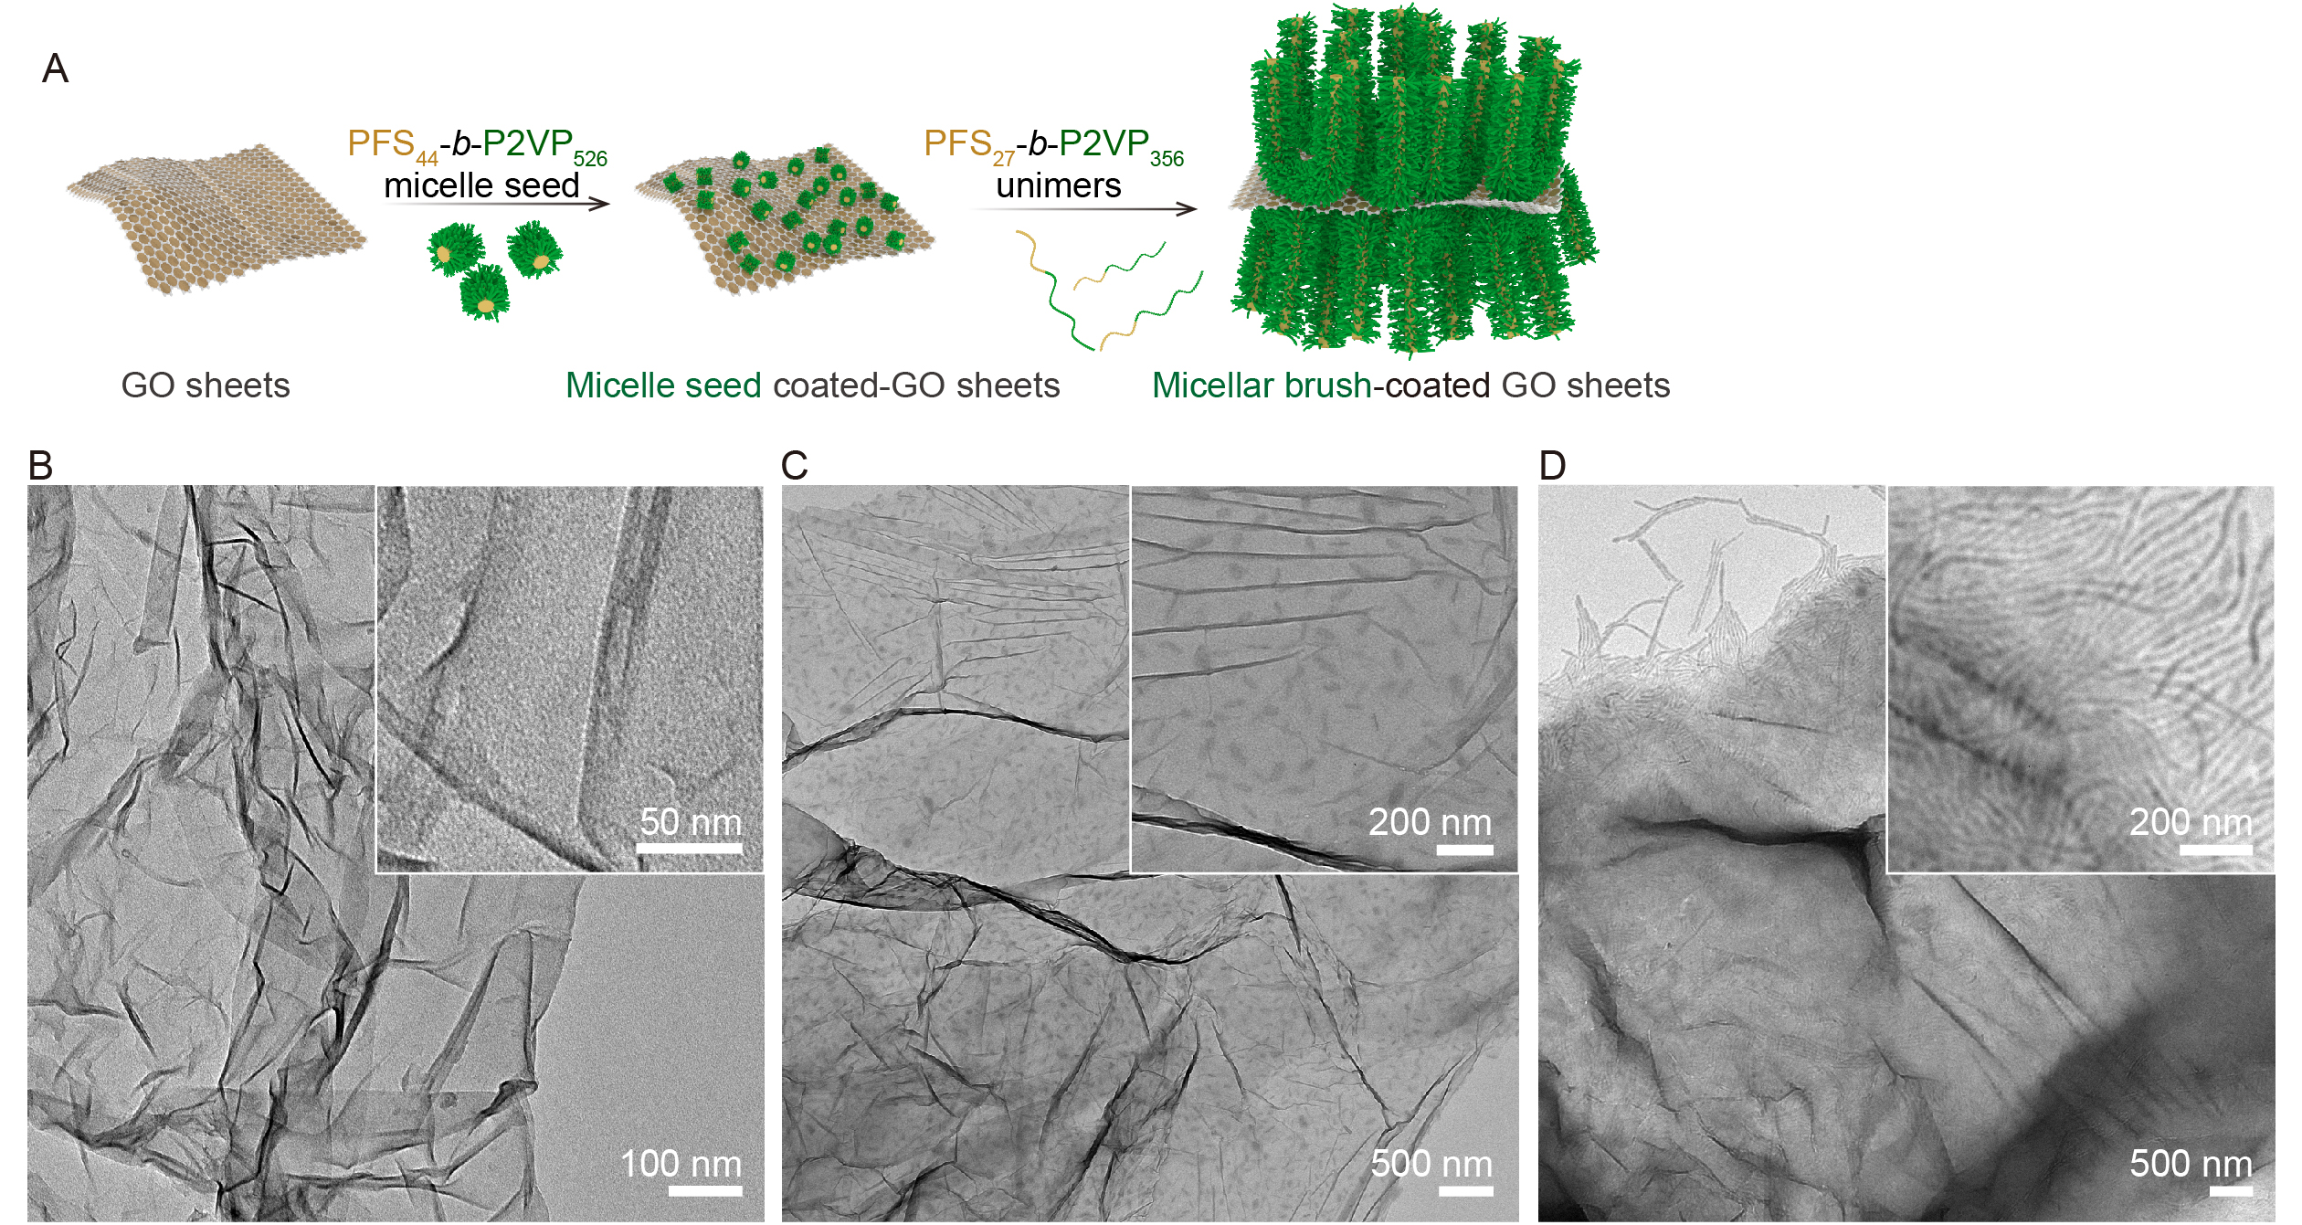
Figure S51. Preparation of micellar brush-coated GO sheets. (A) Schematic illustration of the formation of micellar brush-coated GO sheets. TEM images of (B) GO sheets, (C) micelle seed-coated GO sheets (for micelle seeds, L_{n} = 66 nm, L_{w}/L_{n} = 1.03), (D) micellar brush-coated GO sheets.
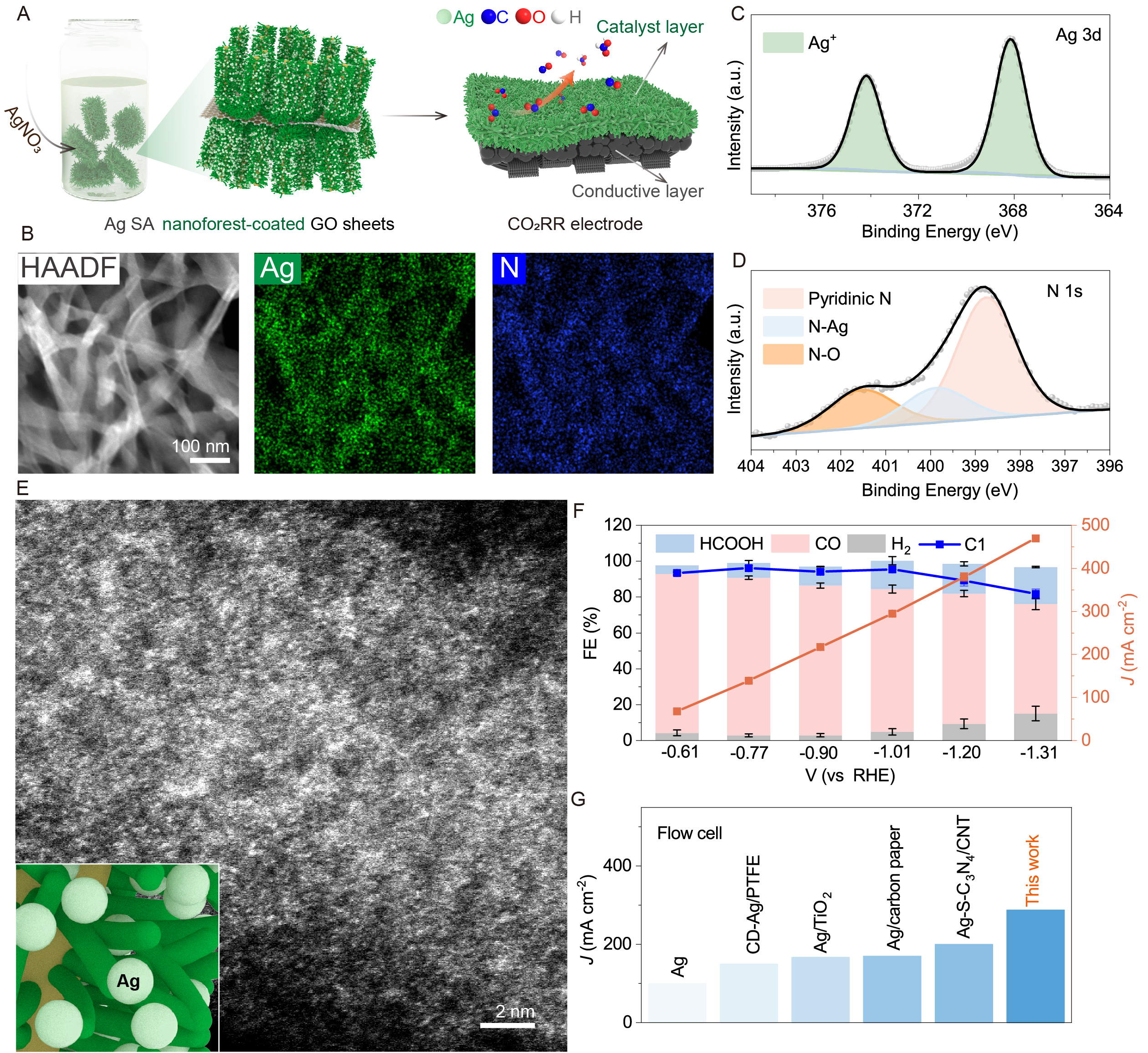
Figure S52. Fabrication of Ag SA nanoforest on GO sheets and electrochemical CO₂RR performance. (A) Schematic illustration of Ag SA nanoforest on GO sheets and fabrication of CO₂RR electrode. (B) HAADF-TEM image and element mapping of Ag SA nanoforest on GO sheets. (C and D) XPS spectra of (C) Ag 3d and (D) N 1s for Ag SA nanoforest on GO sheets. (E) AC-ADF-STEM image of Ag SA nanoforest on GO sheets. (F) Potential-dependent FEs of each product and total current density of Ag SA nanoforest on GO sheets. (G) Comparison of CO₂RR performance with previously reported Ag-based catalysts.

Table S7. Comparison of CO₂RR performance with previously reported Ag-based catalysts for CO production.
Catalysts | Electrolyte | Potential (V) | Partial current density (mA cm⁻¹) | Ref.
Ag SA nanoforest on GO sheets | 1.0 M KOH | -1.31 | 288 | This work
Ag | 1.0 M NaOH | -3.50 | 100 | ²⁷
CD-Ag/PTFE | 1.0 M KOH | -0.70 | 150.0 | ²⁸
Ag/TiO₂ | 1.0 M KOH | -0.64 | 167 | ²⁹
Ag/carbon paper | 0.1 M KHCO₃ | -3.60 | 170.0 | ³⁰
Ag-S-C₃N₄/CNT | 0.1 M KHCO₃ | -2.90 | 200.0 | ³¹

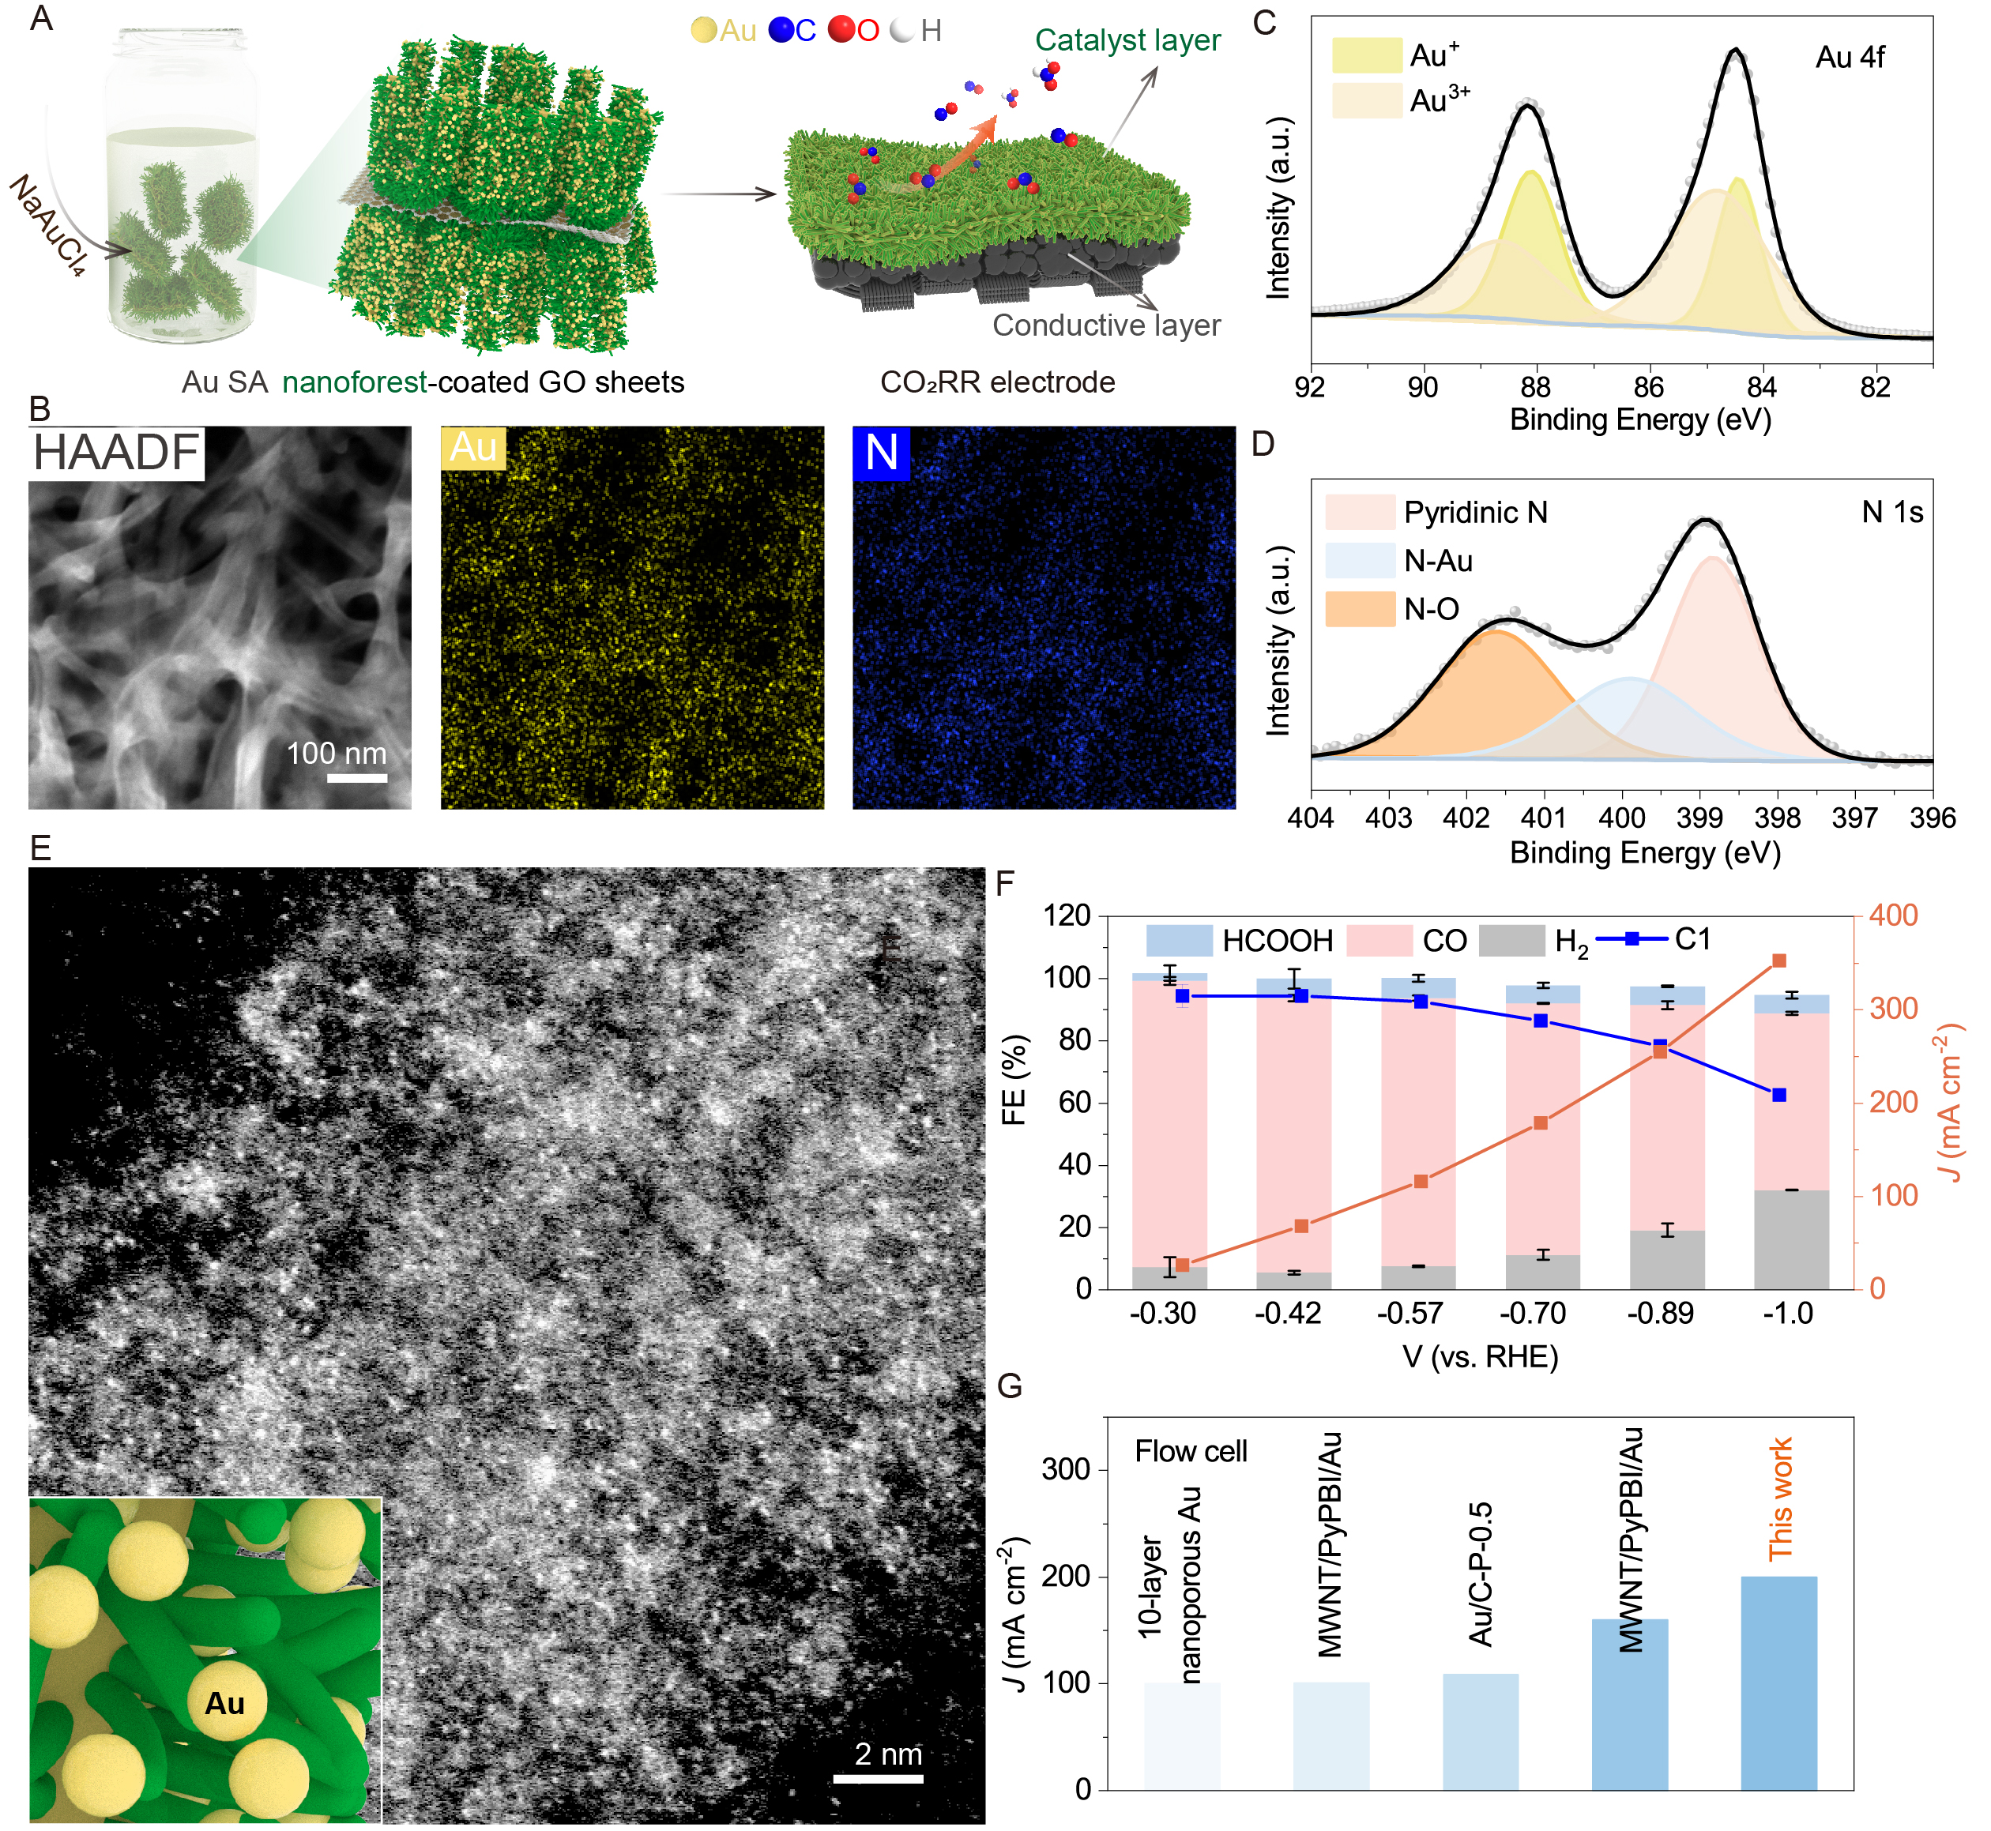
Figure S53. Fabrication of Au SA nanoforest on GO sheets and electrochemical CO₂RR performance. (A) Schematic illustration of Au SA nanoforest on GO sheets and fabrication of CO₂RR electrode. (B) HAADF-TEM image and element mapping of Au SA nanoforest on GO sheets. (C and D) XPS spectra of (C) Au 4f and (D) N 1s for Au SA nanoforest on GO sheets. (E) AC-ADF-STEM image of Au SA nanoforest on GO sheets. (F) Potential-dependent FEs of each product and total current density of Au SA nanoforest on GO sheets. (G) Comparison of CO₂RR performance with previously reported Au-based catalysts.

Table S8. Comparison of CO₂RR performance with previously reported Au-based catalysts for CO production.
Catalysts | Electrolyte | Potential (V) | Partial current density (mA cm⁻¹) | Ref.
Au SA nanoforest  on GO sheets | 1.0 M KOH | -1.0 | 200 | This work
10-layer nanoporous Au | 1.0 M KOH | N/A | 100 | ³²
MWNT/PyPBI/Au | 2.0 M KOH | -2.0 | 100.5 | ³³
Au/C-P-0.5 | 1.0 M KOH | -0.48 | 108.4 | ³⁴
MWNT/PyPBI/Au | 1.0 M KCl | -1.78 | 160 | ³⁵
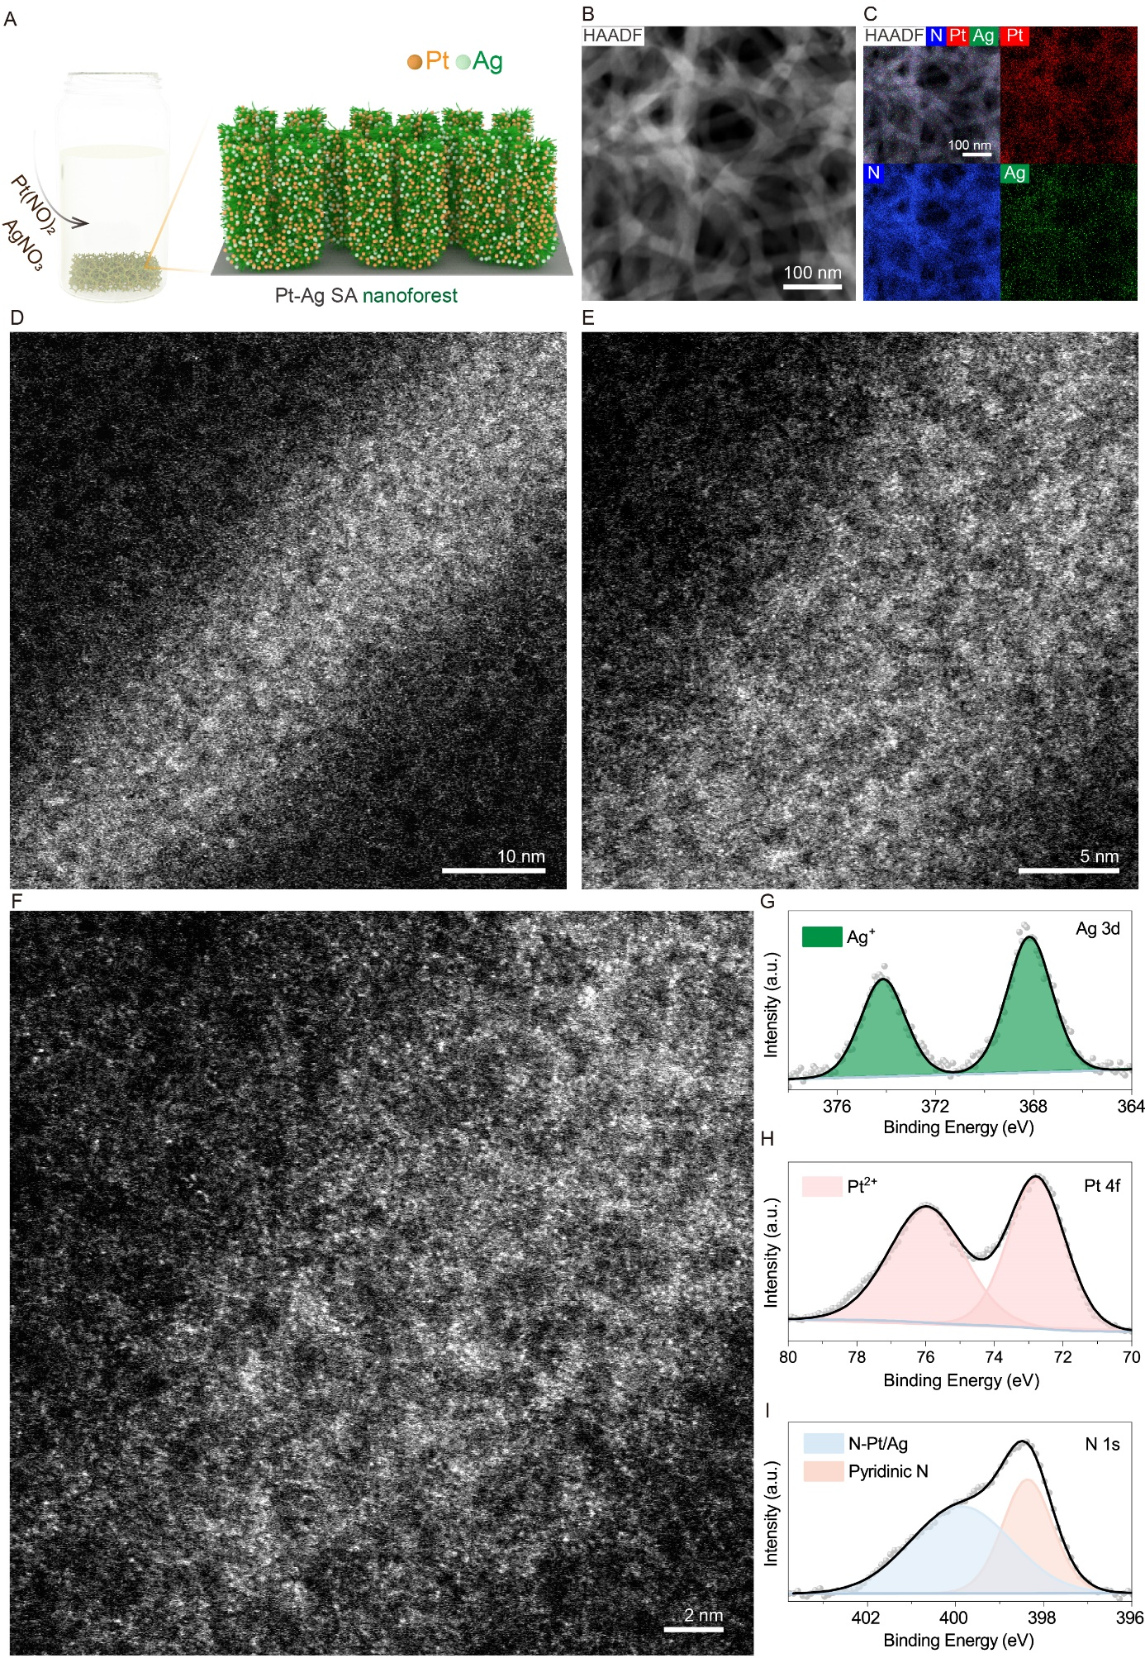
Figure S54. Formation of Pt-Ag SA nanoforest. (A) Schematic illustration of the fabrication of nanoforest containing Pt and Ag SAs on nickel foam. The metal precursors were Pt(NO₃)₂ and AgNO₃. (B) HAADF-STEM image, (C) corresponding element mapping and (D-F) AC-ADF-STEM images of Pt-Ag SA nanoforest. (G-I) XPS spectra of (G) Ag 3d, (H) Pt 4f and (I) N 1s of Pt-Ag SA nanoforest.

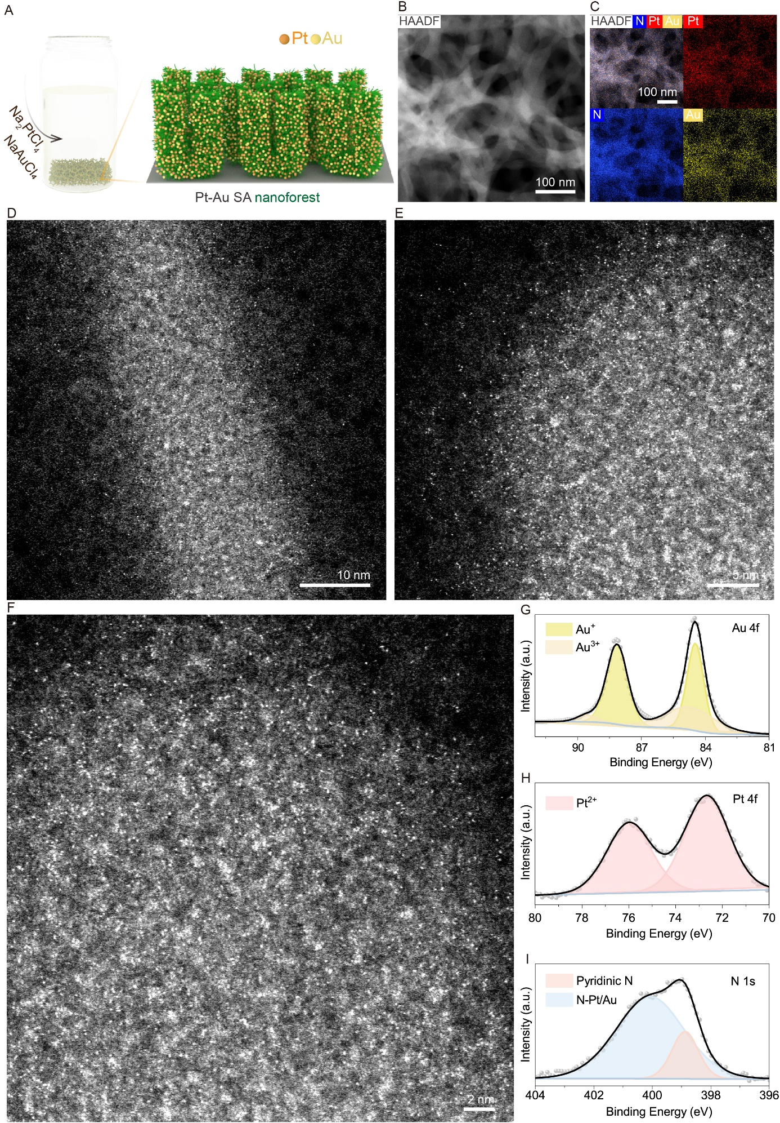
Figure S55. Formation of Pt-Au SA nanoforest. (A) Schematic illustration of the fabrication of nanoforest containing Pt and Au SAs on nickel foam. (B) HAADF-STEM image, (C) corresponding element mapping and (D-F) AC-ADF-STEM images of Pt-Au SA nanoforest. (G-I) XPS spectra of (G) Au 4f, (H) Pt 4f and (I) N 1s of Pt-Au SA nanoforest.

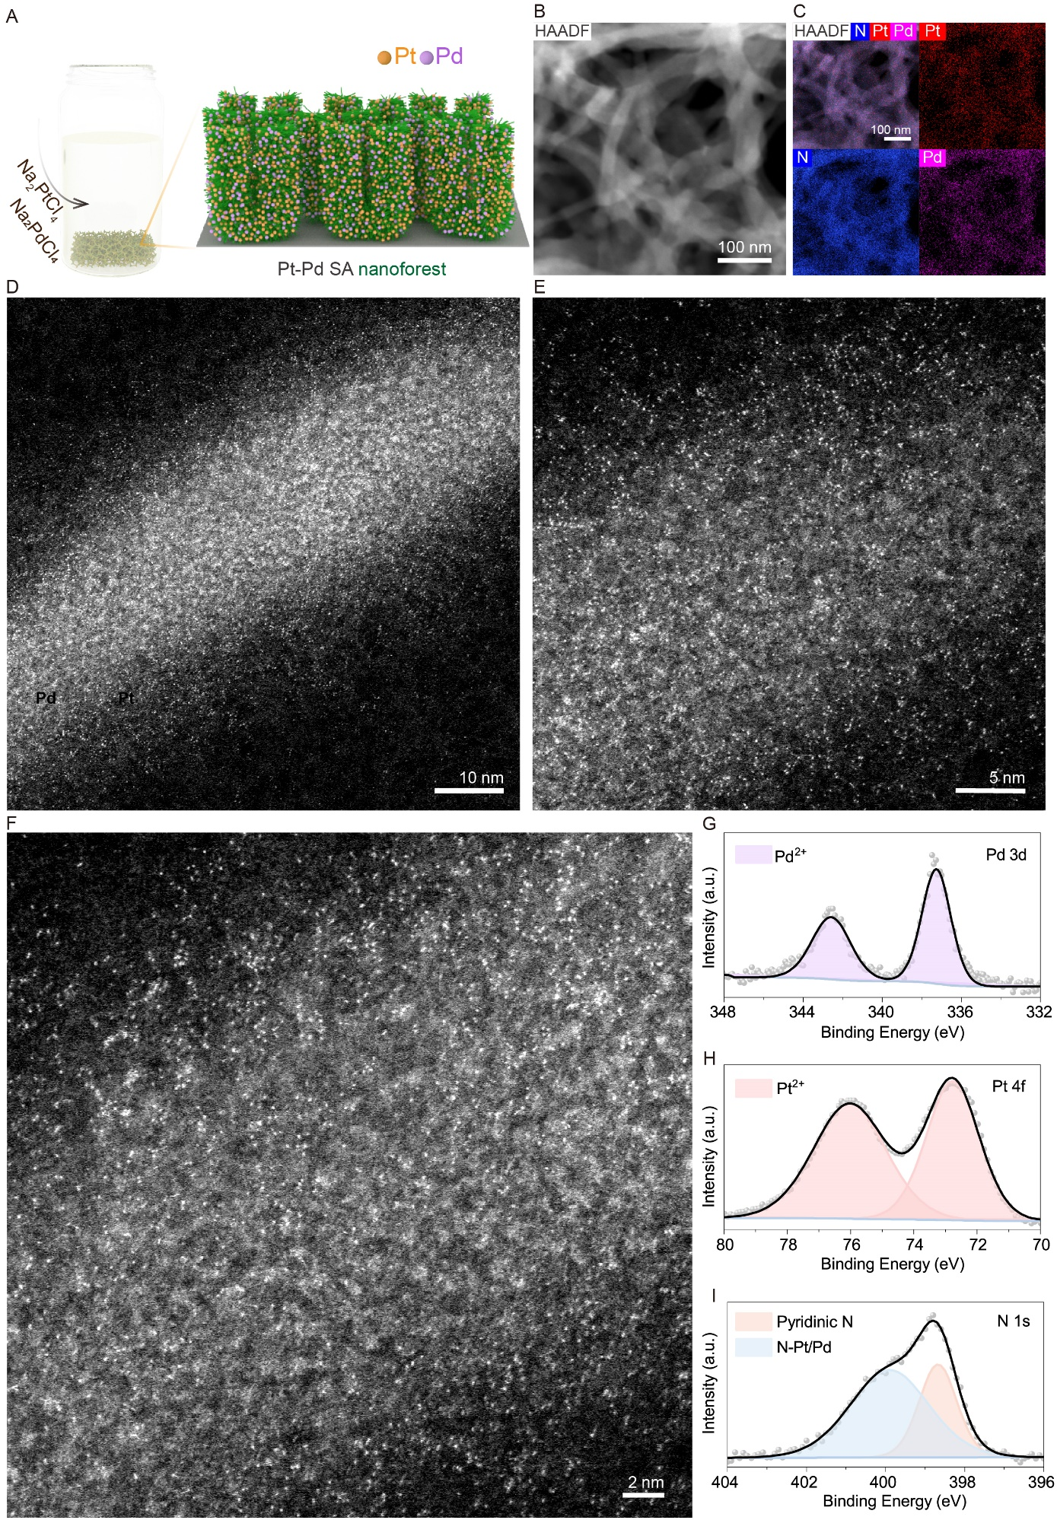
Figure S56. Formation of Pt-Pd SA nanoforest. (A) Schematic illustration of the fabrication of nanoforest containing Pt and Pd SAs on nickel foam. (B) HAADF-STEM image, (C) corresponding element mapping and (D-F) AC-ADF-STEM images of Pt-Pd SA nanoforest. (G-I) XPS spectra of (G) Pd 3d, (H) Pt 4f and (I) N 1s of Pt- Pd SA nanoforest.

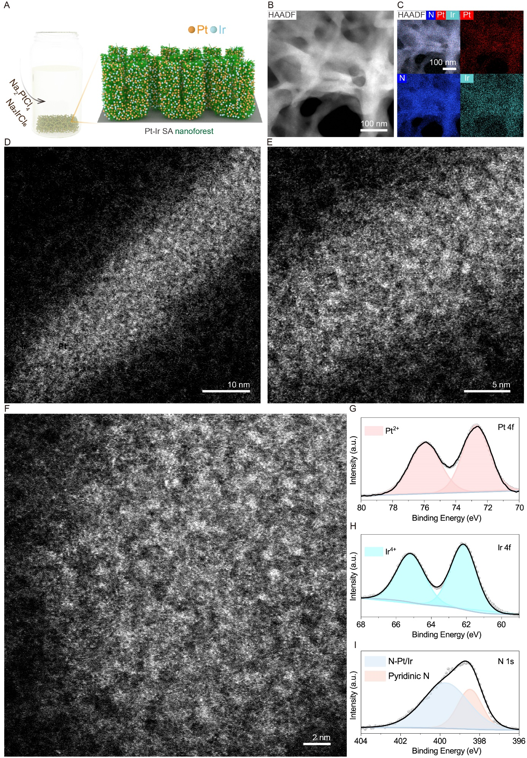
Figure S57. Formation of Pt-Ir SA nanoforest. (A) Schematic illustration of the fabrication of nanoforest containing Pt and Ir SAs on nickel foam. (B) HAADF-STEM image, (C) corresponding element mapping and (D-F) AC-ADF-STEM images of Pt-Ir SA nanoforest. (G-I) XPS spectra of (G) Pt 4f, (H) Ir 4f and (I) N 1s of Pt-Ir SA nanoforest.

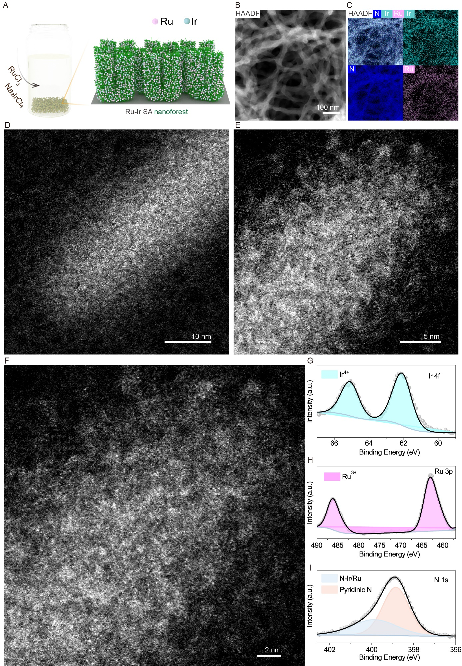
Figure S58. Formation of Ir-Ru SA nanoforest. (A) Schematic illustration of the fabrication of nanoforest containing Ir and Ru SAs on nickel foam. (B) HAADF-STEM image, (C) corresponding element mapping and (D-F) AC-ADF-STEM images of Ir-Ru SA nanoforest. (G-I) XPS spectra of (G) Ir 4f, (H) Ru 3p and (I) N 1s of Ir-Ru SA nanoforest.

Figure S59. Electrochemical seawater splitting performances. LSV curves of naked nickel foam and nickel foam decorated with individual metal SA nanoforests, Ir-Ru SA nanoforest, 5-SA nanoforest, and 8-SA nanoforest.

References
1 Hai, X., et al. Scalable two-step annealing method for preparing ultra-high-density single-atom catalyst libraries. Nat. Nanotechnol. 17, 174-181 (2022).
2 Han, L., et al. A single-atom library for guided monometallic and concentration-complex multimetallic designs. Nat. Mater. 21, 681-688 (2022).
3 Li, T., et al. Photochemical solid-phase synthesis of platinum single atoms on nitrogen-doped carbon with high loading as bifunctional catalysts for hydrogen evolution and oxygen reduction reactions. ACS Catal. 8, 8450-8458 (2018).
4 Zhang, L., et al. Potential-cycling synthesis of single platinum atoms for efficient hydrogen evolution in neutral media. Angew. Chem. Int. Ed. 56, 13694-13698 (2017).
5 Zhu, J., et al. Enhanced electrocatalytic hydrogen evolution activity in single-atom Pt-decorated VS₂ Nanosheets. ACS Nano 14, 5600-5608 (2020).
6 Li, C., et al. Polyvinylpyrrolidone-coordinated single-site platinum catalyst exhibits high activity for hydrogen evolution reaction. Angew. Chem. Int. Ed. 59, 15902-15907 (2020).
7 Jin, H., et al. Simple and scalable mechanochemical synthesis of noble metal catalysts with single atoms toward highly efficient hydrogen evolution. Adv. Funct. Mater. 30, 2000531 (2020).
8 Cheng, Q., et al. Carbon-defect-driven electroless deposition of Pt atomic clusters for highly efficient hydrogen evolution. J. Am. Chem. Soc. 142, 5594-5601 (2020).
9 Zhang, L., et al. Charge polarization from atomic metals on adjacent graphitic layers for enhancing the hydrogen evolution reaction. Angew. Chem. Int. Ed. 58, 9404-9408 (2019).
10 Ye, S., et al. Highly stable single Pt atomic sites anchored on aniline-stacked graphene for hydrogen evolution reaction. Energy Environ. Sci. 12, 1000-1007 (2019).
11 Park, J., et al. Investigation of the support effect in atomically dispersed Pt on WO_{3-x} for utilization of Pt in the hydrogen evolution reaction. Angew. Chem. Int. Ed. 58, 16038-16042 (2019).
12 Liu, D., et al. Atomically dispersed platinum supported on curved carbon supports for efficient electrocatalytic hydrogen evolution. Nat. Energy 4, 512-518 (2019).
13 Jiang, K., et al. Single platinum atoms embedded in nanoporous cobalt selenide as electrocatalyst for accelerating hydrogen evolution reaction. Nat. Commun. 10, 1743 (2019).
14 Ji, J., et al. Platinum single-atom and cluster anchored on functionalized MWCNTs with ultrahigh mass efficiency for electrocatalytic hydrogen evolution. Nano Energy 63, 103849 (2019).
15 Liang, Q., et al. General synergistic capture-bonding superassembly of atomically dispersed catalysts on micropore-vacancy frameworks. Nano Lett. 22, 2889-2897 (2022).
16 Wang, X., et al. Rapid activation of platinum with black phosphorus for efficient hydrogen evolution. Angew. Chem. Int. Ed. 58, 19060-19066 (2019).
17 Wan, X. K., et al. Confining sub-nanometer pt clusters in hollow mesoporous carbon spheres for boosting hydrogen evolution activity. Adv. Mater. 32, 1901349 (2020).
18 Zhao, Z., et al. Surface-engineered ptni-o nanostructure with record-high performance for electrocatalytic hydrogen evolution reaction. J. Am. Chem. Soc. 140, 9046-9050 (2018).
19 Huang, H., et al. Equilibrated PtIr/IrOx Atomic Heterojunctions on Ultrafine 1D Nanowires Enable Superior Dual-Electrocatalysis for Overall Water Splitting. Small 18, 2201333
20 Baek, D. S., et al. Ordered mesoporous metastable alpha-MoC_{1-x} with enhanced water dissociation capability for boosting alkaline hydrogen evolution activity. Adv. Funct. Mater. 29, 1901217 (2019).
21 Lao, M., et al. Platinum/nickel bicarbonate heterostructures towards accelerated hydrogen evolution under alkaline conditions. Angew. Chem. Int. Ed. 58, 5432-5437 (2019).
22 Niu, S., et al. Single-atom Pt promoted Mo₂C for electrochemical hydrogen evolution reaction. J. Energy Chem. 57, 371-377 (2021).
23 Peng, X., et al. Heteroatom coordination induces electric field polarization of single Pt sites to promote hydrogen evolution activity. Nanoscale 13, 7134-7139 (2021).
24 Yang, W., et al. Tuning the cobalt–platinum alloy regulating single‐atom platinum for highly efficient hydrogen evolution reaction. Adv. Funct. Mater. 32, 2205920 (2022).
25 Zhou, K. L., et al. Platinum single-atom catalyst coupled with transition metal/metal oxide heterostructure for accelerating alkaline hydrogen evolution reaction. Nat. Commun. 12, 3783 (2021).
26 Fan, B., et al. Single atoms (Pt, Ir and Rh) anchored on activated NiCo LDH for alkaline hydrogen evolution reaction. Chem. Commun. 58, 8254-8257 (2022).
27 Salvatore, D. A., et al. Electrolysis of gaseous CO₂ to CO in a flow cell with a bipolar membrane. ACS Energy Lett. 3, 149-154 (2018).
28 Dinh, C. T., et al. High rate, selective, and stable electroreduction of CO₂ to CO in basic and neutral media. ACS Energy Lett. 3, 2835-2840 (2018).
29 Kim, Y. E., et al. Highly tunable syngas production by electrocatalytic reduction of CO₂ using Ag/TiO₂ catalysts. Chem. Eng. J. 413, 127448 (2021).
30 Xu, Y., et al. Self-cleaning CO₂ reduction systems: unsteady electrochemical forcing enables stability. ACS Energy Lett. 6, 809-815 (2021).
31 Chen, J., et al. Efficient electroreduction of CO₂ to CO by Ag-decorated S-doped g-C₃N₄/CNT nanocomposites at industrial scale current density. Mater. Today Phys. 12, 100176 (2020).
32 Qi, Z., et al. Electrochemical CO₂ to CO reduction at high current densities using a nanoporous gold catalyst. Mater. Res. Lett. 9, 99-104 (2021).
33 Verma, S., et al. Insights into the low overpotential electroreduction of co₂ to co on a supported gold catalyst in an alkaline flow electrolyzer. ACS Energy Lett. 3, 193-198 (2018).
34 Shi, R., et al. Efficient wettability-controlled electroreduction of CO₂ to CO at Au/C interfaces. Nat. Commun. 11, 3028 (2020).
35 Jhong, H. R. M., et al. Gold Nanoparticles on polymer-wrapped carbon nanotubes: an efficient and selective catalyst for the electroreduction of CO₂. ChemPhysChem 18, 3274-3279 (2017).

