Table 3. Molecular docking and binding interactions of Tricyclo 20, 8, 0, 0(7,16)] triacontane 1(22), 7(16), diepoxy produced by S. albus (A); Octadecahydro2R3S4Z9Z, 11R, 12S produced by P. fluorescens (B) and 2,7, Bispirocyclopropane bicyclo 22,1heptan produced by S. marcescens (C) on the binding sites of AChE

Microbial strain | Inhibitor compound | Inhibitor structure | Type of interaction | Interacted AA and ligand atoms | ΔG (Kcal/mol) | pKd | LE | D (Å)²
Streptomyces albus | Tricyclo 20, 8, 0, 0(7,16)]triacontane 1(22), 7(16), diepoxy | 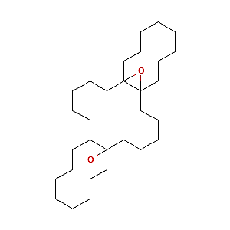 | H-Bonding | GLN(432) | -10 | 4.99 | -0.21 | 2.61
Streptomyces albus | Tricyclo 20, 8, 0, 0(7,16)]triacontane 1(22), 7(16), diepoxy |  | Alkyle interaction | VAL(661) | -10 | 4.99 | -0.21 | 4.30
Pseudomonas fluorescens | Dibenzo[a,h]cyclotetradecene, 2,3,11,12-tetraethenyl-1,2,3,4,5,6,7,8,9,10,11,12,13,14,15,16,17,18-octadecahydro-, (2R*,3S*,4Z,9Z,11R*,12S*)- | 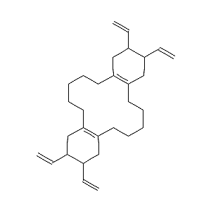 | Alkyl | PRO(85)  PRO(85)  PRO(658)  VAL(661)  VAL(661)  VAL(661)  VAL(490) | -9.5 | 5.19 | -0.23 | 5.49  4.75  4.09  4.40  5.02  4.17  4.26
Pseudomonas fluorescens |  |  | Pi-alkyl | TYR(489)  PHE(83)  TYR(86) | -9.5 | 5.19 | -0.23 | 5.18  5.28  5.14
Serratia marcescens | 2,7,Bispirocyclopropane bicyclo 22,1heptan | 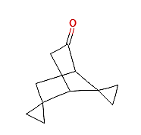 | Alkyl | LYS(654)  ALA(436)  PRO(85) | -6 | 2.20 | -0.25 | 3.99  4.98  4.51
Serratia marcescens | 2,7,Bispirocyclopropane bicyclo 22,1heptan |  | Pi-alkyl | PHE(83) | -6 | 2.20 | -0.25 | 5.41

