SUPPLEMENTARY FIGURES
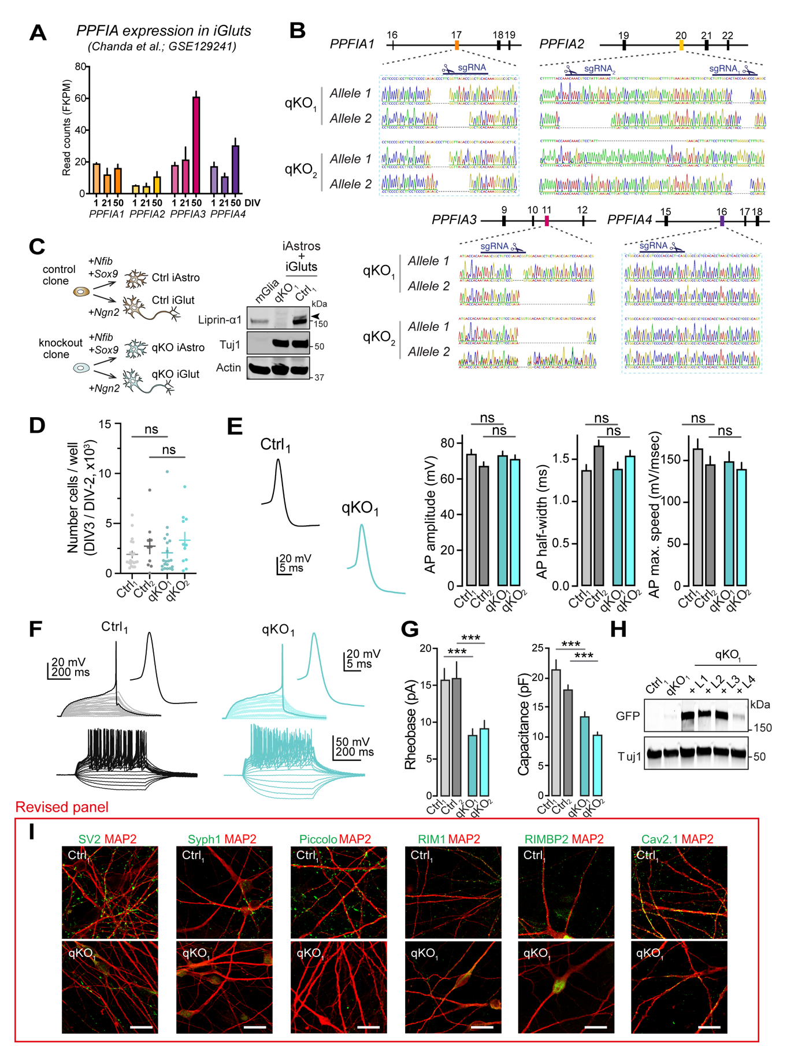
Figure S1 – Liprin-α expression, validation of Liprin-α knockouts, and basic physiological and morphological characterization of qKO neurons (related to Figure 1).
(A) Expression of PPFIA1-4 in Ngn2-induced iGluts at the indicated DIV. Data from GSE129241 ¹.
(B) Sanger sequencing traces across gene-edited exons of PPFIA1-4. The mutant clones share the same mutations in PPFIA1 and PPFIA4.
(C) Experimental outline (left) and western blots (right) of experiment to confirm removal of Liprin-α1 in human Ngn2-induced iGluts by co-culture with human induced astrocytes ². Arrowhead indicates the Liprin-α1 isoform migrating at a higher apparent molecular weight.
(D) Conversion rates for iGluts derived from control (Ctrl1 and Ctrl2) and mutant (qKO1 and qKO2). Number of cells/well were counted upon replating at DIV3 (after Puromycin selection) and normalized to the number of ES-cells seeded at DIV-2. Number of batches: Ctrl1,20; Ctrl2,10; qKO1,20; qKO2,11.
(E) Action potential properties of iGluts derived from control (Ctrl1 and Ctrl2) and mutant (qKO1 and qKO2) clones. Left to right: amplitude, half-width, and max. speed. Number of cells/batches: Ctrl1,24/3; Ctrl2,22/3; qKO1,23/3; qKO2,23/3.
(F) Top. Estimation of minimal current required to trigger spikes (Rheobase). Stimulus: 500 ms, +1 pA steps. Bottom. Voltage responses to current injections of increasing amplitude (500 ms, 20 pA steps from -100 to +200 pA).
(G) Summary plots of rheobase and capacitance in induced neurons derived from two control (Ctrl1, Ctrl2) and two knockout (qKO1, qKO2) hESC lines. Number of fields/batches: Capacitance; Ctrl1, 45/3; Ctrl2, 30/3; qKO1, 40/3; qKO2, 31/3. Rheobase; Ctrl1, 40/3; Ctrl2, 31/3; qKO1, 37/3; qKO2, 40/3.
(H) Western blot of Liprin-α protein expression in rescue experiments (Fig. 1IJ and 3G-H).
(I) Low-magnification images of control (Ctrl) and knockout (qKO) neurons immunolabeled for SV2, Synaptophysin-1, Piccolo, RIM1, RIM-BP2 and CaV2.1, shown in Fig. 1J. Scale bars, 20 μm.
Data represented as means ± SEM; ns, non-significant; *** p < 0.001.

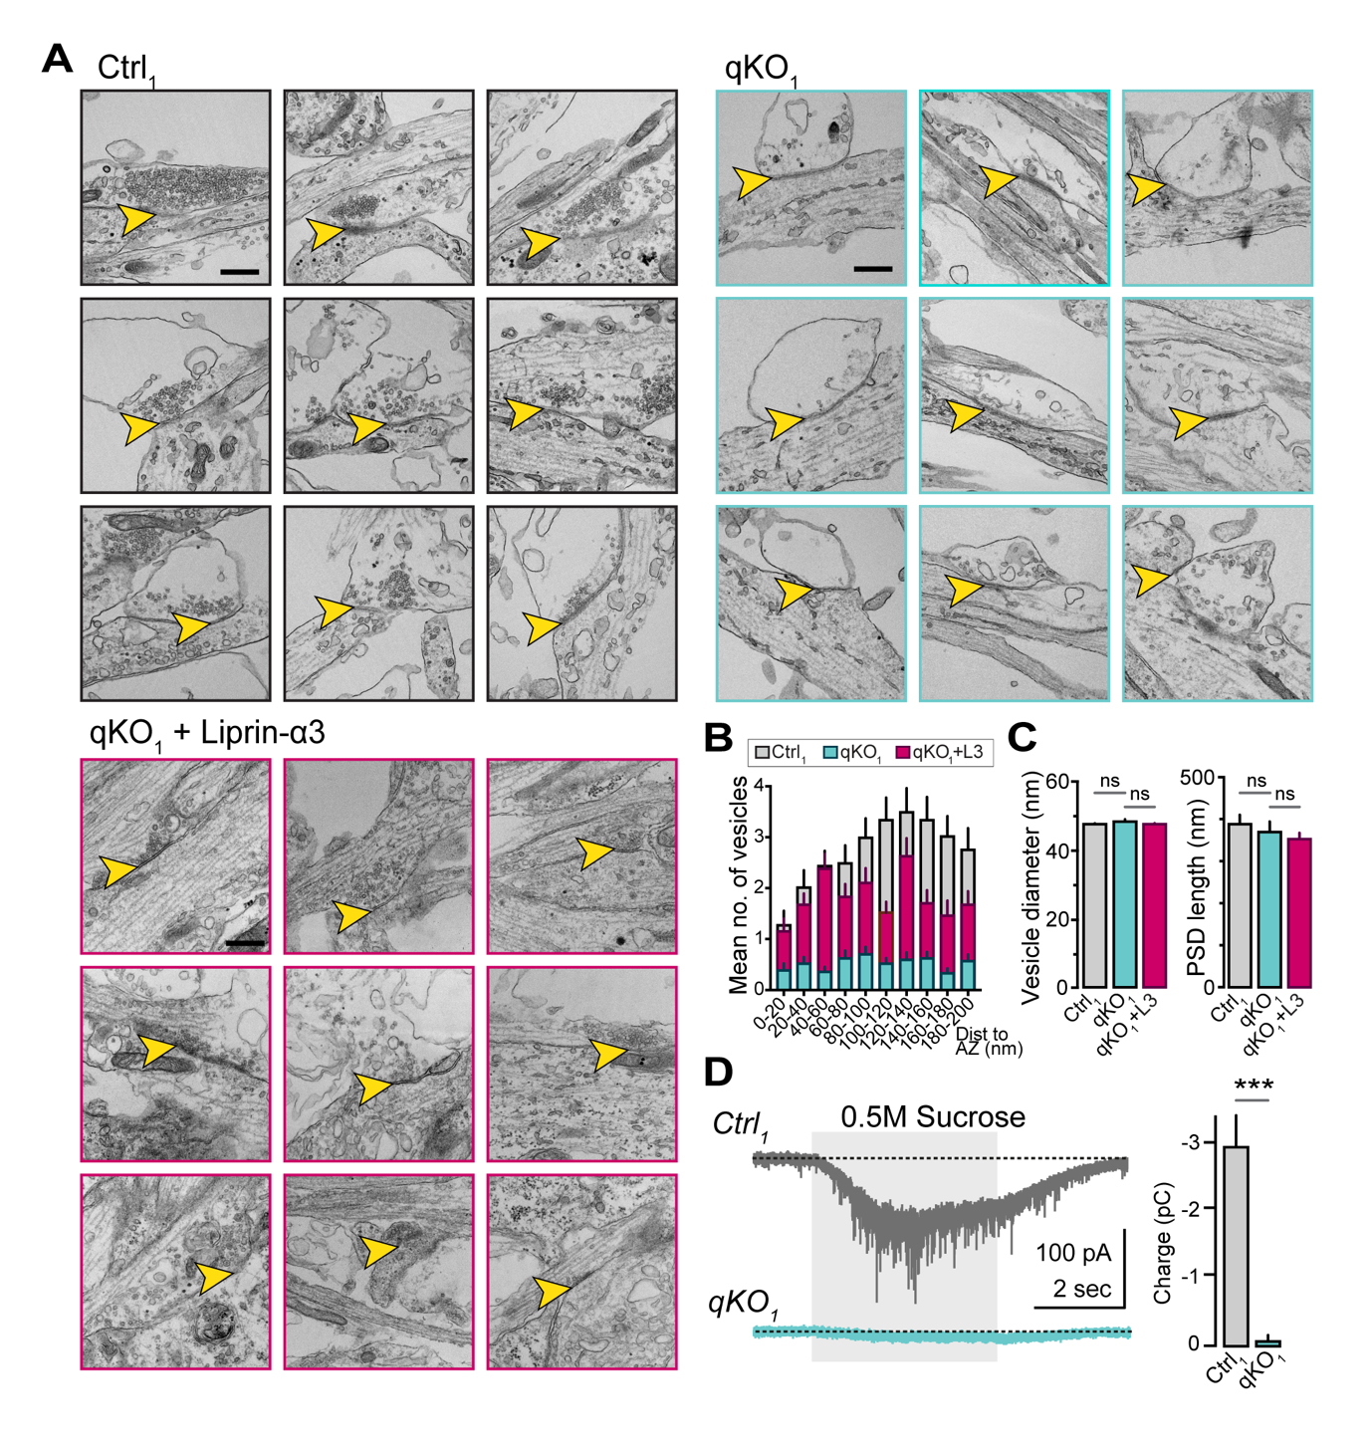
Figure S2 – Impact of Liprin-α deletion on synaptic protein recruitment, vesicle recruitment and vesicle pool size (related to Figure 2).
(A) Additional electron micrographs showing the fine structure of synapses in control (Ctrl), knockout (qKO), and knockout expressing Liprin-α3 (qKO+Liprin-α3).
(B) Summary of distribution of synaptic vesicles in close proximity to the presynaptic active zone in control (Ctrl), knockout (qKO), and knockout rescued with Liprin-α3 (qKO + Liprin-α3) synapses. Scale bar, 500 nm.
(C) Summary plots of the vesicle diameter (left) and the postsynaptic density (PSD) length (right) measurements assessed by electron microscopy. Number of vesicles/batches: Ctrl1, 3154/2; qKO, 705/2; qKO + Liprin-α3, 1440/1. Number of PSDs/batches: Ctrl1, 49/2; qKO, 53/2; qKO + Liprin-α3, 41/1.
(D) Hyperosmotic sucrose response in control (Ctrl, gray) and Liprin-ɑ knockout (qKO, light blue) neurons. Left. Representative responses with duration of sucrose application highlighted (light gray background). Right. Summary plots of the total charge transfer. Number of experiments/batches: Ctrl1, 47/3; qKO1, 59/3.
Data in summary plots is represented as means ± SEM; *** p < 0.001.

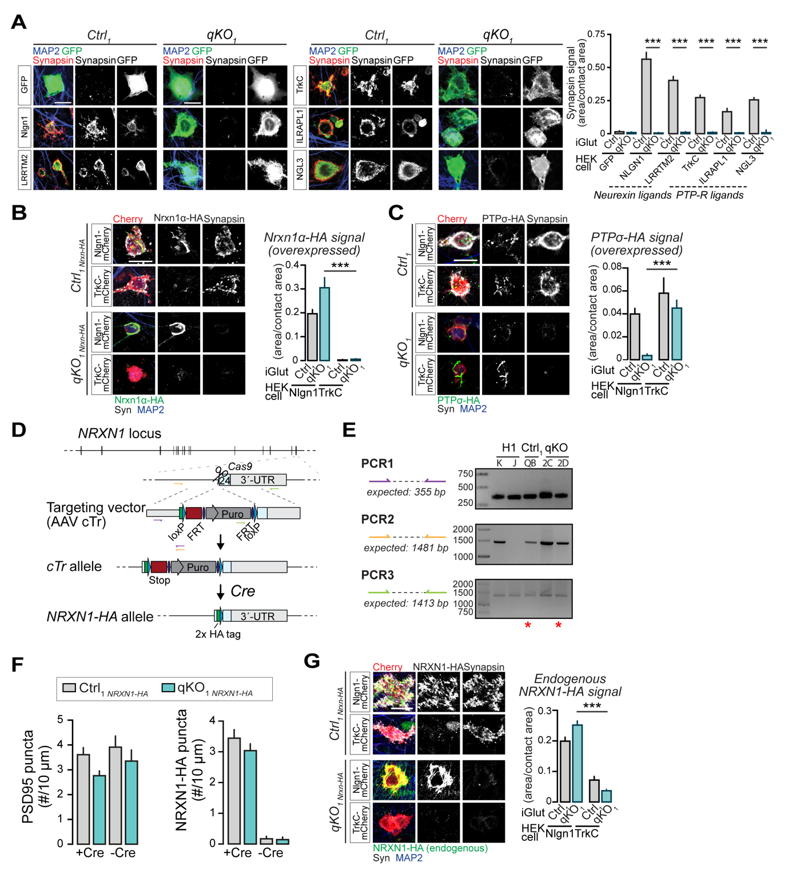
Figure S3 – Analysis of presynaptic CAM pathways by heterologous synapses, insertion of an HA-tag in NRXN1 by homologous recombination and analysis of endogenous NRXN1 distribution (related to Figure 2)
(A) Analysis of heterologous synapse formation by different pathways. Left. Representative images of HEK293-cells expressing the indicated GFP-tagged CAMs and co-cultured with Ctrl or qKO iGluts. Right. Quantitative analysis of synapsin recruitment area to HEK293-cell contacts of Liprin-ɑ control (Ctrl) and mutant (qKO) neurons with HEK293T. Number of cells(coverslips)/batches: 44-130(3)/1 (see Table S1).
(B) Recruitment of overexpressed Nrxn1α-HA onto Nlgn1- or TrkC-expressing HEK293-cells. Left. Representative images. Right. Quantitative analysis of HA-recruitment to artificial synapses of Liprin-ɑ control (Ctrl) and mutant (qKO) neurons with HEK293T. Number of cells/batches: 23-164/2-4 (see Table S1).
(C) Recruitment of overexpressed HA-tagged PTPσ onto Nlgn1- or TrkC-expressing HEK293-cells. Left. Representative images. Right. Quantitative analysis of control (Ctrl) and mutant (qKO) HA signal area onto HEK293-cells. The partial recruitment of PTPσ-HA by Nlgn1 in control cells may be explained by intracellular CASK–Liprin-α interactions ³. Number of cells/batches: 80-161/3-4 (see Table S1).
(D) Schematic representation of the donor vector and targeting strategy to insert an HA-tag in the last exon of the NRXN1 gene. Homologous recombination yields a conditional truncation allele (cTr) that produces a soluble HA-tagged Neurexin-1 protein that lacks transmembrane region and is degraded ⁴. Cre-mediated recombination restores expression of HA-tagged, wildtype protein.
(E) PCRs to confirm correct insertion of the HA-tag in NRXN1 in control and knockout clones, respectively. Location of each primer pair, color-coded, is indicated in (D). Wildtype H1 cells were included as positive controls for the gene editing. Clones selected for use in experiments as Ctrl1-NRXN1-HA and qKO1-NRXN1-HA, respectively, are marked by asterisks.
(F) Summary plots showing quantification of PSD95 puncta density (left) and NRXN1 puncta density (right) from control and Liprin-α qKO clones knock-in for NRXN1-HA (related to Fig. 2E). Number of dendrites(coverslips)/batches: Ctrl1-NRXN1-HA[+Cre], 281(8)/2; qKO1-NRXN1-HA[+Cre], 240(8)/2; Ctrl1-NRXN1-HA[-Cre] 126(1)/2 and qKO1-NRXN1-HA[-Cre] 86(1)/2.
(G) Recruitment of endogenous HA-tagged NRXN1 onto Nlgn1- or TrkC-expressing HEK293-cells. Left. Representative images. Right. Quantitative analysis of control (Ctrl) and mutant (qKO) HA signal area onto HEK293-cells. Number of cells/batches: 90-239/2-3 (see Table S1).
Data in summary plots is represented as means ± SEM; *** p < 0.001.

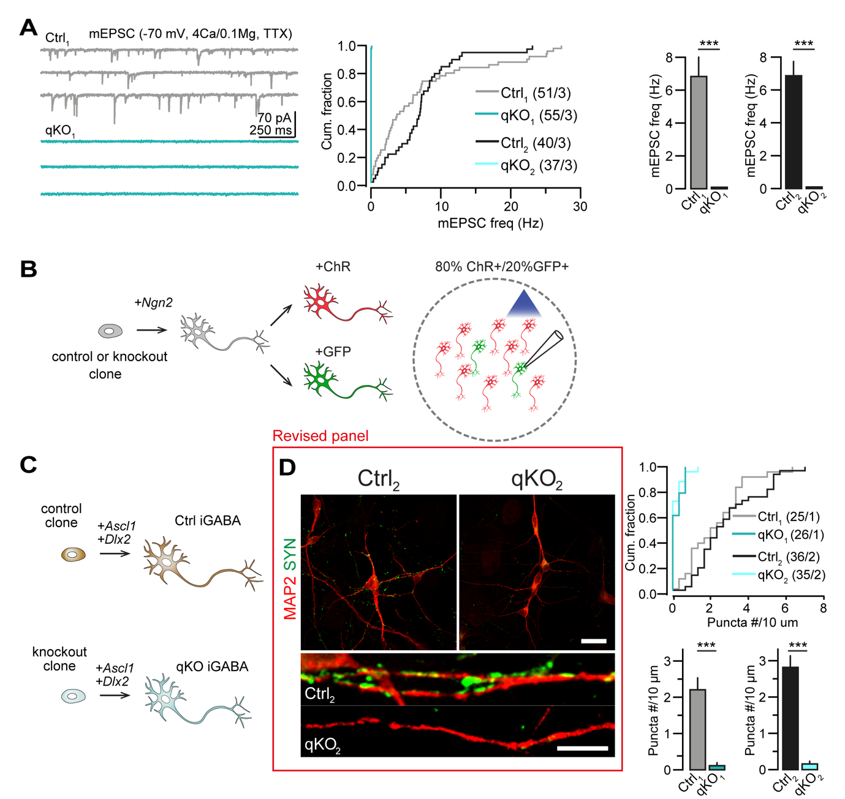
Figure S4 – Impact of Liprin-α deletion on excitatory and inhibitory transmission (related to Figure 3).
(A) Impact of Liprin-α deletion on miniature release, measured with high (4 mM) extracellular calcium concentration. Left. Representative traces. Middle. cumulative distribution of mEPSC frequencies in iGluts derived from control (Ctrl1 and Ctrl2), and mutant (qKO1 and qKO2) clones, respectively. Right. summary plots of EPSC frequency averages. Number of cells/batches analyzed: indicated in the figure panel in the middle.
(B) Schematic representation of approach used to record channelrhodopsin-assisted evoked synaptic transmission in control and qKO mutant iGluts.
(C) Schematic showing the approach used to derive control or knockout induced GABA neurons (iGABAs).
(D) Synapsin distribution in Liprin-ɑ control (Ctrl) and knockout (qKO) human iGABAs stained with antibodies against Synapsin (green) and MAP2 (red). Left, top. Representative images at low magnification. Left, bottom. Higher magnification images. Right. Cumulative distribution plots (top) and summary graphs (bottom) of Synapsin puncta density in iGABAs derived from control (Ctrl1 and Ctrl2) and mutant (qKO1 and qKO2) clones. Number of cells/batches analyzed indicated in the figure. Scale bar, 20 μm (top), 5 μm (lower).
Data in summary plots is represented as means ± SEM; *** p < 0.001.

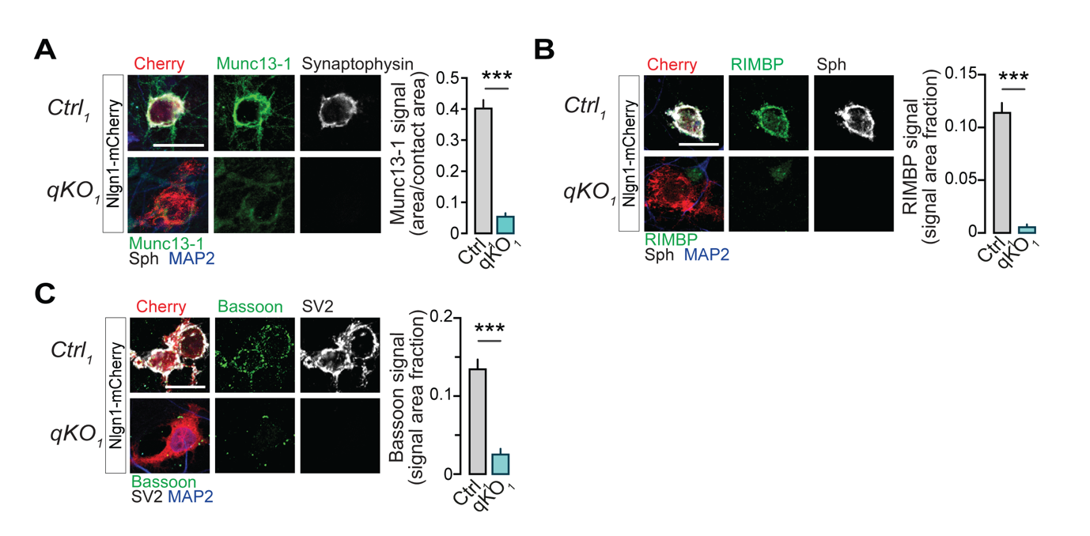
Figure S5 – Recruitment of active zone components to heterologous synapses (related to Figure 4).
(A) Recruitment of Munc13-1 to HEK293 cells expressing Nlgn1. Left. Representative images. Right. Summary statistics. Number of cells/batches: Ctrl1, 101/3; qKO1, 80/3.
(B) Recruitment of RIMBP to HEK293 cells expressing Nlgn1. Left. Representative images. Right. Summary statistics. Number of cells/batches: Ctrl1, 78/3; qKO1, 69/3.
(C) Recruitment of Bassoon to HEK293 cells expressing Nlgn1. Left. Representative images. Right. Summary statistics. Number of cells/batches: Ctrl1,108/3; qKO1, 99/3.
Scale bars, 20 μm. Data represented as means ± SEM; *** p < 0.001.

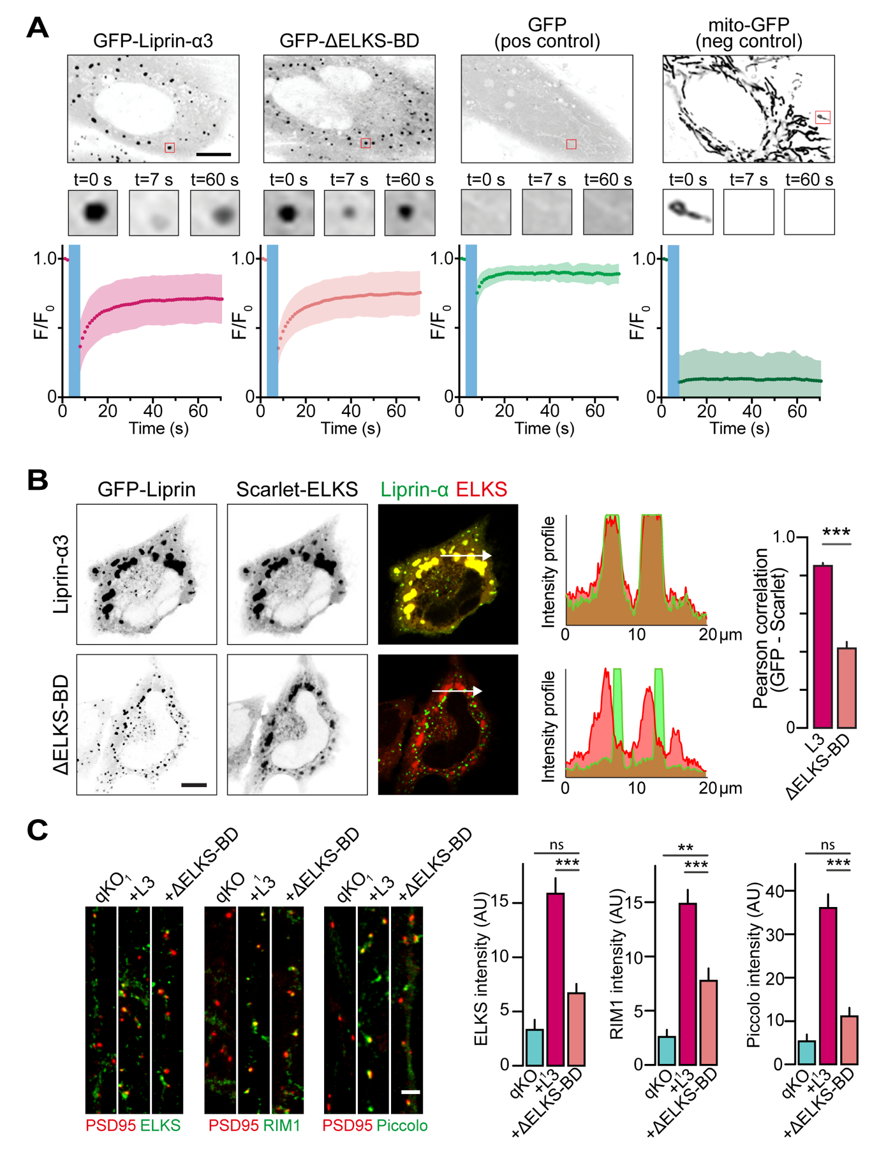
Figure S6 – Liprin-ɑ-ELKS interactions promote active zone formation (Related to Figure 5).
(A) FRAP-experiments in HeLa cells, performed in presence of PMA (phorbol 12- myristate 13-acetate). Cytosolic regions-of-interests (ROIs, red squares) were photobleached and the fluorescence recovery within each ROI subsequently measured. Cells expressing soluble GFP were included as positive controls for recovery, and cells expressing mitochondrially targeted GFP included as negative controls (by photobleaching isolated mitochondria in their entirety). Traces represent mean ± standard deviation. Number of cells/batches analyzed: GFP-Liprin-α3, 30/4; Liprin-α3(ΔELKS-BD), 42/4; GFP, 21/2; mito-GFP, 21/2. Scale bar, 10 μm.
(B) Co-localization between the indicated GFP-tagged Liprin-α3 constructs and Scarlet-tagged ELKS in HeLa cells. Left. Representative images, with intensity profiles of green and red fluorescence across the indicated white arrows. Scale bar, 10 μm. Right. Summary graph of green/red colocalization assessed by Pearson correlation coefficient. L3, Liprin-α3 (WT). Number of cells/batches analyzed: GFP-Liprin-α3, 56/4; Liprin-α3(ΔELKS-BD), 46/4.
(C) Recruitment of active zone proteins ELKS, RIM1, and Piccolo, to presynaptic boutons in qKO iGluts expressing wildtype Liprin-ɑ3 (L3) or the ΔELKS-BD mutant. Signal intensity of active zone markers was measured only inside ROIs defined by PSD-95. Representative images (left) and summary plots (right) of fluorescence intensity in qKO neurons expressing different Liprin-ɑ mutants. Scale bar, 2 μm. Number of ROIs/batches: 12-20/1 (see Table S1).
Data in summary plots is represented as means ± SEM; **p < 0.01, *** p < 0.001.

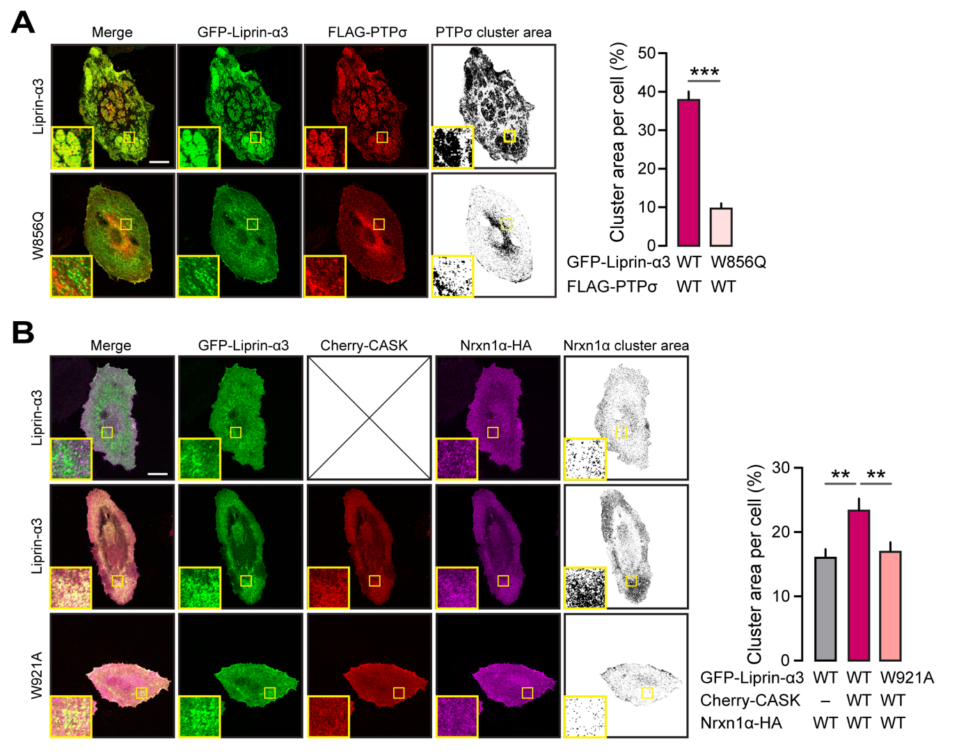
Figure S7 – Analysis of Liprin-α-mediated clustering of PTPσ and Neurexin in HeLa cells (related to Figure 6).
(A) HeLa cells co-transfected with GFP-tagged Liprin-α3 wildtype or the Liprin-α3 W895Q mutant, and Flag-tagged PTPσ. Left. Representative images with inserts showing enlarged (4x) regions of interest, and quantified (thresholded) signal to the right. Right. Quantification of the PTPσ cluster area per cell.
(B) HeLa cells co-transfected with HA-tagged Neurexin and GFP-tagged liprin-α3 wildtype or its mutant (W921A) with or without Cherry-tagged CASK. Left. Representative images with inserts showing enlarged (4x) regions of interest, and quantified (thresholded) signal to the right. Right. Quantification of the Neurexin cluster area per cell.
Scale bars, 20 μm. Data represented as means ± SEM (number of cells/batches: 30/3, per condition). ** p< 0.01, *** p< 0.001.
SUPPLEMENTARY TABLES

Table S1 – Summary of statistical results
Figure/panel | Sample size | Statistical test | Results
Figure 1D  MAP2 | Ctrl₁ 84 fields/3 batches  Ctrl₂ 94 fields/3 batches  qKO₁ 94 fields/3 batches  qKO₂ 80 fields/3 batches | Unpaired two-tailed Student’s t-tests | Ctrl₁ vs. qKO1 p<0,0001  Ctrl₂ vs. qKO₂ p<0,0001
Figure 1E  Tuj1 | Ctrl₁ 27 fields/3 batches  Ctrl₂ 18 fields/3 batches  qKO₁ 20 fields/3 batches  qKO₂ 21 fields/3 batches | Unpaired two-tailed Student’s t-tests | Ctrl₁ vs. qKO₁ p= 0.22, ns  Ctrl₂ vs. qKO₂ p=0.64, ns
Figure 1F  Protein levels | Ctrl₁ 3-7 batches  qKO₁ 3-5 batches  Ctrl₂ 3-7 batches  qKO₂ 3-5 batches | 2-way ANOVA with Holm-Šídák test for multiple comparisons, comparing  Ctrl₁₊₂ vs. qKO₁₊₂ | PTPRS: n=3+3 vs 3+3, adj. p = 0,9875  pan Nrxn: n=4+4 vs. 4+4, adj. p = 0,8998  CASK: n=5+3 vs. 5+3, adj. p = 0,8104  Nlgn1: n=5+3 vs. 5+3, adj. p = 0,8998  Homer: n=6+3 vs. 6+3, adj. p = 0,3607  PSD95: n=3+3 vs 3+3, adj. p > 0,9999  ERC 1/2: n=3+3 vs 3+3, adj. p = 0,9338  RIM1: n=3+3 vs 3+3, adj. p > 0,9999  RIMBP2: n=4+4 vs. 4+4, adj. p = 0,1327  Munc13-1: n=5+5 vs. 5+5, adj. p > 0,9999  Mint1: n=6+3 vs. 6+3, adj. p = 0,3835  Veli 1: n=5+3 vs. 5+3, adj. p = 0,761  Veli 2/3: n=5+3 vs. 5+3, adj. p = 0,8998  Synapsin2: n=7+4 vs. 7+4, adj. p = 0,3835  Syntaxin: n=7+3 vs. 7+3, adj. p = 0,3835  SNAP25: n=3+3 vs 3+3, adj. p = 0,9669  Synaptotagmin1: n=6+3 vs. 6+3, adj. p = 0,0441  Rab3a: n=4+4 vs. 4+4, adj. p = 0,0178
Figure 1H | Ctrl₁ 19 fields/1 batch  Ctrl₂ 30 fields/1 batch  qKO₁ 22 fields/1 batch  qKO₂ 28 fields/1 batch | Two-tailed Mann-Whitney test | Ctrl₁ vs. qKO₁ p < 0.0001  Ctrl₂ vs. qKO₂ p < 0.0001
Figure 1I  Synapsin puncta Rescues | qKO₁ 57 cells/4 batches  qKO₁ +L1 62 cells/4 batches  qKO₁ +L2 66 cells/4 batches  qKO₁ +L3 64 cells/4 batches  qKO₁ +L4 32 cells/2 batches | KW test followed by Dunn's multiple comparisons test | qKO₁ vs. qKO1 + L1, p < 0.001  qKO₁ vs. qKO1 + L2, p < 0.001  qKO₁ vs. qKO1 + L3, p < 0.001  qKO₁ vs. qKO1 + L4, p < 0.001
Figure 1J | SV2:  Ctrl₁ 16 fields/2 batches  qKO₁ 16 fields/2 batches  Synaptophysin-1:  Ctrl₁ 35 fields/1 batch  qKO₁ 10 fields/1 batch  Piccolo:  Ctrl₁ 67 fields/2 batches  qKO₁ 54 fields/2 batches  RIM1:  Ctrl₁ 15 fields/1 batch  qKO₁ 12 fields/1 batch  RIMBP:  Ctrl₁ 16 fields/1 batch  qKO₁ 10 fields/1 batch  CaV2.1:  Ctrl₁ 16 fields/1 batch  qKO₁ 9 fields/1 batch | Two-tailed Mann-Whitney test | SV2 puncta:  qKO₁ vs. Ctrl₁, p < 0.0001  Synaptophysin-1 puncta:  qKO₁ vs. Ctrl₁, p < 0.0001  Piccolo puncta:  qKO₁ vs. Ctrl₁, p < 0.0001  RIM1 puncta:  qKO₁ vs. Ctrl₁, p < 0.0001  RIMBP2 puncta:  qKO₁ vs. Ctrl₁, p < 0.0001  CaV2.1 puncta:  qKO₁ vs. Ctrl₁, p = 0,0462
Figures 2B  and  Suppl. S2B, S2C  EM vesicle counts | Total number of vesicles analyzed:  Ctrl₁ 3154 vesicles (11 grids / 2 batches)  qKO₁ 705 (11 grids / 2 batches)  qKO₁+L3 1440 (11 grids /1 batch) | 1-way ANOVA with Holm-Šídák test for multiple comparisons | Vesicles per bouton:  qKO₁ vs. Ctrl₁ adj. p < 0.0001  qKO₁ vs. qKO₁+L3 adj. p = 0.0105  qKO₁+L3 vs. Ctrl₁ adj. p < 0.0001  Vesicle size:  qKO₁ vs. Ctrl₁ adj. p = 0,9824, ns  qKO₁ vs. qKO₁+L3 adj. p = 0,9824, ns  qKO₁+L3 vs. Ctrl₁ adj. p = 0,9824, ns
Figure 2F  PSD95-NRXN1 puncta ratios | Ctrl_{1 Nrxn-HA} +Cre 281 dendrites/2 batches  qKO_{1 Nrxn-HA} +Cre 240 dendrites/2 batches  Ctrl_{1 Nrxn-HA} -Cre 126 dendrites/2 batches  qKO_{1 Nrxn-HA} -Cre 86 dendrites/2 batches | (no statistical comparisons made)
Figure 2G-I  PSD95 length, NRXN nanocluster size and number | Ctrl_{1 Nrxn-HA} +Cre 32 boutons /1 batch  qKO_{1 Nrxn-HA} +Cre 25 boutons/1 batch | (no statistical comparisons made)
Figure 3B  mEPSCs | Ctrl₁ 49 cells/3 batches  qKO₁ 49 cells/3 batches  Ctrl₂ 33 cells/3 batches  qKO₂ 34 cells/3 batches | Two-tailed Mann-Whitney test | Ctrl₁ vs. qKO₁ p < 0.0001  Ctrl₂ vs. qKO₂ p < 0.0001
Figure 3D  Evoked EPSCs | Ctrl₁ 36 cells/2 batches  qKO₁ 35 cells/2 batches  Ctrl₁ 35 cells/2 batches  qKO₁ 35 cells/2 batches | Two-tailed Mann-Whitney test | Ctrl₁ vs. qKO₁ p < 0.0001  Ctrl₂ vs. qKO₂ p < 0.0001
Figure3F  mIPSCs | Ctrl₁ 41 cells/2 batches  qKO₁ 41 cells/2 batches  Ctrl₂ 59 cells/3 batches  qKO₂ 61 cells/3 batches | Two-tailed Mann-Whitney test | Ctrl₁ vs. qKO₁ p < 0.0001  Ctrl₂ vs. qKO₂ p < 0.0001
Figure 3H  mEPSC Rescues | qKO₁ 60 cells/3 batches  qKO₁+L1 70 cells/5 batches  qKO₁+L2 70 cells/5 batches  qKO₁+L3 65 cells/5 batches  qKO₁+L4 25 cells/2 batches | One-way ANOVA followed by a Bonferroni test for multiple comparisons | qKO₁ vs. qKO₁ + L1 p < 0.0001  qKO₁ vs. qKO₁ + L2 p < 0.0001  qKO₁ vs. qKO₁ + L3 p < 0.0001  qKO₁ vs. qKO₁ + L4 p = 0.0089
Figure 4A  SV2 transport | Ctrl₁ 14 fields/2 batches  qKO₁ 13 fields/2 batches | Two-tailed Student’s t-tests | Velocity:  qKO₁ vs. Ctrl₁, p = 0.54  Movement events:  qKO₁ vs. Ctrl₁, p = 0.03
Figure 4B  ELKS transport | Ctrl₁ 10 fields/3 batches  qKO₁ 12 fields/3 batches | Two-tailed Student’s t-tests | Velocity:  qKO₁ vs. Ctrl₁, p = 0.55  Movement events:  qKO₁ vs. Ctrl₁, p = 0.33
Figure 4C  CASK recruitment | Ctrl₁ 158 cells /4 batches  qKO₁ 119 cells /4 batches | Two-tailed Mann-Whitney test | Ctrl₁ vs. qKO₁ p < 0.0001
Figure 4D  ELKS recruitment | Ctrl₁ 126 cells/3 batches  qKO₁ 94 cells/3 batches | Two-tailed Mann-Whitney test | Ctrl₁ vs. qKO₁ p < 0.0001
Figure 4E  RIM recruitment | Ctrl₁ 123 cells/3 batches  qKO₁ 96 cells/3 batches | Two-tailed Mann-Whitney test | Ctrl₁ vs. qKO₁ p < 0.0001
Figure 4F  Piccolo recruitment | Ctrl₁ 143 cells/3 batches  qKO₁ 79 cells/3 batches | Two-tailed Mann-Whitney test | Ctrl₁ vs. qKO₁ p < 0.0001
Figure 4G  CaV2.1 recruitment | Ctrl₁ 98 cells/3 batches  qKO₁ 86 cells/3 batches | Two-tailed Mann-Whitney test | Ctrl₁ vs. qKO₁ p < 0.0001
Figure 5B  Recruitment ASF | qKO₁+L3 75 HEK cells/1 batch  qKO₁+L3ΔCC 52 HEK cells /1 batch  qKO₁+L3ΔRIMBD 127 HEK cells /1 batch  qKO₁+L3ΔELKSBD 97 HEK cells /1 batch  qKO₁+L3ΔSAM 50 HEK cells /1 batch  qKO₁+L3ΔLoop 67 HEK cells /1 batch  qKO₁+L3W921A 64 HEK cells /1 batch  qKO₁+L3W856Q 71 HEK cells /1 batch | (no statistical comparisons made)
Figure 5C  Synapsin Puncta | qKO₁ + L3 51 cells/3 batches  qKO₁ + L3 ΔCC 38 cells/3 batches  qKO₁ + L3 ΔRIMBD 41 cells/3 batches  qKO₁ + L3 ΔELKSBD 45 cells/3 batches  qKO₁ + L3 ΔSAM123 38 cells/3 batches  qKO₁ + L3 ΔLoop 40 cells/3 batches  qKO₁ + L3 W921A ΔCASK 40 cells/3 batches  qKO₁ + L3 W856Q 46 cells/3 batches | KW test followed by Dunn's multiple comparisons test | qKO₁ vs. qKO₁ + L3 ΔCC, p > 0.99  qKO₁ vs. qKO₁ + L3 ΔRIMBD, p < 0.001  qKO₁ vs. qKO₁ + L3 ΔELKSBD, p = 0.82  qKO₁ vs. qKO₁ + L3 ΔCASKIS, p < 0.001  qKO₁ vs. qKO₁ + L3 W931A, p < 0.001  qKO₁ vs. qKO₁ + L3 ΔSAM123, p = 0.014  qKO₁ vs. qKO₁ + L3 W856Q, p = 0.001
Figure 5D  mEPSC | qKO₁ + L3 66 cells/3 batches  qKO₁ + L3 ΔCC 59 cells/3 batches  qKO₁ + L3 ΔRIMBD 67 cells/3 batches  qKO₁ + L3 ΔELKSBD 71 cells/3 batches  qKO₁ + L3 ΔSAM123 70 cells/3 batches  qKO₁ + L3 ΔLoop 68 cells/3 batches  qKO₁ + L3 W931A ΔCASK 71 cells/3 batches  qKO₁ + L3 W856Q 68 cells/3 batches | One-way ANOVA followed by a Tukey’s multiple comparison test | L3 ΔCC vs. L3 ΔRIMBD, p < 0.001  L3 ΔCC vs. L3 ΔELKSBD, p > 0.9999  L3 ΔSAM123 vs. ΔLoop, p < 0.001  L3 ΔSAM123 vs. L3 W921A, p < 0.001  L3 ΔSAM123 vs. L3 W856Q, p < 0.05
Figure 5E  Sucrose | qKO₁ + L3 32 cells/3 batches  qKO₁ + L3 ΔCC 29 cells/3 batches  qKO₁ + L3 ΔRIMBD 32 cells/3 batches  qKO₁ + L3 ΔELKSBD 48 cells/3 batches  qKO₁ + L3 ΔSAM123 30 cells/3 batches  qKO₁ + L3 ΔLoop 62 cells/3 batches  qKO₁ + L3 W971A ΔCASK 31 cells/3 batches  qKO₁ + L3 W856Q 39 cells/3 batches | One-way ANOVA followed by a Tukey’s multiple comparison test | L3 ΔCC vs. L3 ΔRIMBD, p < 0.0001  L3 ΔCC vs. L3 ΔELKSBD, p > 0.968  L3 ΔSAM123 vs. ΔLoop, p < 0.0001  L3 ΔSAM123 vs. L3 W921A, p < 0.0001  L3 ΔSAM123 vs. L3 W856Q, p < 0.05
Figure 6B  QA recruitment | Ctrl₁ + L3 73 HEK cells/2 batches  Ctrl₁ + QA 188 HEK cells/3 batches  qKO₁ + L3 78 HEK cells/3 batches  qKO₁ + QA 156 HEK cells/3 batches | Two-tailed Mann-Whitney test | qKO₁ + L3 vs. qKO1 + QA p < 0.0001
Figure 6C  mEPSCs QA rescue | qKO₁ 70 cells/5 batches  qKO₁ + L3 52 cells/5 batches  qKO₁ + L3 QA 83 Cells/5 batches | KW test followed by Dunn's multiple comparisons test | qKO1 vs. qKO1+L3, p < 0.0001  qKO1 vs. qKO1+L3 QA, p = 0.1605
Figure 6D  Synapsin puncta QA rescue | qKO₁ 63 cells/4 batches  qKO₁ + L3 64 cells/4 batches  qKO₁ + L3W921A; W856Q 66 cells/4 batches | KW test followed by Dunn's multiple comparisons test | qKO₁ vs. Ctrl₁, p < 0.001  qKO₁ vs. L1, p < 0.001  qKO₁ vs. qKO₁ + L3 Q/A, p = 0.452
Figure 6E  Sucrose QA mutant | qKO₁ 35 cells/2 batches  qKO₁ + L3 43 cells/2 batches  qKO₁ + L3 QA 34 cells/2 batches | KW test followed by Dunn's multiple comparisons test | qKO1 vs. qKO1+L3, p < 0.0001  qKO1 vs. qKO1+L3 QA, p = 0.3051
Figure 6F  Active zone markers | ELKS signal:  qKO₁ 12 ROIs/1 batch  qKO₁ + L3 19 ROIs/1 batch  qKO₁ + L3 QA 8 ROIs/1 batch  RIM1 signal:  qKO₁ 12 ROIs/1 batch  qKO₁ + L3 20 ROIs/1 batch  qKO₁ + L3 QA 18 ROIs/1 batch  Piccolo signal:  qKO₁ 13 ROIs/1 batch  qKO₁ + L3 12 ROIs/1 batch  qKO₁ + L3 QA 17 ROIs/1 batch | One-way ANOVA followed by a Tukey’s multiple comparison test | ELKS signal:  qKO₁ vs. qKO₁+L3, p < 0.0001  qKO₁ vs. qKO₁+L3 QA, p = 0.4444  RIM1 signal:  qKO₁vs. qKO₁+L3, p < 0.0001  qKO₁ vs. qKO₁+L3 QA, p = 0.0621  Piccolo signal:  qKO₁ vs. qKO₁+L3, p < 0.0001  qKO₁ vs. qKO₁+L3 QA, p = 0.1026
Figure S1D  Conversion | Ctrl₁ 20 batches  Ctrl₂ 10 batches  qKO₁ 20 batches  qKO₂ 11 batches | Two-tailed Mann-Whitney test | Ctrl₁ vs. qKO₁ p = 06157, ns  Ctrl₂ vs. qKO₂ p = 0.6047, ns
Figure S1E  AP properties | Ctrl₁ 24 Cells/2 batches  qKO₁ 23 Cells/2 batches  Ctrl₂ 22 Cells/2 batches  qKO₂ 23 Cells/2 batches | Two-tailed Mann-Whitney test | AP amplitude  Ctrl₁ vs. qKO₁ p = 0.1835  Ctrl₂ vs. qKO₂ p = 0.1509  AP half-width  Ctrl₁ vs. qKO₁ p = 0,8043  Ctrl₂ vs. qKO₂ p = 0.2016  AP max speed  Ctrl₁ vs. qKO₁ p = 0.1632  Ctrl₂ vs. qKO₂ p = 0.7401
Figure S1G  Rheobase and Capacitance | Rheobase:  Ctrl₁ 40 cells/3 batches  qKO₁ 37 cells/3 batches  Ctrl₂ 31 cells/3 batches  qKO₂ 40 cells/3 batches  Capacitance:  Ctrl₁ 45 cells/3 batches  qKO₁ 40 cells/3 batches  Ctrl₂ 30 cells/3 batches  qKO₂ 31 cells/3 batches | Unpaired two-tailed Student’s t-test with Welch’s correction | Rheobase:  Ctrl₁ vs. qKO₁ p<0.0001  Ctrl₂ vs. qKO₂ p<0.0028  Capacitance:  Ctrl₁ vs. qKO₁ p<0.0001  Ctrl₂ vs. qKO₂ p<0.0001
Figure S2C  EM PSD analysis | Total number of PSDs analyzed:  Ctrl₁ 49 PSDs / 2 batches  qKO1 53 PDSs / 2 batches  qKO₁+L3 41 PSDs / 1 batch | 1-way ANOVA with Holm-Šídák test for multiple comparisons | PSD length:  qKO₁ vs. Ctrl₁ adj. p = 0,7733, ns  qKO₁ vs. qKO₁+L3 adj. p = 0,7733, ns  qKO₁+L3 vs. Ctrl₁ adj. p = 0,5420, ns
Figure S2D  Sucrose response | Ctrl₁ 47 cells/3 batches  qKO₁ 59 cells/3 batches | Two-tailed Mann-Whitney test | qKO₁ vs. Ctrl₁, p<0.0001
Figure S3A  Artificial synapse formation | GFP:  Ctrl₁ 70 HEK cells/1 batch  qKO₁ 59 HEK cells/1 batch  NLGN1:  Ctrl₁ 76 HEK cells/1 batch  qKO₁ 77 HEK cells/1 batch  LRRTM2:  Ctrl₁ 86 HEK cells/1 batch  qKO₁ 80 HEK cells/1 batch  TrkC:  Ctrl₁ 93 HEK cells/1 batch  qKO₁ 69 HEK cells/1 batch  ILRAPL1:  Ctrl₁ 130 HEK cells/1 batch  qKO₁ 122 HEK cells/1 batch  NGL3:  Ctrl₁ 84 HEK cells/1 batch  qKO₁ 44 HEK cells/1 batch | KW test followed by Dunn's multiple comparisons test | GFP:  qKO₁ vs. Ctrl₁ ns, adj. p > 0.999  NLGN1:  qKO1 vs. Ctrl₁, adj. p < 0.0001  LRRTM2  qKO₁ vs. Ctrl₁, adj. p < 0.0001  TrkC  qKO₁ vs. Ctrl₁, adj. p < 0.0001  ILRAPL1  qKO₁ vs. Ctrl₁, adj. p < 0.0001  NGL3  qKO₁ vs. Ctrl₁, adj. p < 0.0001
Figure S3B  Nrxn1α-HA overexpressed | Nrxn-HA Nlgn1:  Ctrl₁ 164 HEK cells/4 batches  qKO₁ 45 HEK cells/2 batches  Nrxn-HA TrkC:  Ctrl₁ 43 HEK cells /2 batches  qKO₁ 23 HEK cells /2 batches | KW test followed by Dunn's multiple comparisons test | qKO₁ + Nlgn₁ vs. qKO₁+TrkC p < 0.0001
Figure S3C  PTPσ-HA overexpressed | PTPRS-HA Nlgn1:  Ctrl₁ 161 HEK cells /4 batches  qKO₁ 85 HEK cells /4 batches  PTPRS-HA TrkC:  Ctrl₁ 80 HEK cells /3 batches  qKO₁ 90 HEK cells /3 batches | KW test followed by Dunn's multiple comparisons test | qKO₁+TrkC vs. qKO₁+Nlgn1 p < 0.0001
Figure S3G  NRXN1-HA endogenous | Nlgn1:  Ctrl₁ 239 HEK cells /3 batches  qKO₁ 107 HEK cells /3 batches  TrkC:  Ctrl₁ 233 HEK cells /2 batches  qKO₁ 90 HEK cells /2 batches | KW test followed by Dunn's multiple comparisons test | qKO₁ NrxnHA+Nlgn1 vs. qKO₁ NrxnHA+TrkC adj. p < 0.0001
Figure S4A  mEPSCs (4 mM Ca) | Ctrl₁ 51 cells/3 batches  qKO₁ 55 cells/3 batches  Ctrl₂ 40 cells/3 batches  qKO₂ 37 cells/3 batches | Two-tailed Mann-Whitney test | Ctrl₁ vs. qKO₁ p < 0.0001  Ctrl₂ vs. qKO₂ p < 0.0001
Figure S4C  iGABA Synapsin puncta | Ctrl₁ 25 cells/2 batches  qKO₁ 26 cells/2 batches  Ctrl₂ 36 cells/2 batches  qKO₂ 35 cells/2 batches | Unpaired two-tailed Student’s t-tests | Ctrl₁ vs. qKO₁ p < 0.0001  Ctrl₂ vs. qKO₂ p < 0.0001
Figure S5A  Munc13 recruitment | Ctrl₁ 101 HEK cells/3 batches  qKO₁ 80 HEK cells/3 batches | Two-tailed Mann-Whitney test | Ctrl₁ vs. qKO₁ p < 0.0001
Figure S5B  RIMBP recruitment | Ctrl₁ 78 HEK cells/3 batches  qKO₁ 69 HEK cells/3 batches | Two-tailed Mann-Whitney test | Ctrl₁ vs. qKO₁ p < 0.0001
Figure S5C  Bassoon recruitment | Ctrl₁ 108 HEK cells/3 batches  qKO₁ 99 HEK cells/3 batches | Two-tailed Mann-Whitney test | Ctrl₁ vs. qKO₁ p < 0.0001
Figure S6B  Pearson co-localization | GFP-Liprin-α3 + Scarlet-ELKS 56 cells/4 batches  GFP-ΔELKSBD + Scarlet-ELKS 46 cells/4 batches | Two-tailed Mann-Whitney test | L3 vs ΔELKSBD, p < 0.001
Figure S6C  Active zone markers | ELKS signal:  qKO₁ 12 ROIs/1 batch  qKO₁ + L3 19 ROIs/1 batch  qKO₁ + L3 ΔELKSBD 17 ROIs/1 batch  RIM1 signal:  qKO₁ 12 ROIs/1 batch  qKO₁ + L3 20 ROIs/1 batch  qKO₁ + L3 ΔELKSBD 18 ROIs/1 batch  Piccolo signal:  qKO₁ 13 ROIs/1 batch  qKO₁ + L3 20 ROIs/1 batch  qKO₁ + L3 ΔELKSBD 17 ROIs/1 batch | One-way ANOVA followed by a Tukey’s multiple comparison test | ELKS signal:  qKO1 vs. qKO1+L3, p < 0.0001  qKO1 vs. qKO1+L3 ΔELKSBD, p = 0.0686  RIM1 signal:  qKO1 vs. qKO1+L3, p < 0.0001  qKO1 vs. qKO1+L3 ΔELKSBD, p = 0.0062  Piccolo signal:  qKO1 vs. qKO1+L3, p < 0.0001  qKO1 vs. qKO1+L3 ΔELKSBD, p=0.2251
Figure S7A | L3 + PTPσ 30 cells/3 batches  L3 W856Q + PTPσ 30 cells/3 batches | Unpaired two-tailed Student t-test | L3 vs. L3 Q856Q p < 0.0001
Figure S7B | L3 + Nrxn1α 30 cells/3 batches  L3 + CASK + Nrxn1α 30 cells/3 batches  L3 W921A + CASK + Nrxn1α 30 cells/3 batches | 1-way ANOVA with Holm-Šídák test for multiple comparisons | L3 + Nrxn1α vs.  L3 + CASK + Nrxn1α p = 0.0014  L3 + CASK + Nrxn1α vs.  L3 W921A + CASK + Nrxn1α p = 0.0040

SUPPLEMENTARY DATA REFERENCES
1. Chanda, S., et al. Direct Reprogramming of Human Neurons Identifies MARCKSL1 as a Pathogenic Mediator of Valproic Acid-Induced Teratogenicity. Stem Cell 25, 1-24 (2019).
2. Canals, I., et al. Rapid and efficient induction of functional astrocytes from human pluripotent stem cells. Nature Methods 15, 1-10 (2018).
3. LaConte, L.E., et al. CASK stabilizes neurexin and links it to liprin-alpha in a neuronal activity-dependent manner. Cell Mol Life Sci 73, 3599-3621 (2016).
4. Pak, C., et al. Human Neuropsychiatric Disease Modeling using Conditional Deletion Reveals Synaptic Transmission Defects Caused by Heterozygous Mutations in NRXN1. Cell Stem Cell 17, 316-328 (2015).

