Table 5. Synthesized hydrazone derivatives under solvent-free conditions
Entry | Product | Time (h) | Yield  (%) | Ref.
1 | 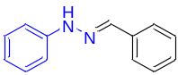 | 0.5 | 95 | [16]
2 | 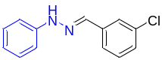 | 2.2 | 97 | [17]
3 | 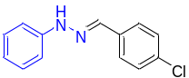 | 2.5 | 97 | [16]
4 | 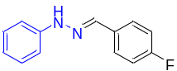 | 2.5 | 93 | [16]
5 | 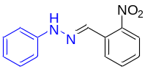 | 2.2 | 95 | [18]
6 | 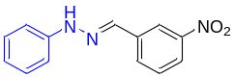 | 2.2 | 95 | [19]
7 | 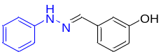 | 3.0 | 90 | -
8 | 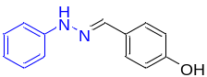 | 3.0 | 91 | [20]
9 | 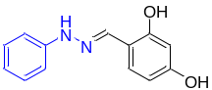 | 3.2 | 83 | [21]
10 | 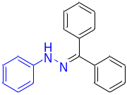 | 2.8 | 89 | [22]
11 | 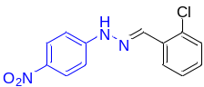 | 2.2 | 96 | -
12 | 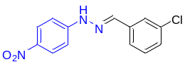 | 2.1 | 95 | -
13 | 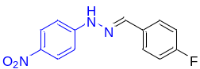 | 2.6 | 95 | -
14 | 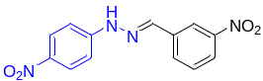 | 2.7 | 93 | -
15 | 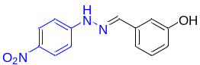 | 2.7 | 90 | -
16 | 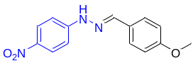 | 2.8 | 88 | [23]
17 | 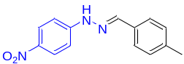 | 2.8 | 93 | -
18 | 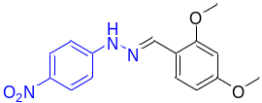 | 2.5 | 85 | -
19 | 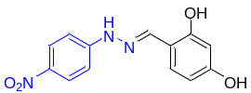 | 3.4 | 87 | -
20 | 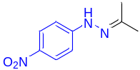 | 2.5 | 84 | [24]
21 | 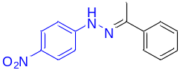 | 2.7 | 87 | [24]
22 | 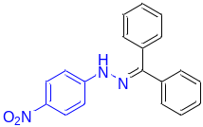 | 2.5 | 84 | [25]
23 | 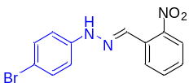 | 2.6 | 90 | [26]
24 | 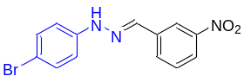 | 2.2 | 92 | [27]
25 | 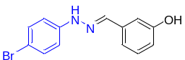 | 2.7 | 89 | -
26 | 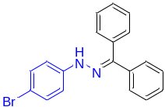 | 2.4 | 95 | [28]
27 | 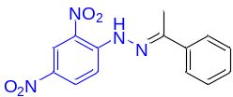 | 2.2 | 93 | [29]
28 | 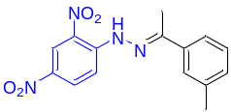 | 2.1 | 92 | -
Reaction conditions: phenylhydrazine 1.0 mmol, benzaldehyde 1.0 mmol, and MgO NPs 0.03 g as the catalyst under solvent-free condition at 80°C.

