SUPPLEMENTARY MATERIAL
SUPPLEMENTARY RESULTS
Other Nominally Significant Associations in MGI’s Candidate Study
In addition to OPRM1, MGI had nominally significant (p<0.05) associations at previously reported high-value variants in two other genes: COMT and GRK5 . In our survey of extant literature, we found that five studies in our literature survey had collectively posited four SNPs in COMT for significant associations with outcomes related to OUD (morphine dosage, pharmacodynamic effects of various opioids, and somnolence as an adverse effect of opioid analgesic therapy);^{5–9} All four associations were found in candidate studies with small sample sizes (≤204 participants) (Figure 3; Supplementary Table 1). Of these four variants, two highly correlated SNPs (r²=0.99) were nominally significant in the full MGI dataset (rs4633-T: OR=1.07, p=0.017, MAF=0.49; rs4680-A: OR=1.07, p=0.016, MAF=0.49) (Figure 3; Table 2). Additionally, in a candidate study of GRK5 (sample size: 344), Wang et. al. 2018 identified eight SNPs having significant associations with methadone dosage;¹⁰ one of these SNPs, rs10886472-A, had nominal significance in the naive MGI dataset (OR=0.89, p=0.028, MAF=0.47) (Figure 3; Table 2).

Genome-wide Association Results
GWAS of the full and opioid-naive datasets produced three associations with p-values suggestive for significant association with POU (p≤5×10⁻⁸) but not meeting our criterion for genome-wide significance (p≤1.5×10⁻⁸) and one association attaining genome-wide significance (Supplementary Figure 3). Each of these associations involved a rare (0.0001≤MAF<0.001) or low-frequency (0.001≤MAF<0.01) variant (Supplementary Table 3). One association occurred in the full dataset (rs189503278-C intronic to RAB17, MAF=0.0007, beta=3.81, p=2.8×10⁻⁸) and three appeared in the opioid-naive dataset (rs73325169-T intronic to ERGIC1, MAF=0.0001, beta=43.16, p=3.3×10⁻⁸; rs1047623607-C intronic to RBM20, MAF=0.0003, beta=20.40, p=3.2×10⁻⁸; and rs754477085-A intronic to EHF, MAF=0.0067, beta=3.81, p=7.5×10⁻⁹) (Supplementary Figure 3; Supplementary Table 3).

SUPPLEMENTARY DISCUSSION
Biology of Other Nominally Significant Associations in MGI’s Candidate Study
While the discovery of significant associations between POU and previously reported variants in OPRM1 establishes an important link between POU and OUD, in recent decades many SNPs in other genes also have been associated with OUD or related outcomes. Aside from variants in OPRM1, none of the tested SNPs reached the significance threshold adjusted for multiple testing across 23 genes (p<0.0022), but a few variants in COMT and GRK5 had nominally significant associations (p<0.05) in MGI.
COMT, a gene that encodes enzymes necessary for the degradation of catecholamines and is involved in dopamine metabolism, has been a candidate gene for opioid studies for years due to its role in processing dopamine (Supplementary Table 1). Although multiple studies over almost two decades have thought COMT a worthwhile gene to test for association with opioid-related outcomes, it remains unclear if COMT truly plays a role in opioid use. Our discovery of nominally significant associations in COMT provides some additional evidence for its association with opioid-related outcomes, but is by no means conclusive.
In contrast to the biologically motivated study of COMT, SNPs from another gene, GRK5, were chosen for further analysis in a candidate study after the gene showed an initial promising association in a gene-based test (GRK5: p=6.76×10⁻⁵).¹⁰ Though GRK5 was not a biologically obvious choice like COMT, it may nonetheless hold biological interest because it “encodes an enzyme related to μ-opioid receptor desensitization.”¹⁰ Further testing is necessary to confirm the role of GRK5 in opioid use.

Biology of MGI Associations with POU (p≤5×10⁻⁸)
None of the four associations in MGI with p≤5×10⁻⁸, nor the genes to which they are intronic, have been reported in previous studies of OUD or related outcomes. Two of the implicated genes, ERGIC1 and RBM20, have no apparent biological relationship to opioids. ERGIC1 is a membrane-bound protein that regulates traffic between the endoplasmic reticulum and golgi. ERGIC1 is associated with two neuromuscular disorders, amyotrophic lateral sclerosis^{11–14} and arthrogryposis multiplex congenita¹⁵, as well as several other conditions. RBM20 is an RNA-binding motif protein expressed primarily in the heart and skeletal muscles; it is predominantly associated with cardiac disease.^{16–20}
The other two genes, RAB17 and EHF, are more interesting for our study of POU. RAB17 is among the small GPTase genes, which regulate membrane trafficking; RAB17 is epithelial cell-specific and therefore active in organs with epithelium, such as kidneys, liver, and brain. Interestingly, RAB17 is associated with brain development^{21–27} and regulation of the blood-brain barrier²⁸ as well as various other traits. EHF (ETS homologous factor) is an epithelial cell-specific member of the ETS family of transcription factors. EHF is most noted for its involvement in cystic fibrosis^{29–31} and multiple types of cancers;^{32–36} however, McClay et. al. 2011 also reported an association between an intronic variant of EHF and “vigilance” in schizophrenia patients after taking the antipsychotic drug ziprasidone.³⁷
Although none of the genes noted in our GWAS have been reported previously for association with opioid use, the signals in RAB17 and EHF are somewhat intriguing due to their expression in epithelial cells. The association of EHF with schizophrenia patient responses to antipsychotic drugs has been attributed to potential variation in the gene that could play a role in epithelial barrier permeability, potentially affecting the efficacy of antipsychotic drugs.³⁷ Similarly, it is possible that variations in RAB17 and EHF, which are both epithelial cell-specific, could affect absorption levels of opioids; this line of reasoning is particularly intriguing with regard to RAB17, which has known associations with brain development and the blood-brain barrier.
Regardless of these hypotheses, previous research indicates that associations for MGI phenotypes involving low-frequency or rare variants with 5×10⁻⁹<p≤5×10⁻⁸, as is the case with these four associations, are likely to be false (expected false discovery rate ~90%).⁴ The statistical indications of the viability of these associations with POU is low, and they should be treated circumspectly in the absence of further evidence.

SUPPLEMENTARY METHODS
Statistics: Genome-wide Association Analysis
We performed GWAS of the POU outcome in both the full dataset and opioid-naive subset using SAIGE software (logistic mixed model, two-sided tests) and controlling for prescription dataset, sex, age, and four principal components.¹ We defined genome-wide significance as p≤1.5×10⁻⁸, following recommendations from the 1000 Genomes Project and other studies for datasets with large numbers of imputed variants.^{2–4}
SUPPLEMENTARY TABLES AND FIGURES

Supplementary Table 1 | Literature survey results. Contains information on publications, genetics, study samples, study outcomes, and inclusion status in the MGI high-value candidate analysis for all results from our literature survey of opioid-related outcomes.

Supplementary Table 2 | Studies of opioid-related outcomes with sample sizes ≥10,000.

PMID | First Author | Date | Analysis  Type | Ancestry | Clinical  Context | Sample  Size | No.  Cases | No.  Controls
35879402 | Deak | 2022 | GWAS | African; European | Opioid use disorder | 639,063 | 20,686 | 618,377
36171425 | Kember | 2022 | GWAS | African; European; Hispanic | Opioid use disorder | 447,580 | 37,826 | 409,754
36207451 | Gaddis | 2022 | GWAS; candidate; gene-based | European | Opioid use disorder | 304,831 | 7,281 | 297,550
34728798 | Sanchez-Roige | 2021 | GWAS | European | Opioid misuse | 132,113 | 27,805 | 104,308
32492095 | Zhou | 2020 | GWAS | European | Opioid use disorder | 82,707 | 10,544 | 72,163
Current analysis | Annis | 2023 | GWAS | European | Persistent opioid use  after surgery | 39,519 | 3,198 | 36,321
32099098 | Polimanti | 2020 | GWAS;  gene-based | African; European | Opioid use disorder | 36,673 | 4,173 | 32,500
Preprint | Coenen | 2022 | GWAS | — | Pharmacogenetic research | 23,815 | 11,089 | 12,726
32961455 | Song | 2020 | GWAS | European | Opioid use disorder | 21,310 | 1,039 | 20,271
25744370 | Hancock | 2015 | Candidate | African; European | Opioid use disorder | 16,729 | 4,287 | 12,442

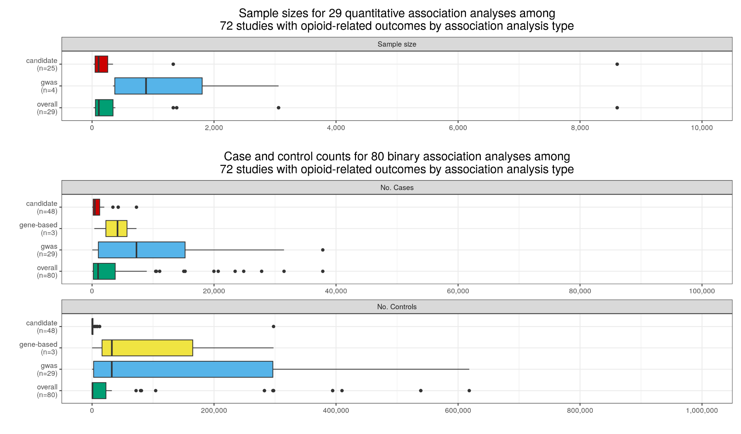

Supplementary Figure 1 | Sample size distributions for association analyses of OUD or related outcomes in previous studies. Total of 109 analyses across 72 studies. Boxplots of sample sizes for quantitative and binary outcomes by study type.

A
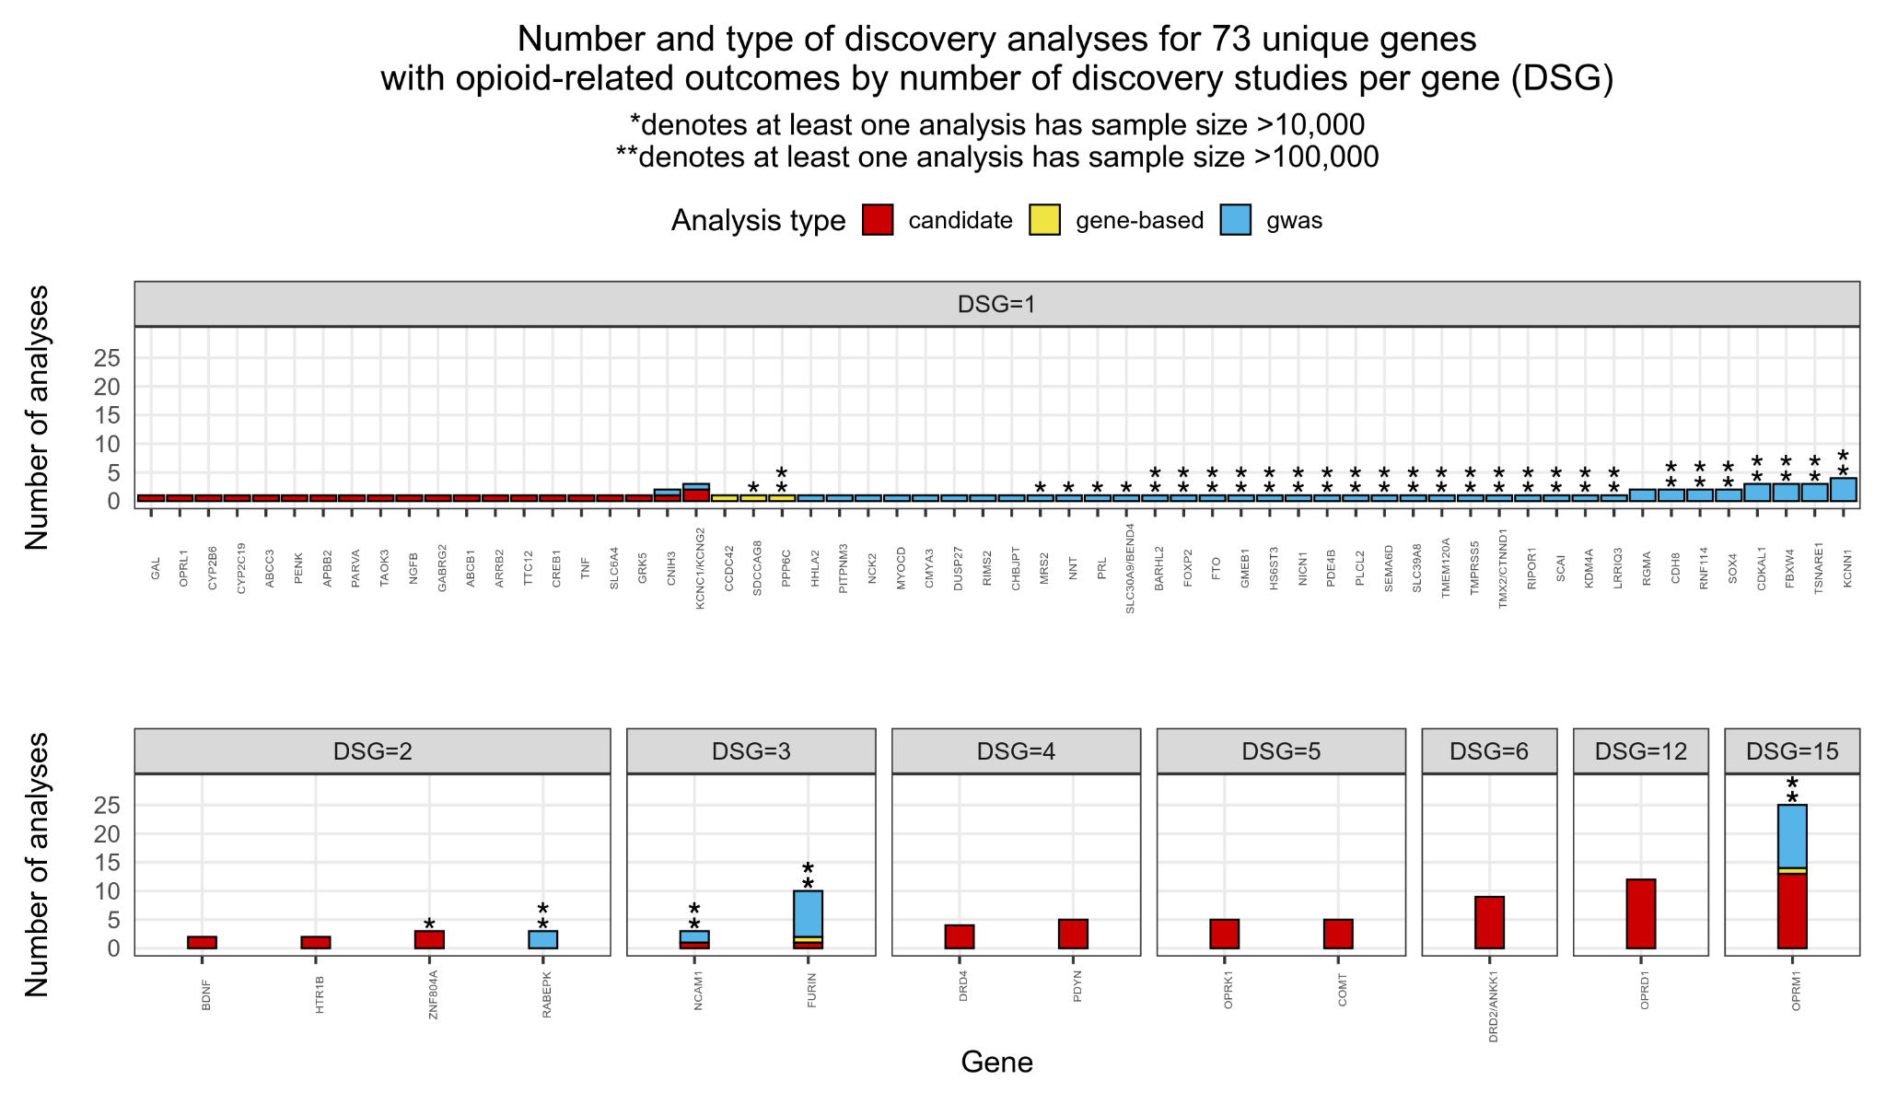
B
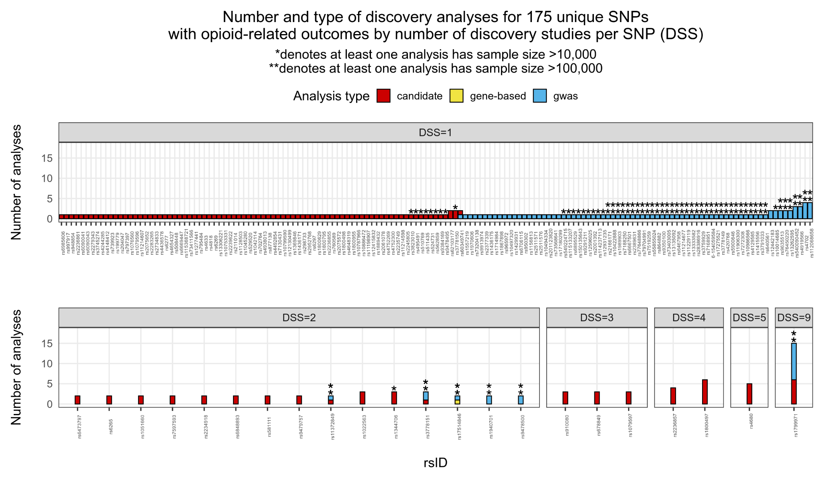

Supplementary Figure 2 | Number and type of discovery analyses by number of discovery studies for literature survey results. Individual plots indicate the number of studies with significant associations with OUD or related outcomes. Bars indicate the total number of analyses with significant associations with OUD or related outcomes (some studies contribute multiple analyses). A) Results for 73 genes. DSG = discovery studies per gene. B) Results for 175 SNPs. DSS = discovery studies per SNP.

A
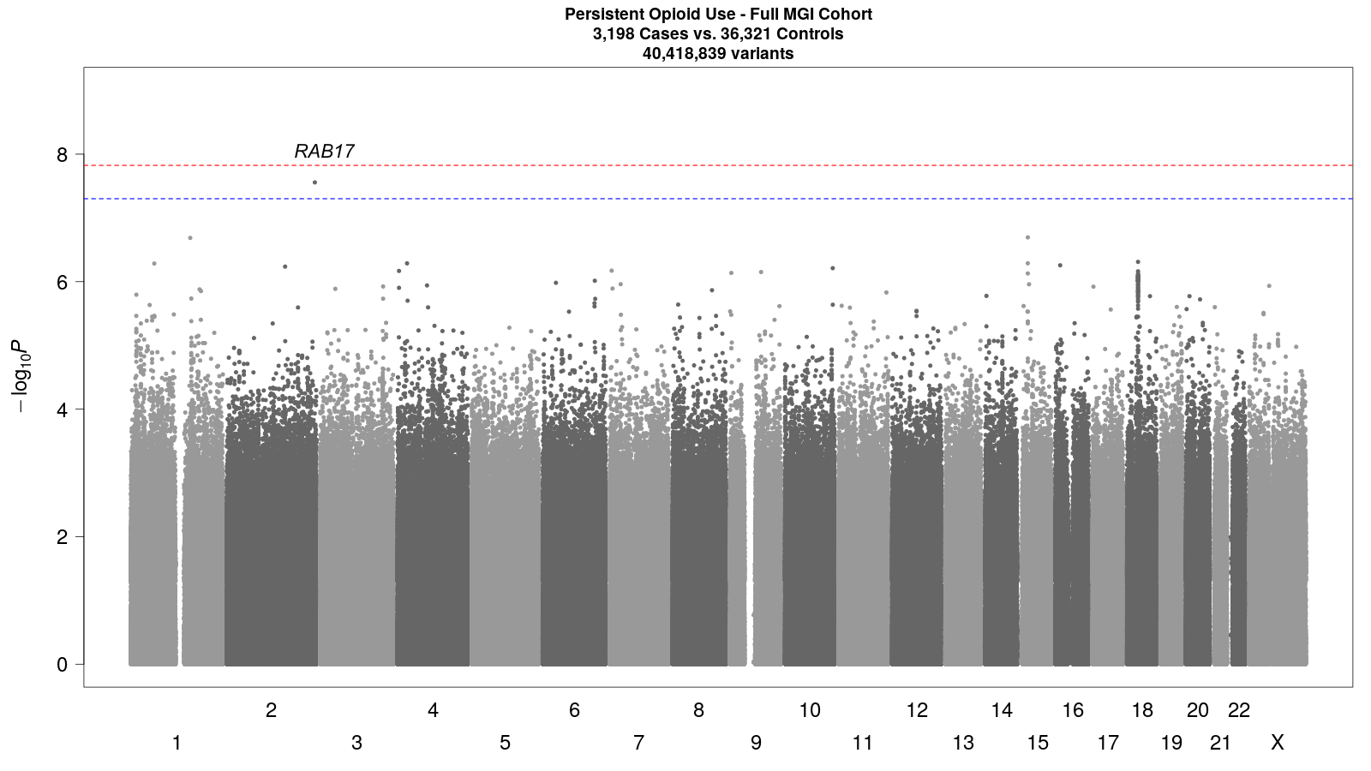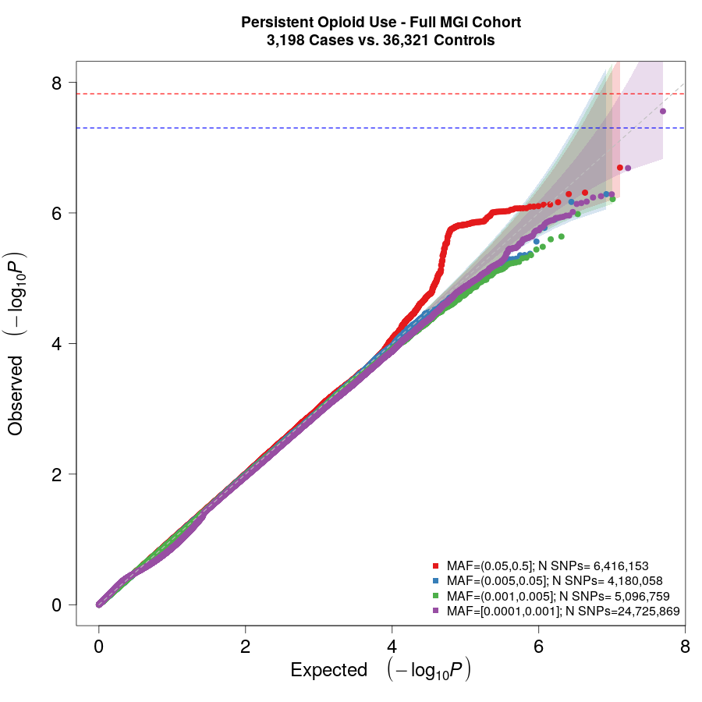
B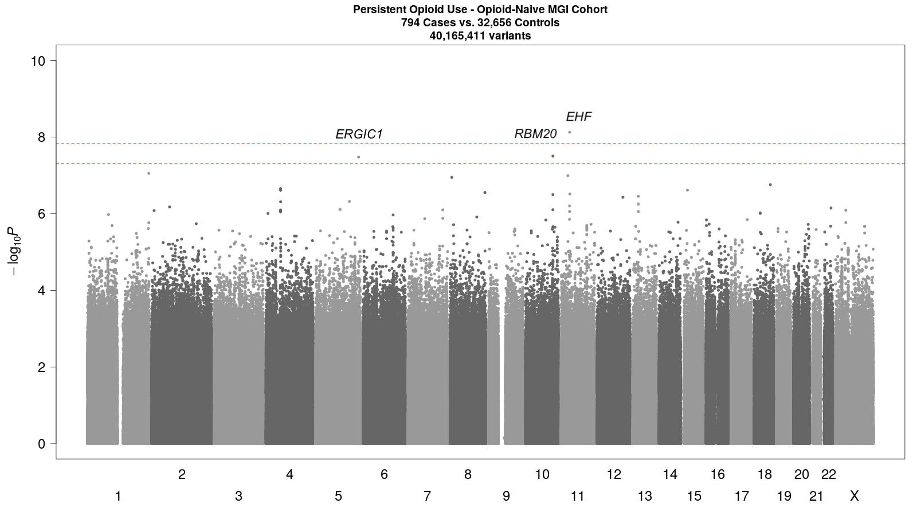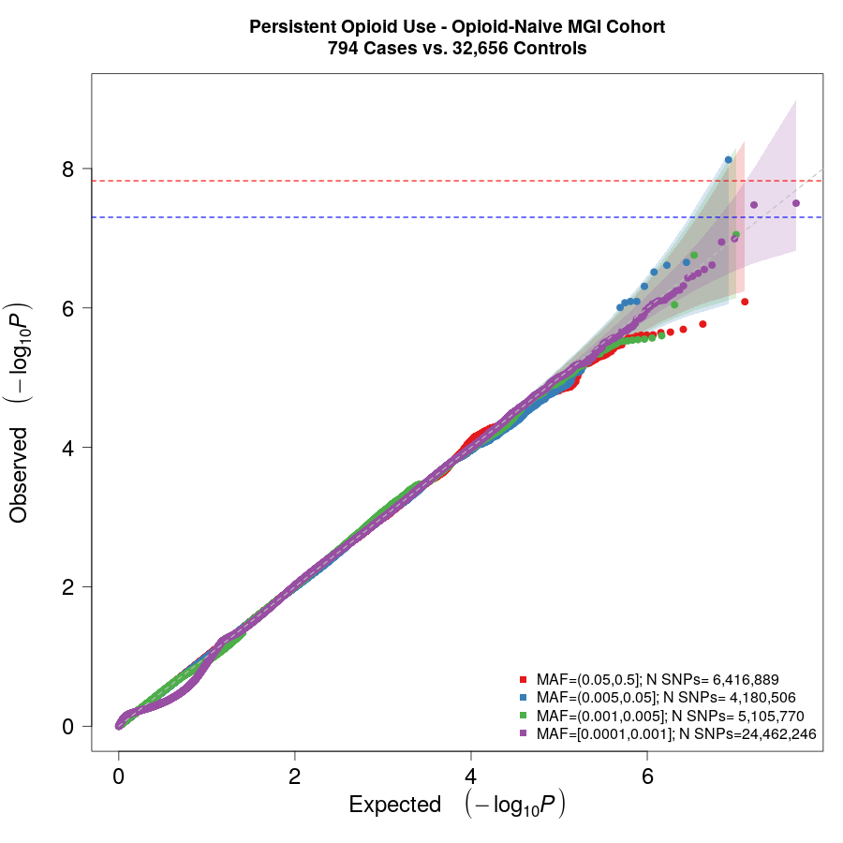
Supplementary Figure 3 | Manhattan and QQ plots for persistent opioid use GWAS. Upper line (red) lies at 1.5✕10⁻⁸. Lower line (blue) lies at p=5✕10⁻⁸. A) Full sample Manhattan plot shows one suggestive (p≤5✕10⁻⁸) association at rs189503278-C in RAB17 (MAF=0.0007, beta=3.81). No associations attain genome-wide significance (p≤1.5✕10⁻⁸). B) Opioid-naive Manhattan plot shows two suggestive (p≤5✕10⁻⁸) associations at rs73325169-T in ERGIC1 (MAF=0.0001, beta=43.16) and rs1047623607-C in RBM20 (MAF=0.0003, beta=20.40), and one genome-wide significant (p≤1.5✕10⁻⁸) association at rs754477085-A in EHF (MAF=0.0067, beta=3.81).
Supplementary Table 3 | Suggestive and significant associations from full and opioid-naive GWAS of persistent opioid use. Three suggestive associations with p≤5✕10⁻⁸. One genome-wide significant association with p≤1.5✕10⁻⁸.

rsID  (effect allele) | Location  (b38) | Nearest Gene | Effect (beta) | P-value | MAF | SNP Effect | Discovery  Dataset
rs189503278 (C) | 2-237587875 | RAB17 | 3.81 | 2.77 × 10⁻⁸ | 0.0007 | Intron | Full
rs73325169 (T) | 5-172892500 | ERGIC1 | 43.16 | 3.32 × 10⁻⁸ | 0.0001 | Intron | Naive
rs1047623607 (C) | 10-110698049 | RBM20 | 20.40 | 3.15 × 10⁻⁸ | 0.0003 | Intron | Naive
rs754477085 (A) | 11-34646919 | EHF | 3.81 | 7.50 × 10⁻⁹ | 0.0067 | Intron | Naive

Supplementary Table 4 | Comparison of GWAS meta-analysis significant (p≤5✕10⁻⁸) results for Deak et. al. 2022 OUD outcome and OUD MTAG outcome. Discrepancies in results indicate that the outcomes likely capture different genetic signals. EA = European American ancestry. AA = African American ancestry. MTAG = Multi-trait analysis of GWAS (adjusting for genetically correlated substance use disorders). **rs11372849 (T) and rs17514846 (A) are 2,882 bp apart (chr15:90876202 and chr15:90873320); LD not calculated due to rs11372849 not being present in MGI.

rsID | Effect  Allele | Nearest  Gene | Deak — OUD GWAS meta-analysis  EA: 15,251 cases, 538,935 controls  AA: 5,435 cases, 79,442 controls |  |  |  | Deak — OUD MTAG GWAS  meta-analysis  EA: 15,251 cases, 538,935 controls
rsID | Effect  Allele | Nearest  Gene | Z-score | P-value | Population | Z-score |  | P-value | Population
rs11372849 / rs17514846* | T / A | FURIN | 6.12 | 9.54 × 10⁻¹⁰ | EA | -5.59 |  | 2.30 × 10⁻⁰⁸ | EA
rs1799971 | A | OPRM1 | 5.85 | 4.92 × 10⁻⁰⁹ | EA | — |  | — | —
rs79704991 | T | OPRM1 | 5.71 | 1.11 × 10⁻⁰⁸ | EA | — |  | — | —
rs9478500 | T | OPRM1 | -5.62 | 1.95 × 10⁻⁰⁸ | AA; EA | — |  | — | —
rs11229119 | T | TMX2/CTNND1 | — | — | — | -6.50 |  | 7.03 × 10⁻¹¹ | EA
rs77648866 | A | NICN1 | — | — | — | 6.33 |  | 1.82 × 10⁻¹⁰ | EA
rs1989903 | A | FOXP2 | — | — | — | -6.20 |  | 2.47 × 10⁻¹⁰ | EA
rs7519259 | A | PDE4B | — | — | — | 5.73 |  | 2.68 × 10⁻¹⁰ | EA
rs13135092 | A | SLC39A8 | — | — | — | 6.51 |  | 3.60 × 10⁻¹⁰ | EA
rs1940701 | T | NCAM1 | — | — | — | -6.1 |  | 9.63 × 10⁻¹⁰ | EA
rs864882 | T | RABEPK | — | — | — | -5.60 |  | 1.24 × 10⁻⁰⁹ | EA
rs9350100 | T | RP11-254A17.1 | — | — | — | 5.62 |  | 1.76 × 10⁻⁰⁹ | EA
rs2166171 | T | BARHL2 | — | — | — | -5.88 |  | 4.80 × 10⁻⁰⁹ | EA
rs55855024 | A | PLCL2 | — | — | — | 5.73 |  | 7.89 × 10⁻⁰⁹ | EA
rs6467958 | T | TMEM120A | — | — | — | -5.50 |  | 1.06 × 10⁻⁰⁸ | EA
rs11214677 | T | TMPRSS5 | — | — | — | -5.65 |  | 1.16 × 10⁻⁰⁸ | EA
rs6667501 | A | GMEB1 | — | — | — | 5.55 |  | 1.74 × 10⁻⁰⁸ | EA
rs10422888 | A | CTB-129P6.11 | — | — | — | 5.55 |  | 1.99 × 10⁻⁰⁸ | EA
rs73403005 | A | SEMA6D | — | — | — | -5.69 |  | 2.46 × 10⁻⁰⁸ | EA
rs2389631 | A | HS6ST3 | — | — | — | -5.61 |  | 2.53 × 10⁻⁰⁸ | EA
rs7188250 | T | FTO | — | — | — | 5.64 |  | 3.63 × 10⁻⁰⁸ | EA

REFERENCES
1. Zhou, W. et al. Efficiently controlling for case-control imbalance and sample relatedness in large-scale genetic association studies. Nat. Genet. 50, 1335–1341 (2018).
2. 1000 Genomes Project Consortium et al. A global reference for human genetic variation. Nature 526, 68–74 (2015).
3. Fadista, J., Manning, A. K., Florez, J. C. & Groop, L. The (in)famous GWAS P-value threshold revisited and updated for low-frequency variants. Eur. J. Hum. Genet. 24, 1202–1205 (2016).
4. Annis, A. et al. False discovery rates for genome-wide association tests in biobanks with thousands of phenotypes. Research Square (2021) doi:10.21203/rs.3.rs-873449/v1.
5. Rakvåg, T. T. et al. The Val158Met polymorphism of the human catechol-O-methyltransferase (COMT) gene may influence morphine requirements in cancer pain patients. Pain 116, 73–78 (2005).
6. Matsuoka, H. et al. Prospective replication study implicates the catechol-O-methyltransferase Val158Met polymorphism as a biomarker for the response to morphine in patients with cancer. Biomed Rep 7, 380–384 (2017).
7. Jones, J. D. et al. Assessing the contribution of opioid- and dopamine-related genetic polymorphisms to the abuse liability of oxycodone. Pharmacol. Biochem. Behav. 186, 172778 (2019).
8. Ho, K. W. D., Wallace, M. R., Staud, R. & Fillingim, R. B. OPRM1, OPRK1, and COMT genetic polymorphisms associated with opioid effects on experimental pain: a randomized, double-blind, placebo-controlled study. Pharmacogenomics J. 20, 471–481 (2019).
9. Tanaka, R. et al. Influence of genetic variants of opioid-related genes on opioid-induced adverse effects in patients with lung cancer: A STROBE-compliant observational study. Medicine 100, e27565 (2021).
10. Wang, S.-C. et al. GRK5 Is Associated with the Regulation of Methadone Dosage in Heroin Dependence. Int. J. Neuropsychopharmacol. 21, 910–917 (2018).
11. Karch, C. M. et al. Selective Genetic Overlap Between Amyotrophic Lateral Sclerosis and Diseases of the Frontotemporal Dementia Spectrum. JAMA Neurol. 75, 860–875 (2018).
12. Soo, K. Y. et al. Rab1-dependent ER-Golgi transport dysfunction is a common pathogenic mechanism in SOD1, TDP-43 and FUS-associated ALS. Acta Neuropathol. 130, 679–697 (2015).
13. van Rheenen, W. et al. Common and rare variant association analyses in amyotrophic lateral sclerosis identify 15 risk loci with distinct genetic architectures and neuron-specific biology. Nat. Genet. 53, 1636–1648 (2021).
14. Nakamura, R. et al. A multi-ethnic meta-analysis identifies novel genes, including ACSL5, associated with amyotrophic lateral sclerosis. Commun Biol 3, 526 (2020).
15. Reinstein, E. et al. Mutations in ERGIC1 cause Arthrogryposis multiplex congenita, neuropathic type. Clin. Genet. 93, 160–163 (2018).
16. Roselli, C. et al. Multi-ethnic genome-wide association study for atrial fibrillation. Nat. Genet. 50, 1225–1233 (2018).
17. Nielsen, J. B. et al. Biobank-driven genomic discovery yields new insight into atrial fibrillation biology. Nat. Genet. 50, 1234–1239 (2018).
18. Verweij, N. et al. The Genetic Makeup of the Electrocardiogram. Cell Syst 11, 229–238.e5 (2020).
19. Roselli, C. et al. Genome-wide association study reveals novel genetic loci: a new polygenic risk score for mitral valve prolapse. Eur. Heart J. 43, 1668–1680 (2022).
20. Cárcel-Márquez, J. et al. A Polygenic Risk Score Based on a Cardioembolic Stroke Multitrait Analysis Improves a Clinical Prediction Model for This Stroke Subtype. Front Cardiovasc Med 9, 940696 (2022).
21. Mori, Y., Matsui, T., Furutani, Y., Yoshihara, Y. & Fukuda, M. Small GTPase Rab17 regulates dendritic morphogenesis and postsynaptic development of hippocampal neurons. J. Biol. Chem. 287, 8963–8973 (2012).
22. Mori, Y., Matsui, T. & Fukuda, M. Rabex-5 protein regulates dendritic localization of small GTPase Rab17 and neurite morphogenesis in hippocampal neurons. J. Biol. Chem. 288, 9835–9847 (2013).
23. Mori, Y. & Fukuda, M. Rabex-5 determines the neurite localization of its downstream Rab proteins in hippocampal neurons. Commun. Integr. Biol. 6, e25433 (2013).
24. Mori, Y., Fukuda, M. & Henley, J. M. Small GTPase Rab17 regulates the surface expression of kainate receptors but not α-amino-3-hydroxy-5-methyl-4-isoxazolepropionic acid (AMPA) receptors in hippocampal neurons via dendritic trafficking of Syntaxin-4 protein. J. Biol. Chem. 289, 20773–20787 (2014).
25. Mori, Y. & Fukuda, M. Assay of Rab17 and its guanine nucleotide exchange factor Rabex-5 in the dendrites of hippocampal neurons. Methods Mol. Biol. 1298, 233–243 (2015).
26. Shikanai, M., Yuzaki, M. & Kawauchi, T. Rab family small GTPases-mediated regulation of intracellular logistics in neural development. Histol. Histopathol. 33, 765–771 (2018).
27. Kam, K.-L. et al. Use of immunohistochemistry to determine expression of Rab5 subfamily of GTPases in mature and developmental brains. Methods Mol. Biol. 2293, 265–271 (2021).
28. Villaseñor, R., Schilling, M., Sundaresan, J., Lutz, Y. & Collin, L. Sorting tubules regulate blood-brain barrier transcytosis. Cell Rep. 21, 3256–3270 (2017).
29. Kerschner, J. L. et al. A functional genomics approach to investigate the differentiation of iPSCs into lung epithelium at air-liquid interface. J. Cell. Mol. Med. 24, 9853–9870 (2020).
30. Swahn, H. et al. Coordinate regulation of ELF5 and EHF at the chr11p13 CF modifier region. J. Cell. Mol. Med. 23, 7726–7740 (2019).
31. Stolzenburg, L. R. et al. Regulatory dynamics of 11p13 suggest a role for EHF in modifying CF lung disease severity. Nucleic Acids Res. 45, 8773–8784 (2017).
32. Oyelakin, A. et al. EHF is a novel regulator of cellular redox metabolism and predicts patient prognosis in HNSCC. NAR Cancer 4, zcac017 (2022).
33. Luk, I. Y. et al. Epithelial de-differentiation triggered by co-ordinate epigenetic inactivation of the EHF and CDX1 transcription factors drives colorectal cancer progression. Cell Death Differ. 29, 2288–2302 (2022).
34. Tanaka, Y. et al. Multi-omic profiling of peritoneal metastases in gastric cancer identifies molecular subtypes and therapeutic vulnerabilities. Nat Cancer 2, 962–977 (2021).
35. Scimeca, M. et al. The ETS Homologous Factor (EHF) Represents a Useful Immunohistochemical Marker for Predicting Prostate Cancer Metastasis. Diagnostics (Basel) 12, (2022).
36. Wang, S. & Gao, Y. Pancreatic cancer cell-derived microRNA-155-5p-containing extracellular vesicles promote immune evasion by triggering EHF-dependent activation of Akt/NF-κB signaling pathway. Int. Immunopharmacol. 100, 107990 (2021).
37. McClay, J. L. et al. Genome-wide pharmacogenomic study of neurocognition as an indicator of antipsychotic treatment response in schizophrenia. Neuropsychopharmacology 36, 616–626 (2011).

