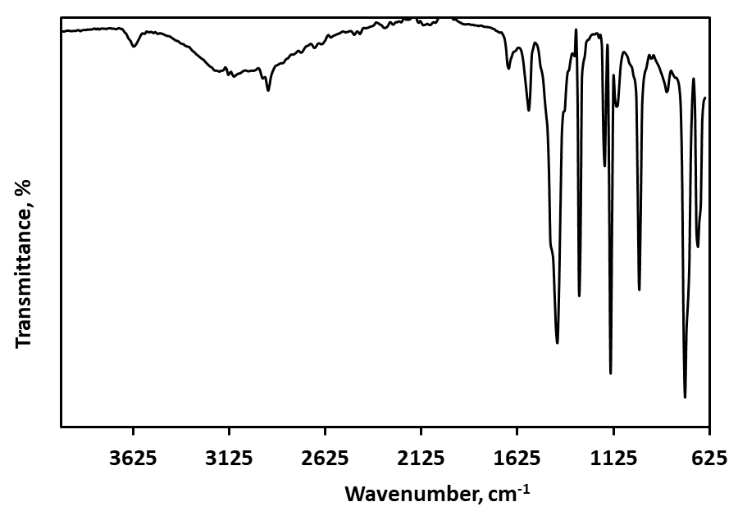
Fig. S1. FTIR spectra of ZIF-67.
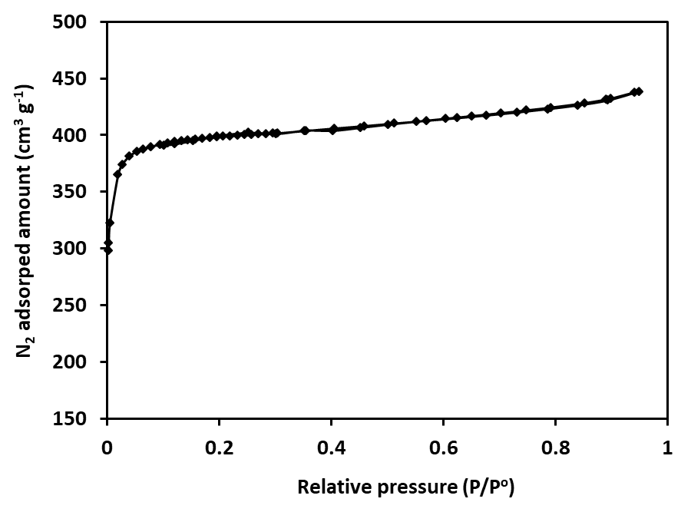
Fig. S2. N₂ physisorption isotherm of ZIF-67.

