Supplementary Fig. PhP typing-based dendrogram, antimicrobial resistance profile, SCCmec type, and ccr type of MRSA strains recovered from patients with DFIs.
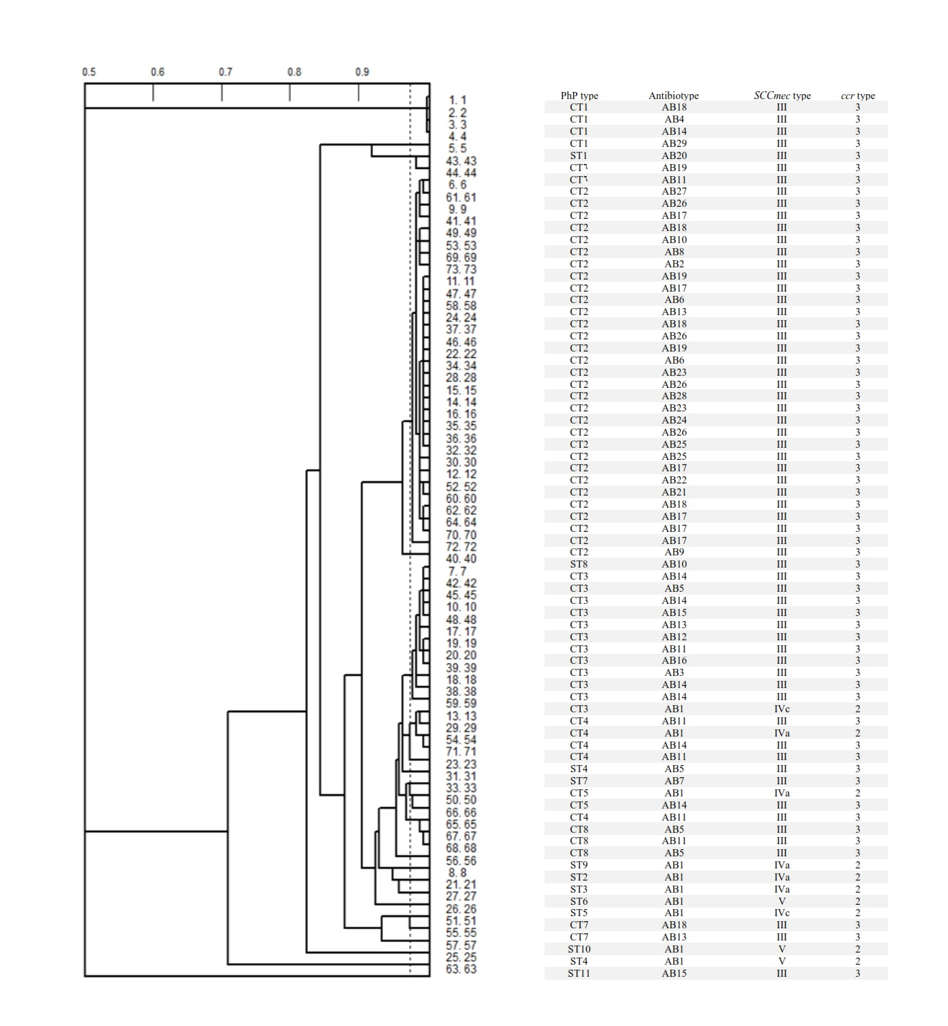

Supplementary Table. The list of primers used in this study.
Reference | Amplicon size (bp) | Oligonucleotide sequence (5´ to 3´) | Primer
5 | 310 | TAATGTACAAAGGTCAAC  TGATAAATATGGACGTGGCT | nucA-F  nucA-R
5 | 195 | TGGCTATCGTGTCACAATCG  CTGGAACTTGTTGAGCAGAG | mecA-F  mecA-R
11 | 613 | GCTTTAAAGAGTGTCGTTACAGG  GTCTCTCATAGTATGACGTCC | SCCmec type I-F  SCCmec type I-R
11 | 398 | CGTTGAAGATGATGAAGCG  CGAAATCAATGGTTAATGGACC | SCCmec type II-F  SCCmec type II-R
11 | 280 | CCATATTGTGTACGATGCG  CCTTAGTTGTCGTAACAGATCG | SCCmec type III-F  SCCmec type III-R
11 | 776 | GCCTTATTCGAAGAAACCG  CTACTCTTCTGAAAAGCGTCG | SCCmec type IVa-F  SCCmec type IVa-R
11 | 493 | TCTGGAATTACTTCAGCTGC  AAACAATATTGCTCTCCCTC | SCCmec type IVb-F  SCCmec type IVb-R
11 | 200 | ACATATTTGTATTATCGGAGAGC  TTGGTATGAGGTATTGCTGG | SCCmec type IVc-F  SCCmec type IVc-R
11 | 881 | CTCAAAATACGGACCCCAATACA  TGCTCCAGTAATTGCTAAAG | SCCmec type IVd-F  SCCmec type IVd-R
11 | 325 | GAACATTGTTACTTAAATGAGCG  TGAAAGTTGTACCCTTGACACC | SCCmec type V-F  SCCmec type V-R
11 | 695 | ATTGCCTTGATAATAGCCITCT  AACCTATATCATCAATCAGTACGT | Type 1 ccr-βc  Type 1 ccr-α1
11 | 937 | ATTGCCTTGATAATAGCCITCT  TAAAGGCATCAATGCACAAACACT | Type 2 ccr- βc  Type 2 ccr-α2
11 | 1791 | ATTGCCTTGATAATAGCCITCT  AGCTCAAAAGCAAGCAATAGAAT | Type 3 ccr- βc  Type 3 ccr-α3
11 | 336 | ATGAATTCAAAGAGCATGGC  GATTTAGAATTGTCGTGATTGC | Type 5 ccr- βc  Type 5 ccr-α
20 | 433 | ATCATTAGGTAAAATGTCTGGACATGATCCA  GCATCAAGTGTATTGGATAGCAAAAGC | Luk-PV-1  Luk-PV-2

