Table S1: Physio-chemical properties of naturally Cd and Pb contaminated soil (S8) used for plant experiment
Soil Characteristics | Unit | Value | Reference
Texture | - | Sandy loam | Gee and Bauder (1986)
pHs | - | 7.93±0.01 | Richard (1954)
ECe | dS m⁻¹ | 3.01±0.005 | -
SAR | - | 10.25±1.10 | Estefan et al. (2013)
Organic Matter | % | 1.21±0.04 | Walkley and Black (1934)
Extractable phosphorus | mg kg⁻¹ | 12.38±0.94 | Olsen et al. (1954)
Total nitrogen | % | 0.18±0.004 | Bremner and Mulvaney (1960)
Cadmium | mg kg⁻¹ | 0.264±0.001 | Lindsay and Norvell (1978)
Lead | mg kg⁻¹ | 5.022±0.002 | Lindsay and Norvell (1978)
Data are shown as mean±SD of three replicates

Treatment-set up
Control | PM-L2 | PM-L1
PM-L1 | Control | PM-L2
PM-L2 | PM-L1 | Control
SSP | SSP+ PM-L2 | SSP+ PM-L1
PM-L1+SSP | SSP | SSP+ PM-L2
PM-L2+SSP | SSP+ PM-L1 | SSP
PM-L1: 10 g PM kg⁻¹, PM-L2: 20 g PM kg⁻¹, SSP: single super phopahe at 250 mg kg⁻¹ soil.
Fig. S1: Treatment set-up of the plant experiment

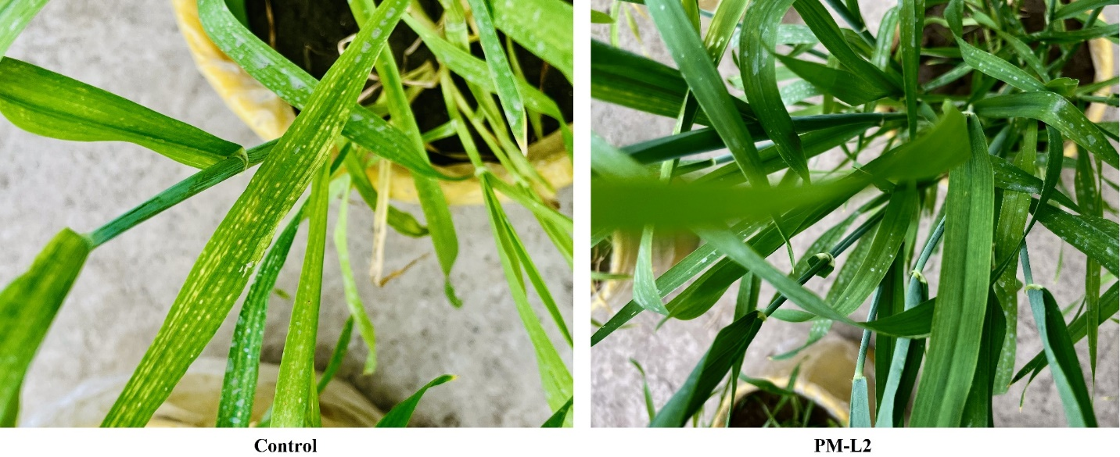
Fig. S2: Effect of PM application on alleviating metal toxicity symptoms in wheat seedlings

