Assembly, annotation and analysis of the chloroplast genome of the Algarrobo tree Neltuma pallida (Subfamily: Caesalpinioideae).
Esteban Caycho¹, Renato La Torre¹, Gisella Orjeda^{1*}
¹Laboratory of Genomics and Bioinformatics for Biodiversity, Faculty of Biological Sciences, Universidad Nacional Mayor de San Marcos, Lima 15081, Peru.
*Correspondence: morjedaf@unmsm.edu.pe
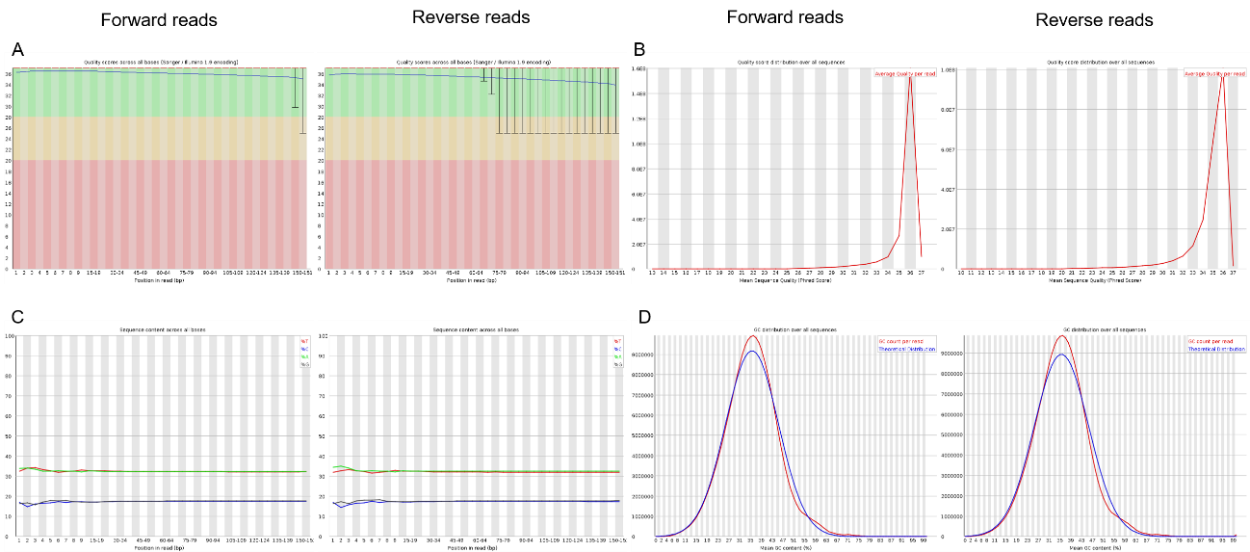
Figure S1. Quality analysis of the filtered reads used to assemble the Neltuma pallida chloroplast genome. (A) Quality scores across all bases. (B) Quality score distribution over all sequences. (C) Sequence base content across all bases. (D) GC distribution over all sequences.
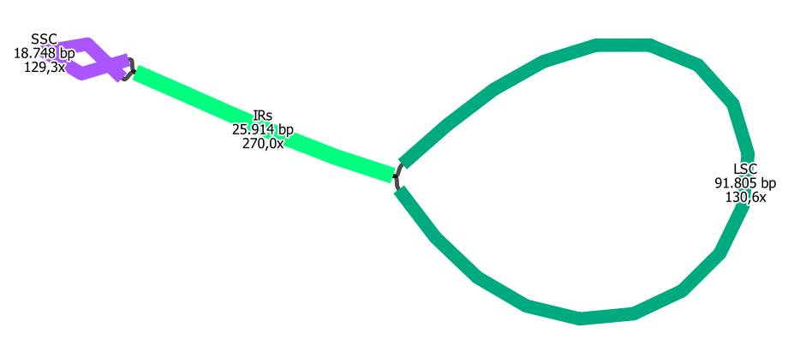
Figure S2. Graphical representation of the N. pallida chloroplast genome structure. The names, sequence length and sequencing coverage of each region of the genome are displayed over the figure.

