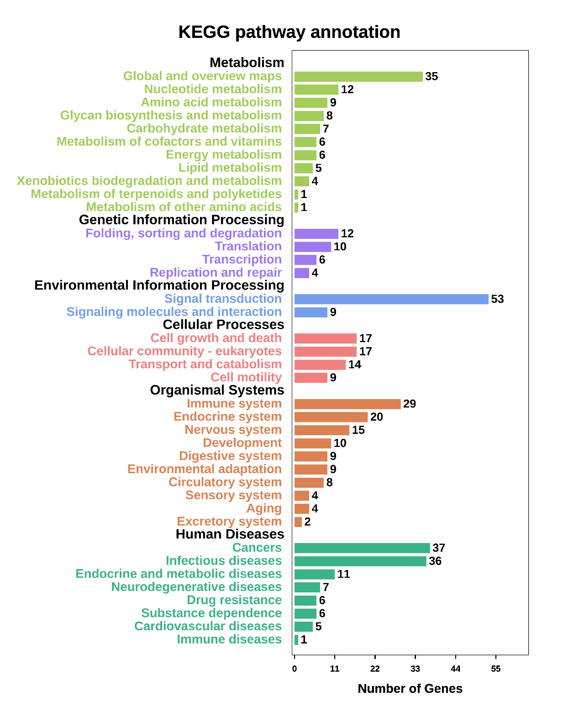

Figure S2 Bar plot of KEGG pathway annotation for all significant genes

